Methods for Estimating Vaccination Coverage and Zero-Dose Prevalence: Head-to-Head Comparison Report (2026)
Rafael Pilliard-Hellwig (Mindset, Data Scientist)
Valeria Strusi (Mindset, Research Manager)
Gianmarco Meta (Mindset, Senior Research Associate)
Manuel Di Loreto (Mindset, Research Associate)
Funmi Oyerinde (Mindset, Senior Project Manager)
Anas Al Masri (Mindset, Technical Director)
Dr. Kyle Vincent (Consultant)
Friday, May 22, 2026
Table of contents

List of Figures

Preface
The report was compiled on 2026-05-22 using version dde89fb of the analysis script.

Acknowledgements
This research was funded by the Gates Foundation (GF) under grant INV-070641. The authors wish to thank GF and the field enumerator team for making this research possible. We also thank Dale Rhoda and his team at Biostat Global Consulting for their technical guidance and analytical support throughout the project. Finally, we thank Dr. Logan Brentzel for her contributions to the time-motion and costing analyses.

Acronyms

List Of Acronyms
AAPOR
American Association of Public Opinion Research
AFENET
The African Field Epidemiology Network
AIC
Akaike Information Criterion
ARR
Administrative Records Review
AS
Adaptive Sampling
AUC-ROC
Area Under the Receiver Operating Characteristic Curve
BCG
Bacille Calmette-Guérin
BeSD
Behavioral and Social Drivers
CA
Catchment Area
CAPI
Computer-Assisted Personal Interviewing
CBN
Central Bank of Nigeria
CHAI
Clinton Health Access Initiative
CI
Confidence Interval
CPI
Consumer Price Index
CRS
Coordinate Reference System
CV
Coefficient of Variation
CVw
Coefficient of Variation of Sampling Weights
DEFF
Design Effect
DHIS2
District Health Information System
DHS
Demographic and Health Survey
DIM
Decentralized Immunization Monitoring
DP
Data Processing
DPT
Diphtheria-Pertussis-Tetanus
EA
Enumeration Area
EGH
Exemplars in Global Health
EPI
Expanded Programme on Immunization
ESS
Effective Sample Size
FDR
False Discovery Rate
FPC
Finite Population Correction
GAM
Generalized Additive Model
GEA
Government Enumeration Area
GF
Gates Foundation
GHSL
Global Human Settlement Layer
GIS
Geospatial Information Systems
GLM
Generalized Linear Model
GPS
Global Positioning System
GREG
Generalized Regression Estimator
GS
Gold Standard
HBR
Home-based record
HDI
Highest Density Interval
HFC
Health Facility Census
HH
Household
HMIS
Health Management Information System
HR
Human Resource
HT
Horvitz-Thompson
HepB
Hepatitis B
IA2030
Immunization Agenda 2030
ICC
Intraclass Correlation Coefficient
IHME
Institute for Health Metrics and Evaluation
IMF
International Monetary Fund
IMR
Infant Mortality Rate
IPV
Inactivated Polio Vaccine
IRB
Institutional Review Board
IRMMA
Identify, Reach, Monitor, Measure, and Advocate
KMO
Kaiser–Meyer–Olkin
KNBS
Kano Bureau of Statistics
KZDS
Kano Zero-Dose Survey
KZDST
Kano Zero-Dose Survey Tool
LCB
Lower Confidence Bound
LGA
Local Government Area
LOE
Level of Effort
LQA
Lot Quality Assurance
LQAS
Lot Quality Assurance Sampling
M&E
Monitoring and Evaluation
MAD
Mean Absolute Difference
MAE
Mean Absolute Error
MCMC
Markov Chain Monte Carlo
MCV
Measles-Containing Vaccine
MENI
Meningitis
MICS
Multiple Indicator Cluster Survey
MOE
Margin of Error
MOS
Measure of Size
MOSV
Missed Opportunity for Simultaneous Vaccination
MOV
Missed Opportunity for Vaccination
MSA
Measure of Sampling Adequacy
MSZ
Morphological Settlement Zone
NCHS
National Center for Health Statistics
NDHS
Nigeria Demographic and Health Survey
NERICC
National Emergency Routine Immunization Coordination Centre
NHMIS
National Health Management Information System
NLSS
Nigeria Living Standards Survey
NPC
National Population Commission
NPHCDA
National Primary Health Care Development Agency
NPI
National Programme on Immunization
NSHDP II
Second National Strategic Health Development Plan
NSIPSS
Nigeria Strategy for Immunization and PHC System Strengthening
NSUM
Network Scale-Up Method
OPV
Oral Polio Vaccine
OPV0
Oral Polio Vaccine at Birth
OR
Odds Ratio
PAHO
Pan American Health Organization
PCA
Principal Components Analysis
PCV
Pneumococcal Conjugate Vaccine
PHC
Primary Health Center
PII
Personally Identifiable Information
PIRI
Periodic Intensification of Routine Immunization
PMTCT
Prevention of Mother-to-Child Transmission of HIV
PPS
Probability Proportional-to-Size
PSU
Primary Sampling Unit
Penta
Pentavalent
QA
Quality Assurance
RB
Rao-Blackwell
RCM
Rapid Convenience Monitoring
RMNCAH+N
Reproductive, Maternal, Newborn, Child, Adolescent Health, and Nutrition
RV
Rotavirus
S-NSUM
Summation Network Scale-Up Method
SA
Supervision Area
SD
Standard Deviation
SDG
Sustainable Development Goal
SE
Standard Error
SMOD
Global Human Settlement Layer Settlement Model
SMOH
State Ministry of Health
SPHCDA
State Primary Health Care Development Agency
SPHCMB
State Primary Health Care Management Board
SRS
Simple Random Sample
SSU
Secondary Sampling Unit
SYG
Sen-Yates-Grundy
TSP
Travelling Salesperson Problem
TSU
Tertiary Sampling Unit
U1
Under the Age of 1
UCB
Upper Confidence Bound
UNICEF
United Nations International Children’s Emergency Fund
USAID
United States Agency for International Development
USD
United States Dollar
VCQI
Vaccination Coverage Quality Indicators
VCTC
Vaccination Coverage and Timeliness Chart
VF
Visibility Factor
VGLM
Vector Generalized Linear Model
WHO
World Health Organization
WoR
Without Replacement
YF
Yellow Fever
ZD
Zero-Dose
ZDC
Zero-Dose Child
ZDLA
Zero-Dose Learning Agenda
ZDLH
Zero-Dose Learning Hub

Executive Summary
Zero-dose children remain a central concern for immunization planning in Nigeria, where an estimated 2.2 million children were unvaccinated as of 2022 (Gavi Zero-Dose Learning Hub 2023), and Kano State carries one of the country’s heaviest burdens. Multistage cluster probability surveys are the methodological gold standard for measuring vaccination coverage, but their cost and timelines often exceed what programmes can sustain for routine decisions. That gap has driven interest in faster, lower-cost alternatives. In late 2024, the GF commissioned Mindset to conduct a baseline study of zero-dose children in Kano State and, alongside it, a head-to-head comparison of five candidate measurement methods against the gold-standard benchmark. The aim was to map the trade-offs between statistical rigour, speed, and cost across the methods most often proposed as substitutes or complements, rather than to identify a single replacement for the gold standard.
The gold-standard survey covered 15 priority Local Government Areas (LGAs): three sentinel LGAs (Gabasawa, Gaya, Nassarawa) powered for change detection, plus 12 combined non-sentinel LGAs. Penta-1 coverage came in at 66.8% in Gabasawa, 62.2% in Gaya, 74.7% in Nassarawa, and 61.7% in the non-sentinel stratum. Fieldwork ran about three months. The sample size was driven by the dual objective of establishing a baseline and powering future impact evaluation in the sentinel LGAs, which pushed our gold-standard implementation to the larger end of what a coverage benchmark would normally require. That is itself a useful reminder of the cost rapid alternatives are trying to displace. It also has a consequence for the analysis: some comparisons in the report apply analytic adjustments, for instance by matching sample sizes via simulation, so that a method’s measured performance reflects the method itself rather than the scale of the survey it was paired with.
The five alternatives evaluated against this benchmark were the Network Scale-Up Method (NSUM), Adaptive Sampling (AS), Lot Quality Assurance Sampling (LQAS), an enhanced Administrative Records Review (ARR) method, and Rapid Convenience Monitoring (RCM). Each was assessed on six dimensions: bias, precision, efficiency, scale/time, analytic complexity, and operational burden. They differ in purpose, not only in performance. Some estimate prevalence, some classify areas against a threshold, and some support rapid follow-up in a defined catchment or intervention area. Treating them as interchangeable coverage estimators would blur the comparison; method choice should start with the decision at hand, the geographic scope it requires, and the uncertainty the programme can tolerate. Table 1 gives the verdict for each.
Table 1: Head-to-head verdict by method
Method | Observed gap vs. gold standard | Precision | Speed / scale | Bottom line
Gold Standard | None (benchmark) | High in this study; design-tunable | Slow / large | Methodological benchmark; pair with rapid tools
AS | Nil or negligible in simulation study | Our implementation was on-par with an equally-sized PPS gold-standard sample | Slow / large | Conditional; promising family, tested variant roughly on par with an equally sized PPS sample
LQAS | Small to modest; implementation-sensitive | Low for coverage; right-sized for classification | Fast / small | Recommended for ward-level classification; secondary use for coverage estimation possible but less efficient
NSUM | High; unstable, not calibratable | Theoretically improved; bias-dominated | Moderate | Not recommended
ARR | High | Not quantifiable (no sampling) | Fast / desk-based | Not recommended
RCM | High; bounded to walked corridor | Dangerously low (n ≈ 20; serial autocorrelation) | Fast / small | Mop-up and within-corridor description only under tested protocol; generalising to unvisited households requires stronger design
The five methods cluster at the extremes of the scale-accuracy spectrum, with no real middle ground. At one end sits the gold-standard probability survey: large, slow, statistically defensible. At the other are the rapid, small-sample tools: RCM visits 20 children per ward, and LQAS in classification mode draws only 19. The two methods most hoped to bridge that gap turned out to fare worst on statistical validity: NSUM, which uses respondents’ social networks to extract more information per interview, and ARR, which estimates coverage from existing administrative data with little or no fieldwork.
Neither NSUM nor ARR produced credible coverage estimates in this study, and we do not recommend either for that purpose. NSUM was hampered by a restricted effective network (roughly 11 eligible alters per respondent, well below the 100+ where the method tends to pay off) and by pervasive transmission errors about contacts’ children’s vaccination status. ARR, even with numerators calibrated against Primary Health Center (PHC) audits and geospatial denominators, left a large, unstable gap to the gold standard that the enhancements we added could not close.
LQAS earns a positive recommendation for the classification task for which it was designed, albeit with some suggestions to improve validity. It worked through 32 sentinel wards against a 50% Penta-1 threshold (n = 19 per lot, both error rates below 10%) and flagged eight wards as potentially below threshold. It can also be configured to produce coverage estimates at higher levels of aggregation, for example by treating lots as strata with appropriate weighting; our pooled aggregates tracked the gold standard reasonably well in most strata, though one diverged materially. Even used this way, LQAS is less efficient for coverage estimation than a properly sized gold-standard sample, and its small per-lot samples leave less room for the non-response adjustments and field protocols that larger probability surveys can sustain.
AS is a more conditional recommendation. It is best understood as a family of designs, and our conclusions apply to the variant we fielded. In a simulation study of that variant, the implementation came out roughly on par with an equally sized conventional Probability Proportional-to-Size (PPS) sample, not consistently better. We also ran an exploratory simulation of an empirical Bayes variant that looked more promising in retrospective testing, suggesting that the adaptive family has further room to be tuned toward implementations that more reliably beat equally sized gold-standard designs. Even if such improvements materialise, the main constraint is analytic complexity: adaptive selection and variance estimation require a skilled survey statistician in the field, which makes routine use unrealistic for many implementers unless the expected gain is large.
RCM occupies a narrow legitimate niche but is not a general-purpose coverage tool under the protocol tested here. A single walk to a 20-child quota produces a route-defined snapshot whose meaning does not extend to the broader catchment area, and vaccination status clusters along the walk (OR ≈ 2.35), further shrinking effective information. The method is well-suited to mop-up activities, by directly identifying and referring unvaccinated children encountered along the walk, and to descriptive claims about the households actually canvassed. What the tested protocol does not support well is generalising from the walked corridor to unvisited households in the wider catchment, except in the unusual case where the walk plausibly covers the entire population of interest. Stronger design principles, such as multiple random walks, tighter specification of the area being characterised, and the other enhancements detailed in the RCM chapter, could broaden its scope. As implemented here, RCM should not underpin programme decisions about higher administrative levels.
The cost analysis complicates the intuition that rapid methods are necessarily cheap. Labor is the dominant input across all methods: field labor drives person-hours, but specialist analytical and technical labor drives financial cost, because higher-priced specialist time is concentrated in those phases. Marginal field costs per additional interview are more similar across methods than total costs, so large total-cost gaps reflect implementation scope and fixed overhead rather than per-unit differences. A practical consequence is that sample-size reduction is a limited lever for total cost: halving sample size does not come close to halving total cost. The useful frame is right-sizing rather than uniform reduction:
- modest upward adjustments for very small designs, where moving from 20 to 40 children halves variance and cuts standard error by about 29%;
- measured downward trimming for very large designs, where marginal precision is cheap but specialist overhead dominates the bill.
The most promising direction is not a new method but a more flexible use of the existing one. Probability sampling does not have to mean a single one-size multi-stage cluster design. The same framework can be right-sized to fill the missing middle between large benchmark surveys and rapid tools, and made more efficient still through model-assisted estimation that borrows strength from open-source geospatial data and prior survey estimates. The model-based geostatistics literature, which we did not directly assess in this report, sits upstream of that direction. It generates granular coverage surfaces that are independently useful for microplanning, and those same surfaces can feed back into the design and analysis of more efficient probability samples.
The gold standard is not replaceable in this setting, but it can be made smaller, faster, and more efficient. The distinction between gold-standard and rapid alternatives is better understood as a continuum of probability designs than as a categorical divide. Right-sized probability surveys, paired with LQAS for routine supervisory classification and informed by open-source geospatial priors, offer a more defensible path to routine zero-dose measurement than any of the indirect or non-probability alternatives tested here.

1. Introduction
Zero-dose children, defined as children who have not received any routine vaccinations, remain a central concern for immunization planning in Nigeria. As of 2022, an estimated 2.2 million children in the country were unvaccinated (Gavi Zero-Dose Learning Hub 2023), and Kano State continues to carry one of the highest zero-dose burdens in the country. Yet it remains difficult to pinpoint where zero-dose children are concentrated and why they are missed, because actionable information is often limited at local levels, even as routine monitoring data continue to improve. This creates a familiar tension for measurement: estimates must be representative and credible, but also timely and affordable.
For vaccination coverage, multistage cluster probability surveys are widely treated as the gold standard because they are designed to support valid inference to the target population. In practice, representativeness is achieved by sampling clusters such as enumeration areas and then sampling households within them. This clustering is operationally efficient, but it inflates sampling variance relative to simple random sampling and therefore increases the sample size needed to reach a given precision. In settings without a unified registry of children, these designs also require probabilistic household selection, listing and screening to find age-eligible children, travel beyond convenient areas, and repeat visits to address non-contact and non-response. Recent World Health Organization (WHO) guidance further emphasizes probability designs tailored to explicit inferential objectives and precision targets, rather than the historically common Expanded Programme on Immunization (EPI) $30×7$ template (WHO 2018). In many contexts, that shift implies larger sample sizes than past practice, and it makes the time and cost burden of methodical field logistics harder to avoid.
In late 2024, the GF commissioned Mindset to conduct a baseline study of zero-dose children in Kano State using this gold-standard approach (Mindset 2025). The study covered 15 LGAs identified by government as priority areas for improving immunization uptake. Three LGAs were designated as sentinel strata (Gaya, Gabasawa, and Nassarawa) and sampled to support standalone, representative estimates. The remaining 12 LGAs were combined into a fourth, non-sentinel stratum. The baseline was intentionally large, even by vaccination coverage survey standards, and field data collection took three months to complete. The study was powered not only to estimate baseline coverage, but to support inference about change in the sentinel LGAs, including detection of relatively small differences at a subsequent assessment. Because implementing partners are running interventions in these areas, the GF required a baseline precise enough to support hypothesis testing of program impacts, which increased the required sample size beyond what a conventional EPI-style design would suggest.
The large sample size for the Mindset baseline study exemplifies why gold-standard surveys are not always a realistic default for ongoing monitoring. Even when they are the right tool for establishing a benchmark, their timelines and costs can exceed what is feasible for routine decisions. This gap between what is methodologically ideal and what is operationally feasible has sharpened interest in alternatives, especially as new open-source data streams and maturing technologies expand the set of plausible options for measuring coverage. The practical question is therefore not whether the gold standard is valuable, but when it is feasible, and how other measurement approaches compare to it in terms of accuracy, timeliness, cost, and operational burden.
There is therefore strong interest in systematically comparing faster, lower-cost approaches to the gold-standard benchmark. To build that evidence base, Mindset implemented five alternative methods alongside the baseline probability survey as part of a head-to-head comparison study. The methods included the NSUM, an AS design, LQAS, an enhanced administrative method, and RCM. The sections below briefly describe each method before presenting the comparison results.
- NSUM: This method uses respondents’ reports about their personal networks to infer the prevalence of a characteristic in the broader population. In practice, respondents are asked how many people they know (their alters) and how many of those alters meet the criterion of interest — in this study, whether any of an alter’s children aged 12–23 months are unvaccinated. The method then scales these alter counts to estimate prevalence, effectively increasing information per interview relative to direct measurement. Its performance depends on strong assumptions about mixing patterns, visibility, and reporting accuracy, which can introduce bias if violated.
- AS: This method begins with an initial probability sample and then expands the sample using a pre-specified rule based on information observed during data collection. In networked or clustered settings, this often means adding linked individuals or nearby households when a trigger condition is met — for example, when the number of zero-dose children observed in an initial cluster exceeds a pre-set threshold. The objective is to increase efficiency for rare or spatially concentrated outcomes by reallocating effort toward areas with higher yield. Inference requires careful accounting for the adaptive selection mechanism to avoid biased estimates and to quantify precision.
- LQAS: This method is designed primarily for classification, not point estimation. It has been widely used in global health and development for vaccination coverage monitoring and supervision. It uses small samples within lots (for example, administrative wards or health facility catchments) to determine whether coverage is likely above or below a threshold level. The method is attractive operationally because it can be fast and resource-light, and it maps naturally to supervisory decisions. Weighted point estimates can be produced at aggregate levels, but these are typically secondary and may be unstable unless sample sizes are increased beyond standard LQAS practice.
- RCM: This method is a rapid field approach intended to identify missed populations and operational gaps, rather than to produce representative estimates. It typically relies on convenience selection of locations and households, often guided by local knowledge and implementation priorities. The main output is actionable intelligence about the children and areas encountered along the walk, such as surfacing reasons for non-vaccination or flagging apparent service gaps where they happen to be observed. Because selection is non-probabilistic, population-level prevalence estimates are not interpretable without strong and usually unjustified assumptions.
- Administrative approaches: This family of methods estimates coverage using routine service statistics reported by PHCs on platforms like District Health Information System (DHIS2), typically by combining counts of doses delivered with target population denominators. They can be produced frequently and at fine geographic resolution, which makes them operationally useful for monitoring. However, both numerators and denominators can be unreliable due to reporting error, duplicate counting, migration and cross-area service use, and outdated population projections. These issues can produce implausible values (for example, coverage above 100%) and can make trends hard to interpret without validation.
While much of the comparison centers on estimated prevalences of coverage and zero-dose status, not all methods are designed to estimate in the same way. LQAS is primarily a classification tool with estimation as a secondary objective, and RCM is explicitly not representative and is not intended for population-level coverage estimation. Even among methods that do target prevalence, sample sizes, sampling frames, and inferential assumptions differ substantially, leading to different precision and different vulnerability to bias. For that reason, the report emphasizes structured, fair comparisons, including normalization and design-aware adjustments where needed, rather than treating any single set of raw estimates as directly commensurate.
Finally, the report includes a cost analysis that decomposes survey activities into their operational components. This provides a more granular view of what drives cost and duration across methods, and generates practical inputs for future planning. Together, the accuracy, precision, and operational findings are intended to inform method selection for future coverage measurement, with an explicit focus on the trade space between statistical performance, cost, and speed.

2. Methodology
This report compares a gold-standard multistage cluster probability survey with five alternative approaches for measuring zero-dose prevalence and related vaccination indicators. A direct comparison of headline results is appealing but rarely feasible in any strict sense: the methods were designed for different objectives, operate at different scales, and rely on different units of observation and field footprints. Several components also share fieldwork processes or overlap in sampled units, which affects both inference and cost attribution. This section provides context for interpreting those comparisons: what each method is designed to do, how design choices shape precision requirements, where bias may arise, and how implementation choices and shared logistics affect interpretation. For full details of the baseline survey’s sampling design—including the gridded Enumeration Area (EA) construction, direct building-footprint sampling in the sentinel LGAs, and the associated sample size calculations—readers are referred to the Survey Design chapter of the baseline report (Mindset 2025).

2.1 Differing Objectives
If methods were straightforward to compare, they would share a single inferential objective, most naturally population-level prevalence estimation. The methods in this study were built to serve different program decisions, and several balance multiple objectives that compete with one another in design and implementation. Some approaches are optimized for a single aggregate prevalence estimate (for example, NSUM). Others are optimized for classification relative to an operational threshold, with prevalence estimation treated as a secondary output conditional on the decision rule (for example, LQAS). Many multistage cluster surveys are designed to deliver estimates at multiple levels of aggregation, such as a state estimate alongside LGA-level estimates, which often implies different precision targets across domains and drives larger sample sizes. Some designs are explicitly powered to support inference about change over time (as in the baseline study), while others prioritize rapid identification of zero-dose children for immediate follow-up within selected catchments rather than broad generalization (as in RCM). Because each method was optimized around different objectives and tradeoffs, head-to-head comparisons must account for what each approach was built to do.
The 2025 baseline study used as the benchmark is unusually large by vaccination coverage survey standards. Sample sizes were set so that each of four strata could meet a stratum-specific precision target, and the design was powered to support inference about change in the sentinel LGAs, including detection of relatively small differences at a subsequent assessment. These objectives are more demanding than designs focused on a single reasonably precise estimate and therefore increased required sample size relative to conventional EPI-style practice. This provides a very precise reference point for judging other methods, but it also means the baseline is not a neutral yardstick for efficiency, because its low error reflects a deliberate design choice driven by planned baseline-to-follow-up comparisons.

2.2 Differing Precision Targets
A head-to-head comparison naturally examines statistical error: how well each method estimates the underlying population quantity, and how much sampling error would be expected under repeated application of the same design in comparable settings. But sampling error is shaped by more than the operational characteristics of a method (such as clustering or stratification) or its field dynamics (such as nonresponse). It also reflects design choices, especially the tolerated error and the sample size and allocation required to achieve it. For this reason, it is not informative to declare a very large gold-standard survey superior simply because it yields lower error than a deliberately small-sample approach such as RCM. A fair comparison asks what each method delivers, in bias and uncertainty, relative to the time, cost, and operational burden it requires, and whether that performance is fit for purpose.
Most methods begin with an explicit or implicit error criterion, framed as a precision bound for an estimate, power to detect change, or a tolerated risk of misclassification. Once specified, it largely determines sample size given the design’s variance structure and expected field conditions. However, methods differ in how much latitude they leave to implementers when setting these targets. Some are highly prescriptive and effectively fix precision through fixed sample sizes or quotas, as in the traditional EPI $30×7$ design and in RCM protocols that target approximately 20 eligible children per catchment. Other methods are flexible in principle but often converge to common defaults in practice. For example, LQAS can accommodate a wide range of decision risks and sample sizes. In practice, however, many implementations revert to common conventions, such as sampling 19 children per lot. More broadly, classification designs often adopt more permissive Type I error rates, such as $α=0.10$. This contrasts with the $α=0.05$ convention that is more typical when reporting confidence intervals for prevalence-focused surveys. By contrast, probability-based prevalence designs such as multistage cluster surveys, and indirect estimation approaches such as NSUM, can be implemented across a wide range of precision targets, with sample sizes that vary substantially depending on whether the objective is a single aggregate estimate, disaggregated domain estimates, or inference about change over time. These differing goal posts mean precision comparisons across methods must be interpreted cautiously, because the methods were not designed around a common precision target.
The present study illustrates how strongly these design choices can drive scale. The Gold Standard survey was powered primarily as the baseline against which implementing-partner interventions would be evaluated, and secondarily as a methodological comparator. This required unusually tight precision, and the sample size planning for the Gold Standard stratum samples targeted power to detect a three-point difference in prevalence with 80% power within each sentinel LGA. By comparison, had the study instead followed the widely used EPI benchmark, the survey team would have selected 30 clusters with 7 children per cluster for each of the four strata (three Sentinel LGAs and one combined Non-Sentinel area), yielding $30×7×4=840$ children. That scale is far smaller than the roughly twelve thousand interviews ultimately completed in this study.
In other cases, the effective precision targets and resulting sample sizes were driven more by logistical convenience than by a standalone planning exercise. For example, no formal sample size planning was undertaken for NSUM. Because it was implemented as an additional module within the main household questionnaire, its achieved sample size largely inherited the Gold Standard design choices. The realized NSUM sample size also reflected predictable losses driven by the method’s within-household selection step, including nonresponse when the randomly selected adult member was not present.
For LQAS, sample size planning followed common conventions used in other implementations, including The African Field Epidemiology Network (AFENET)’s Decentralized Immunization Monitoring (DIM) approach. In each of the 32 wards across the three Sentinel LGAs, data were gathered on 19 children aged 12–23 months. For RCM, the decision to conduct two RCMs per stratum was pragmatic rather than design-optimal, but the within-location target of approximately 20 eligible children followed RCM guidance.
The latest WHO guidance makes this explicit: sample size should be driven by the study’s inferential objectives and precision targets, not by a single prescriptive template (WHO 2018). Accordingly, the gold standard is best understood as a family of probability-based designs that share core principles and operational practices but vary in scale, domain objectives, and analytic purpose. In this report, the term gold standard refers to these probabilistic foundations and field and analytic practices, and the baseline survey implemented here represents a higher-intensity design than a typical cluster coverage survey.
Given this flexibility in scale, one way to make comparisons more interpretable is to shift from raw precision to a normalized efficiency metric such as the Design Effect (DEFF). When the inferential objective is the same and probability sampling is used, a DEFF can summarize variance inflation relative to a simple random sample of the same nominal size. This provides a measure of design efficiency that can be compared across probability-based approaches even when realized sample sizes differ. However, DEFF has its limits. It is outcome specific and estimand-specific and is not generally meaningful for comparing methods built around different targets, such as classification designs versus prevalence estimation. It also does not address bias: when an estimator is materially biased, DEFF can still describe variance inflation, but it no longer summarizes overall accuracy, which depends on both variance and bias. Because two of the methods assessed showed signs of considerable bias, this further complicated its use as a comparative metric, and we did not prioritize it for that purpose.

2.3 Potential Bias
Precision comparisons are most interpretable when methods can be treated as approximately unbiased for the estimand of interest, but this assumption is not equally plausible across approaches. Some methods introduce clear pathways for bias by design, even when they can be informative in practice. For example, NSUM estimates can be biased by transmission and barrier effects (discussed in the NSUM chapter), and RCM relies on a non-probability walk protocol that may recruit households in a systematically unrepresentative way. Even methods intended to support approximately unbiased inference, such as multistage cluster probability surveys, can exhibit bias in practice due to operational factors such as nonresponse, incomplete screening, or differential contact success across households. Weighting adjustments and strong field procedures can reduce some of these risks, but they cannot guarantee unbiasedness. This complicates head-to-head comparison because bias is often difficult to detect and quantify, and total error reflects both variance and bias that are not easily disentangled. In this report, comparisons are benchmarked to the gold-standard survey for the same population, domain, and reference period where feasible, and large departures by alternative methods are interpreted as consistent with potential bias. The benchmark itself carries uncertainty, however, which limits how decisively such bias can be attributed.

2.4 Implementation Variability
A method label does not uniquely determine either its operational footprint or its inferential properties. Even when two organizations report using the same method, design and field decisions can differ enough to change who enters the sample, how defensible inference is, and what it costs to execute. As a result, nominally identical methods can, in practice, be meaningfully different from one organization to the next.
For some methods, this range reflects built-in flexibility rather than accidental variation, whereas in other cases it reflects that multiple protocols exist under the same umbrella method. For LQAS, results depend on how the classification problem is parameterized, including the lower and upper thresholds, tolerated misclassification risks (for example, $α$ and the corresponding power), and how the probability sample is operationalized within wards. For RCM, implementation follows World Health Organization (2024) guidance, but related protocols by similar names exist. For example, rapid house-to-house monitoring can incorporate more structured randomization, including multiple random walks, which may change both field burden and inferential interpretability. Furthermore, organizations make distinct operational choices in how the design is carried out. Data collection firms often implement the same nominal design in systematically different ways, reflecting differences in capability, logistics, training, piloting, and quality-control philosophy. Choices about the sampling frame, selection rules, and the discipline with which the selection protocol is followed in the field can materially affect classification performance and interpretability. For multistage probability surveys, implementation quality depends on the stated design and on how clusters and households are actually selected, listed, and screened, and on whether field teams adhere to pre-specified selection rules under operational pressure and temptations. Agencies differ in how strictly they maintain probabilistic selection, whether they substitute convenience or quota approaches when field conditions are difficult, and how aggressively they pursue callbacks and revisits to mitigate nonresponse. These differences affect the error properties of each method and shift both timelines and cost per completed interview.

2.5 Differing Geographic Scope
For practical and comparability reasons, some methods were intentionally limited to specific geographic domains rather than implemented statewide. Table 2.1 summarizes the areas visited by each component.
Table 2.1: Geographic areas visited by method
Method | Sentinel LGAs | Non-sentinel LGAs
Gold Standard | ✓ | ✓
NSUM | ✓ | ✓
Adaptive Sampling |  | ✓
LQAS | ✓
RCM | ✓ | ✓
ARR | ✓ | ✓
LQAS was implemented only in the sentinel LGAs, because comparison to the gold standard data would not be possible in non-sentinel areas. The baseline study was not designed or powered to support ward-level (or LGA-level) inference in the non-sentinel stratum, which meant many wards in non-sentinel areas had very little data for comparison. In fact, under the realized random draw, some wards in non-sentinel areas had zero EAs sampled within them in the gold standard sample.
Conversely, the AS component was not undertaken in sentinel LGAs. In those areas, sampling fractions were sufficiently high that much of each LGA would have been covered anyway, with interviewed households clustered densely and in close proximity. Because adaptive methods are designed to concentrate marginal sampling effort around detected hotspots, the incremental value of adaptivity was limited under such near-saturation coverage.
Finally, although RCM was not geographically restricted by design, the protocol was implemented as two RCMs locations per stratum (three sentinel LGAs plus one combined non-sentinel stratum). This implies that only two locations would be visited in the non-sentinel stratum, and the random selection resulted in locations in Kiru and Kumbotso.
For head-to-head comparison, these differences in coverage mean that results should be compared within the same geographic domains rather than across unmatched areas.

2.6 Shared Survey Logistics
Several methods in this study were implemented as an integrated field program rather than as fully standalone surveys. As a result, some components shared the same planning, travel, screening, training, supervision, and data-collection infrastructure, and some overlap in sampled units occurred by design or by chance. This matters for two reasons. First, overlap can affect statistical comparisons when the same or related units contribute to multiple estimates, as estimates are not fully independent. Second, it complicates cost efficiency analysis and future planning because observed costs reflect joint production and shared overhead rather than purely method-specific effort.
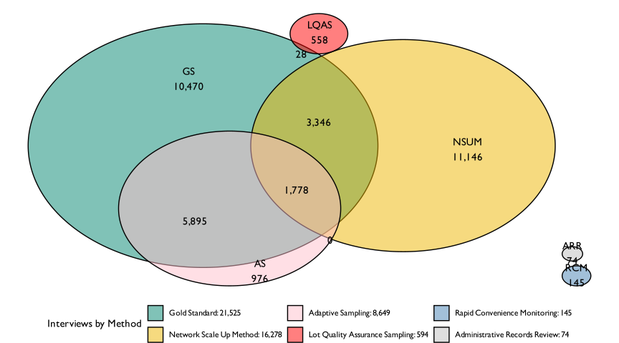
Figure 2.1: Number of successful interviews by method. The intersecting areas represent shared interview subjects between different methods.
Overlap occurred through three main mechanisms, as shown in Figure 2.1. First, some overlap was structural by design. The adaptive sampling design built on the multistage probability sample by drawing a supplementary sample that was combined with the conventional portion to improve precision. This means the adaptive method necessarily shared upstream sampling and fieldwork processes with the gold-standard survey. Second, some overlap was created for logistical efficiency. The gold-standard household survey included an NSUM module, enabling two approaches to be fielded within the same household-contact and travel footprint, even when the NSUM respondent differed from the primary caregiver respondent. Third, some overlap occurred by chance because sampling fractions were high in some domains. In the sentinel areas, independently drawn LQAS samples occasionally revisited households already interviewed by the gold standard. Where this occurred, previously collected responses were used rather than re-interviewing households with essentially the same instrument.
Shared logistics also shaped the timing of data collection. As shown in Figure 2.2, the gold standard, NSUM, and the initial AS component largely coincided because they shared a survey instrument and field teams. In many respects this pooling increased efficiency, but it also created a capacity constraint: the same teams and support staff could only undertake so much at once. As a result, methods that would ideally be fielded concurrently for maximum comparability had to be sequenced. For example, LQAS, RCM, and the AS supplement were implemented later, owing to distinct protocols, separate field plans, and the practical need to stagger workloads.
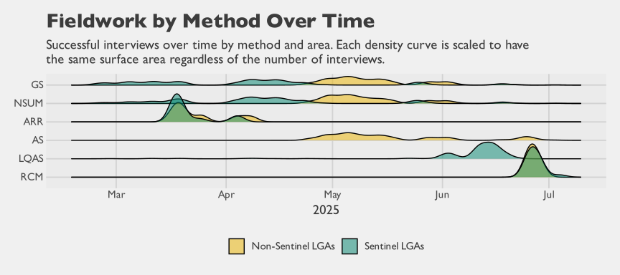
Figure 2.2: Fieldwork volume by method and area
These shared processes mean that the total observed field costs cannot be interpreted as the standalone cost of each method. They also imply that comparisons based on raw totals can be misleading, because methods differ in both scale and the extent to which they benefited from shared infrastructure. For this reason, the cost analysis later in this report accounts for this joint production process, apportioning shared inputs and overhead as judiciously as possible between methods using a data-driven rule based on each method’s share of successful interviews. Even with careful allocation, shared production limits how directly these cost results generalize to standalone implementations.
Taken together, these comparative challenges motivate the planning tools provided in Appendix B, which allow readers to vary key assumptions, operational parameters, and cost structures, and to see how those choices translate into sample size requirements and expected costs in their own context.

3. Findings

3.1 Gold Standard Survey: Baseline Prevalence Estimates
This methodological report evaluates five alternative estimation approaches for measuring zero-dose coverage (the proportion of children aged 12–23 months who have not received the first dose of pentavalent vaccine, comparing each against a gold-standard multistage cluster probability-based survey conducted in Kano State). The latter employs a stratified, probability-proportional-to-size sampling design across four study areas—Nassarawa, Gabasawa, Gaya LGAs, and non-sentinel areas—providing design-weighted estimates with confidence intervals that represent the true population zero-dose prevalence.
Figure 3.1 presents the zero-dose prevalence estimates by study area, each with its 95% confidence interval. The yellow dashed reference line at 42.2% (FMoHSW, NPC, and ICF 2024) marks the 2023–24 Nigeria Demographic and Health Survey (NDHS) estimate for Kano State, providing a key benchmark for comparison. The green dashed reference line at 20% represents the aspirational target corresponding to 80% Penta-1 coverage. Our survey findings reveal substantial geographic variation: Nassarawa (25%) falls closest to the 20% target, while Gabasawa (33%) and Gaya (38%) show progressively higher zero-dose prevalence. The non-sentinel areas (38%) show the highest zero-dose prevalence, reflecting the broader immunization challenges in areas outside the three sentinel LGAs.
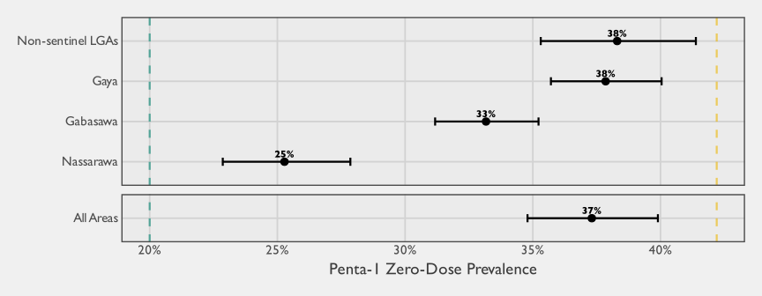
Figure 3.1: Zero-dose prevalence by study area (gold standard survey)
These baseline estimates represent the gold standard against which each of the other estimation methods will be evaluated. Subsequent sections present each method’s results and performance characteristics.

3.1.1 Precision at Sub-State Geographic Levels
The gold-standard survey in this study was powered to detect small changes in prevalence over time within each sentinel LGA, producing unusually precise estimates relative to typical coverage surveys. To help readers calibrate what precision to expect from a probability survey at different geographic scales, Table 3.1 compares the margin of error (MOE) achieved in this study with the MOE expected under a hypothetical EPI $30×7$ design (30 clusters of 7 children per stratum). The EPI scenario uses the non-sentinel gridded-EA Intraclass Correlation Coefficient (ICC) from the stratum-specific baseline ICC analysis (see the Intraclass Correlation annex) to derive the design effect, since the non-sentinel stratum used conventional first-stage cluster sampling of gridded enumeration areas.
Table 3.1: Gold standard survey precision at sub-state geographic levels: achieved margin of error vs. hypothetical EPI 30×7 design
 | Gold standard (this study) |  | EPI 30×7 (hypothetical)
Geographic level | n | MOE | n | MOE
Ward (median, sentinel) | ~222 | ±7.1 pp | 21ª | ±27.8 pp
Sentinel LGA (median) | ~2,912 | ±2.2 pp | 210 | ±8.8 pp
Combined non-sentinel | 3,608 | ±3.0 pp | 210 | ±8.8 pp
ªThe EPI 30×7 design allocates 30 clusters per stratum (LGA), not per ward. Assuming 10 wards per LGA, each ward receives roughly 3 clusters (21 children), which is insufficient for reliable ward-level inference.
Ward-level values are medians across the 32 sentinel wards; LGA-level values are medians across 3 sentinel LGAs. MOE = margin of error (half-width of a 95% confidence interval), expressed in percentage points. EPI 30×7 calculations assume gridded-EA ICC = 0.152 (non-sentinel), DEFF = 1.91, and prevalence = 33.2%.
The table illustrates two points relevant to interpreting the method comparisons that follow. First, even the gold-standard design in this study–which was considerably larger than a typical coverage survey–produces ward-level margins of error that are nontrivial. Second, under a more typical EPI $30×7$ design, LGA-level precision would widen substantially and ward-level inference would not be viable. The EPI scenario in the table assumes the LGA is the stratum, so that all 210 children fall within a single LGA. When a survey is instead designed at the state level, each LGA receives only a fraction of the state-level allocation; with 44 LGAs in Kano State, for example, a state-level $30×7$ design would yield fewer than five children per LGA on average, rendering LGA-level inference infeasible as well.

3.2 Network Scale-Up Method

3.2.1 Overview
The NSUM pairs a survey and estimation strategy that uses respondents’ reports about people in their personal networks to estimate the prevalence of a characteristic that is difficult to enumerate directly, such as zero-dose status among children. The variant used in the Kano Zero-Dose Baseline Study is the Summation Network Scale-Up Method (S-NSUM) (McCarty et al. 2001). In S-NSUM, a probability sample is drawn from the general population and each respondent (the ego) is asked about the number of people in their personal network, typically defined over specific relationship types such as family members, friends, coworkers, neighbors, and acquaintances. These network members are commonly referred to as alters and are usually defined as people with whom the respondent has had frequent and recent face-to-face contact. Respondents are then asked how many of their alters have the characteristic of interest — in our case, whether they have an unvaccinated child. An extrapolation formula scales these alter counts to the full population to produce a prevalence estimate. A further practical advantage is that NSUM collects only aggregate counts of alters rather than names or other identifying information, which makes it well suited to settings where the characteristic of interest is not directly observable by the interviewer — such as the vaccination status of children in other households. This indirect structure can also reduce social desirability pressure when respondents might otherwise underreport the trait of interest.
The NSUM literature includes a long history of empirical applications. For example, it has been used to estimate the size of child sex-trafficking populations in Maharashtra, India (IST Research, University of California, Los Angeles, and Global Fund to End Modern Slavery 2020), and child trafficking populations in Sierra Leone (Yi et al. 2023). In the Sierra Leone study, adults reported on children because children could not be interviewed directly, a structure that parallels our setting in which information about zero-dose children must be reported indirectly through adults. We draw on the lessons from that work in the design and interpretation of this study. To our knowledge, NSUM has not previously been applied to vaccination coverage or zero-dose estimation, either in the published literature or in documented operational use, making this application novel.
In its simplest form, the NSUM model assumes a binomial distribution so that the proportion of people in a person’s network that belong to the population of interest is approximately equal to that population’s proportion of the general population (Killworth et al. 1998). The intuition is that if a respondent reports a network of size 100 and two of these people have the characteristic of interest, then an estimate for its prevalence is $2\%$ of the general population. In mathematical terms, one can start with
$$\frac{m}{c}≈\frac{h}{t} \left(3.1\right)$$
where $m$ is the mean number of people known in the population of interest, $c$ is the mean personal social network size, $h$ is the size of the population of interest, $t$ is the total population size, and $q=h/t$ is the prevalence of the population of interest. For our applications, the estimand $q$ could be either a particular vaccine coverage rate, or the zero-dose rate.
Conveniently indexing the sample respondents as $1,2,…,n$, and writing $\left(m_{j},c_{j}\right)$ for respondent $j$’s reported target-population count and network size, a natural estimator for the prevalence is the ratio
$$\hat{q}=\frac{\sum_{j=1}^{n}{m_{j}}}{\sum_{j=1}^{n}{c_{j}}}. \left(3.2\right)$$
Given a known total population size $t$, the corresponding estimator for the size of the population of interest is
$$\hat{h}=t⋅\hat{q}=t⋅\frac{\sum_{j=1}^{n}{m_{j}}}{\sum_{j=1}^{n}{c_{j}}}. \left(3.3\right)$$
Equation 3.2 and Equation 3.3 are most naturally motivated under a Simple Random Sample (SRS), where unweighted sample totals approximate population totals. In many real-world applications, however, respondents are selected under a complex sampling design that integrates elements such as multistage sampling, so we use a weighted ratio estimator.
One of the main appeals of NSUM is that, when its assumptions hold, it can deliver large gains in statistical efficiency. Equivalently, a given level of precision can be achieved with substantially smaller respondent samples. The intuition is straightforward: rather than extracting a single binary data point from each respondent, NSUM leverages information about the respondent’s network, effectively increasing the amount of information collected per interview.
Figure 3.2 illustrates these theoretical gains by comparing margins of error for a direct estimator of a simple proportion (green) with those for the NSUM prevalence estimator (yellow). The comparison is intentionally idealized and abstracts away from the biases and complications that arise in practice. Under these assumptions, the NSUM estimator reaches useful precision much more quickly, which is especially attractive when estimating rare populations. For example, with an average network size of 30, achieving an absolute margin of error of approximately $±0.03$ under the conservative maximum-variance planning assumption ($q=0.5$, the standard worst case used in sample-size planning even when a prior estimate is available) requires on the order of $36$ respondents under NSUM, compared to roughly $1067$ respondents for direct estimation from a simple random sample. These figures are not operational targets. Their purpose is to illustrate that, at least in theory, the efficiency gains from NSUM can be substantial when its underlying assumptions are met.
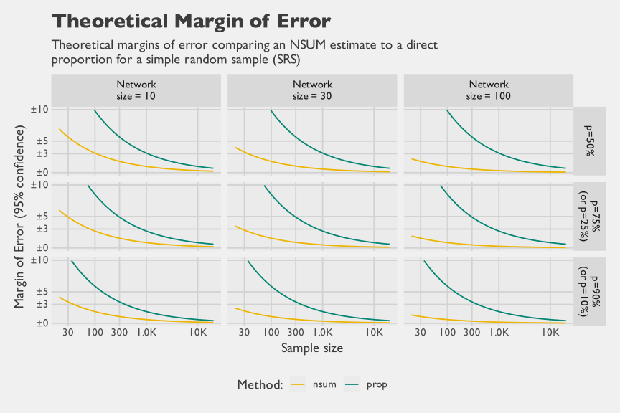
Figure 3.2: Idealized theoretical 95% margins of error under simple random sampling for direct estimation of a proportion versus the NSUM prevalence estimator, by assumed mean network size and true prevalence; ignores complex-design effects and potential NSUM biases (for example, transmission error and barrier effects).
As Figure 3.2 makes clear, for proportions, the efficiency gains from NSUM are most pronounced when respondents’ effective network sizes are large, because each interview contributes information on many alters rather than a single observation. In contexts where denominators reflect broad adult contact networks (e.g., $>100$), precision improves rapidly, but the chart also shows that meaningful gains can persist even with much smaller networks. This distinction matters for our application: unlike many NSUM studies that use an individual’s full adult contact network as the denominator, our denominator is restricted to adult contacts who have age-eligible children, yielding a substantially smaller effective network ($≈11$ alters per respondent).

3.2.2 Implementation Details
The NSUM is an attractive procedure as it can be appended to virtually any probability-based survey since it only requires an additional module of questions to be asked of the respondents. Hence, the NSUM can provide an alternative prevalence estimate at only a marginal cost. Further, the NSUM is particularly useful when the characteristic of interest cannot be directly verified at interview — for example, a respondent may know that a neighbor has young children but not know their vaccination status. Because respondents report only aggregate counts rather than identifying specific individuals, the method can also reduce social desirability pressure and may yield less biased estimates than direct self-report in sensitive contexts. NSUM can likewise be useful in some settings when certain types of respondents are simply hard to include in a conventional sample — for example, mobile, transient, or otherwise hard-to-reach groups — because their characteristics may still be observable to other respondents through the network even when those individuals themselves are not interviewed.
NSUM estimates have the potential to suffer from three adverse effects, each of which can have implications on the NSUM’s ability to provide efficient and unbiased estimates. First, barrier effects exist when people are not equally likely to know those with the characteristic of interest. When this is the case, the underlying assumption of the binomial distribution is violated. A helpful way to think about barrier effects is heterogeneity in exposure to the group of interest: some respondents are systematically more likely to know group members than others, so the probability that an alter belongs to the group is not constant across egos and the binomial mixing assumption is violated. For example, if households with unvaccinated children are concentrated in specific communities or social networks, respondents outside those circles will know few or none, while those inside may know several, creating overdispersion. When the sample overrepresents less-connected respondents — those with little exposure to the group of interest — the result is likely underestimation. Conversely, if the group is highly visible within certain circles, such as community mobilizers or popular market traders, overrepresentation of these high-exposure respondents can inflate estimates.
Some researchers have proposed strategies to reduce the impact of barrier effects. For example, Maltiel et al. (2016) argues that bias from differential mixing can be limited, in part, by designing the sample to be as balanced as possible across key covariates that predict social contact patterns, since NSUM estimates effectively pool network reports across respondents at the estimation stage. They also propose modeling heterogeneity in personal network size (degree) using random effects, which can help stabilize inference when degrees vary widely. These steps can improve robustness, but they do not eliminate barrier effects, because the core problem is not only geographic clustering: it is systematic heterogeneity in who knows whom that can cut across geography through social stratification, institutions, and network topology.
 Sources of Bias in NSUM Studies
There are three main sources of bias in NSUM studies:
Barrier effects exist when people are not equally likely to know those with the characteristic of interest (a violation of the assumption of the binomial distribution)
Recall effects occur when at the time of interview a respondent is unable to recall the number of individuals in their personal network that belong to the population of interest.
Transmission effects occur when the respondent is unaware of the number of people in their personal network that are part of the population of interest.

Second, recall effects occur when, at the time of interview, a respondent cannot accurately recall either (i) who belongs in their personal network in the first place (the denominator) or (ii) which network members belong to the population of interest (the numerator). Both matter, but errors in the numerator are often more consequential for accuracy. If a respondent forgets an alter entirely, that person is effectively missing from both the denominator and the numerator, which can introduce error but may partially cancel in the ratio when omissions are not systematically related to membership in the population of interest.
By contrast, recalling an alter but misidentifying whether they belong to the population of interest directly perturbs the numerator conditional on the denominator, which tends to translate more directly into bias in the estimated prevalence. Such effects can be mitigated through enumerator probing and by asking respondents to review and reconcile their counts at the end of the NSUM module. A practical design choice is to structure the module around mutually exclusive and collectively exhaustive alter categories, prompting respondents to enumerate their network in sub-communities such as close family, extended family, colleagues, friends, neighbors, and an “anyone else not previously reported” category. This decomposition reduces cognitive burden by providing concrete retrieval cues, increases the likelihood that respondents enumerate their networks comprehensively, and helps standardize the concept of “who counts” as an alter across respondents.
In international development contexts, an additional challenge is that a child’s exact age may not be known even to immediate family, because birthdates are not always recorded and numeracy can be limited in lower-education settings. As a result, respondents may struggle to identify which contacts have age-eligible children (for example, 12–23 months), and this uncertainty can introduce error both by omitting eligible alters from the network denominator and by misclassifying eligibility when determining membership in the population of interest.
Third, transmission effects arise when respondents cannot report membership in the population of interest even in principle, because they do not actually know the relevant status of their alters. In our application, this is a central and arguably the strongest assumption: respondents may not reliably know the vaccination status of parents’ (guardians’) children, even when they know those households well. Transmission error is therefore distinct from recall error, which concerns failures of memory given information that was once known; here the information may never have been available to the respondent.
A common way to address this limitation is through a Visibility Factor (VF) adjustment, which represents the probability that an alter’s true status is visible to the respondent. In practice, information to estimate a VF is often collected in a separate survey that interviews members of the population of interest (or their households), rather than through the NSUM instrument itself, which is typically administered to a general-population sample of adults. In our setting, this aligns closely with the role of the gold-standard household survey, so we incorporated an additional question asking caregivers to approximate what proportion of people in their own social networks would know the vaccination status of their children. This caregiver-reported visibility information can then be used as an inflation factor to adjust NSUM counts for transmission error. Because VF is itself uncertain and may vary across respondents and subgroups, it is best paired with validation work, such as re-interviews or targeted follow-up on a subsample, to quantify reporting error and support an adjustment model that reduces bias in the final NSUM estimates.

3.2.2.1 The S-NSUM Module for this Study
The S-NSUM application for this study focused on estimating the number of zero-dose children. To avoid double counting within respondent’s networks, the NSUM module was set up to ask male respondents only about males in their personal network and similarly to ask female respondents only about females in their personal network; for example, a respondent could report knowing a married couple that have children together and each person would contribute the same counts of children towards the NSUM response.
Upon selecting a household for observation, the questionnaire was first administered to a caregiver of an age-eligible child, if one was available. Regardless of whether this was the case, one adult was selected then subsequently from household through a pseudo-random procedure based on asking for the adult resident in the household who most recently had a birthday. By random chance, this could happen to be the same caregiver, or (more frequently) could be someone completely different. The NSUM module commenced with asking the respondent a series of relation-type questions, such as the number of men/women they know that are family members, friends, coworkers, etc. The sum of responses over these questions was used to approximate their personal network size of known adults of the same sex. For each category of relational type, the NSUM module then asked for counts in the respondent’s network on the number of people that have a child aged 12-23 months (the actual denominator for our NSUM study), and then asked the number of such children that did not receive any vaccinations out of those counts.
There are several implementation details worth noting. First, the NSUM estimand in this study differs slightly from what is commonly targeted in the literature. Specifically, we estimate the proportion of households with a child aged 12–23 months that include at least one unvaccinated child, rather than the proportion of 12–23-month-old children who are unvaccinated. In practice, the gap between the two definitions is small in our setting because most eligible households contain only one age-eligible child: in the gold-standard household screener, an estimated 91.1% (95% Confidence Interval (CI) 90.4–91.8) of households with a child aged 12–23 months contain exactly one such child, 7.6% contain two, and the rest contain three or more, averaging 1.10 such children per eligible household. Second, respondents were asked more generally whether their contacts had any unvaccinated children, rather than being prompted specifically about Penta-1 (the Gavi proxy indicator). These choices remain comparable to the gold-standard survey because we can re-express the probability-sample data to match the same household-level and vaccine-specific definitions. They do, however, require some nuance when interpreting head-to-head comparisons, since the NSUM target is closely related to but not identical to the estimands used by other methods.

3.2.2.2 Estimation
Several quality safeguards were implemented to strengthen data integrity. First, the Computer-Assisted Personal Interviewing (CAPI) instrument enforced logical constraints within each alter category, preventing respondents from reporting numerator counts that exceeded the corresponding denominators. Second, the CAPI program automatically summed alter-category totals and prompted enumerators to read back the implied network size for respondent confirmation, creating an opportunity to correct clerical errors and other implausible entries in real time. Third, during estimation we applied an additional round of quality assurance checks to identify and resolve remaining inconsistencies and apparent recording errors in the NSUM responses. Because some respondents did not answer all NSUM items (about 4.8% of respondents had at least one missing item), missing values were imputed using predictive mean matching with a model that included the NSUM items and key demographic covariates (for example, age, education, and marital status). Finally, we top-coded reported network sizes at 150 to limit the influence of implausibly large networks on estimation, consistent with evidence on typical upper bounds for stable human social network size (Hill and Dunbar 2003).
Several software packages exist to analyze NSUM data. With the R statistical language (R Core Team 2025), the NSUM package (Maltiel and Baraff 2015) can fit Bayesian models that explicitly accommodate barrier and recall effects. The networkreporting R package (Feehan and Salganik 2014), while still under development, supports survey-weighted estimation for classic summation NSUM estimators, bootstrap-based standard errors, and top-coding strategies to limit the influence of unusually large reported network sizes (Zheng, Salganik, and Gelman 2006). In this study, however, final estimation was implemented using the R survey and srvyr packages (Gao, Schneider, and Kolenkikov 2026; Freedman Ellis and Schneider 2026) to fully account for the complex sampling design. We expressed NSUM prevalence as a survey ratio and implemented derived quantities (including the estimated number of unvaccinated children, with or without VF adjustments) as survey contrasts. This formulation allowed complex design features to be propagated directly into variance estimation and uncertainty intervals.
We initially explored sex-specific estimation as a sensitivity analysis. Specifically, we estimated NSUM quantities separately for female respondents reporting about mothers in their networks (“NSUM-F”) and male respondents reporting about fathers in their networks (“NSUM-M”), treating respondent sex as a stratification variable. One design consideration for an immunization-focused application is that women — frequently the primary caregivers of young children — may have more accurate knowledge of children’s vaccination status in their personal networks, which would make restricting NSUM data collection to female respondents a natural choice in principle. In our data, however, this expectation is not borne out: as shown in Figure 3.3, the NSUM-F and NSUM-M point estimates are very similar to each other across strata, and neither tracks the gold standard appreciably better than the other; to the extent that bias affects NSUM in this setting, it appears to affect male and female respondents to a comparable degree. At the same time, the number of male respondents was substantially smaller than expected under equal selection probabilities. This imbalance likely reflects differential availability or participation, with men less likely to be at home at the time of interview, and less likely to agree to be interviewed, rather than a difference in respondent knowledge of vaccination status; it also accounts for the wider uncertainty intervals around the male-based estimates.
Given the negligible differences in results and the loss of precision from analyzing the smaller male stratum on its own, we adopted a single combined analysis under the full complex survey design. Operationally, this pools female-to-mother reports and male-to-father reports into one estimator, while retaining design-based weighting and variance estimation. This approach also aligns more closely with standard NSUM practice, which typically does not constrain network measurement by respondent demographics, and avoids over-interpreting sex differences that our data are not well powered to detect.

3.2.3 Results
We begin the results by presenting sex-disaggregated NSUM estimates in Figure 3.3. These results compare estimates derived from female respondents reporting about mothers in their networks with estimates derived from male respondents reporting about fathers. Across strata, there are no particularly discernible differences in the point estimates reported by men versus women. However, men were less likely to participate in the NSUM module, resulting in substantially smaller effective sample sizes and correspondingly wider uncertainty intervals around the male-based estimates.
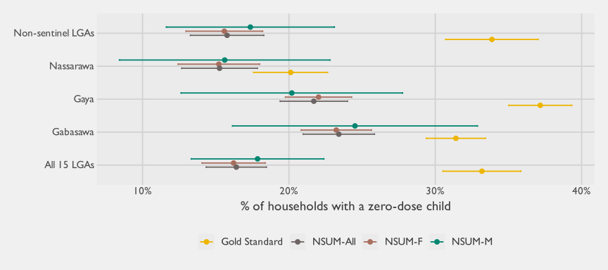
Figure 3.3: Comparison of NSUM estimates to the Gold Standard, stratified by the sex of the respondent
Given the similarity in point estimates and the reduced precision of the male-disaggregated results, the remainder of the analysis focuses on combined estimates. In the sections that follow, we pool female-to-mother and male-to-father reports within a single complex-survey framework, using the full design weights and variance estimation to obtain our primary NSUM results. Table 3.2 summarizes these combined findings, reporting the average network size (the mean number of same-sex contacts who have age-eligible children) and the corresponding survey ratio that estimates the prevalence of households with unvaccinated children. For completeness, the table also reports the estimated standard error of the prevalence, its coefficient of variation, and the associated design effect ($\text{deff}$).
Table 3.2: NSUM survey ratios as zero-dose prevalences
Stratum | # of HH interviews | Average network size | NSUM Zero-Dose prevalence | Coefficient of Variation | Design Effect | Margin of Error
Gabasawa | 3,177 | 13.6 | 26.7% | 3.6% | 1.2 | ±1.9
Gaya | 3,144 | 11.5 | 24.8% | 4.0% | 1.2 | ±1.9
Nassarawa | 2,762 | 9.9 | 19.2% | 6.4% | 0.9 | ±2.4
Non-sentinel LGAs | 6,833 | 10.7 | 17.7% | 8.2% | 6.4 | ±2.8
All 15 LGAs | 15,916 | 10.8 | 18.7% | 6.3% | 9.0 | ±2.3
Table 3.2 indicates that respondents reported relatively small effective networks of same-sex contacts with age-eligible children, averaging about 10–14 alters across strata (overall mean: 10.8). On this basis, the estimated prevalence of households with at least one unvaccinated child is highest in the sentinel LGAs Gabasawa (26.7%) and Gaya (24.8%), lower in Nassarawa (19.2%), and lowest in the combined non-sentinel stratum (17.7%), yielding an overall estimate of 18.7% across all 15 LGAs. Despite the modest network sizes, uncertainty is fairly tight in absolute terms, with 95% margins of error ranging from approximately ±1.9 to ±2.8 percentage points, and coefficients of variation between 3.6% and 8.2%. At the same time, the design effects are notably elevated for the non-sentinel stratum (6.4) and for the pooled 15-LGA estimate (9.0), underscoring that complex-design features materially inflate variance relative to simple random sampling, even with large respondent samples.
We next place these survey-ratio NSUM estimates in context by comparing them directly to the gold-standard probability survey in Figure 3.4. The figure reproduces the same NSUM prevalence estimates while varying the operational definition of the personal network, ranging from the full set of eligible alters to narrower, tighter networks such as close family only. The rationale is a classic tradeoff: restricting to closer alters reduces the effective network size (and therefore statistical power), but it may improve data quality by limiting recall and transmission errors, since respondents are more likely to know the vaccination status of close contacts’ children. In this application, however, the NSUM variants tend to under-estimate zero-dose prevalence relative to the gold standard, with the magnitude of under-estimation varying by stratum. Nassarawa is comparatively close to the gold-standard estimate, whereas Gabasawa and especially Gaya show larger gaps. Taken together, this pattern is consistent with respondents undercounting the number of zero-dose households in their networks, motivating an explicit adjustment for imperfect visibility of vaccination status.
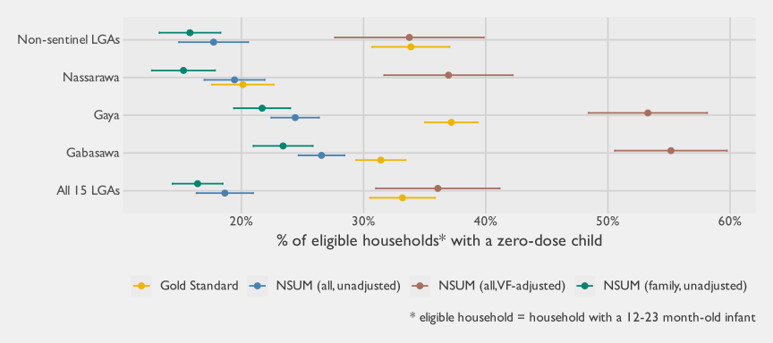
Figure 3.4: Comparisons of NSUM estimates against the gold standard
To explore transmission error directly, Figure 3.4 also includes a VF-adjusted variant of the full-network NSUM estimator. As described earlier, we estimate the VF from the gold-standard household survey by asking caregivers of age-eligible children what percentage of people in their social networks they would expect to know the vaccination status of their children (see Table 3.3). Because this VF question was asked at the caregiver level and not disaggregated by alter category, the adjustment can only be applied to the full network NSUM variant; we cannot compute separate VFs for restricted networks such as close family only. Empirically, the VF-adjusted estimator substantially increases the implied zero-dose prevalence and tends to over-estimate the gold-standard rate in the sentinel LGAs, with the non-sentinel stratum as the main exception where the adjustment brings estimates closer.
Table 3.3: Mean visibility reported by caregivers (gold standard)
area | mean_visibility | mean_visibility_se | mean_visibility_low | mean_visibility_upp
Gabasawa | 20.1% | 0.7% | 18.7% | 21.6%
Gaya | 15.5% | 0.6% | 14.4% | 16.7%
Nassarawa | 14.0% | 0.7% | 12.6% | 15.4%
Non-sentinel LGAs | 9.9% | 0.6% | 8.6% | 11.1%
All 15 LGAs | 10.9% | 0.5% | 9.9% | 11.9%
Full computational details are provided below. Table 3.4 reports the design-based survey totals that serve as inputs to the NSUM estimators (for example, weighted sums of network sizes and reported zero-dose acquaintances under alternative network definitions, along with the components used to construct the VF). Table 3.5 then shows how these totals are combined into the specific NSUM variants, defining the corresponding ratios and survey contrasts, along with their associated standard errors and confidence intervals. This including the VF itself, prevalence estimates under different network definitions, and the derived estimates of totals.
Table 3.4: Survey totals used as inputs in NSUM estimation
var | description | Gabasawa | Gaya | Nassarawa | Non-sentinel LGAs | All 15 LGAs
a | Weighted sum of network sizes (immediate family) | 807,553 | 682,342 | 1,324,456 | 12,328,527 | 15,142,878
b | Weighted sum of reported unvaccinated acquaintances (immediate family) | 189,055 | 148,045 | 202,087 | 1,946,516 | 2,485,703
c | Weighted sum of acquaintances with an infant 12-23 mo | 85,524 | 68,660 | 75,602 | 830,657 | 1,060,443
d | Weighted sum of visibility estimates | 60,853 | 49,587 | 88,941 | 581,439 | 780,820
e | Estimated total visibility reporters | 126,390 | 108,243 | 169,089 | 1,106,995 | 1,510,717
f | Weighted sum of conditional individual selection probabilities | 107,474 | 114,965 | 200,757 | 1,998,664 | 2,421,859
g | Weighted sum of network sizes (full network) | 4,096,779 | 3,588,767 | 6,184,390 | 62,939,427 | 76,809,363
h | Weighted sum of reported unvaccinated acquaintances (full network) | 1,088,002 | 875,764 | 1,202,012 | 11,156,177 | 14,321,955
Table 3.5: Survey contrasts computed from NSUM respondents
 | Description | Contrast | Estimate | SE | degf | CV | 95% CI
 |  |  |  |  |  |  | Lower bound | Upper bound
Gabasawa
1 | Visibility factor (VF) | d / e | 48.1% | 1.1% | 499 | 2.3% | 45.9% | 50.4%
2 | Proportion of households with a ZD child (family network, no VF adjustment) | b / a | 23.4% | 1.2% | 499 | 5.3% | 21.0% | 25.8%
3 | Proportion of households with a ZD child (full network, no VF adjustment) | h / g | 26.6% | 1.0% | 499 | 3.6% | 24.7% | 28.4%
4 | Proportion of households with a ZD child (full network, with VF adjustment) | h / (g * (d / e)) | 55.2% | 2.3% | 499 | 4.2% | 50.6% | 59.8%
5 | Number of households with children 12-23 (method 1) | f / 2 | 53,737 | 1,177 | 499 | 2.2% | 51,430 | 56,044
6 | Number of households with children 12-23 (method 2) | c | 85,524 | 3,565 | 499 | 4.2% | 78,537 | 92,510
7 | Number of zero-dose children, no VF adjustment | (h / g) * c | 22,713 | 1,350 | 499 | 5.9% | 20,066 | 25,360
8 | Number of zero-dose children, with VF adjustment | (h / (g * (d / e))) * c | 47,174 | 2,913 | 499 | 6.2% | 41,464 | 52,884
Gaya
1 | Visibility factor (VF) | d / e | 45.8% | 1.1% | 499 | 2.4% | 43.7% | 47.9%
2 | Proportion of households with a ZD child (family network, no VF adjustment) | b / a | 21.7% | 1.2% | 499 | 5.4% | 19.4% | 24.0%
3 | Proportion of households with a ZD child (full network, no VF adjustment) | h / g | 24.4% | 1.0% | 499 | 4.1% | 22.4% | 26.4%
4 | Proportion of households with a ZD child (full network, with VF adjustment) | h / (g * (d / e)) | 53.3% | 2.5% | 499 | 4.7% | 48.4% | 58.1%
5 | Number of households with children 12-23 (method 1) | f / 2 | 57,482 | 1,346 | 499 | 2.3% | 54,844 | 60,121
6 | Number of households with children 12-23 (method 2) | c | 68,660 | 3,306 | 499 | 4.8% | 62,180 | 75,141
7 | Number of zero-dose children, no VF adjustment | (h / g) * c | 16,755 | 1,096 | 499 | 6.5% | 14,607 | 18,903
8 | Number of zero-dose children, with VF adjustment | (h / (g * (d / e))) * c | 36,575 | 2,555 | 499 | 7.0% | 31,566 | 41,583
Nassarawa
1 | Visibility factor (VF) | d / e | 52.6% | 1.6% | 499 | 3.0% | 49.5% | 55.7%
2 | Proportion of households with a ZD child (family network, no VF adjustment) | b / a | 15.3% | 1.3% | 499 | 8.7% | 12.7% | 17.8%
3 | Proportion of households with a ZD child (full network, no VF adjustment) | h / g | 19.4% | 1.3% | 499 | 6.5% | 17.0% | 21.9%
4 | Proportion of households with a ZD child (full network, with VF adjustment) | h / (g * (d / e)) | 37.0% | 2.7% | 499 | 7.3% | 31.7% | 42.2%
5 | Number of households with children 12-23 (method 1) | f / 2 | 100,378 | 2,480 | 499 | 2.5% | 95,517 | 105,240
6 | Number of households with children 12-23 (method 2) | c | 75,602 | 5,634 | 499 | 7.5% | 64,561 | 86,644
7 | Number of zero-dose children, no VF adjustment | (h / g) * c | 14,694 | 1,490 | 499 | 10.1% | 11,774 | 17,615
8 | Number of zero-dose children, with VF adjustment | (h / (g * (d / e))) * c | 27,936 | 2,981 | 499 | 10.7% | 22,093 | 33,779
Non-sentinel LGAs
1 | Visibility factor (VF) | d / e | 52.5% | 1.6% | 499 | 3.1% | 49.3% | 55.7%
2 | Proportion of households with a ZD child (family network, no VF adjustment) | b / a | 15.8% | 1.3% | 499 | 8.1% | 13.3% | 18.3%
3 | Proportion of households with a ZD child (full network, no VF adjustment) | h / g | 17.7% | 1.4% | 499 | 8.2% | 14.9% | 20.6%
4 | Proportion of households with a ZD child (full network, with VF adjustment) | h / (g * (d / e)) | 33.7% | 3.1% | 499 | 9.2% | 27.7% | 39.8%
5 | Number of households with children 12-23 (method 1) | f / 2 | 999,332 | 39,385 | 499 | 3.9% | 922,138 | 1,076,525
6 | Number of households with children 12-23 (method 2) | c | 830,657 | 72,077 | 499 | 8.7% | 689,389 | 971,926
7 | Number of zero-dose children, no VF adjustment | (h / g) * c | 147,236 | 17,468 | 499 | 11.9% | 112,999 | 181,473
8 | Number of zero-dose children, with VF adjustment | (h / (g * (d / e))) * c | 280,321 | 33,485 | 499 | 11.9% | 214,691 | 345,951
All 15 LGAs
1 | Visibility factor (VF) | d / e | 51.7% | 1.2% | 499 | 2.4% | 49.3% | 54.1%
2 | Proportion of households with a ZD child (family network, no VF adjustment) | b / a | 16.4% | 1.0% | 499 | 6.4% | 14.4% | 18.5%
3 | Proportion of households with a ZD child (full network, no VF adjustment) | h / g | 18.6% | 1.2% | 499 | 6.4% | 16.3% | 21.0%
4 | Proportion of households with a ZD child (full network, with VF adjustment) | h / (g * (d / e)) | 36.1% | 2.6% | 499 | 7.2% | 31.0% | 41.1%
5 | Number of households with children 12-23 (method 1) | f / 2 | 1,210,930 | 39,624 | 499 | 3.3% | 1,133,268 | 1,288,591
6 | Number of households with children 12-23 (method 2) | c | 1,060,443 | 72,608 | 499 | 6.8% | 918,135 | 1,202,752
7 | Number of zero-dose children, no VF adjustment | (h / g) * c | 197,731 | 18,210 | 499 | 9.2% | 162,040 | 233,423
8 | Number of zero-dose children, with VF adjustment | (h / (g * (d / e))) * c | 382,567 | 35,418 | 499 | 9.3% | 313,150 | 451,984
As part of our diagnostic checks, we examined whether the NSUM prevalence estimate (implemented as a survey ratio) varied systematically with respondents’ reported network size (the denominator). Such a relationship could indicate differential reporting behavior or other measurement artifacts, for example if respondents with larger networks systematically under- or over-report zero-dose households. Reassuringly, we did not find compelling evidence of a consistent pattern: the estimated zero-dose prevalence was broadly similar across network-size levels, within sampling uncertainty. A design-based regression Wald test corroborates this, finding no evidence of a statistically significant linear association between network size and the estimated prevalence $(F_{\left(1,498\right)}=0.0$, $p=.987)$.
Table 3.6 summarizes agreement between the NSUM variants and the gold-standard estimates of zero-dose prevalence across the four NSUM analysis areas. For each variant, we report the mean signed difference (interpreted as average bias), the mean absolute difference, and the root mean square error to characterize the typical magnitude of discrepancies. We also report the ICC and its $p$-value as a summary measure of concordance in area-level patterns, indicating whether NSUM and the gold standard tend to rank areas similarly even when point estimates differ.
Table 3.6: Agreement metrics between NSUM and Gold Standard estimates of zero-dose prevalence
Estimate | Number of estimates (areas) | Mean Signed Difference (Bias) | Mean Absolute Difference | Root Mean Square Error | Intraclass Correlation Coefficient (ICC) | ICC p-value
NSUM estimate, family network, unadjusted | 4 | 11.61 | 11.61 | 12.79 | -0.22 | 0.627
NSUM estimate, full network, unadjusted | 4 | 8.61 | 8.61 | 10.58 | -0.09 | 0.541
NSUM estimate, full network, VF-adjusted | 4 | -14.14 | 14.20 | 16.63 | -0.05 | 0.515
Note: Bias, MAD, and RMSE are expressed in percentage points. ICC is on the 0–1 scale.
Taken together, these metrics quantify the degree of divergence across the four area-level estimates and indicate substantial disagreement: even the least poor-performing variant (full network, unadjusted) has a mean absolute difference of about 9 percentage points, which is too large for the method to be considered reliable for prevalence estimation in this setting.

3.2.4 Discussion
Overall, the head-to-head results suggest that NSUM, as implemented here, does not reproduce the gold-standard estimates in a way that would support routine operational use for zero-dose prevalence measurement. Across strata and across network definitions, the NSUM variants diverge meaningfully from the benchmark, and the discrepancies do not behave like a stable offset that could be removed through simple calibration. This matters because the appeal of NSUM is not only lower cost, but also the prospect of decision-relevant accuracy; in this application, that second condition does not appear to be met.
Several aspects of this setting likely make NSUM less forgiving than in many published applications. First, our effective network definition is narrow, with an average network size of about 10.8 (same-sex contacts who have age-eligible children), rather than the much larger adult-contact networks often used elsewhere (commonly >100). This mechanically reduces the theoretical efficiency gains that motivate NSUM and increases the role of sampling variability. More importantly, it introduces additional layers of uncertainty because respondents must determine not only whether an alter has an unvaccinated child, but also whether an alter has a child in the 12–23 month age band at all. In contexts where birthdates are not reliably recorded or remembered, respondents may have limited ability to screen alters by child age, meaning the denominator can be noisy in a way that is atypical for NSUM studies that rely on more stable network definitions.
The observed pattern of divergence is also consistent with a combination of barrier and transmission effects whose magnitude varies by stratum. Barrier effects need not produce a constant bias across LGAs: if the social mixing processes that shape who knows whom differ across urban and rural settings, across service environments, or across community structures, then the induced bias can change direction and magnitude across strata. Transmission effects are particularly salient for vaccination status, where knowledge is often indirect and unevenly distributed across relationship types, and where respondents may infer status based on cues (clinic attendance, attitudes, rumors) rather than direct confirmation. This helps explain why tightening the network definition (for example, close-family-only) does not reliably move estimates toward the gold standard: restricting to closer alters may increase confidence in responses, but it does not guarantee correct classification, and it reduces the effective network size at the same time.
The VF-adjusted variant provides an instructive diagnostic. In principle, inflating by VF should correct undercounting due to incomplete visibility of vaccination status (transmission error). In practice, the VF-adjusted estimates tend to overshoot substantially in the sentinel LGAs, suggesting that the adjustment is compensating for the wrong mechanism or that the VF being applied is not commensurate with the way respondents actually generate their counts. One plausible explanation is that respondents do not interpret the NSUM numerator as children they know for a fact are unvaccinated, but instead give an impressionistic answer that implicitly imputes status for uncertain alters based on perceived norms in their community. If respondents are already internally adjusting their counts for unknown status, then applying an external VF inflation can double-correct and lead to systematic overestimation, which aligns with what we observe. A second issue is that we can only apply a single, overall VF to the full-network definition, because caregiver-reported visibility was not collected separately by alter category; if visibility differs sharply between close family, friends, neighbors, and more distant ties, then a single pooled VF will be a blunt instrument.
Taken together, these findings point to a core limitation for this use case: the NSUM denominator and numerator both require respondents to make compound judgments about other households’ composition and vaccination behavior, and those judgments are likely heterogeneous, partially inferred, and socially patterned. With a small effective network size and multiple opportunities for misclassification, even modest departures from the ideal assumptions can translate into large discrepancies relative to a probability-based benchmark.
Based on the present evidence, therefore, a standard summation NSUM approach does not appear to be a dependable substitute for probability-based coverage surveys when the objective is accurate estimation of zero-dose prevalence.

3.2.5 Recommendations
Based on the evidence from this study, we do not recommend using NSUM for vaccination coverage or zero-dose prevalence estimation as implemented here.
Unfortunately, it is difficult to diagnose the precise source of the discrepancies. While we discuss plausible mechanisms (for example, barrier and transmission effects), these explanations remain partly speculative, and the available data do not allow us to attribute error cleanly to any single cause. However, the patterns observed do point to concrete design changes that could be tested in future work. Priority avenues include stronger elicitation and validation, such as collecting VF by alter category, incorporating re-interviews or follow-ups that verify a subsample of reported alters, and using modeling approaches that allow heterogeneous mixing and differential visibility. In addition, the questionnaire could more explicitly separate known from unknown vaccination status through structured probing and response options, reducing the risk that respondents provide impressionistic counts that blend confirmed information with assumptions about uncertain alters.
Even if some of these deficiencies can be addressed, our effective networks remain relatively small (mean 10.8 alters). This limits how much information each interview can contribute and therefore caps the achievable efficiency gains. As a result, even in an improved implementation, the reductions in required respondent sample size would likely be less dramatic than in many published NSUM applications that rely on much larger adult contact networks (often >100 alters).

3.2.6 Conclusions
Overall, this head-to-head comparison finds that NSUM, as implemented in the Kano Zero-Dose Baseline Study, does not produce zero-dose prevalence estimates that are consistently compatible with the gold-standard probability survey. Across strata and across alternative network definitions, NSUM estimates diverge meaningfully from the benchmark, and the differences do not behave like a stable offset that could be corrected by simple calibration. The VF-adjusted variant illustrates the difficulty: while intended to correct for incomplete visibility of vaccination status, it tends to overcorrect in the sentinel LGAs and does not yield a uniformly improved match to the gold standard. Taken together, the evidence suggests that a standard summation NSUM approach is not a dependable substitute for probability-based coverage measurement when the objective is accurate estimation of zero-dose prevalence.
These results are plausibly explained by the same mechanisms highlighted earlier, with barrier and transmission effects likely playing a central role, alongside unusually strong measurement challenges in both the numerator and denominator. Relative to many published NSUM applications, our effective network definition is narrow and small (mean network size of roughly 10.8 alters), which reduces theoretical efficiency gains and increases sensitivity to reporting error. In addition, respondents must identify which contacts have age-eligible children and assess vaccination status that may not be directly known, making both eligibility screening and status classification prone to uncertainty, inference, and social-patterned visibility. Future work could test whether NSUM can be made more reliable for immunization measurement through improved elicitation and validation, including VF measures by alter category, re-interviews or verification studies, modeling approaches that explicitly allow heterogeneous mixing and differential visibility, and questionnaire designs that separate confirmed from unknown vaccination statuses to avoid impressionistic reporting.

3.3 Adaptive Sampling

3.3.1 Overview
Adaptive sampling lets the sample respond to what field teams learn as data collection unfolds (Thompson and Seber 1996; Thompson 2006). If early observations suggest that a rare outcome is concentrated in particular places, the design can add nearby units instead of continuing as if every location were equally informative. The intuition is straightforward, but the design and estimation theory are demanding, which has limited its use in routine coverage surveys.
Zero-dose measurement has that structure in principle. If zero-dose children cluster across neighboring Primary Sampling Units (PSUs), an adaptive design may recover more information per PSU than a conventional PPS survey. The version evaluated here is an adaptive web sampling design (Thompson 2006).
Two evidence sources matter for interpreting the results. The non-sentinel field implementation shows what happened when AS was used in the study. A simplified resampling simulation on sentinel data then asks whether, at the same total PSU budget, this version of AS would usually beat a conventional PPS sample.

3.3.2 Implementation Details

3.3.2.1 Sampling
The adaptive sampling design was applied independently within each LGA. It first selected a preliminary set of PSUs by PPS, using PSU population size as the measure of size. After those preliminary PSUs were visited, the team estimated the total number of zero-dose children in each selected PSU. Those PSU-level zero-dose counts then guided the adaptive selections.
The adaptive phase then gave higher selection probabilities to unvisited neighbors of preliminary PSUs with high zero-dose counts, and sampled from those updated measures using PPS. This made the design more likely to visit places near observed zero-dose concentrations, while avoiding reselection of PSUs already visited in the preliminary phase.

3.3.2.2 Estimation
Both phases assigned every PSU a positive probability of selection. With the correct weights, the preliminary selections alone can therefore support a valid design-based estimate. This preliminary-only estimate is the baseline against which the adaptive sampling estimator is evaluated.
The adaptive sampling estimator uses Rao-Blackwellization (Thompson 2006). In plain terms, it averages over the different ways the final set of selected PSUs could have been split into preliminary and adaptive selections. This keeps the same target quantity but can reduce variance. The intuition is that the observed final set of PSUs is the same regardless of which preliminary/adaptive split produced it, so averaging over the splits that could have arisen removes arbitrary variation without changing what is being estimated.
For an adaptive design, Rao-Blackwellization requires estimates for all sample reorderings: all possible assignments of selected PSUs to the preliminary and adaptive components that could have produced the observed final sample. The adaptive sampling estimate is the probability-weighted average of the estimates from those reorderings.
The mathematical details are in Section A.1.

3.3.3 Results
The field implementation evidence comes from the non-sentinel LGAs. These results compare the preliminary and adaptive sampling estimates produced by the implemented adaptive design. They do not compare AS with a conventional PPS survey of the same total size; that comparison is addressed later using a simplified resampling simulation on sentinel LGA data.
Adaptive selections were based on estimates of the total number of zero-dose children per selected PSU. Because the adaptive rule targeted high zero-dose counts, its clearest gains should be for population totals, not necessarily for prevalence or every secondary outcome. The technical appendix provides the mathematical details required for evaluating the point and variance estimates.
The first two tables report the preliminary and adaptive sampling point estimates, variance estimates, and 95% confidence intervals for the total number and prevalence of zero-dose children. All variance estimates returned strictly positive values; no negative-variance cells arise here.
The numbers in Table 3.7 and Table 3.8 use two methodological safeguards. First, the Rao-Blackwell calculation preserves the alignment between each sampled PSU and its inclusion probability across all reorderings. Second, uncertainty is estimated at the PSU level rather than treating children as independent first-stage sampling units.
Table 3.7: Numerical comparison between preliminary and adaptive sampling estimates for the number of zero-dose children, by LGA
LGA | Preliminary |  |  | Improved
LGA | # | Variance | 95% CI | # | Variance | 95% CI
Gezawa | 57,629 | 812,740,436 | (1,753; 113,505) | 48,084 | 322,769,171 | (12,872; 83,297)
Ungogo | 29,057 | 35,260,705 | (17,419; 40,695) | 26,439 | 27,398,177 | (16,180; 36,698)
Bebeji | 23,674 | 45,083,813 | (10,514; 36,834) | 21,354 | 24,824,386 | (11,588; 31,119)
Dambatta | 10,948 | 6,041,113 | (6,131; 15,766) | 10,938 | 5,760,075 | (6,234; 15,642)
Dawakin Kudu | 19,874 | 13,308,366 | (12,724; 27,024) | 17,770 | 11,570,443 | (11,103; 24,437)
Dawakin Tofa | 19,511 | 22,529,840 | (10,208; 28,814) | 17,453 | 11,929,297 | (10,684; 24,223)
Kiru | 18,987 | 9,681,584 | (12,888; 25,085) | 20,358 | 18,946,254 | (11,827; 28,889)
Kumbotso | 16,353 | 17,742,545 | (8,098; 24,609) | 16,033 | 16,942,947 | (7,966; 24,101)
Sumaila | 41,252 | 56,532,550 | (26,515; 55,988) | 38,367 | 53,257,724 | (24,063; 52,670)
Takai | 30,247 | 42,778,510 | (17,427; 43,066) | 31,881 | 63,677,070 | (16,241; 47,522)
Tarauni | 2,508 | 1,042,474 | (506; 4,509) | 2,423 | 1,021,317 | (443; 4,404)
Tudun Wada | 57,926 | 188,569,574 | (31,012; 84,841) | 52,381 | 114,933,865 | (31,369; 73,394)
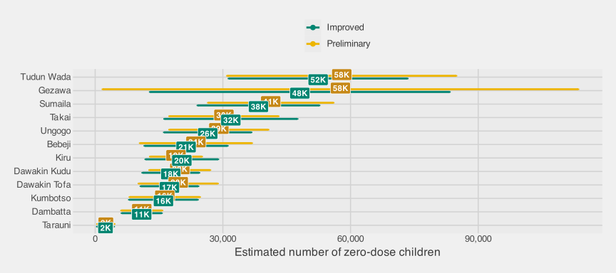
Figure 3.5: Visual comparison of preliminary and adaptive sampling estimates (with 95% CIs) for the number of zero-dose children, by LGA
Table 3.8: Numerical comparison between preliminary and adaptive sampling estimates for the prevalence of zero-dose children, by LGA
LGA | Preliminary |  |  | Improved
LGA | % | Variance | 95% CI | % | Variance | 95% CI
Gezawa | 44.6% | 76.1 | (27.5; 61.7) | 39.4% | 19.7 | (30.7; 48.1)
Ungogo | 23.3% | 3.3 | (19.8; 26.8) | 23.1% | 3.5 | (19.5; 26.8)
Bebeji | 42.0% | 26.5 | (31.9; 52.1) | 42.4% | 26.8 | (32.2; 52.5)
Dambatta | 26.9% | 8.0 | (21.4; 32.5) | 27.2% | 7.9 | (21.7; 32.7)
Dawakin Kudu | 32.3% | 13.2 | (25.1; 39.4) | 33.0% | 14.1 | (25.6; 40.3)
Dawakin Tofa | 25.2% | 14.9 | (17.6; 32.7) | 23.5% | 10.5 | (17.1; 29.8)
Kiru | 31.8% | 14.3 | (24.4; 39.2) | 33.8% | 21.0 | (24.8; 42.7)
Kumbotso | 20.5% | 13.0 | (13.5; 27.6) | 20.9% | 13.5 | (13.7; 28.2)
Sumaila | 38.5% | 36.6 | (26.7; 50.4) | 37.2% | 34.7 | (25.7; 48.8)
Takai | 37.1% | 32.3 | (25.9; 48.2) | 37.7% | 41.7 | (25.1; 50.4)
Tarauni | 12.4% | 7.7 | (7.0; 17.8) | 12.0% | 7.6 | (6.6; 17.4)
Tudun Wada | 42.2% | 16.7 | (34.2; 50.2) | 43.2% | 19.3 | (34.6; 51.8)
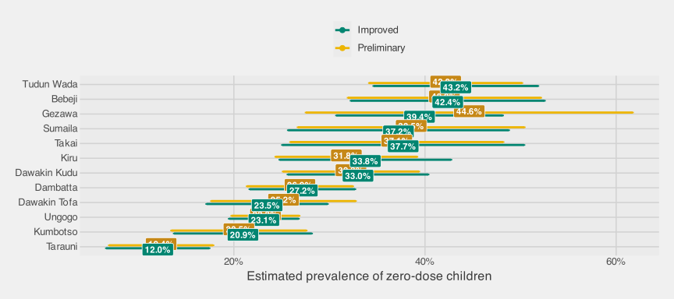
Figure 3.6: Comparison between preliminary and adaptive sampling estimates for the prevalence of zero-dose children, by LGA

3.3.4 Findings
Two questions need separate answers. The field data show whether the adaptive step improved the AS estimator that was actually fielded. The sentinel simulation tests whether that design family usually beats conventional PPS at the same PSU budget.

3.3.4.1 Field Implementation
The non-sentinel field data show that the adaptive step can materially change the precision of the implemented AS estimator. Most preliminary estimates, based only on the preliminary selections, were close to the adaptive sampling estimates, based on the full set of preliminary and adaptive selections. That agreement is reassuring for the non-sentinel field estimates themselves.
The field results answer a narrow question: given the AS design that was actually fielded, how did the adaptive sampling estimator’s estimated uncertainty compare with the preliminary estimator’s? They do not answer the policy question that a survey planner usually faces: whether the same total budget would have been better spent on a conventional PPS survey. The non-sentinel field sample cannot answer that question directly because we did not observe all PSUs that alternative adaptive or conventional samples might have selected.
For zero-dose totals, the adaptive sampling estimator had a lower estimated standard error than the preliminary one in 10 of the 12 non-sentinel LGAs. Across all 12 LGAs, the average estimated standard-error reduction was about 6%; among the 10 LGAs where the adaptive sampling estimator had lower estimated standard error, the average reduction was about 14%. For prevalence, the two estimators were close on average: the adaptive sampling estimator had a lower estimated standard error in a handful of LGAs but had moderately higher estimated variance than the preliminary estimator in a few others, consistent with the adaptive rule targeting totals rather than ratios. These estimates show that the adaptive reordering step carried information in the field implementation. They should not be interpreted as evidence that AS would necessarily beat a same-size conventional survey.
Operationally, the adaptive sampling design was feasible but not simple. The main challenge was timing: the field team had to pause while analysts estimated selected survey variables, evaluated selection probabilities, computed calibrated weights, and chose the adaptive PSUs. Future implementations could reduce that pause by routing on raw PSU-level zero-dose counts. Those counts are likely to be highly correlated with the weighted PSU-level totals that drive the adaptive rule, and they are much faster to compute during fieldwork.
The adaptive rule used PSU-level zero-dose totals as its signal, so variables strongly correlated with zero-dose counts should see the largest precision gains. Outcomes weakly correlated with zero-dose counts are unlikely to benefit as much. Future implementations with several priority outcomes should balance adaptive effort across those outcomes rather than optimize only for zero-dose counts.

3.3.4.2 Simulation Study
The field implementation leaves two useful methodological questions unresolved. First, if a survey team redirected the same total PSU budget to a conventional PPS design, would AS still improve precision? Second, how effective and efficient would the adaptive design be at smaller budgets that more closely resemble a routine survey?
The non-sentinel AS data cannot answer those questions cleanly. They contain one realized adaptive sample, not the counterfactual PSUs that a conventional design or another adaptive draw would have selected. A stage-1 PPS sample also cannot be downsampled into a smaller adaptive experiment after the fact, because each adaptive draw depends on the zero-dose counts observed in its own preliminary PSUs. Once the field design is fixed, we also cannot know how thousands of other adaptive designs would have behaved under different preliminary fractions or total budgets.
The sentinel LGAs provide the needed workaround. In Gabasawa, Gaya, and Nassarawa, the gold-standard survey covered the full set of gridded EAs used as analytic PSUs across each LGA. These gridded EAs were created for the study with geospatial algorithms, because the study did not have access to an National Population Commission (NPC) frame of official EAs. We can therefore treat the observed sentinel sample as a fixed geographic universe, repeatedly redraw simplified conventional and adaptive designs, and compare what those designs recover from the same underlying zero-dose pattern. The simulation helps answer planning comparisons that the single non-sentinel AS realization cannot fully answer.
How to read this simulation. This is a simplified resampling exercise built on the sentinel LGA zero-dose data, not a second field implementation or a model of the entire Kano population. Its purpose is to ask a practical planning question: at smaller fixed PSU budgets, would this version of AS usually beat a conventional PPS sample of the same size? Technical details on the adaptive design family and the variance identity are in Section A.1.2.
This fixed-universe assumption is deliberately modest, but it preserves the feature that matters most for AS. The spatial pattern among sentinel PSUs determines whether preliminary selections point to useful neighboring PSUs, so the simulation tests whether the adaptive rule has signal to exploit.
The simulation varies two choices a planner controls:
- Total PSU budget $B∈\{30,40,50,60\}$;
- Preliminary fraction $ϕ∈\{0.5,0.6,0.7,0.8,0.9,1.0\}$ (the preliminary share of $B$; $ϕ=1$ collapses to a pure conventional design with no adaptive supplement; this is the comparison anchor).
Table 3.9 translates the grid into the number of PSUs assigned to the preliminary and adaptive phases. Each cell reports preliminary/adaptive PSUs; for example, 32/8 means 32 preliminary PSUs and 8 adaptive PSUs.
Table 3.9: Preliminary/adaptive PSU split across the simulated design grid
Preliminary fraction | B = 30 | B = 40 | B = 50 | B = 60
0.5 | 15/15 | 20/20 | 25/25 | 30/30
0.6 | 18/12 | 24/16 | 30/20 | 36/24
0.7 | 21/9 | 28/12 | 35/15 | 42/18
0.8 | 24/6 | 32/8 | 40/10 | 48/12
0.9 | 27/3 | 36/4 | 45/5 | 54/6
1.0 | 30/0 | 40/0 | 50/0 | 60/0
For each design, the preliminary PSUs are drawn by PPS, and any remaining PSUs are selected by the same adaptive rule used in the field implementation. Within each selected PSU, the simulation samples up to $30$ observed children, mimicking an EPI-style second stage.
The main outcome is operational: does the adaptive sampling estimator produce a smaller standard error than a conventional PPS design with the same total PSU budget? Detailed bias and variance diagnostics are reported in Section A.1.3.
Figure 3.7 plots the relative standard error (mean Standard Error (SE) divided by the universe-truth total) as a function of $ϕ$, with one line per total budget $B$ and LGA. The diamond at $ϕ=1$ is the conventional PPS benchmark at that budget. Points to the left show the adaptive sampling estimator for different splits between the preliminary and adaptive phases.
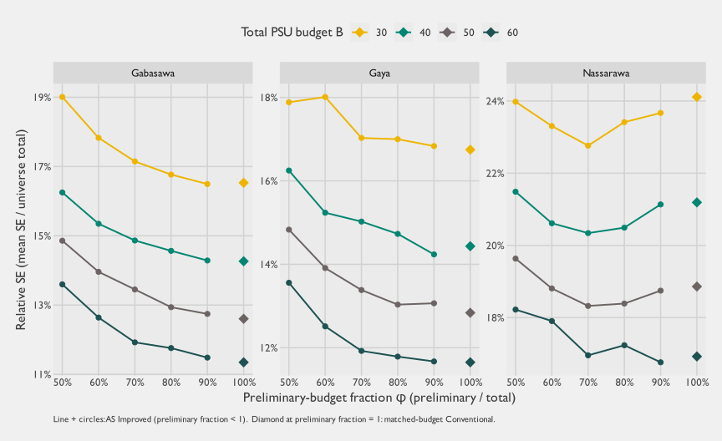
Figure 3.7: Universe-truth relative standard error for the estimated total number of zero-dose children across the (B, φ) grid, by sentinel LGA. Each color is one total PSU budget B ∈ {30, 40, 50, 60}: the line and circles show the adaptive sampling estimator across φ ∈ {0.5, 0.6, 0.7, 0.8, 0.9}, and the diamond at φ = 1 marks the matched-budget Conventional baseline at the same B. The Preliminary curve is omitted because the substantive comparison is adaptive sampling vs conventional; the Preliminary line is dominated by both.
The main result is easy to state. Across most of the grid, the adaptive sampling estimator sits close to the same-budget conventional benchmark. The adaptive-sampling-to-conventional relative-SE ratios run from about 0.94 to 1.20 across cells, with a median of about 1.02. In practical terms, AS often did about as well as a same-size conventional PPS sample, but the grid leans slightly toward conventional rather than showing broad adaptive gains.
Nassarawa is the clearest exception. At $B=30$ and $B=40$, the adaptive sampling curve dips below the conventional benchmark around $ϕ≈0.6$–$0.9$. At $B=50$ and $B=60$, the best Nassarawa cells also fall slightly below the conventional benchmark, but by narrower margins. This is the clearest coherent evidence in the simulation that AS can help when the zero-dose outcome is clustered enough for the adaptive rule to find signal.
Figure 3.8 recasts the same information as a matrix: each cell is one $\left(B,ϕ\right)$ combination, the fill encodes the adaptive-sampling-to-conventional relative SE ratio band at the same total budget (so values $<1$ mean AS beats matched-budget conventional, and values $>1$ mean it loses), and the size encodes the absolute relative SE of the adaptive sampling estimator (bigger circle = more uncertainty). The $ϕ=1$ row is the conventional baseline, shown at ratio = $1$ by construction.
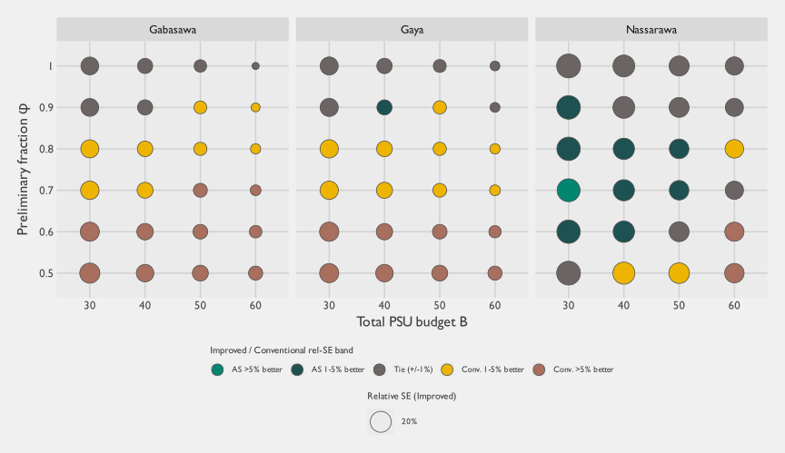
Figure 3.8: Universe-grid matrix dot plot: at each (B, φ, LGA) cell, the fill shows the adaptive-sampling-to-conventional rel-SE ratio band at the same total PSU budget, ordered from AS-better to conventional-better. The size shows the absolute adaptive sampling rel-SE (mean SE / universe truth). The φ = 1 row is the Conventional baseline (ratio = 1 by construction). Cells where adaptive sampling consistently underperforms matched-budget conventional appear as larger conventional-better circles.
Two patterns stand out in the matrix view. First, most cells fall in the near-tie or conventional-better bands, so AS roughly ties the conventional design across much of the grid while underperforming most clearly when the preliminary fraction is low. Second, the clearest coherent zone where the adaptive sampling estimator beats matched-budget conventional is the mid-to-high-$ϕ$ band in Nassarawa ($ϕ≈0.6$–$0.9$): the small-budget cells ($B=30$ and $B=40$) fall in the AS-better bands (adaptive-sampling-to-conventional ratio between 0.94 and 0.99), with margins narrowing or vanishing at $B=50$ and $B=60$. One Gabasawa cell and a few Gaya cells also fall below $1$, but they do not form as stable a pattern across neighboring budgets and preliminary fractions. This is the highest-prevalence, sparsest-coverage LGA. The pattern is exactly where adaptive sampling should help: the target outcome is clustered enough for the preliminary sample to identify useful neighboring PSUs. Across the rest of the grid the ratio is often close to $1.0$, so at coverage-survey-scale budgets the adaptive sampling estimator and same-budget conventional produce broadly similar precision, with conventional more often ahead when too much of the budget is reserved for the adaptive phase.
The reason is a budget tradeoff. Every PSU reserved for the adaptive phase is a PSU not included in the preliminary PPS sample. AS wins only if the adaptive step recovers more precision than it loses by shrinking that preliminary foundation. The formal break-even rule makes the tradeoff explicit. Let $ϕ$ be the preliminary share of the total PSU budget, and let $R$ be the within-design Rao-Blackwell variance reduction produced by the adaptive sampling estimator. Under the leading-order no-Finite Population Correction (FPC) approximation derived in Section A.1.2, the adaptive sampling estimator beats matched-budget conventional only when:
$$R>1−ϕ. \left(3.7\right)$$
The larger the adaptive share, the larger the variance reduction required to break even. At $ϕ=0.8$, for example, the adaptive step must remove more than $20\%$ of the preliminary-estimator variance before AS can beat a conventional design that spends all $B$ PSUs on the first-stage sample. For policy readers, the practical implication is twofold. First, unless the adaptive signal is strong, the safer allocation is preliminary-heavy. Second, small-budget studies make the tradeoff sharper because PSUs are discrete. Once most of a small budget is reserved for the preliminary sample, the adaptive supplement may contain only a handful of PSUs. The analytic and operational complexity of AS is largely fixed, so that overhead becomes harder to justify when it buys only a few adaptive selections.
Matched-budget PPS is also a strong comparator because it already uses the Measure of Size (MOS) to allocate first-stage effort. When the MOS is a useful proxy for the number of eligible children, conventional PPS naturally scales sample allocation toward PSUs where the expected number of zero-dose children is larger. The adaptive rule evaluated here used the estimated zero-dose count from each neighboring preliminary PSU as the signal for nearby candidate PSUs, but it did not combine that local zero-dose signal with the MOS for each candidate PSU. A natural extension is to treat the adaptive step as a mid-course update to the MOS, rather than as a purely local neighborhood rule.
The ingredients of that extension are not new. Classical adaptive cluster sampling (Thompson 1990, 1050) and adaptive web sampling (Thompson 2006, 1224) established the design family for rare, clustered outcomes, with later work adding auxiliary variables and unequal-probability or PPS initial samples (Chao and Thompson 2001, 517; Felix-Medina and Thompson 2004, 877; Roesch 1993, 655; Wang and Yang 2024, 1668 and Section 3.2). Model-based and Bayesian variants use prior or accumulating data to guide later sampling and inference for rare, spatially clustered populations (Rapley and Welsh 2008, 717; Chipeta et al. 2016, 70–71), and the Malawi rolling malaria surveys give a public-health analogue: later household samples were chosen using prevalence predictions from earlier rounds, with Bayesian spatial models producing updated prevalence and high-risk maps (Kabaghe et al. 2017, “Household sampling” and “Statistical analysis” sections). What is less common is the operational comparison that matters for vaccination surveys: whether a fixed-budget adaptive design beats a same-budget conventional PPS cluster survey that already uses a population MOS. Our version below keeps the machinery lighter and closer to coverage-survey practice: a simple empirical Bayes shrinkage estimate updates the second-phase PPS size measure, and we then evaluate the resulting design against the conventional PPS alternative a vaccination survey team would otherwise field.

3.3.4.2.1 Empirical Bayes Adaptive Sampling
We therefore ran an exploratory extension, Empirical Bayes Adaptive Sampling, that treats the adaptive step as an update to the PPS size measure. This was not the design fielded in Kano, and it should not replace the main comparison above. It tests whether AS becomes more competitive when the adaptive rule preserves the main advantage of conventional PPS: sampling effort remains proportional to expected population size.
The empirical Bayes rule uses the preliminary sample to estimate a pooled zero-dose risk across sampled PSUs. Every unsampled candidate PSU receives a baseline size measure equal to this pooled risk multiplied by its original MOS. For candidates adjacent to preliminary PSUs, the rule sets the candidate’s zero-dose risk to a weighted average of the local zero-dose rate from its preliminary neighbors and the pooled preliminary risk, leaning toward the pooled risk when the local evidence is thin:
$${\hat{p}}_{i,\text{EB}}=\frac{y_{\text{local},i}+τ{\hat{p}}_{\text{global}}}{n_{\text{local},i}+τ}, {\text{size}}_{i}={\text{MOS}}_{i}×{\hat{p}}_{i,\text{EB}}. \left(3.8\right)$$
Here $y_{\text{local},i}$ and $n_{\text{local},i}$ pool the zero-dose count and observed child denominator from preliminary PSUs adjacent to candidate PSU $i$. When a candidate has no adjacent preliminary PSU, ${\hat{p}}_{i,\text{EB}}$ equals the pooled preliminary risk. We set $τ=30$, matching the intended child quota per PSU, so weak local evidence stays close to the global preliminary risk while stronger adjacent evidence can move the candidate’s size measure up or down.
The expanded empirical Bayes grid used the same budgets $B∈\{30,40,50,60\}$, extended the preliminary fraction to $ϕ∈\{0.3,0.4,…,1.0\}$, and repeated each cell $50$ times. Table 3.10 summarizes the best empirical Bayes adaptive cell against the matched-budget conventional benchmark for each LGA, budget, outcome, and metric.
Table 3.10: Empirical Bayes Adaptive Sampling: best adaptive sampling cell versus matched-budget conventional PPS across LGA × budget cells. Ratios below 1 mean the empirical Bayes adaptive design had lower uncertainty than conventional PPS at the same total PSU budget.
Outcome | Metric | AS wins | Mean AS / Conv | Median AS / Conv | Lowest AS / Conv | Highest AS / Conv
Zero-dose prevalence | Mean model SE | 12/12 | 0.81 | 0.80 | 0.71 | 0.90
Zero-dose prevalence | Empirical point-estimate SD | 11/12 | 0.86 | 0.85 | 0.65 | 1.01
Zero-dose total | Mean model SE | 12/12 | 0.93 | 0.94 | 0.89 | 0.97
Zero-dose total | Empirical point-estimate SD | 12/12 | 0.88 | 0.88 | 0.78 | 0.95
The empirical Bayes results were much stronger than the original adaptive rule. For zero-dose prevalence, the best empirical Bayes adaptive cell beat matched-budget conventional PPS in all 12 LGA-by-budget comparisons for model-based mean SE, with an average adaptive-to-conventional ratio of 0.81. It also beat conventional in 11 of 12 comparisons for empirical replicate-to-replicate Standard Deviation (SD), with an average ratio of 0.86. For zero-dose totals, the best empirical Bayes adaptive cell beat conventional in 12 of 12 comparisons for model-based mean SE and 12 of 12 for empirical SD; the average ratios were 0.93 and 0.88, respectively. The gains are therefore broad but not uniform, with the strongest improvement for prevalence model-based SE and total empirical stability.
Figure 3.9 shows where those gains occur in the expanded tuning grid. Lower preliminary fractions, especially $ϕ=0.3$ and $ϕ=0.4$, often performed well for prevalence mean SE; total estimates favored a more mixed set of preliminary fractions. This makes practical sense: once the adaptive rule keeps a population-scaled baseline for all unsampled PSUs and smooths local evidence toward the pooled preliminary risk, a larger adaptive supplement no longer discards the core logic of PPS in the way the original local-neighbor rule did.
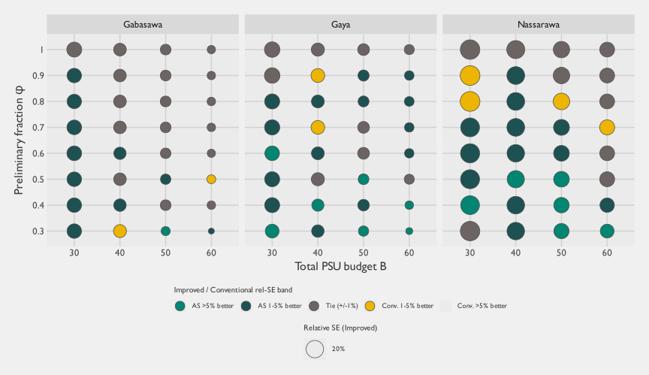
Figure 3.9: Empirical Bayes Adaptive Sampling universe-grid matrix dot plot: at each (B, φ, LGA) cell, the fill shows the empirical Bayes adaptive-sampling-to-conventional rel-SE ratio band at the same total PSU budget, ordered from AS-better to conventional-better. The size shows the absolute adaptive sampling rel-SE (mean SE / universe truth). The φ = 1 row is the Conventional baseline (ratio = 1 by construction).
These results change the interpretation of the adaptive-family evidence. The fielded rule did not broadly beat a matched-budget conventional PPS design, but Empirical Bayes Adaptive Sampling was much more competitive in this fixed sentinel universe. That does not prove that the empirical Bayes rule would outperform conventional PPS in the field; it was tested retrospectively on the sentinel universe and would need simulation specified in advance, along with operational validation, before deployment. It does show that the weaker performance of the fielded rule should not be read as a rejection of adaptive sampling as a class. An adaptive design that updates PPS size measures using preliminary zero-dose risk appears much more competitive than a rule that assigns all neighboring candidates the same local zero-dose count regardless of their population size.
Table 3.11 surfaces the operational comparison numerically: at each $B$, the best-performing $ϕ$ for the adaptive sampling estimator alongside the pure-conventional ($ϕ=1$) baseline.
Table 3.11: Universe-grid operational comparison for the zero-dose total: relative SE (mean SE / truth total) at the pure-conventional design (φ = 1) and at the best adaptive sampling cell per LGA × budget. Smaller is better; an adaptive sampling / conventional ratio < 1 means AS beats matched-budget conventional.
LGA | Budget B | Conv rel-SE (phi = 1) | Best AS Improved phi | Best AS Improved rel-SE | Improved / Conv
Gabasawa | 30 | 16.5% | 90% | 16.5% | 1.00
Gabasawa | 40 | 14.3% | 90% | 14.3% | 1.00
Gabasawa | 50 | 12.6% | 90% | 12.7% | 1.01
Gabasawa | 60 | 11.3% | 90% | 11.5% | 1.01
Gaya | 30 | 16.7% | 90% | 16.8% | 1.01
Gaya | 40 | 14.4% | 90% | 14.2% | 0.99
Gaya | 50 | 12.8% | 80% | 13.0% | 1.02
Gaya | 60 | 11.7% | 90% | 11.7% | 1.00
Nassarawa | 30 | 24.1% | 70% | 22.8% | 0.94
Nassarawa | 40 | 21.2% | 70% | 20.3% | 0.96
Nassarawa | 50 | 18.9% | 70% | 18.3% | 0.97
Nassarawa | 60 | 16.9% | 90% | 16.8% | 0.99

3.3.4.2.2 Extension to prevalence estimation
The main comparison above focuses on the total number of zero-dose children, because the adaptive rule was built around PSU-level zero-dose counts. We also repeated the comparison for zero-dose prevalence, which is often the more familiar program indicator. For prevalence, Table 3.12 uses the empirical replicate-to-replicate SD as the precision measure. That choice avoids relying on a model-based variance estimator that was unstable when the preliminary phase was very small.
Table 3.12: Universe-grid operational comparison for zero-dose prevalence: empirical relative SD (replicate SD / truth prevalence) at the pure-conventional design (φ = 1) and at the best adaptive sampling cell per LGA × budget. Smaller is better; an adaptive sampling / conventional ratio < 1 means AS beats matched-budget conventional. Empirical SD is used in preference to model SE because the ratio estimator’s model variance is unstable when the preliminary phase is small (see caveats).
LGA | Budget B | Conv rel-SD (phi = 1) | Best AS Improved phi | Best AS Improved rel-SD | Improved / Conv
Gabasawa | 30 | 11.5% | 90% | 11.6% | 1.01
Gabasawa | 40 | 9.4% | 70% | 9.4% | 1.00
Gabasawa | 50 | 9.3% | 90% | 8.1% | 0.86
Gabasawa | 60 | 8.3% | 70% | 7.5% | 0.91
Gaya | 30 | 12.3% | 80% | 11.9% | 0.97
Gaya | 40 | 10.5% | 70% | 10.5% | 1.00
Gaya | 50 | 9.9% | 90% | 9.6% | 0.97
Gaya | 60 | 8.6% | 90% | 8.2% | 0.96
Nassarawa | 30 | 20.6% | 70% | 18.5% | 0.90
Nassarawa | 40 | 17.7% | 50% | 15.4% | 0.87
Nassarawa | 50 | 15.2% | 90% | 14.0% | 0.92
Nassarawa | 60 | 13.5% | 90% | 12.6% | 0.93
The prevalence results point in the same general direction, but they are less orderly than the totals results. The adaptive sampling estimator and matched-budget conventional often remain close, with Nassarawa showing the most consistent wins and some Gabasawa and Gaya cells also improving. This suggests that, in these sentinel data, the PSU-level zero-dose count signal could also be informative for prevalence, even though prevalence was not the quantity the adaptive rule directly optimized.
A few caveats specific to this grid should temper the interpretation.
Takeaways from the grid exercise
The grid exercise supports four practical takeaways:
- Operational comparison. For zero-dose totals, the adaptive sampling estimator roughly ties matched-budget conventional across most of the grid. The clearest wins are in Nassarawa at small budgets and mid-range preliminary fractions.
- Bias. Both estimators are approximately unbiased in this simulated sentinel universe, with the adaptive sampling estimator showing slightly smaller absolute bias than matched-budget Conventional for the total (mean relative bias of about 0.8% versus 1.3%).
- Replicate-to-replicate stability. The adaptive sampling estimator and matched-budget conventional have similar replicate-to-replicate spread, so the adaptive step does not create a major stability penalty.
- Uncertainty reporting. Model-based SE is broadly close to empirical variability for totals, but prevalence is better summarized with empirical replicate SD when the preliminary phase is small.

3.3.5 Recommendations
- Do not treat this adaptive design as the default replacement for conventional PPS sampling. The fixed-budget simulations show that this version of AS can work: Nassarawa provides a concrete example where the adaptive sampling estimator beat a matched-budget conventional design in several low-budget, mid-$ϕ$ cells. Across the other sentinel simulation cells, however, those gains were not the dominant pattern. The adaptive sampling estimator more often tied or underperformed a conventional PPS sample with the same total PSU budget, with narrower wins scattered outside the main Nassarawa pattern. Empirical Bayes Adaptive Sampling is more encouraging, but it was not fielded and should be treated as a candidate design for further validation rather than as a settled recommendation.
- Use adaptive sampling only when there is prior evidence of useful spatial clustering at the PSU scale. The adaptive step pays off only if the preliminary sample reveals enough signal about where high-yield neighboring PSUs are likely to be. That signal depends on the spatial correlation structure of the outcome, which survey planners rarely know well before fieldwork begins. Without credible prior data, pilot evidence, or a strong geographic mechanism for clustering, the expected efficiency gain is too uncertain to justify the design as a routine choice.
- Choose the preliminary/adaptive split jointly with the adaptive size-measure rule. At fixed total budget, the adaptive design starts with a sample-size handicap because only $ϕB$ PSUs are selected in the preliminary phase. The Rao-Blackwell improvement must overcome that handicap. The break-even rule above shows that the adaptive design needs $R>1−ϕ$ before it can beat a matched-budget conventional design. For the fielded local-neighbor rule, practical allocations should be preliminary-heavy unless strong prior evidence supports a larger adaptive supplement. For Empirical Bayes Adaptive Sampling, lower preliminary fractions sometimes performed well because the adaptive draw retained a population-scaled PPS baseline and smoothed local evidence toward pooled preliminary risk. This finding argues for design-specific simulation before fieldwork rather than for a universal default split.
- Be explicit about the estimand the adaptive rule is optimizing. The design evaluated here used PSU-level zero-dose counts as its signal, so it is best suited to estimating zero-dose totals and outcomes strongly correlated with those totals. It should not be expected to improve every outcome collected on the survey instrument. If prevalence, subgroup estimates, or multiple outcomes carry equal decision weight, a conventional design or a different adaptive rule may be the better choice.
- Budget for the analytic and operational complexity. This design requires timely preliminary estimation, correct weights, a well-defined adjacency structure, Rao-Blackwell reordering, and careful variance reporting while fieldwork is still active. Those requirements create a real complexity penalty relative to a conventional PPS survey of the same size. Where the expected precision gain is modest, that penalty can outweigh the benefit.
- Do not generalize these results to every adaptive design. The evidence here covers one fixed-budget, two-phase PSU-level adaptive design. Other adaptive designs, or different implementations of adaptive web sampling, may behave differently. Empirical Bayes Adaptive Sampling illustrates the point: combining observed neighboring zero-dose risk with candidate-level MOS was much more competitive with matched-budget PPS than the fielded local-neighbor rule in this simulation. Programs interested in adaptive sampling should simulate the specific design they intend to field, using the best available information about geography, outcome clustering, population size, and operational constraints.

3.3.6 Conclusions
Taken together, the field implementation and sentinel resampling results are a proof of possibility, not a general recommendation. The non-sentinel implementation shows that this design was feasible and that the adaptive sampling estimator could gain precision over the preliminary estimator. The sentinel simulation asks the sharper planning question: whether the same total PSU budget would have been better spent on AS or on a conventional PPS sample. AS can improve precision when the target outcome is spatially clustered in a way that the preliminary sample can detect. The sentinel simulation shows this most clearly in Nassarawa: for several small-budget, mid-$ϕ$ designs, the adaptive sampling estimator outperformed a matched-budget conventional PPS sample.
The broader simulation pattern is more restrained. For zero-dose estimation in this simplified sentinel universe, the adaptive sampling estimator often did not do much better than a conventional PPS sample with the same total number of PSUs. The main reason is structural. Adaptive sampling reallocates part of a fixed budget away from the preliminary sample and into an adaptive supplement. That supplement helps only if the adaptive step yields enough variance reduction to offset the smaller preliminary foundation. The break-even condition makes the tradeoff explicit: using the notation above, the leading-order no-FPC condition is $R>1−ϕ$ (Equation 3.7). The larger the adaptive share, the larger the required adaptive gain.
Empirical Bayes Adaptive Sampling shows that this tradeoff is not fixed by adaptivity alone. When the adaptive draw retained a population-scaled PPS baseline and smoothed local adjacent risk toward the pooled preliminary risk, the best adaptive cells beat matched-budget conventional PPS in 12 of 12 prevalence mean-SE comparisons and 12 of 12 total mean-SE comparisons. Empirical replicate-to-replicate SD gains were also generally favorable but not universal. The result remains exploratory because the rule was tested retrospectively rather than fielded. Still, it materially changes the methodological lesson: the weaker results for the original rule appear to reflect how that rule used the preliminary signal, not a general failure of adaptive sampling.
The tradeoff remains hard to manage prospectively because $R$ depends on the spatial correlation of the outcome at the scale of neighboring PSUs, the quality of the MOS, and the way the adaptive size measure combines those two sources of information. Survey teams usually do not know that correlation structure before the survey, and weak or uneven clustering can leave the adaptive supplement with little signal to exploit. This uncertainty changes the practical interpretation of the method. Adaptive sampling should be considered when prior data, pilot work, or strong contextual knowledge suggest clustered zero-dose pockets, especially if the design can update a credible PPS MOS rather than replace it with a purely local rule. Absent that evidence and design work, a conventional PPS design of the same size will often be simpler and similarly precise.
The complexity penalty is substantial. This version of AS requires real-time estimation, adaptive field routing, specialized reordering calculations, and careful variance diagnostics. Those requirements may be worthwhile in settings like Nassarawa, where the adaptive signal is strong enough to produce clear gains. Across the sentinel simulation as a whole, however, the modest and uneven gains do not generally justify the additional operational and analytic burden.
These conclusions apply to the fixed-budget, two-phase PSU-level design evaluated in this study, using the gridded EA frame and zero-dose outcome observed in Kano. They should not be read as a rejection of adaptive sampling as a class of methods. Other variants may produce different tradeoffs. The empirical Bayes results suggest one promising direction: let the adaptive size measure combine local zero-dose risk from adjacent hotspot PSUs with candidate-level MOS, so the design adapts toward both higher-risk and larger-population neighbors while allowing weak local evidence to shrink toward the preliminary global risk. Adaptive web sampling, for example, can run multiple adaptive waves rather than the single adaptive supplement evaluated here; that design could exploit spatial signal differently, but we did not evaluate it. Other PSU frames could also change the result. Official NPC EAs might not behave like the gridded EAs used in this study, and a design that adapts directly over building footprints would operate at a much finer spatial resolution. The lesson from this study is narrower but useful: at this gridded PSU resolution, for this outcome in Kano, the fielded local-neighbor rule probably does not justify its added complexity unless the team has strong prior evidence of useful spatial clustering, while Empirical Bayes Adaptive Sampling is promising enough to warrant prospective testing.

3.4 Lot Quality Assurance Sampling

3.4.1 Overview
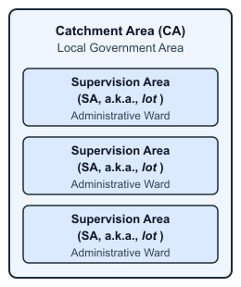
Figure 3.10: LQAS unit nomenclature: from catchment areas to lots
In routine immunization settings, LQAS uses hypothesis testing to classify randomly selected Supervision Areas (SAs)—also known as lots—as having acceptable or potentially unacceptable vaccination coverage. It is mainly used as a monitoring approach to classify SAs rather than to generate point estimates. As a secondary objective, data from individual SAs can be pooled to estimate vaccination coverage rates at the aggregate level of a Catchment Area (CA), but this is only valid when the included lots are exhaustive or selected to represent that aggregate area. If lots are chosen for convenience, selected because interventions are being delivered there, or purposively targeted because low coverage is suspected, pooled estimates will generally be biased for the full CA. Because it uses a smaller sample size than multistage vaccine coverage cluster surveys, LQAS is often considered a rapid, cost-efficient method to identify areas with low vaccination rates (Hora et al. 2024).
Table 3.13: LQAS parameters
Parameter | Value
Element-wise Type I error rate (upper bound) | α < 0.1
Element-wise Type II error rate (upper bound) | β < 0.1
Lower threshold | P₀ = 50%
Upper threshold | P₁ = 80%
Catchment Area (CA): LGAs | 3
Supervision Area (SA) / Lots: Wards | 32
Targeted sample size per SA | n = 19
Total targeted sample size | 608
Decision rule | d* = 13
LQAS studies are often characterized by their lot sample size $n$ and decision threshold $d^{*}$ (Robertson et al. 1997). Based on other organizations that have run LQAS assessments in Nigeria using the popular “$n=19,d^{*}=13$” design (Attahiru et al. 2025), Mindset adopted the same approach, targeting 19 children aged 12-23 months per ward.
The study design was based on a lower threshold of $P_{0}=0.5$. In other words, if the research team could confidently conclude that more than 50 percent of children in a given lot (ward) had received the Penta-1 vaccine, the lot was classified as acceptable; otherwise, the lot was rejected and classified as potentially unacceptable. Since 19 children were sampled per ward, cases where exactly 10, 11, or 12 children were vaccinated still led to rejection, even though $\frac{10}{19}$, $\frac{11}{19}$, and $\frac{12}{19}$ all exceed 50 percent. This occurred because those results did not provide sufficient statistical evidence to confidently conclude that the true coverage in those wards as at least 50 percent.
Formally, the null and alternative hypotheses in the LQAS study are expressed as:
$$H_{0}:P_{d}=0.5 \text{vs} H_{a}:P_{d}>0.5 \left(3.9\right)$$
This formulation applies a protective null hypothesis: it assumes all wards have unacceptable coverage unless there is strong enough evidence to conclude otherwise (Rhoda et al. 2010). In the “$n=19,d^{*}=13$” design, the decision rule $d^{*}=13$ means that any ward with at least 13 vaccinated children passes the statistical test and is classified as acceptable based on the 50 percent cutoff. This requisite sample size and decision rule can also be found in the widely used LQAS table published by Valadez et al. (2002, 25).
Type I and Type II error
If we frame our LQAS problem using a protective null hypothesis, then:
A Type I error ($α$) occurs when a lot is accepted as having adequate coverage even though true coverage is unacceptable. It represents community risk, as it may result in withholding resources from communities that truly need them.
A Type II error ($β$) occurs if a lot is rejected for having potentially unacceptably low coverage even though true coverage is acceptable. It represents implementer risk, as it may cause implementers to allocate resources to areas that already meet acceptable coverage standards.

The frequentist hypothesis testing framework is characterized by its ability to control different types of sampling errors. Here, a Type I error means classifying a ward as acceptable when true coverage is below 50 percent; a Type II error means rejecting a ward as potentially unacceptable when coverage is actually adequate. If we require both Type I and Type II errors to be below 10 percent for any standalone test (i.e., $α<0.1$ and $β<0.1$), then with a true simple random sample of 19 households, the test would falsely reject the null less than 10 percent of time. Similarly, under the “$n=19,d^{*}=13$” design, if true coverage is 80 percent, the test would misclassify the ward as unacceptable less than 10 percent of the time.
This study implemented LQAS within the three sentinel LGAs of Gaya, Gabasawa, and Nassarawa. Using typical LQAS terminology, each LGA served as a CA, and the 32 administrative wards within these areas represented the SAs. Following a popular design, the team aimed to complete 19 interviews in each ward, for a total intended sample of $32×19=608$ household interviews.

3.4.2 Implementation Details
Following the LQAS design used in Nigeria by AFENET under the DIM approach (Attahiru et al. 2025), Mindset adopted a multistage sampling design. Within each ward, 19 interview locations — each one a Government Enumeration Area (GEA) drawn via systematic PPS without replacement — were sampled to anchor the subsequent within-cluster selection of buildings, households, and an eligible child. The stage-one sampling frame was the list of GEAs maintained by the NPC and based on the 2006 census. As this sampling frame is not publicly available, the PPS sampling was carried out directly by government counterparts, who then provided the selected sample to the research team.
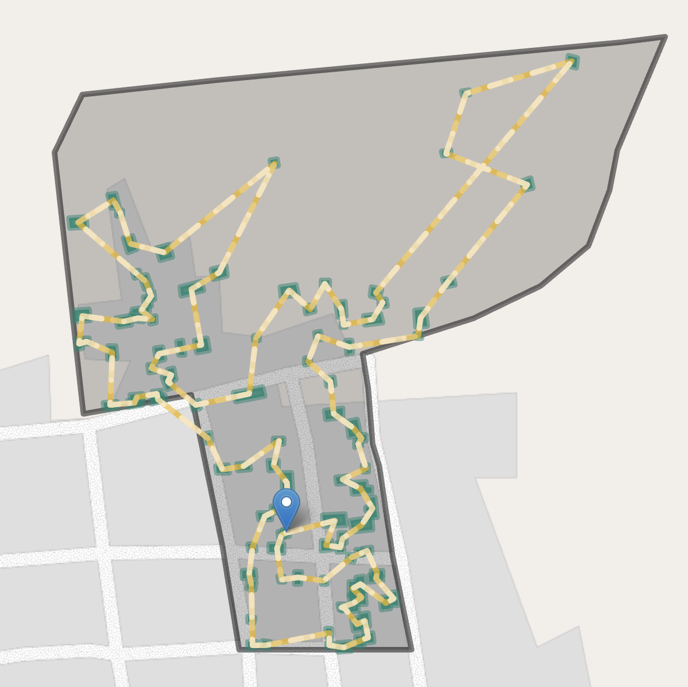
Figure 3.11
For the following sampling stages, Mindset used the NPC PDF maps of the GEAs, along with building footprint data from Google, to list and number all buildings within each GEA (Sirko et al. 2021). The research team then used computer programs to create a directed cycle connecting all enumerated buildings. This predetermined route served as a visitation path for enumerators, minimizing the risk of bias from selectively choosing convenient buildings and avoiding distant ones. Although the route was not necessarily the shortest possible path, it was designed to be practical for fieldwork. One building was randomly selected as the starting point for data collection.
Upon visiting a building, enumerators used CAPI tools to enumerate the number of residential addresses. If a building contained more than one household, the CAPI tools randomly determined the order in which households were approached. Field teams then interviewed available households in this random order, until they completed one successful interview with a caregiver of an infant aged 12-23 months. If an eligible household had more than one child aged 0-23 months, vaccination histories were collected for all children. If no household met the screening criteria, enumerators moved to the next building in the predetermined building visitation cycle, continuing until one successful interview was achieved in the GEA (or until all buildings in the GEA had been exhausted). Although the LQAS analysis focused on classification based on the Penta-1 vaccine, enumerators collected full vaccination histories for each eligible child, following the same questionnaire used for the gold standard sample.
CAPI tools required field enumerators to enter the serial number of the building into tablet software before attempting an interview. Geofencing techniques that use GPS coordinates from the tablet prevented enumerators from initiating the interview unless they were within 30 meters of the target point, and the tablet required a GPS accuracy of 5 meters or better before the distance check could be evaluated. If an enumerator was outside the 30-meter radius, the tablet displayed their live distance to the target and a map pointer to the correct location, and would not advance to the interview module until they were within range. Building serial numbers also helped identify whether a household had already been contacted through the gold-standard multistage sample, ensuring enumerators skipped those addresses to avoid duplicate interviews. Quality Assurance (QA) teams monitored compliance to confirm enumerators were following the prescribed path of visitation. Together, the predetermined visitation cycle, geofenced start points, and compliance monitoring substantially reduced scope for enumerators to substitute more accessible households at the selection stage.
A separate concern remains: because the second-stage protocol stops at the first successful interview without revisiting non-responding households, the realized sample can still be biased toward caregivers who are more often at home—a feature of the design rather than of enumerator behaviour. This non-response dimension is taken up further below, both in the interpretation of LGA-level differences from the gold standard and in the discussion of design effects for aggregate coverage.
Although field teams captured information on all children aged 12-23 months within the first eligible household found per GEA, only one child per household was randomly retained for analysis. Since each SA includes only 19 children, and vaccination status tends to be highly correlated within households, including multiple children from the same home would have inflated the test error. In practice this convention affected a small share of visits and added little to LQAS fieldwork cost, which is dominated by travel to each GEA and the door-to-door screening required to secure one successful interview per lot rather than by the time spent administering the questionnaire once an eligible household is found.
In a small number of cases, field teams visited all buildings in a sampled GEA without finding any eligible households. This resulted in missing data, leaving some wards with fewer than 19 observations. Different valid approaches could be devised to overcome this problem. One option is to accept the smaller sample and adjust the decision threshold to match the achieved sample size. Other potential strategies include sampling reserve clusters or imputing values from the main survey. Because the research team did not control the stage-one sampling, the reserve-cluster approach was not feasible. The team therefore accepted a smaller sample size for affected wards and adjusted the decision threshold accordingly.

3.4.3 Results
A simple LQAS approach assumes that a SRS can be drawn from each SA. Under this assumption, a simple decision threshold such as $d^{*}=13$ can be used to classify each SA. This cutoff mitigates the need for complex statistical calculations and makes the classification of accepted and rejected lots easy to implement.
However, these assumptions are rarely satisfied in routine immunization studies, where a complete sampling frame is seldom available. In such cases, multistage cluster sampling is typically the only feasible approach. That is the approach used here, modelled on the AFENET DIM design described earlier in this chapter. Such designs generally produce greater sampling error than a true SRS of the same size. In addition, non-contact and refusal cases can introduce non-response bias, further weakening the assumptions underlying SRS.
In contrast, a weighted classification approach uses Lower Confidence Bounds (LCBs) to determine whether SAs are accepted or rejected. As described in the WHO’s reference manual, this can be achieved by using survey software to obtain a 90 percent LCB by calculating the LCB of a two-sided 80 percent CI (World Health Organization 2018, 86). The advantages and limitations of each approach are summarized in Table 3.14 and further discussed below.
(a) Classification of SAs
 | Simple (Unweighted) Classification | Weighted Classification
Classification of SAs | Decision rule d* | Classification based on constructing a lower confidence bound (LCB) in survey software
Requires survey software? | Noª | Yes
Impacted by repeated testing? | Yes | Yes
Limitations | Results may understate the true error if a complex sample is used | More complex than simple LQAS. Requires an analyst familiar with survey estimation.
ªSimple classification uses only the decision rule d* and does not require survey software.

(b) Coverage estimation for CAs
 | Simple (Unweighted) Coverage | Weighted Coverage
Coverage estimate of CAs | Simple quotient (sum of vaccinated / total interviews) | Weighted average (typically using survey software)
Asymptotically unbiased? | No (unless a sampling design is truly self-weighting) | Yes
Requires survey software? | Yes, if CIs are neededª | Yes, if CIs are needed
Impacted by repeated testing? | Not directly | Not directly
Limitations | No theoretical foundation; risks being very inaccurate | More complex than simple LQAS. Requires an analyst familiar with survey estimation.
ªSimple coverage estimation uses a basic quotient (vaccinated / interviewed) and does not require survey software unless confidence intervals are needed.

Table 3.14: Comparison of simple LQAS and weighted LQAS when data flows from a complex sample

3.4.3.1 Simple Classification
As classification is the primary objective of LQAS, we first turn to analyzing classification results. Table 3.15 lists each SA, the number of vaccinated children observed, and the achieved sample size. 5 lots are rejected using the simple LQAS approach.
 Key Findings
Using a simple LQAS approach, we reject 5 lots as having potentially unacceptable Penta-1 coverage rates: 4 in Gaya, 1 in Gabasawa, and 0 in Nassarawa.

Alongside this rule-based classification, Table 3.15 also presents the corresponding $p$-values. These $p$-values are simply another way of expressing the same decision: they represent the probability of observing as many (or more) vaccinated children if the true coverage rate were 50 percent. With a significance level ($α$) of 0.1, any lot with a $p$-value below 0.1 would be classified as acceptable.
The unadjusted $p$-values treat each lot in isolation as though it was the only test performed. By comparison, the adjusted $p$-value column applies a correction for repeated testing, ensuring that the expected proportion of lots falsely classified as acceptable remains below 10 percent (the pre-specified False Discovery Rate (FDR) threshold for this study, discussed further in Section 3.4.4.2).
Table 3.15: Simple LQAS classification summary (simple approach)
 | Vaccinated  Children¹ | Sample  Size | Decision  Threshold² | Determination | p-value
 |  |  |  |  | Unadjusted | Adjusted
Gabasawa LGA
Mekiya | 9 | 19 | 13 | Rejected lot | .676 | .721
Yautar Kudu | 13 | 19 | 13 | Accepted lot | .084 | .099
Tarauni | 13 | 19 | 13 | Accepted lot | .084 | .099
Zakirai | 13 | 19 | 13 | Accepted lot | .084 | .099
Joda | 13 | 19 | 13 | Accepted lot | .084 | .099
Yumbu | 14 | 19 | 13 | Accepted lot | .032 | .048
Zugachi | 14 | 19 | 13 | Accepted lot | .032 | .048
Yautar Arewa | 15 | 19 | 13 | Accepted lot | .010 | .019
Garun Danga | 16 | 19 | 13 | Accepted lot | .002 | .006
Gabasawa | 17 | 19 | 13 | Accepted lot | <.001 | .002
Karmami | 17 | 19 | 13 | Accepted lot | <.001 | .002
Gaya LGA
Gamarya | 7 | 19 | 13 | Rejected lot | .916 | .916
Balan | 7 | 19 | 13 | Rejected lot | .916 | .916
Shagogo | 10 | 19 | 13 | Rejected lot | .500 | .552
Maimakawa | 12 | 18 | 13 | Rejected lot | .119 | .136
Kazurawa | 13 | 19 | 13 | Accepted lot | .084 | .099
Gaya North | 14 | 19 | 13 | Accepted lot | .032 | .048
Kademi | 15 | 19 | 13 | Accepted lot | .010 | .019
Gamoji | 15 | 19 | 13 | Accepted lot | .010 | .019
Wudilawa | 16 | 19 | 13 | Accepted lot | .002 | .006
Gaya South | 17 | 19 | 13 | Accepted lot | <.001 | .002
Nassarawa LGA
Hotoro South | 13 | 19 | 13 | Accepted lot | .084 | .099
Giginyu | 13 | 17 | 11 | Accepted lot | .025 | .044
Tudun Murtala | 14 | 18 | 13 | Accepted lot | .015 | .029
Gama | 15 | 19 | 13 | Accepted lot | .010 | .019
Dakata | 16 | 19 | 13 | Accepted lot | .002 | .006
Gwagwarwa | 16 | 19 | 13 | Accepted lot | .002 | .006
Kawaji | 16 | 18 | 13 | Accepted lot | <.001 | .003
Kaura Goje | 16 | 18 | 13 | Accepted lot | <.001 | .003
Hotoro North | 17 | 19 | 13 | Accepted lot | <.001 | .002
Gawuna | 17 | 18 | 13 | Accepted lot | <.001 | .002
Tudun Wada | 12 | 12 | 9 | Accepted lot | <.001 | .002
¹The term 'vaccinated children' refers to those who have received a Penta-1 vaccine (card or recall), based on Gavi's operational definition of the non-zero-dose child (Gavi, 2025).
²The decision threshold reflects the minimum number of vaccinated children needed to be observed in order to confidently conclude that a lot has acceptable vaccination coverage (50% or more for this study).

3.4.3.2 Weighted Classification
Key Findings
Using a weighted LQAS approach, we reject 8 lots as having potentially unacceptable Penta-1 coverage rates: 2 in Gabasawa, 5 in Gaya, and 1 in Nassarawa.

Most operational LQAS guidance relies on simple decision rules like the one above. However, the WHO’s reference manual also describes a classification approach better aligned with complex sampling designs, using survey software to compute LCBs for SA-level proportions (World Health Organization 2018, 86). Because our data flow from a multistage cluster sample rather than a true SRS, we adopt this weighted approach. Having defined $α=0.1$ and $P_{0}=0.5$ in Table 3.13, if the 90 percent LCB falls below 50 percent we reject the lot, otherwise, we accept it. Using this weighted approach, we reject the 8 lots highlighted in pink in Table 3.16. If we wanted additional statistical rigor, we could also reject those highlighted in yellow (more on the reasons for this in Section 3.4.4.2).
Table 3.16: LQAS classification summary (weighted approach)
 | Vaccinated  Children  (Weighted)¹ | 90% LCB² | Design  Effect | Determination | p-value³
 |  |  |  |  | Unadjusted | Adjusted
Gabasawa LGA
Zakirai | 60.3% | 43.4% | 1.1 | Rejected lot | .212 | .243
Mekiya | 60.5% | 43.6% | 1.1 | Rejected lot | .209 | .243
Yautar Kudu | 65.5% | 50.1% | 0.9 | Accepted lot⁴ | .098 | .131
Tarauni | 65.7% | 51.8% | 0.8 | Accepted lot⁴ | .075 | .115
Zugachi | 69.1% | 52.1% | 1.1 | Accepted lot⁴ | .078 | .115
Joda | 72.4% | 58.9% | 0.7 | Accepted lot | .024 | .045
Yumbu | 81.0% | 68.5% | 0.7 | Accepted lot | .005 | .015
Garun Danga | 83.8% | 70.6% | 0.8 | Accepted lot | .005 | .015
Yautar Arewa | 84.7% | 74.1% | 0.6 | Accepted lot | .001 | .012
Karmami | 86.2% | 70.1% | 1.2 | Accepted lot | .011 | .028
Gabasawa | 88.6% | 75.1% | 0.9 | Accepted lot | .005 | .015
Gaya LGA
Gamarya | 30.1% | 20.1% | 0.6 | Rejected lot | .974 | .974
Balan | 36.4% | 22.6% | 1.1 | Rejected lot | .855 | .883
Shagogo | 40.6% | 26.5% | 1.0 | Rejected lot | .783 | .835
Kazurawa | 49.6% | 30.7% | 1.6 | Rejected lot | .511 | .564
Maimakawa | 66.3% | 47.4% | 1.3 | Rejected lot | .132 | .163
Gamoji | 67.4% | 51.6% | 1.0 | Accepted lot⁴ | .081 | .115
Gaya North | 78.8% | 62.6% | 1.1 | Accepted lot | .021 | .043
Kademi | 82.4% | 67.6% | 1.0 | Accepted lot | .010 | .028
Wudilawa | 84.4% | 72.8% | 0.7 | Accepted lot | .003 | .014
Gaya South | 90.2% | 77.9% | 0.8 | Accepted lot | .003 | .014
Nassarawa LGA
Gwagwarwa | 67.6% | 47.8% | 1.5 | Rejected lot | .125 | .159
Hotoro South | 67.3% | 51.4% | 1.0 | Accepted lot⁴ | .083 | .115
Giginyu | 73.4% | 55.1% | 1.1 | Accepted lot | .057 | .095
Gama | 77.1% | 60.5% | 1.1 | Accepted lot | .028 | .049
Tudun Murtala | 81.2% | 65.4% | 1.0 | Accepted lot | .015 | .033
Kaura Goje | 88.3% | 70.6% | 1.3 | Accepted lot | .015 | .033
Hotoro North | 91.0% | 78.7% | 0.8 | Accepted lot | .003 | .014
Kawaji | 94.3% | 83.2% | 0.8 | Accepted lot | .003 | .014
Dakata | 94.4% | 86.8% | 0.5 | Accepted lot | <.001 | .005
Gawuna | 97.0% | 91.4% | 0.3 | Accepted lot | <.001 | .005
Tudun Wada | 100.0% | 73.5% |  | Accepted lot | <.001 | <.001
¹The ward-level prevalence estimates are shown here to evaluate whether they fall above or below the lower confidence bound. They are insufficiently precise at the ward-level to be used as a coverage estimate and would generally not be shown to end-users.
²The 90% lower confidence bound (LCB) is use to classify whether we can confidently conclude that a lot has acceptable vaccination coverage. If the LCB falls below our target of p = 50%, we reject the lot.
³The unadjusted p-value is calculated by transforming the standard error on a survey contrast calculated using survey software. We assessed whether the estimated coverage exceeded the benchmark of 50% by evaluating the contrast log(p / (1-p)) - logit(0.5), which represents the difference between the survey-weighted log-odds of coverage and the log-odds under the null hypothesis.
⁴In a conventional survey-based classification approach using confidence bounds, rows in yellow would be classified as accepted lots. However, practitioners may wish to reject these lots to keep the False Discovery Rate below alpha = 0.1.
Figure 3.12 illustrates the weighted classification approach. Gold-standard survey estimates are shown in tan, while estimates from the weighted LQAS approach are shown in green. Circles show coverage estimates for accepted lots, and triangles show those for rejected lots. The error bands around these point estimates represent the 90 percent LCB, which extend to 100 percent on the right-hand side. The dotted vertical line marks the lower threshold $p_{0}=50$. Classification is determined by whether a lot’s LCB — the left end of its error band — crosses this line, not by the position of the point estimate; a ward can have a point estimate well above 50 percent and still be rejected if its lower bound crosses over.
Although the gold-standard sample was sized to support LGA-level estimation rather than ward-level representativeness, in nearly every ward the gold standard still has a substantially larger effective sample size than LQAS. The reduced precision at this scale does not introduce bias, so the ward-level comparison remains informative.
A few points are worth noting. First, although the gold standard typically had much larger sample sizes than LQAS, this was not universally the case. For instance, in Gwagwarwa ward, the gold-standard estimate was very high (>90 percent), but the small sample size meant we could not confidently conclude that coverage was acceptable—even under the gold standard itself.
Second, several wards are rejected as potentially unacceptable even if their point estimate is above the 50 percent cutoff. This outcome is intentional: it reflects cases where coverage is likely acceptable but the available data do not provide enough statistical evidence to confirm that it is not unacceptably low.
Finally, it is not universally the case that the wards with the lowest coverage are rejected by LQAS. Some wards near the 50 percent mark—such as Tarauni— are not flagged by LQAS, whereas others with relatively strong coverage—such as Zakirai—are rejected.
Together, these observations underscore the variability inherent in small-sample studies such as LQAS, and serve as a reminder that its classifications are typically much less precise than those derived from larger surveys.
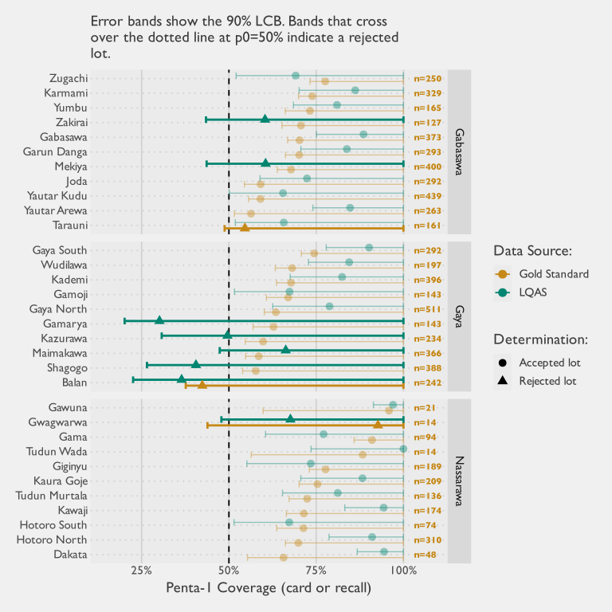
Figure 3.12: Weighted classification using LCBs under both LQAS and the gold standard survey. Error bands represent the 90% LCBs calculated under each method. Bands that cross over the dashed line indicate rejected lots.

3.4.3.3 Aggregate Coverage
A secondary objective of LQAS is to aggregate lot-level data to estimate vaccination coverage at the CA level. In this study, that means estimating Penta-1 coverage for each LGA using the ward-level samples. Because this study covered all 32 of 32 wards in the sentinel LGAs, there is no between-ward sampling error within those sentinel geographies. Estimating at the LGA level by combining observations across wards yields more precise LGA-level estimates than ward-level estimates, because the estimand is now the aggregate rather than each individual ward, although each ward estimate remains noisy because of its small sample. This should not be interpreted as a universal property of LQAS: in implementations where only a subset of wards is selected, aggregate prevalence is only defensible if those selected wards are a probability sample (or otherwise credibly representative) of the wider area. Figure 3.13 shows the resulting estimates from the LQAS data using both a weighted and an unweighted approach, alongside the corresponding estimates from the larger gold-standard multistage survey for comparison.
Figure 3.13 shows two patterns that matter for interpretation. The unweighted LQAS estimates have narrower 95% CIs than the weighted estimates, but this gain in precision is artificial. The unweighted analysis ignores multistage design features and therefore understates uncertainty. Even when the ward-level design is approximately self-weighting, that property does not automatically carry to LGA-level aggregation. At the aggregate level, treating small and large wards equally induces bias, so population weighting remains necessary for valid coverage estimation. The wider weighted intervals are therefore a feature of correct design-based inference, not a weakness of the approach.
The second pattern is the gap between weighted LQAS and gold-standard point estimates. In Figure 3.13, this gap is largest in Nassarawa, moderate in Gabasawa, and small in Gaya. The visual pattern is consistent with sampling noise in Gaya but suggests additional systematic differences in Gabasawa and Nassarawa.
Table 3.17: Survey contrast tests of weighted LQAS versus gold standard Penta-1 coverage
Area | Weighted LQAS | Gold Standard | Difference  (LQAS - GS) | 95% CI for Difference | p-value | FDR-adjusted p-value
Gaya | 64.1% | 62.1% | 2.0% | (-8.4; 12.4) | 0.706 | 0.706
Gabasawa | 74.5% | 66.7% | 7.8% | (1.3; 14.3) | 0.018 | 0.027
Nassarawa | 85.6% | 74.7% | 10.8% | (4.4; 17.3) | 0.001 | 0.003
Table 3.17 formalizes this comparison with design-based Wald contrasts of weighted LQAS versus gold-standard estimates, under an independence assumption (zero cross-survey covariance). Estimated differences (weighted LQAS minus gold standard) are: Gaya: 2.0% (p=0.706); Gabasawa: 7.8% (p=0.027); and Nassarawa: 10.8% (p=0.003). After this formal test, Gabasawa and Nassarawa remain statistically higher than the gold standard, while Gaya does not. Despite these absolute differences, the weighted LQAS approach yields the same relative LGA-level ranking by coverage as the gold standard. Sampling variation is therefore unlikely to be the only driver of the pattern.
Several explanations are plausible. Coverage may have genuinely changed between observation periods, which were separated by roughly one to three months, if partner activity during that interval increased vaccination uptake. Repeated field contact in sentinel areas also makes community-level observer effects plausible. Mindset’s field teams reported that some gold-standard households contacted for callbacks had updated their vaccination status following earlier survey visits.
Other potential explanations concern non-response. The LQAS weights omit adjustments applied in the gold-standard analysis—such as those for non-response and differential eligibility—and aligning these steps would likely reduce at least part of the observed gap. The LQAS protocol also differed in how non-contact was handled: whereas the gold standard attempted revisits to sampled households, enumerators moved to adjacent households until completing a successful interview. Although the visitation path was pre-determined, this protocol difference likely biased the sample toward households more likely to be home at the time of the visit.
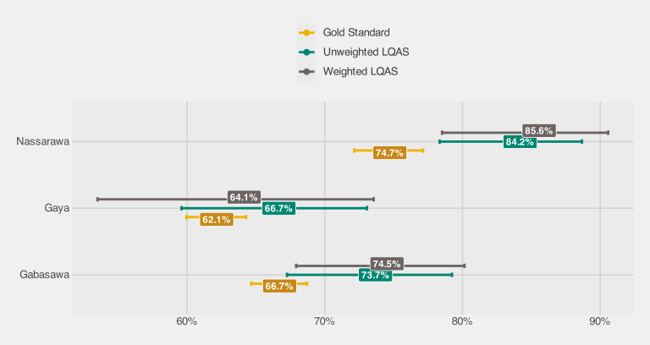
Figure 3.13: Comparison of Penta-1 coverage estimates at the catchment area level (95% CIs)

3.4.3.4 Reasons for Non-Vaccination
Because the LQAS instrument uses the same reasons-for-non-vaccination questionnaire as the gold standard, a comparison of caregiver-reported barrier profiles is possible. Table 3.18 aggregates responses to the four domains of the WHO Behavioral and Social Drivers (BeSD) framework — the coarsest grouping at which a quantitative comparison is feasible — separately for each sentinel LGA.
Even when aggregated to the LGA level from ward-level lots, the effective sample sizes for this comparison are small. Reasons questions are only asked of caregivers of unvaccinated or under-vaccinated children, so with 19 children per ward and coverage in the range of 60–70%, the denominator per ward is typically fewer than 10 children. Pooling across wards within an LGA is valid because wards are treated as strata in the LQAS design, but even after pooling, the denominators remain modest and statistical power is limited. Table 3.18 reports Wald-test p-values for the null hypothesis that each domain proportion is equal under LQAS and the gold standard; non-significant results should therefore not be read as evidence of equivalence.
Table 3.18: Reasons for non-vaccination by BeSD domain (LQAS vs gold standard)
Domain | LQAS (%) | LQAS (n/N) | Gold Standard (%) | Difference  (LQAS - GS) | p-value
 |  |  |  |  | Unadjusted | Adjusted
Gabasawa LGA
Social processes | 43.1% | 18 / 44 | 34.7% | 8.5% | .291 | .582
Beliefs | 13.5% | 6 / 44 | 26.2% | -12.7% | .011 | .045
Access | 14.2% | 7 / 44 | 14.8% | -0.6% | .925 | .925
Health center | 4.0% | 2 / 44 | 5.2% | -1.2% | .601 | .801
Gaya LGA
Social processes | 24.6% | 16 / 49 | 34.6% | -10.0% | .223 | .328
Beliefs | 17.5% | 10 / 49 | 24.8% | -7.3% | .246 | .328
Access | 6.8% | 4 / 49 | 18.7% | -11.9% | .004 | .015
Health center | 6.3% | 4 / 49 | 4.9% | 1.4% | .651 | .651
Nassarawa LGA
Social processes | 37.9% | 6 / 13 | 37.2% | 0.7% | .962 | .962
Beliefs | 12.3% | 2 / 13 | 28.0% | -15.7% | .097 | .193
Access | 0.0% | 0 / 13 | 22.7% | -22.7% | <.001 | <.001
Health center | 5.0% | 1 / 13 | 4.5% | 0.5% | .920 | .962
Percentage of unvaccinated children whose caregivers reported at least one reason in each BeSD domain. LQAS proportions are survey-weighted using LQAS design weights. Gold standard proportions are survey-weighted. p-values from a Wald test (H₀: equal proportions) using design-based SE; adjusted p-values control the false discovery rate across domains. This is a select-multiple question, so domain proportions do not sum to 100%.
The broad ranking of barriers is consistent across methods: social-process and beliefs-related barriers are the most commonly cited categories under both LQAS and the gold standard in all three LGAs. However, three of the twelve domain-level differences are statistically significant after FDR adjustment — beliefs in Gabasawa, and access in both Gaya and Nassarawa — with LQAS underestimating the domain proportion in each case.
Three significant differences out of twelve is more than would be expected if both methods were sampling the same population, and two features of the LQAS design may contribute. First, the second sampling stage relies on a door-to-door random walk that ends once a single eligible household is found in each cluster, so households whose members are more often present are over-represented relative to the gold standard, where non-responding households were revisited and sampling weights were adjusted for non-response. Second, the gold-standard survey preceded the LQAS assessment by several weeks. In the intervening period, partner interventions may have already begun, and the visibility of the gold-standard enumeration itself — hundreds of household visits per LGA — may have raised community awareness of vaccination, shifting caregiver perceptions before LQAS fieldwork took place.
In principle, LQAS-based reasons data can provide a coarse directional signal about demand-side barriers. In practice, however, immunization programme staff typically enter the field with a broad understanding of why caregivers do not vaccinate, and the LQAS denominators are too small to distinguish the local barrier profile from those prior expectations with any precision. The data are therefore unlikely to add actionable diagnostic value beyond what practitioners already know. A parallel comparison of RCM and gold-standard reasons data is presented in Section 3.6.

3.4.4 Discussion
We now turn to a discussion of the study’s key methodological and practical considerations. This section examines how the sampling design influenced the findings, the implications of repeated testing, the challenges of deriving aggregate coverage estimates, the tradeoffs between statistical rigor and operational simplicity, and the efficiency of the approach relative to cost. These themes frame both the strengths and the limitations of applying LQAS in routine immunization studies and point to opportunities for refinement in future work.

3.4.4.1 Sampling Design
Because relatively precise gold-standard estimates of ward-level coverage are available, they can serve both as a benchmark to check how well LQAS classifications align with reality and as a basis for modeling how LQAS would perform under repeated sampling within the sentinel LGAs. Theory dictates that the sampling distribution on the number of rejected lots will be Poisson-Binomial. This distribution is illustrated in Figure 3.14.
Under vaccine coverage conditions matching those found from the gold standard, the most likely outcome (expected about 17 percent of the time) would be the rejection of 13 lots: five in Gaya, six in Gabasawa, and two in Nassarawa. This may seem surprising — the gold-standard estimates in Figure 3.12 place all but one ward above the 50 percent threshold. But it reflects the same counterintuitive asymmetry flagged at the start of this section, now in reverse: just as an observed fraction above 50 percent is not always enough to confidently conclude coverage is acceptable, a true coverage above 50 percent is not always enough for a lot to escape rejection. When the truth sits just above the threshold being tested, no small sample can reliably tell it apart from unacceptable coverage — under a SRS, a ward at 65 percent true coverage still has roughly a one-in-three chance of drawing fewer than 13 vaccinated children out of 19 and being rejected. Yet the simple classification approach rejected only five lots in total (one in Gabasawa and four in Gaya). Seeing so few rejections is not just unlikely; it is exceptionally rare if sampling variability were the only factor at play. Exact calculations show that this outcome would occur only 0.5% of the time for Gabasawa, 15.6% of the time for Gaya, and 5.7% of the time for Nassarawa of the time. The joint probability of observing only five or fewer rejections across all LGAs is even smaller: only 0.03%. Given how far these results deviate from expectation, the random chance of a ‘bad sample’ is not itself a compelling explanation. Something systematic appears to be affecting results under the simple classification approach.
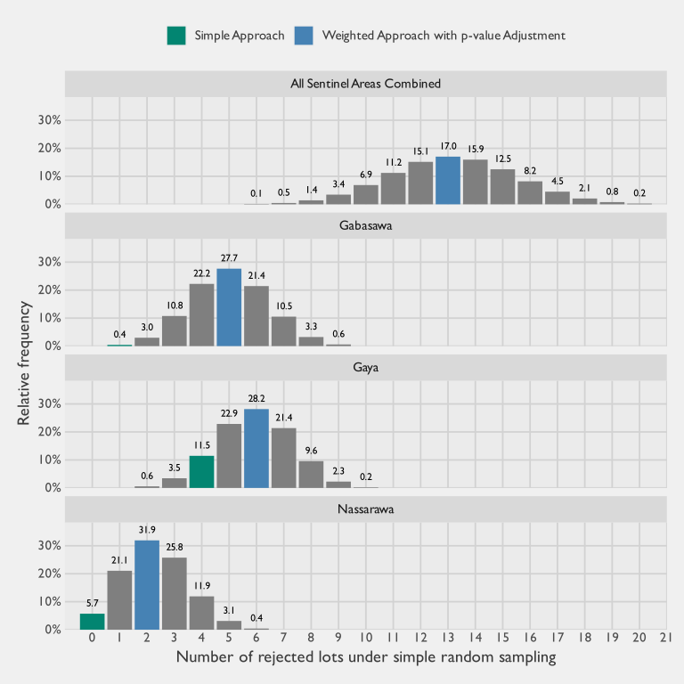
Figure 3.14: Theoretical sampling distribution for the number of rejected lots under simple random sampling, assuming the true Penta-1 coverage per ward was equal to the rates calculated under the gold standard survey. The actual number of rejections observed under the simple classification approach are shown in green, and for the weighted approach (with p-value adjustment) in blue. In some panels the green bar is not visible because the theoretical probability at that value is negligibly small; specifically, the simple approach yielded 5 rejections in the combined panel, 1 in Gabasawa, 4 in Gaya, and 0 in Nassarawa.
In comparison, the number of rejections under the weighted classification approach aligns much more closely with what the sampling distribution predicts. The observed number of rejections from the weighted classification is shown in blue in Figure 3.14.
It is also important to distinguish between a design being self-weighting and having the same error properties as a SRS. A self-weighting design ensures that each sampled unit contributes equally to estimation, but this does not guarantee that its variance behaves like that of an SRS. With one interview per cluster, whether the design behaves like an SRS at the child level depends entirely on how the clusters themselves are selected. If stage-one selection probabilities are exactly proportional to each cluster’s current number of eligible children, every eligible child in the ward has the same marginal inclusion probability, and the estimator is self-weighting for point estimation. Its variance, however, is not identical to that of an SRS even in this idealized case: the joint inclusion probabilities retain the stratified cluster-draw structure that SRS formulas do not anticipate. Any departure from that condition — clusters effectively over- or under-sampled relative to their current share of the ward’s eligible population — produces unequal inclusion probabilities across children, which must be corrected at the analysis stage with variable weights. Any sample carrying variable weights is less efficient than an equal-weight sample of the same nominal size. The LQAS sample size tables commonly used assume an SRS and therefore understate the true SE whenever stage-one selection probabilities depart from current population shares. Treating “self-weighting” as synonymous with “SRS-like” risks underestimating error and overstating the precision of results.
For the PPS+SRS design to approximate self-weighting in practice, the MOS used to select clusters must accurately reflect current population distribution. If the MOS is outdated or inconsistent with reality, then any correct weighting at the analysis stage (weighted based on the new enumeration conducted for the selected GEAs, rather than the 2006 census used to select the GEAs) will reveal substantial variation in weights across sampled units. This may help explain why the unweighted classification approach produces so few rejected lots: the stage-one EAs were selected using MOS data from the 2006 census, and the urban structure of the study area has shifted materially in the two decades since. A direct check of this shift, shown in Appendix E, extracts the Global Human Settlement Layer (GHSL) Degree-of-Urbanization class at each LQAS sample point for 2005 and 2025: roughly three in ten sampled locations now sit in a more urbanised class than they did in 2005, and Penta-1 coverage at each point tracks its 2005 classification more closely than its current one. A 2006-derived MOS therefore over-represents sampling cells that sat in the stable urban core (where zero-dose prevalence is lowest) and under-represents peri-urban cells that have urbanised in the intervening two decades (where the remaining zero-dose burden is concentrated). As a result, an unweighted analysis biases findings toward overstating coverage and underdetecting gaps, painting an overly optimistic picture of program performance.

3.4.4.2 Repeated Testing
A further challenge in applying LQAS is the issue of repeated testing. Since each SA is classified independently, multiple hypothesis tests are carried out simultaneously. The more tests conducted, the higher the probability that at least some lots will be spuriously accepted or rejected purely by chance. Statistical corrections for this problem are well established in other fields, but they are not yet common practice in LQAS applications.
In practice, these corrections are straightforward to apply whenever $p$-values are available as part of the test output. Several adjustment methods exist, but controlling for the FDR is a common and appropriately balanced choice (Benjamini and Hochberg 1995). Implementing such a correction does not require advanced statistical expertise: common software such as R can perform it with a single line of code. Freely available online calculators and downloadable Excel templates also automate the adjustment (“FDR Online Calculator” 2010; “Benjamini–Hochberg and Benjamini–Yekutieli Tests” n.d.). For this reason, programmes with the analytical capacity to incorporate it are encouraged to apply FDR correction, so that the error properties of LQAS remain aligned with the claims it aims to support.
A consideration of the risks of repeated testing becomes even more important when researchers test multiple antigens simultaneously using the same set of children. Because coverage for individual vaccines is highly correlated—as shown in the co-vaccination correlation matrix in Figure 3.15— the information content of these tests is not independent. Nevertheless, each additional hypothesis test still contributes to the risk of false discoveries. Running a full suite of tests across all routine immunizations therefore risks overstating the number of lots classified as acceptable or unacceptable purely by chance. To guard against this, it is preferable to select a limited set of indicators that best reflect the overall state of vaccination in the population. In practice, Penta-1 is a strong candidate because it captures access to services and is highly correlated with subsequent doses and other antigens. At most, one or two representative vaccines may be sufficient for classification purposes, avoiding redundancy while keeping error rates under control.
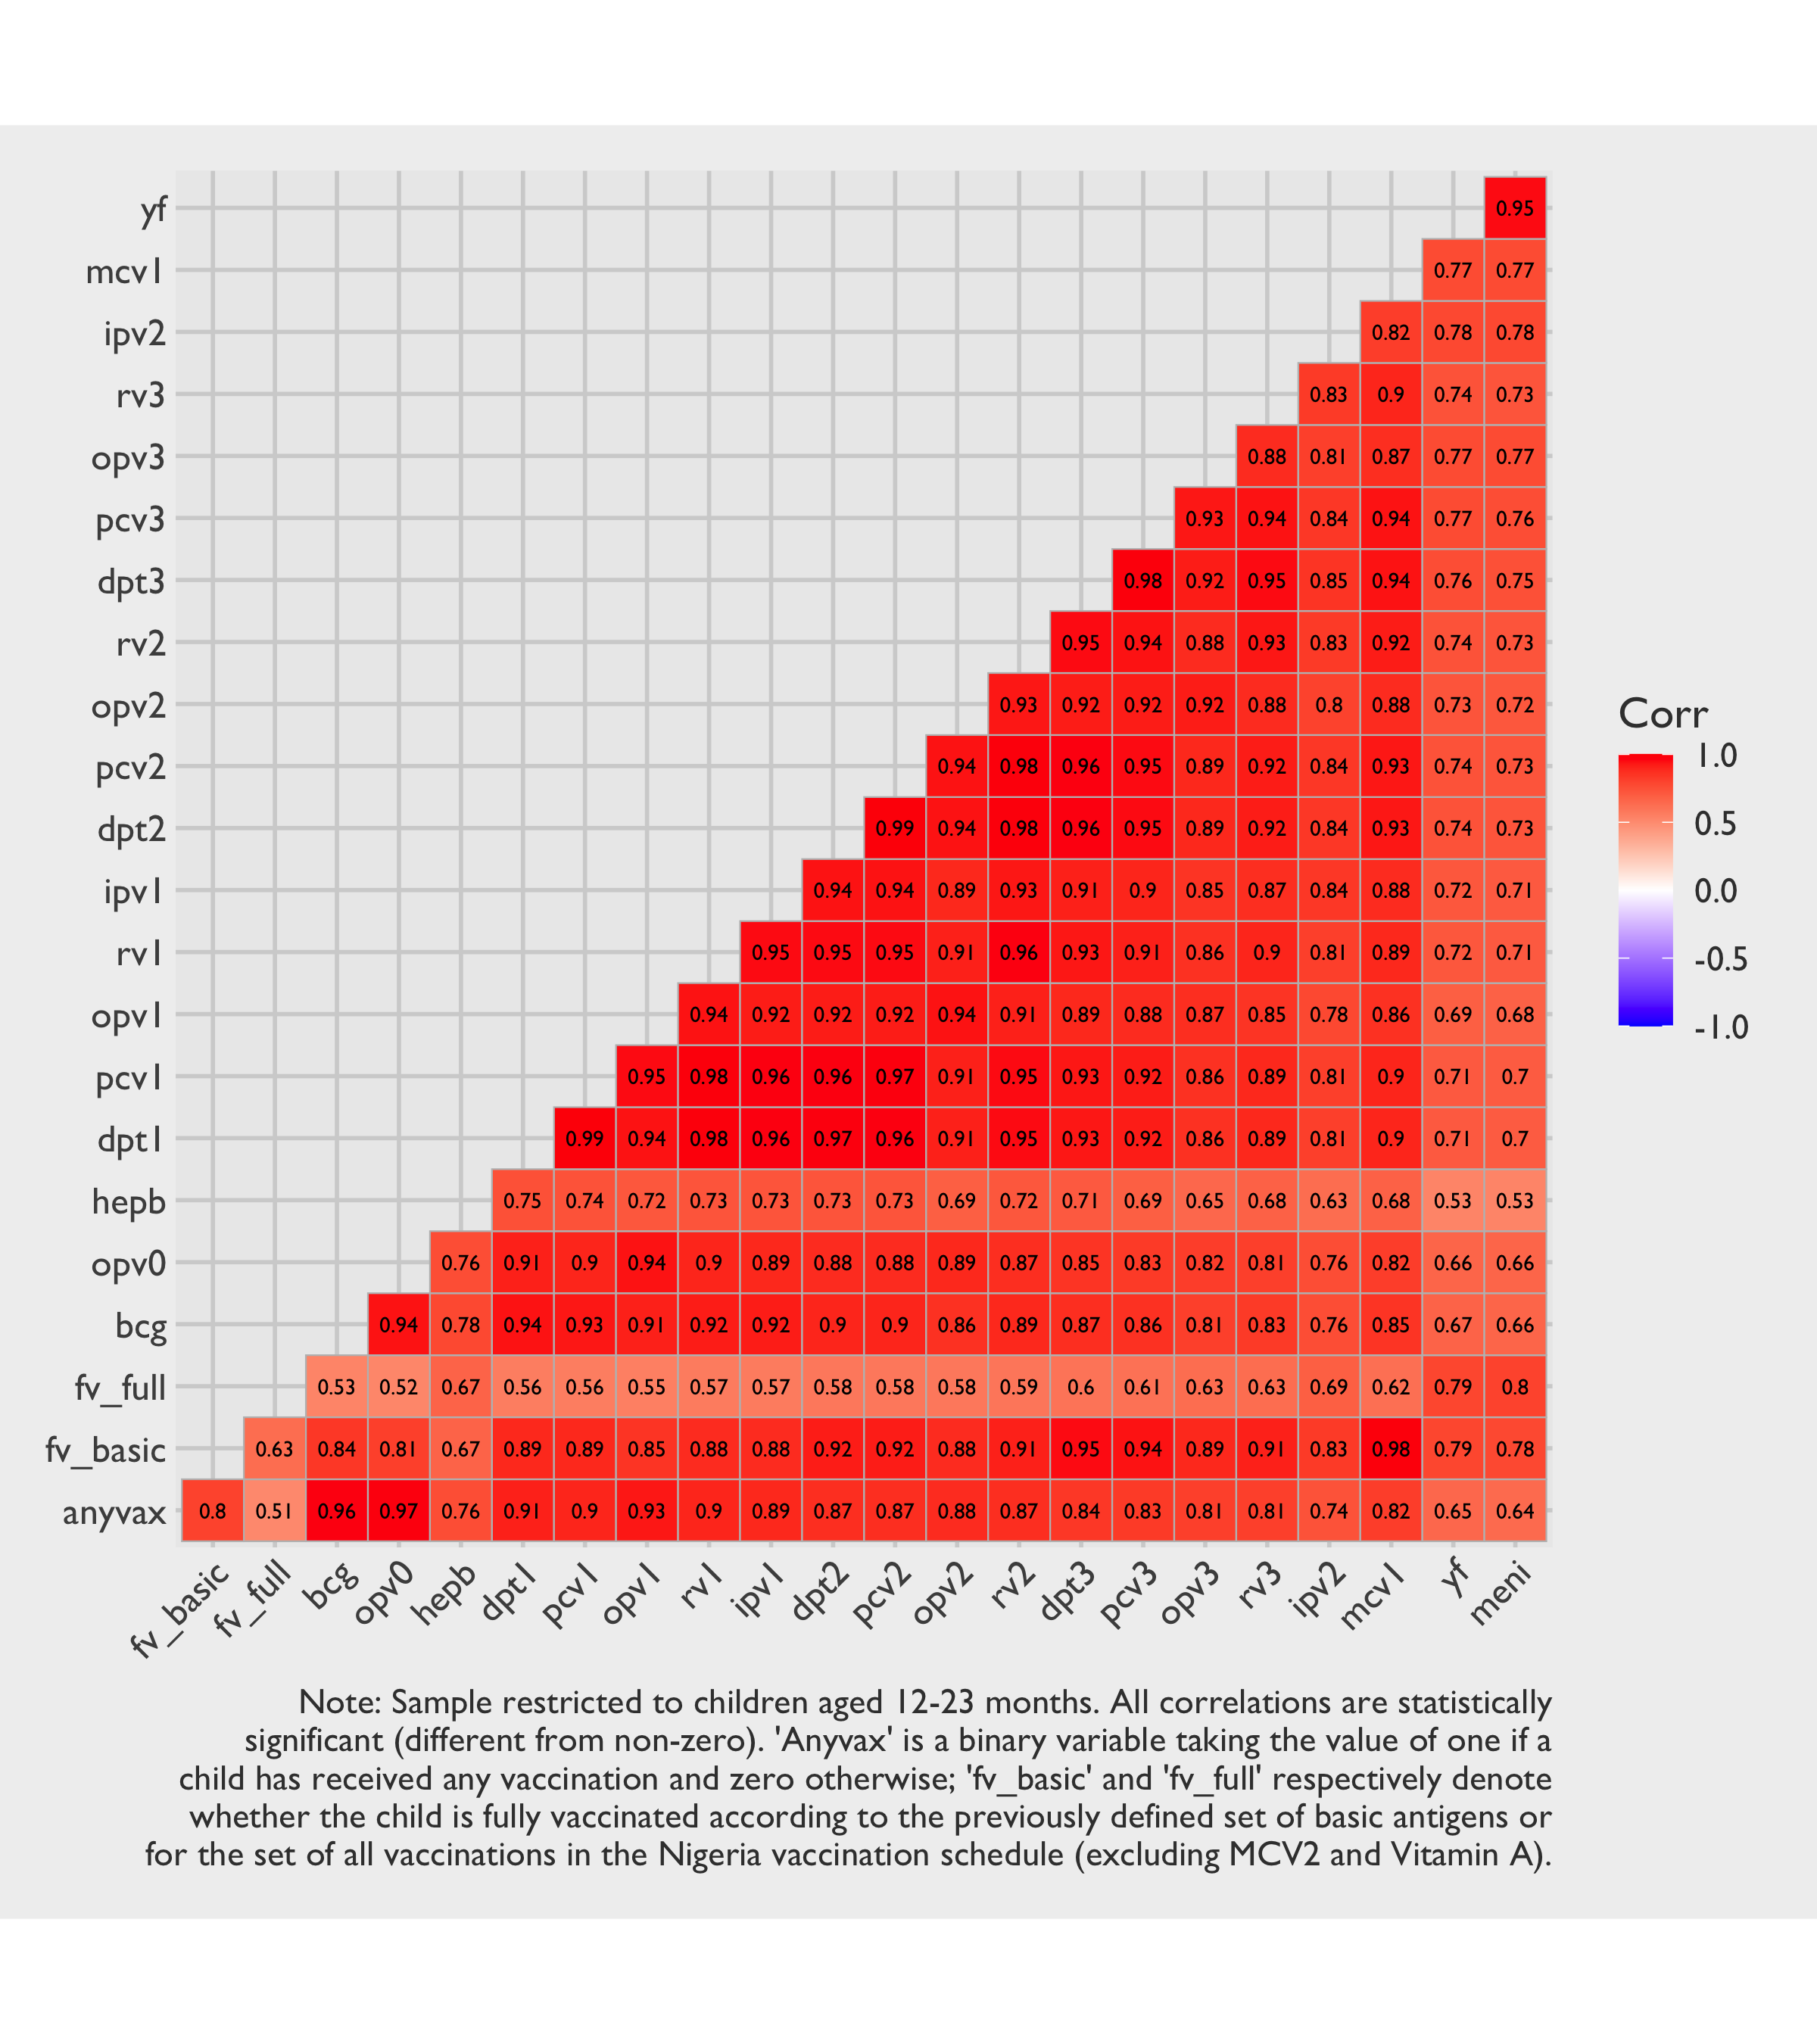
Figure 3.15: Design-based Pearson correlation coefficients between vaccinations (card or recall) from the gold standard survey underscore that vaccinations are highly correlated.
This study illustrates that risk clearly. With 32 wards/SAs and roughly 20 vaccines recommended for children aged 12 months, a full analysis across all antigens would involve $32×20=640$ separate hypothesis tests. Even if coverage patterns are strongly correlated across vaccines, each test still represents a separate statistical comparison and contributes to the overall FDR. Without correction, a nominal $α=0.1$ would imply that around 64 could appear significant purely by chance. The redundancy created by the high co-vaccination correlations means that these tests are not providing 640 independent pieces of information, but the inflation of Type I error remains real. For this reason, relying on a smaller set of representative antigens—such as Penta-1, and perhaps one other indicator of completion like the first Measles-Containing Vaccine (MCV) or Penta-3—is both statistically sound and operationally efficient. This approach limits the number of formal tests while preserving the essential signal about vaccination status.

3.4.4.3 Reliance on Defaults
In applied practice, LQAS parameter selection is sometimes bypassed in favour of a small set of conventional choices: published $\left(P_{0},P_{1}\right)$ combinations, a 30-percentage-point gap between the upper and lower thresholds, and the widely cited “$n=19$” sample-size shortcut. These conventions are sometimes presented as a feature that lowers the technical barriers to entry, but the fact that in practice they are often adopted without meaningful engagement with what they imply for the survey at hand belies that framing: they are habits accumulated around the method, not features of its statistical design.
Not all defaults are equivalent. Some are reasonable working conventions that travel well across contexts: loosened error targets such as $α=β≈0.10$ reflect the classification-only ambition of LQAS and serve a similar conventional role to $α=0.05$ in other applied settings. Others do not earn that status. The 30-percentage-point gap between $P_{0}$ and $P_{1}$, and the “$n=19$” sample-size shortcut, are crude simplifications rather than principled conventions: the appropriate $\left(P_{0},P_{1},n,d^{*}\right)$ depend on the program’s target coverage, realistic expectations about field coverage, and the programmatic consequences of misclassification. A practitioner who adopts these without reflection is, in effect, fielding a data collection whose design cannot speak to the question being asked.
The parameters also do not all play the same role. $P_{0}$, the lower threshold, is the substantive hypothesis under test — the coverage level below which an SA should be flagged for action — and is therefore a programmatic threshold, not a statistical convention. $P_{1}$, the upper threshold, is the power anchor: the plausible best-case coverage against which Type II error is computed; in immunization contexts it is too often set at an aspirational ideal rather than a realistic estimate of field coverage, misaligning the resulting Type II calculations with reality. $n$ and $d^{*}$ are not free parameters at all: they follow from $\left(P_{0},P_{1},α,β\right)$ once those have been chosen honestly, and the chapter’s “$n=19$, $d^{*}=13$” instance is one such derivation, not a universal rule.
Published LQAS sample-size tables remain a useful resource. They remove the need for custom power calculations and let non-statistician planners map parameters to feasible designs without specialised technical support. The problem is not the tables themselves but the shortcut that skips parameter selection entirely and lands on “$n=19$” without ever interrogating whether the implicit parameters match the local decision problem. This “$n=19$” heuristic is, in our view, the single most common and most egregious misuse of LQAS defaults in applied practice.
The defaults warrant particular scrutiny — or outright rejection — in three settings. The first is when program realities make the default $\left(P_{0},P_{1}\right)$ band unsuitable on either axis. A program whose actionable threshold sits well above the conventional $P_{0}=50\%$ — for instance, one in which anything below 80% is already treated as unacceptable — ends up testing the wrong hypothesis if defaults are adopted unchanged; and a default $P_{1}≈80\%$ misrepresents power whenever realistic field coverage lies materially above or below it. The second is when the goal is to monitor coverage change across survey rounds: LQAS is a one-sample test against a fixed threshold, and comparing classifications across rounds is a fundamentally different, two-sample problem that requires substantially more data and lacks valid standard errors under the standard LQAS design. The third is when the post-classification action requires finer resolution than the conventional 30-percentage-point band permits.
Finally, when honest calculations imply unpalatable sample sizes, the temptation is to keep adjusting $\left(P_{0},P_{1},α,β\right)$ until the required $n$ becomes feasible. This does not solve the underlying mismatch between question and budget — it merely re-labels the test so that the nominal error rates now apply to a different substantive question, one the program may have no particular reason to ask.

3.4.4.4 Design Inefficiency for Aggregate Coverage
Another key consideration is that a sampling design must make tradeoffs between competing objectives. In the case of LQAS, the principal objective is classification: determining whether each SA meets or fails a predetermined coverage threshold. The ability to produce aggregate coverage estimates at the CA or higher level is only a secondary benefit. This priority has direct consequences for sampling efficiency of the second objective. It also has consequences for validity: pooling lots to estimate coverage is only justified when lot selection supports inference to the target geography.
A design that samples an equal number of children in every SA ensures that each lot can be classified with the same decision rules, but it does not produce the most statistically (or cost) efficient estimates when those data are later combined. From the perspective of aggregate coverage, such a design is suboptimal because it allocates the same sample size to both small and large SAs, regardless of their contribution to the total population. If the sole objective were accurate estimation of coverage at the CA or LGA level, the more conventional approach would be a stratified random sample with proportional allocation, in which the sample size in each stratum is proportional to its size. This would minimize variance in the aggregate estimates, but at the cost of undermining the equal-lot comparability that LQAS requires.
Table 3.19: Design effect for Penta-1 coverage at the LGA-level
 | Weighted LQAS | Gold Standard
Gabasawa | 1.06 | 1.48
Gaya | 2.17 | 1.51
Nassarawa | 1.45 | 1.10
All Sentinel Areas | 1.71 | 1.45
The result is a design efficiency tradeoff: by prioritizing lot-level classification, the sampling design sacrifices precision in the aggregate. This inefficiency is an inherent tradeoff of the LQAS framework, and it helps explain why aggregate estimates derived from LQAS are often less precise than those from surveys explicitly designed for estimation.
That said, the inefficiency is not absolute; methods such as weighting can partially correct for population size imbalances when aggregating data. But these adjustments add complexity, and they cannot recover all of the lost efficiency compared to a proportional allocation design. Making more sophisticated weighting adjustments—such as enumerator adjustments and non-response adjustment—can also be a challenge if sample sizes are on the smaller side, as is often the case with LQAS. Recognizing these limitations is important for interpreting LQAS results: while LQAS is fast, targeted, and actionable for classification, it should not be expected to deliver aggregate estimates with the same reliability as a survey optimized for estimation.
The ward-level DEFFs are shown in Table 3.15. Values above unity suggest a sampling + estimation approach that is less efficient than a SRS, whereas those below one suggest a more efficient approach. Although it is a slight simplification, a self-weighting sample will typically have lower design effects compared to complex designs with more sampling weight variability. Our observed ward-level DEFFs average at 0.96, suggesting that the stratification and approximate self-weighting design may have been slightly more efficient than a random sample when it comes to classification. In comparison, when the task is to aggregate data for SA-level coverage estimates, design effects will typically be larger for the aforementioned reasons. These are shown in Table 3.19 and quantify the design inefficiency of calculating coverage estimates at the SA level using data collected for CA-level classification. Here, we do indeed see values in the range of 1.1 to 2.2. This increase is attributable to unequal sampling at lower levels as well as effects from non-response.

3.4.4.5 Implementation Complexity
In proposing methodological refinements to LQAS, we recognize that each improvement—whether introducing weights, calculating one-sided confidence bounds, or adjusting for repeated testing—adds layers of complexity. These refinements strengthen the statistical properties of the approach and move the results closer to formal survey standards, but they also demand tools and expertise that may not be readily available to implementing partners. By contrast, the simple unweighted LQAS method is easy to implement, requires minimal training, and can be applied consistently in routine program settings. The challenge, then, is to balance rigor with feasibility: overly complex methods, however correct in principle, risk being impractical for field use and therefore unused in practice.
Of course, drawing a single-stage SRS within wards is rarely feasible in practice, since a complete and up-to-date household sampling frame is usually unavailable. Traditionally, this constraint has led to the use of multistage designs—such as PPS selection of EAs followed by household listing and sampling—that introduce clustering and move the design away from the assumptions underlying LQAS sample size tables. However, the growing availability of open-source geospatial data, such as building footprints, creates new opportunities to sample units more directly. By selecting households from these data, we can circumvent the need for outdated EAs and extensive household listing, while also reducing the number of sampling stages. Although not a perfect substitute for a true SRS of households, this approach may strike a pragmatic balance: keeping LQAS fast and simple to implement, while staying more faithful to the assumptions on which its simple classification rules and sample sizes were originally based.

3.4.5 Recommendations
Each refinement set out below adds analytic or operational complexity, which may at first reading seem at odds with LQAS’s appeal as a fast and lightweight method. To make that tradeoff explicit, we separate these recommendations into two tiers — a “must do” tier required for valid results, and a “nice to have” tier of refinements that improve efficiency or sharpen interpretation. The first tier comprises practices without which the test’s nominal error rates cannot be trusted, sampling weights are misspecified, or pooled estimates do not generalize to the geography they claim to characterize. These are not optional refinements but the conditions under which LQAS’s guarantees actually hold; our own findings illustrate the consequences when one or more are skipped. The second tier comprises improvements whose omission does not invalidate the core classifications. A practitioner working under tight constraints can defer the second tier; the first should be treated as the entry cost of using LQAS responsibly. A compact summary is provided in Table 3.20 at the end of this section.

3.4.5.1 Required for valid results (“must do”)
3.1. If collecting data via a complex sample, use the WHO’s weighted classification approach. Apply the weighted rather than the simple approach whenever the sampling mechanism deviates from simple random sampling. Calculate LCBs with survey software designed for complex samples, and avoid reliance on Wald intervals.
3.2. Use post-stratified or calibrated sampling weights in CA-level coverage estimates, even if simple random sampling is used. Weights should be applied even when a true SRS is drawn within each SA, since SAs are rarely equal in size. These differences in sizes need to be accounted for correctly when aggregating multiple SAs within a CA.
3.3. Only report pooled CA-level coverage when lot selection supports representativeness. If all lots in the target area are included (as in this study’s 32/32 sentinel wards), there is no between-lot sampling error within that frame, and pooled estimates can be interpreted for that area subject only to within-lot uncertainty. If only a subset of lots is included, pooled estimates should only be presented as CA-level prevalence when that subset is sampled probabilistically, or when a strong representativeness argument is explicitly justified. Convenience- or intervention-focused lot selection should not be generalized to the full CA.
3.4. Analyze only one child per household. Because the vaccination status of children in the same household is not independent, including siblings in the analysis can result in greater sampling error, especially under unweighted analyses. Exceptions may be considered if analytic software explicitly accounts for multi-stage sampling and intra-household correlation, in which case the relative ease of collecting data on all eligible children in a given household may be leveraged to obtain a slightly larger sample size. 3.5. Account for potential inefficiencies in PPS designs. Do not simply presume that a PPS+SRS design will result in a self-weighting design. When first-stage selection probabilities are based on stale MOS while the true number of second-stage units has shifted, the design is no longer self-weighting and unweighted estimates may be biased. If it is deemed that the sampling frame used to draw a PPS sample of EAs may no longer be very accurate, we recommend obtaining a reasonably accurate count of households in each sampled enumeration area — whether through a full listing, a quick count of dwellings, or another rapid assessment method — so that sampling weights reflect the actual number of households rather than outdated population figures.
3.6. Set upper LQAS thresholds to reflect realistic coverage expectations. LQAS was originally developed in industrial quality control, where it was reasonable to assume that a machine operating correctly would produce units at a near-ideal rate of non-defects. In that context, setting the upper threshold at an aspirationally good level (representing the standard of proper functioning) made sense. In vaccination coverage surveys, however, the situation is different: we typically begin with the knowledge that coverage is unlikely to be at ideal levels. Designing LQAS with an upper threshold fixed at an aspirational target therefore misaligns Type II error calculations, since it assumes a fictionalized world in which every supervisory area has excellent coverage. A more meaningful approach is to anchor the upper threshold in the best available estimate of actual coverage (for example, based on the regional coverage estimate from the most recent Demographic and Health Survey (DHS), Multiple Indicator Cluster Survey (MICS) or national EPI survey), so that the resulting power calculations and Type II error rates reflect the realities of the field rather than an unattainable benchmark.
3.7. Interrogate LQAS parameter choices rather than relying on common heuristics. Treat $\left(P_{0},P_{1}\right)$ as study-specific decisions rather than default slots to be filled, and let $n$ and $d^{*}$ follow from those choices and the chosen error rates. If honest calculations imply unpalatable sample sizes, resist reverse-engineering the parameters to fit a feasible $n$, as this simply restores the original problem under a different label. See Section 3.4.4.3 for when common defaults warrant particular scrutiny — or outright rejection.

3.4.5.2 Useful refinements (“nice to have”)
3.8. Put in place measures to mitigate enumerator bias. Establish protocols such as predefined paths for random walks to reduce discretionary decision-making in the field. Some form of enumerator training and supervision is universal, and the value of formal predefined-path discipline beyond that baseline depends on the rigour of existing field practice.
3.9. Apply multiple-testing corrections when feasible. Freely available tools are sufficient for this purpose, and we advocate for corrections that control the FDR, although other variants are also valid (e.g., those that control family-wise error). Multi-testing correction is not yet conventional in routine LQAS practice, and small applications with only a handful of lots may judge that the marginal validity gain does not justify the additional analytic step.
3.10. Consider alternative, more efficient sampling designs. A direct SRS of building footprints may approximate a true SRS of infants more closely than a two-stage PPS+SRS design. Google and Microsoft both make such building footprints available for free in many parts of the world. However, complexities such as multi-household dwellings must be taken into account, as these can inflate sampling weights if care is not taken in the sampling and estimation approach.
3.11. Sample more than one household per SA. In multi-stage designs there is a trade-off between the number of first-stage units and the number of households selected within each. Because most fixed costs are incurred once a cluster is reached, interviewing multiple households within the same GEA is usually more cost-efficient than visiting additional clusters. Including at least two households per GEA also allows the within-GEA contribution to variance to be estimated directly, rather than assumed. However, adding more households does not necessarily increase statistical efficiency, since the marginal gain depends on the intra-class correlation. The optimal balance is therefore best determined through DEFF calculations or simulation tailored to the study context.
3.12. Temper expectations for LQAS-based reasons-for-non-vaccination data. Because reasons questions are only administered to caregivers of unvaccinated or under-vaccinated children — a small subset of the already modest LQAS sample — the resulting estimates are far less precise than the coverage classifications for which LQAS is designed. Pooled barrier profiles may broadly reflect the dominant domains, but they are unlikely to reveal local patterns that experienced practitioners do not already anticipate. Programmes seeking actionable demand-side intelligence at the local level should invest in dedicated BeSD or qualitative assessments with appropriately sized samples.
Table 3.20: At-a-glance summary of LQAS recommendations grouped by tier. The ‘must do’ tier comprises practices required for the test’s nominal error rates and pooled estimates to be trustworthy; the ‘nice to have’ tier comprises refinements that improve efficiency or sharpen interpretation but whose omission does not invalidate the core classifications.
# | Recommendation | Tier
3.1 | Use the WHO's weighted classification approach for complex samples | Must do
3.2 | Use post-stratified or calibrated weights for CA-level coverage | Must do
3.3 | Pool to CA only when lot selection supports representativeness | Must do
3.4 | Analyze only one child per household | Must do
3.5 | Re-list households when PPS measures of size are stale | Must do
3.6 | Set upper LQAS thresholds to reflect realistic coverage | Must do
3.7 | Interrogate LQAS parameter choices rather than relying on heuristics | Must do
3.8 | Establish protocols to mitigate enumerator bias | Nice to have
3.9 | Apply multiple-testing corrections (e.g., FDR) | Nice to have
3.10 | Consider efficient sampling designs (e.g., building footprints) | Nice to have
3.11 | Sample more than one household per SA | Nice to have
3.12 | Temper expectations for reasons-for-non-vaccination data | Nice to have

3.4.6 Conclusions
LQAS remains a valuable tool for identifying pockets of potentially low coverage, but its utility depends critically on how it is applied. Its traditional promise of rapid classification with well-defined error rates is best supported under simple random sampling, yet routine immunization applications almost always rely on multistage or otherwise complex designs. Applying the standard unweighted rules to such data can leave nominal and actual error rates misaligned, and claims about LQAS producing aggregate prevalence estimates remain implementation-specific: pooled lot data support CA-level inference only when lot selection is representative of that CA.
The refinements set out in the Recommendations above bring observed performance much closer to the theoretical error properties LQAS is meant to guarantee, even under complex sampling arrangements. Each, however, adds analytic complexity and demands capacity that not every program will have on hand.
As the saying goes—oft attributed to Albert Einstein—“everything should be made as simple as possible, but no simpler.” LQAS appeals precisely because of its simplicity and low resource demands, and we applaud methods that field practitioners can readily implement. However, we caution against situations where departures from the underlying assumptions are so great that the method’s guarantees no longer hold. Our own experience with this study offers a case in point, benchmarked against a strong comparative reference in the form of our gold-standard coverage survey — itself subject to its own sampling error, but providing a credible yardstick against which to assess LQAS performance. The challenge is therefore not to abandon LQAS, but to adapt it in ways that balance rigor with feasibility. With careful implementation of the recommendations outlined here, LQAS can continue to play a constructive role in vaccine program monitoring, offering timely signals of where performance is most at risk while keeping error properties transparent and credible.
Looking ahead, emerging innovations in sampling design may narrow the gap between practical field designs and the theoretical underpinnings of LQAS, making the refinements we recommend here easier to adopt at scale.

3.5 Administrative Methods

3.5.1 Overview
Use of administrative records to estimate immunization coverage is not a new technique. Sometimes referred to as the “administrative method” or the “doses-administered method”, the approach is easy to understand: take the number of vaccine doses as delivered to the target age group as a numerator and divide this number by an estimate of the target population as a denominator. This yields a vaccine coverage percentage. For Penta-1, taking its complement by subtracting it from 1 gives the Penta-1 zero-dose prevalence. In most settings, this estimate is produced through a numerator that comes from routine administrative reporting systems and is valued because it is timely, relatively low-cost, and available at multiple administrative levels (V. Dietz et al. 2004).
However, empirical research shows that administrative coverage is often an unreliable proxy to measure the effective proportion of vaccinated children. This is because both components of the ratio are prone to error: the numerator may be affected by reporting inaccuracies, and the denominator may not accurately represent the target population (V. Dietz et al. 2004; Bosch-Capblanch, Banerjee, and Burton 2012). Numerator errors can arise when vaccinations are not consistently entered into facility registers or when figures are mis-transcribed or altered as they move from facility reports to district and national summaries (Bosch-Capblanch, Banerjee, and Burton 2012; Ngo-Bebe et al. 2025). Denominator errors are common when target population estimates rely on outdated projections or implausible local estimates, or when assumptions about residence do not match service use—particularly where migration and cross-area attendance mean children are vaccinated outside their area of official registration (V. Dietz et al. 2004; Bosch-Capblanch, Banerjee, and Burton 2012; Stashko et al. 2019).
A key issue is that administrative estimates frequently produce values that are not plausible as population measures. Evidence from Nigeria illustrates how far administrative values can diverge from independent estimates: Dunkle et al. (2014) found that routinely reported DPT-3 coverage often exceeded plausible bounds and was substantially higher than survey-based estimates in the same states over multiple years. Importantly, these inconsistencies were found across multiple reporting levels, including state registries and district registries.
Related work shows that the reliability of administrative coverage can vary sharply within a country, and that national figures may conceal large sub-national distortions. In Burkina Faso, Haddad et al. (2010) found that while national administrative estimates were broadly similar to survey-based estimates, regional and district comparisons revealed large discrepancies, sometimes on the order of tens of percentage points. The pattern was not random: remote districts tended to show administrative overestimation, while districts near urban centers tended to show underestimation (Haddad et al. 2010). In other words, at least some of the inaccuracy in the administrative method is often systematic rather than the consequence of isolated reporting errors.
Some studies suggest that reporting may be influenced by accountability regulations and policies. For example, recent evidence from the Democratic Republic of Congo suggests that over-reporting can also reflect pressure to meet targets. Ngo-Bebe et al. (2025) reported widespread overestimation of routine Penta-3 coverage compared with independent benchmarks and linked discrepancies to managerial pressure, including fear of consequences for low reported performance. Qualitative findings indicated that inflation could occur through deliberate overstatement of doses, downward adjustment of target population figures, and errors during data compilation (Ngo-Bebe et al. 2025).
Denominators are also problematic. In principle, the denominator should represent the target population eligible for vaccination (e.g., surviving infants aged 12-23 months), but in practice it is often based on outdated projections, incomplete registration, or population estimates that do not reflect local mobility patterns (V. Dietz et al. 2004). Migrations, cross-district immunizations, and catchment boundary changes mean that the children being vaccinated are not always the same population assumed in official target estimates. In these circumstances, coverage can be inflated if the denominator is too small (or deflated if it is too large), even when the numerator is recorded accurately. V. Dietz et al. (2004) describe this clearly in their review of monitoring practices in the Americas, noting that both numerator integrity and denominator validity shape administrative coverage and that cross-boundary vaccination can systematically bias local estimates.
Large-scale analyses confirm that denominator instability is common rather than the exception. Using WHO/United Nations International Children’s Emergency Fund (UNICEF) administrative reporting data, Stashko et al. (2019) applied consistency checks to identify suspicious target population patterns and implausible coverage values. They found frequent examples of coverage above 100% and demographic inconsistencies embedded in reported target populations, including abrupt year-to-year shifts that are difficult to justify as real population change (Stashko et al. 2019). This work is useful because it shows that denominator problems can often be detected through routine plausibility screening, even when no survey validation is available. It also supports the view that administrative denominators should be treated as uncertain inputs rather than fixed quantities.
A further complication is that even when government population projections exist, they are not always published at the level of granularity needed for sub-state monitoring, and they are rarely available with reliable age-disaggregation for narrow cohorts such as children aged 12–23 months. In practice, analysts often start with a state-level projection and then downscale it using fixed ratios or simple allocation rules. That approach can be fragile because population dynamics are not spatially uniform within a state. Birth rates, infant mortality, migration, and household composition can differ sharply between urban and rural areas and across municipalities, sometimes over short distances. As a result, denominators that may be broadly plausible at the state level can be substantially misallocated at the LGA level. When administrative coverage is computed for small areas, these sub-state denominator errors can dominate the uncertainty, creating apparent high or low coverage that reflects demographic mismeasurement as much as service delivery performance.
Administrative estimates are often evaluated against survey-based coverage. However, empirical research shows that surveys are not perfect either. Cutts et al. (2016) emphasize that coverage surveys can be affected by selection bias and information bias, especially when home-based records are missing and estimates rely partly on caregiver recall. These biases may vary across contexts and can affect subnational comparisons, particularly where documentation is incomplete and recall is used (Cutts et al. 2016). This creates a difficult interpretive problem when administrative and survey estimates disagree. In some cases, administrative bias is the likely driver; in others, survey under-ascertainment may contribute; and in many settings, both processes may be producing error in different ways (Cutts et al. 2016).
Given the limitations of single-source estimation, some authors argue for approaches that combine administrative and survey information rather than selecting one over the other. Hybrid estimation methods represent one attempt to formalize this logic. Jeffery et al. (2018) showed that combining administrative and probability survey information can produce estimates that align closely with surveys while improving statistical precision in their applications. Ocampo et al. (2022) extended this approach to settings where survey data were only available for a subset of districts, using limited survey information to improve denominator estimation and infer coverage in non-surveyed areas. While these approaches are promising, they have been evaluated primarily in campaign contexts, and their transferability to routine service delivery still requires further evidence (Jeffery et al. 2018; Ocampo et al. 2022).
Overall, the academic literature suggests that routine administrative coverage is best treated as an operational indicator rather than a direct measurement of population immunization. It remains useful because it is timely and geographically granular, and it can support monitoring when denominators are stable and reporting is consistent (V. Dietz et al. 2004). However, administrative estimates are especially vulnerable to denominator error, mobility-related misalignment between population and service use, and incentive-driven distortions in reporting (Dunkle et al. 2014; Ngo-Bebe et al. 2025; Stashko et al. 2019). Stashko et al. (2019) highlight the value of comparing country-reported denominators with UN Population Division demographic estimates to flag potentially implausible target population figures. Surveys provide an essential external reference, but they also face limitations related to sampling, documentation, and recall, which complicate their role as a definitive standard (Cutts et al. 2016).

3.5.2 Implementation Details
This section introduces what this paper will call ARR. The approach extends the traditional desk-based administrative method with three novelties. First, it incorporates a light-touch primary data collection component to assess the reliability of PHC-reported immunization data. This audit is then integrated into the estimation process with the intent of informing potential calibration or adjustment of doses used in numerators. Second, the ARR approach also leverages open-source Geospatial Information Systems (GIS) datasets to potentially strengthen the denominator, drawing on geospatial data sources that have become widely available only in recent years and may represent a substantive methodological enhancement relative to earlier applications of similar methods. Third, the ARR approach also leverages data from the 2025 Kano Health Facility Census (HFC) to augment the modeling process with a complete picture of the PHC landscape. This third element helps improve the reliability of the denominator by accounting for potential missing PHCs from administrative records.
The agency records used in this paper are Kano State primary health care data reported through DHIS2. DHIS2 is an open-source health information platform used by public health facilities in Nigeria to routinely report service delivery data, including immunization. Five vaccines are reported on the platform: Bacille Calmette-Guérin (BCG), Penta-1, Penta-3, MCV, and Oral Polio Vaccine (OPV) 1. These data are aggregated for planning, monitoring, and decision-making across multiple levels of the health system. As with many routine health information systems, DHIS2 data may be affected by incomplete reporting and variable data quality across facilities and time. In addition, because reported figures can be linked to performance monitoring and resource planning, there may be incentives that influence how data are recorded and reported by PHCs.
Data entry into DHIS2 generally proceeds as follows. Health workers record service delivery information (e.g., number of children immunized) in paper-based registers at each PHC. At the end of each month, staff compile these records into standardized paper summary forms known as Health Management Information System (HMIS) forms. Summaries from these registers are typically sent to the LGA health office, where they are reviewed, validated, and entered manually into the DHIS2 platform.
The aggregate monthly counts entered into DHIS2 do not separate doses by recipient age. A Penta-1 dose given on-time to an infant at around six weeks of age contributes the same to the reported figure as a catch-up dose administered to an older child, which raises the possibility that the numerator could include events involving children who fall outside the 12–23 month target window used to construct the denominator. However, the baseline study’s time-to-Penta-1 survival curves indicate that catch-up doses beyond six months of age are uncommon in this setting (Mindset 2025), so this potential source of numerator inflation is unlikely to be a major contributor to the difference between ARR and gold-standard estimates.
The scope and degree of data reliability of DHIS2 data are not routinely assessed or reported by independent monitors–and even if they were, such dynamics can vary a great deal over time and space. For this reason, in order to assess the veracity and completeness of DHIS2, an additional data validation step is required to assess and potentially calibrate DHIS2 counts. To this end, Mindset surveyed a sample of 75 PHCs and, using these physical registers as the ground truth, compared these data with DHIS2 figures to estimate the magnitude of the differences between reported and actual service delivery. The findings were then used to adjust DHIS2-based numerators in the ARR estimates.
The initial sampling frame was drawn from a list of 543 Kano State PHCs that reported providing immunization services to the DHIS2. The frame included auxiliary information in the form of the number of 0–1-year-olds that had attended to the PHC in the most recent quarter, to be used as a measure of size for PPS sampling. The number of PHCs per LGAs is provided in Table 3.21.
Table 3.21: Number of PHCs in Kano State, by LGA
LGA | Number of PHCs
Bebeji | 24
Danbatta | 41
Dawakin Kudu | 25
Dawakin Tofa | 44
Gabasawa | 32
Gaya | 31
Gezawa | 29
Kano Municipal | 22
Kiru | 34
Kumbotso | 27
Makoda | 32
Nasarawa | 31
Sumaila | 44
Takai | 35
Tarauni | 24
Tudun Wada | 29
Ungogo | 39
The primary purpose of the sample of PHCs was to reliably estimate the number of audited register doses of Penta-1 (rather than DHIS2-reported). Mindset’s team was given access to pertinent vaccine dose counts from DHIS2, and it was determined that a PPS design was most practical for this study as a unit of size measurement was conjectured to be well correlated with such vaccination counts. A range of sample sizes were considered for this study. With a sample size of 75 PHCs (~15%), an estimate for the quantity of interest would yield an acceptable standard error and an expected MOE of no more than 5 percentage points. The quantity of sampling effort for each LGA was assigned to be approximately proportional to total counts per of vaccinations per LGA. The sample size of 75 PHCs allocated across the study region is displayed by LGA in Table 3.22.
Table 3.22: Sample of PHCs selected in Kano State, by LGA
LGA | Sum of auxiliary observations of interest  as provided in the frame | Number of selected PHCs
Bebeji | 12,478 | 2
Danbatta | 17,458 | 3
Dawakin Kudu | 22,690 | 4
Dawakin Tofa | 20,182 | 3
Gabasawa | 19,498 | 3
Gaya | 9,265 | 2
Gezawa | 20,993 | 3
Kano Municipal | 71,804 | 12
Kiru | 26,531 | 4
Kumbotso | 32,034 | 5
Makoda | 14,865 | 2
Nasarawa | 46,704 | 8
Sumaila | 24,618 | 4
Takai | 26,577 | 4
Tarauni | 31,808 | 5
Tudun Wada | 22,508 | 4
Ungogo | 44,193 | 7
A total of 74 out of the 75 selected PHCs were successfully observed by the field team. In each visited PHC, field teams checked for the availability of physical immunization registers which contains records of all immunized children. If the register was accessible, the team proceeded to review the entries recorded over the past four quarters for each of the five vaccines. If the register was not available, this absence was noted, as it may indicate issues with data management or documentation within the PHC.
In parallel with the dose counts, the audit team also documented what kinds of immunization records each facility maintained, since the format of the audited source affects what the resulting count represents. Table 3.23 summarises the weighted prevalence of each record type, extrapolated from the PPS sample to the population of immunization-providing PHCs in the 15 study LGAs. A child-level immunization register — one row per named child, with columns for dates of each vaccine received — was present at every audited facility, and the team could view it in 99% of cases. The large majority (84%) were the standard National Health Management Information System (NHMIS) 2019 child immunization register; the remainder were other formal name-keyed registers, with no facility relying on an informal or notebook-style register. Daily immunization tally sheets were similarly universal and viewable, with 96% following the standard NHMIS 2019 format. A non-trivial minority of facilities maintained more than one child register concurrently (34%), while only 11% used more than one tally sheet at once. This documentation environment is qualitatively richer than the picture characterised in the 2015 Kano State facility data-quality assessment by Akerele et al. (2020), which described the routine-immunization data flow primarily in terms of tally sheets compiled into monthly summary forms and did not engage with the child-level register layer that the present audit observed at every facility.
Table 3.23: Immunization record environment encountered at audited PHCs, with weighted estimates extrapolating from the 74-facility PPS sample to the population of immunization-providing PHCs in the 15 study LGAs
Indicator | Weighted % (95% CI)
Child immunization register present at the facility | 100.0%
— Standard NHMIS 2019 child immunization register | 93.3% (85.9%–100.0%)
— Other formal child immunization register | 6.7% (0.0%–14.1%)
Child register accessible to the audit team | 98.5% (95.4%–100.0%)
More than one child immunization register in use at once | 23.0% (10.1%–36.0%)
Daily immunization tally sheet present at the facility | 100.0%
— Standard NHMIS 2019 daily tally sheet | 94.2% (86.5%–100.0%)
— Other formal tally sheet | 5.8% (0.0%–13.5%)
Tally sheet accessible to the audit team | 100.0%
More than one daily tally sheet in use at once | 4.5% (0.0%–9.6%)
The audited register data was then compared with data submitted to the DHIS2 for the same four quarters using a multi-level regression model. The model predicts the verified vaccination count as a function of the counts reported in DHIS2 and other covariates. The intermediary output is a verification factor that can be used to estimate the veracity of immunization data in the DHIS2.
Mindset also used the Kano 2025 HFC data to serve as a complete list of facilities that offer vaccination services in a given LGA and used this to post-stratify verification-factor-adjusted estimates modeled through multilevel regression models. Models were refined to post-stratify by type of facility (e.g., large/small, primary/secondary/tertiary) and other covariates available in both the complete list of facilities, and in those that were sampled. This approach uses the sample-based vaccination data to predict values for all facilities in the LGA of interest, using the distribution of predictions for a population and by averaging over these predictions.

3.5.3 Results

3.5.3.1 PHC Register Audit
Figure 3.16 compares, for each of the 74 sampled facilities, the number of Penta-1 and MCV1 doses reported to DHIS2 ($x$-axis) with the number of doses found during the audit of the physical registers ($y$-axis). Each dot represents one health facility, with doses averaged over four periods. The dashed line is the line of parity ($y=x$): points that fall on this line indicate close agreement between the two sources, points above it indicate higher counts in the registers than in DHIS2, and points below it indicate higher counts in DHIS2 than in the registers. The green line overlays the fitted relationship for Penta-1 from a multilevel model, summarizing the expected audited register count for March 2025 given the DHIS2 reported value. Based on multilevel generalized linear models, the number of Penta-1 register doses (for March 2025) can be approximated as
$$\text{register_doses}=2.15×{\left(\text{dhis2_doses}\right)}^{0.791} \left(3.10\right)$$
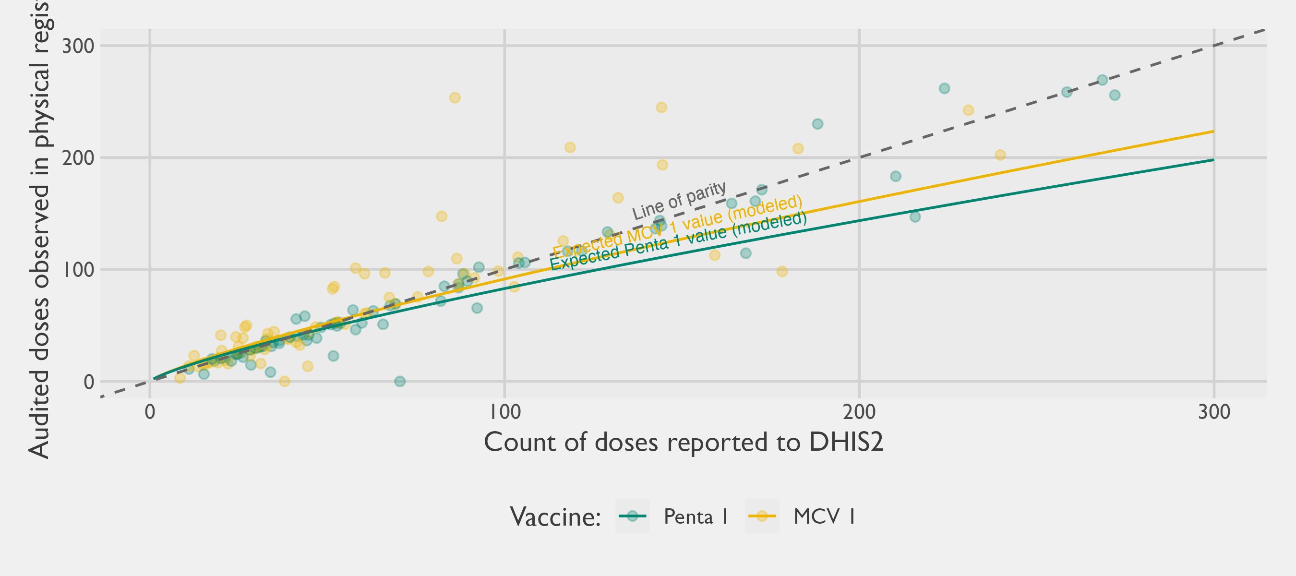
Figure 3.16: Reported doses on DHIS2 vs. audited doses in register (modelled trendline) for 74 sampled facilities
Several patterns stand out. First, there remains substantial divergence between reported counts and audited counts, even though the overall association is clearly positive. The scatter around the parity line is wide in both the low-volume and high-volume range, indicating that discrepancies are not confined to a narrow subset of facilities or vaccines. A minority of observations lie close to the parity line, suggesting that for some facility–vaccine combinations the routine reporting and the registers are broadly consistent, but many observations deviate materially in either direction.
Second, at lower volumes the discrepancies appear less directional. Among facilities reporting relatively few doses, points fall both above and below the parity line, consistent with a mixture of over- and under-reporting (or differences in timing, transcription, and reconciliation) rather than a single systematic pattern. In practical terms, this means that for smaller sites the difference between DHIS2 and the registers often looks like noise with no clear sign, even when the absolute difference is meaningful relative to the small totals.
The most consequential feature is that a directional bias becomes more evident as volumes increase. As the number of doses reported to DHIS2 grows, a larger share of points fall below the parity line, implying that DHIS2 totals are frequently higher than what is ascertained in the registers for higher-volume settings. The fitted trendline reinforces this: it sits increasingly below the parity line at higher counts, implying a sublinear relationship in which audited register totals rise more slowly than reported DHIS2 totals. Put plainly, the gap tends to widen with facility size. A small number of observations also show very large discrepancies, which matter because high-volume facilities, though fewer in number, can exert outsized influence on aggregate totals. This pattern also supports the intuition that probability proportional-to-size (PPS) sampling is an efficient design for audit work: when selection probabilities are tied to reported service volume, larger facilities, which both contribute more to totals and appear more prone to consequential discrepancies, are more likely to be included in the audit. In effect, PPS concentrates verification effort where potential error has the greatest leverage on system-wide estimates, improving the precision and practical value of any subsequent calibration.
In the modeling process, the research team explored whether richer facility characteristics from the 2025 Health Facility Census could explain additional variation in discrepancies, including immunization readiness scores and tracer indicators. In this dataset, these variables did not appear to add meaningful predictive power beyond the DHIS2 volume itself and the facility/LGA/month structure captured by random effects. This result is informative in its own right: it suggests that discrepancies are not easily reduced to a small set of observable readiness features, and that facility-specific reporting dynamics remain important.
These findings have direct implications for administrative approaches to estimating immunization coverage. If audited registers are treated as the best available reference (an important assumption, since registers can also be incomplete or imperfect), then simply summing DHIS2 counts is likely to yield a biased estimate of total doses delivered, with the bias driven disproportionately by higher-volume facilities.
Table 3.24: Different choices of numerators for the administrative method (estimated number of Penta-1 doses administered over 12 months)
Stratum | Numerator #1: DHIS2 Annualized Summation | Audited register doses from sampled PHCs (unweighted) | Numerator #2: Design-Weighted Estimate of Register Doses | Numerator #3: Regression-Adjusted Doses
Gabasawa | 12,860 | 1,385 | 14,452 | 12,746
Gaya | 11,439 | 856 | 12,022 | 11,259
Nassarawa | 30,717 | 13,088 | 29,411 | 27,663
Non-Sentinel | 213,339 | 41,980 | 203,841 | 200,442
Bringing all these insights together, Table 3.24 summarizes three approaches to estimating the numerator for the administrative method. The first method sums the reported values on DHIS2 for the 12 months in 2025, only making annualization corrections for missing data. The second method estimates the register doses for an entire LGA on the basis of the sampling weights for the sampled PHCs. We call this second method a design-based numerator as it uses only the sampling design and sample data from the audit. The third method also estimates the total register doses by calibrating DHIS2 reported values, but by applying Equation 3.10 from the multilevel model. For reference, Table 3.24 also shows the unweighted sum of audited register doses from the sampled PHCs only – that is, the raw facility-level audit totals underlying the scatter plot above, before any sampling weights are applied to extrapolate to the full LGA.
The 2025 HFC showed that routine immunization service delivery is dominated by public facilities in Kano, and that DHIS2 reporting coverage for immunization is reasonably complete among the facilities that materially contribute to doses delivered. As a result, any concern that any of these numerators may under-estimate doses due to missing PHC is likely not a major source of error.

3.5.3.2 Geospatial Denominators
The preceding sections focused on improving the numerator by assessing and, where appropriate, calibrating administrative dose counts. The next step in the ARR framework is to construct a credible denominator: the total number of children aged 12–23 months in each analytic stratum. For this study, strata are often equivalent to the LGA level, since our coverage estimates and any subsequent adjustments are interpreted and reported at that granularity. Fine-scale population denominators are often unavailable, and in Nigeria the most recent population census was conducted in 2006. While the NPC produces intercensal projections, the accuracy of those estimates at subnational levels is difficult to verify, particularly in settings experiencing rapid urban growth, internal migration, or changing settlement patterns. During the planning phase of this study, the research team obtained LGA- and ward-level projection tables from state counterparts. These tables were constructed by applying a single statewide growth factor to 2006 census values across all sub-state units, so the relative population distribution across LGAs and wards mirrors the 2006 baseline rather than reflecting differential growth over the subsequent two decades. The analyses presented here therefore use spatially explicit geospatial products as the primary denominators at the LGA level. The official projections remain a useful benchmark for the state aggregate.
This motivates the use of open-source geospatial population products. These approaches use recent satellite imagery and related GIS layers to infer where people live, typically by identifying built-up structures and then redistributing population counts across space in proportion to settlement footprints, sometimes with additional growth models over time. In principle, this offers two advantages for administrative estimation. First, it can produce granular estimates aligned to current settlement patterns rather than relying solely on extrapolations from older censuses. Second, it can be aggregated consistently to any boundary system of interest, including LGAs. In this analysis we use two such sources: GRID3 and the GHSL. GRID3 has undergone more Nigeria-specific validation exercises and plausibility checks than many alternative products, which is appealing given the intended use in program monitoring and planning. GRID3 also provides age- and sex-disaggregated estimates; however, the documentation indicates these disaggregations are derived from fixed population ratios (for Kano State, here using 2022 ratios) rather than being estimated uniquely for each LGA. As a result, while the underlying spatial distribution may be updated using more recent settlement layers, the age and sex structure is effectively imposed uniformly across the state and does not reflect within-state heterogeneity or temporal change.
A further practical constraint is that GRID3 does not provide an estimate specifically for children aged 12–23 months. Instead, the available age groupings include Under the Age of 1 (U1) and 1–4 years cohorts. We therefore construct an approximation for the 12–23 month denominator by adjusting the U1 population to account for infant mortality, following an approach similar to Moturi et al. (2025). Specifically, we apply the 2024 NDHS estimate of the Infant Mortality Rate (IMR) for Kano (86 infant deaths per 1,000 live births), yielding an estimate of surviving infants:
$$\text{surviving infants}=\text{U1 infants}×\left(1−\text{IMR}\right) \left(3.11\right)$$
These different denominators are presented in Table 3.25. A similar approach is taken to transform total population estimates from the GHSL using Equation 3.11.
Table 3.25: Different choices of denominators for the administrative method (geospatial estimates)
Stratum | GRID3 U1 estimate | Denominator #1: GRID3 IMR-adjusted estimate (12-23mo) | Denominator #2: GHSL IMR-adjusted estimate (12-23mo)
Gabasawa | 13,370 | 12,220 | 11,074
Gaya | 15,170 | 13,865 | 11,733
Nassarawa | 32,491 | 29,697 | 16,142
Non-Sentinel | 265,259 | 242,447 | 198,756
The denominators presented in Table 3.25 are necessarily approximate. The adjustments from Equation 3.11 assume that the IMR applies uniformly across LGAs and that the U1 estimates correspond closely to the relevant birth cohort that will contribute to the 12–23 month population, despite potential variation in fertility, mortality, and migration across space and time. Naturally, this is a strong assumption, as we would expect vaccinated children to have lower mortality rates. Combined with the broader limitations noted above, these steps inject meaningful uncertainty into the denominator.

3.5.3.3 Coverage Estimation
Having estimated both potential numerators and denominators in the previous sections, we can now combine the two to produce a Penta-1 coverage estimate. The complement proportion of this estimate represents the theoretical Penta-1 zero-dose prevalence ($1−p$). The results of the ARR approach are given in Figure 3.17 for the Penta-1 coverage. Four variants are presented.
- The first variant (in light green) uses a design-based numerator that estimates Penta-1 doses purely on the basis of the sampling probabilities from the sampling design. It uses numerator #2 from Table 3.24 and denominator #1 from Table 3.25.
- The second variant (in dark green) uses the annualized summation of DHIS2 doses as the numerator. It uses numerator #1 from Table 3.24 and denominator #1 from Table 3.25.
- The third variant (in grey) uses a predictive distribution of register doses based on a multilevel regression model trained on the collected PHC data. It uses numerator #3 from Table 3.24 and denominator #1 from Table 3.25.
- The fourth variant (in black) shows the regression-adjusted numerator of register doses with a denominator estimated from the GHSL instead of GRID3. It uses numerator #3 from Table 3.24 and denominator #2 from Table 3.25.

Chart
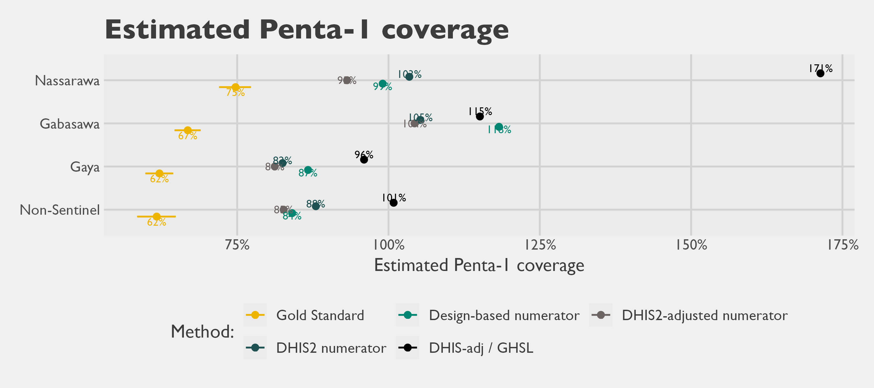
Figure 3.17: Estimated Penta-1 Coverage, ARR versus Gold Standard

Table
Table 3.26: Estimated Penta-1 Coverage, ARR versus Gold Standard
Stratum | Gold Standard | ARR variant #1 | ARR variant #2 | ARR variant #3 | ARR variant #4
Gabasawa | 66.8% | 118.3% | 105.2% | 104.3% | 115.1%
Gaya | 62.1% | 86.7% | 82.5% | 81.2% | 96.0%
Nassarawa | 74.7% | 99.0% | 103.4% | 93.2% | 171.4%
Non-Sentinel | 61.7% | 84.1% | 88.0% | 82.7% | 100.8%
All variants of the ARR approach overestimate Penta-1 coverage relative to the gold standard. Several estimates even exceed 100%, which is not meaningful for vaccine coverage but highlights a core limitation of the method: the numerator and denominator are constructed from different sources and can drift out of alignment. With only four strata it is difficult to assess whether the bias is systematic, although the discrepancy appears largest in Gabasawa. For zero-dose estimation, the implication is straightforward: an analogous administrative approach would likely understate zero-dose prevalence substantially, and in some cases could even yield implausible negative values.
Table 3.27 summarizes the agreement metrics for the ARR method when evaluated against the gold standard. It shows that the mean absolute difference between the gold standard and the ARR estimates range between 24 and 54 percentage points. On the whole, variant #3– which uses the regression based adjustment for the numerator along with a GRID3-based denominator– performs the best. However, the high magnitude of the differences between even the best method and the gold standard estimate call into question the utility of this method overall.
Table 3.27: Agreement metrics between Penta-1 prevalence estimates from the 2025 Gold Standard and the ARR method (evaluated on 4 strata estimates)
Administrative Method Variant | Number of estimates (strata) | Mean Signed Difference (Bias) | Mean Absolute Difference | Root Mean Square Error | Intraclass Correlation Coefficient (ICC)
variant #1 | 4 | 30.7 | 30.7 | 32.9 | -0.49
variant #2 | 4 | 28.4 | 28.4 | 29.2 | -0.52
variant #3 | 4 | 24.0 | 24.0 | 25.2 | -0.48
variant #4 | 4 | 54.5 | 54.5 | 59.9 | -0.37

3.5.4 Discussion
Pinpointing the source of error is not straightforward because discrepancies can arise from the numerator, the denominator, or both. Over-reporting of Penta-1 doses in facility registers is one plausible contributor.
Several additional sources of error could also be at play:
- Population denominators (GRID3): The GRID3 sex-age estimates likely introduce meaningful error because they apply state-level population ratios uniformly across LGAs. Our own analyses of LGA-specific birth dynamics show substantial variation in fertility across LGAs, implying that the number of children aged 12–23 months may be poorly estimated in some areas. In addition, the GRID3 estimates are based on 2022 data and carry the usual uncertainty from geospatial modeling.
- Incomplete DHIS2 reporting: Not all facilities report to DHIS2, particularly private facilities. However, the 2025 Kano HFC suggests immunization is predominantly delivered through the public sector. While some immunizing facilities may still be missing from DHIS2, the scale of this gap for immunization appears limited. Note also that incomplete DHIS2 reporting would, if anything, shrink the numerator and so cannot explain over-estimation of coverage relative to the gold standard — it would only make the discrepancy larger if reporting were more complete.
- Political and administrative incentives: Over-reporting in registers is possible, including in response to performance pressures. In constructing our numerator, we treated the register audit counts as the best available reference and assumed they reflected true doses delivered. That assumption may be too strong. With the data available in this study, we cannot independently verify whether what we observed in the registers is accurate, as opposed to being affected by recording practices or intentional inflation. Establishing the validity of register entries would require a different validation approach (for example, client-level verification or an independent tracing method). This was beyond the scope of this study.
- Outreach and supplementary activities: Doses delivered to children in the facility’s catchment through outreach sessions or supplementary immunization activities may also be entered into routine facility registers without being clearly separated from routine, fixed-post service delivery. To the extent that the audit counts include these doses, the numerator captures a broader set of events than the routine Penta 1 deliveries the rate is intended to reflect. Other recording artifacts — for example, vials drawn from facility stocks for outreach or campaign use being counted as delivered even when some are not subsequently administered to a child — are unlikely to be major mechanisms in this study because a child-level immunization register was present and accessible at virtually every audited facility (Table 3.23). Inflation of the numerator through entries that do not correspond to a specific named child would therefore have to take the form of deliberate over-reporting, which is discussed under “Political and administrative incentives” above.
- Cross-LGA vaccination: Some children may be vaccinated outside their LGA of residence. Long-distance travel is unlikely given the widespread availability of services, but cross-border use near LGA boundaries is plausible. For example, Nassarawa could attract clients from nearby densely populated areas.
The most plausible explanation is a combination of these factors rather than a single dominant failure point. Overall, these results are consistent with broader experience in the literature: ARR-based coverage estimates can be unstable. In our setting, the differences from the gold standard are large enough that the ARR approach is not suitable for decision-making.

3.5.5 Recommendations
Based on the evidence from this study, we recommend avoiding administrative-based coverage estimation as a standalone method, particularly for fine-grained reporting such as the LGA level.
That guidance reflects the current state of routine data systems rather than a permanent ceiling on the method. Two complementary steps would strengthen those systems and, over time, narrow the gap between administrative and survey-based estimates.
- Follow up with facilities and LGA data officers on register–DHIS2 discrepancies. The numerator analyses in this chapter show meaningful differences between audited facility register counts and the DHIS2 totals reported for the same period. Those divergences can arise from incomplete monthly summary submissions, transcription error, aggregation rules applied at the LGA health office, or genuine gaps between what is delivered and what is reported up the chain. Targeted follow-up with the facilities and LGA data officers responsible for compiling and uploading these counts is the most direct way to learn which of these mechanisms dominate in a given setting and to design corrective action accordingly. Without that diagnostic step, the source of the divergence remains ambiguous and the same gap is likely to recur in the next reporting cycle.
- Adopt routinized data audits to shift incentives toward accurate reporting. With the data available in this study, we could not independently verify whether the register entries reflect doses actually delivered, as opposed to recording artifacts or inflation in response to performance pressures. Register audits are the natural starting point because they sit closest to the point of service delivery, but the same routine cycle can extend upward to monthly summary forms and DHIS2 entries to address the broader reporting pipeline. Building such audits into the routine supervisory cycle, rather than treating them as one-off research exercises, would help confirm dose counts against the children recorded in the register and surface systematic over- or under-reporting at higher reporting tiers. Over time, a credible expectation that entries will be checked is itself the mechanism by which audits improve data quality, and it is among the more direct levers available to programs that wish to use administrative data for decision-making.

3.5.6 Conclusions
In our analysis, ARR variants consistently overestimated Penta-1 coverage relative to the gold standard, and this pattern aligns with findings reported by other researchers. We also tested three refinements intended to address known failure points in administrative estimation: (i) down-calibrating the reported numerator to align with register audit findings, (ii) replacing traditional denominators with geospatial population estimates, and (iii) cross-checking and adjusting reported numerators using totals from the health facility census. None of these modifications materially improved performance. Even after these adjustments, ARR-based estimates remained substantially inflated and, in some strata, implausible. The magnitude of the discrepancies is large enough that ARR outputs should not be used for operational decisions without additional validation.
That said, there may be pathways to make administrative approaches more useful, but we have not evaluated them in depth. One option would be to apply a bias adjustment (for example, scaling ARR estimates by a multiplicative correction factor) if the bias were stable. However, stability is not guaranteed: bias can vary across geographies and over time as population dynamics shift and record quality improves or deteriorates with changing levels of scrutiny. Any credible correction would therefore require periodic re-estimation using recent reference data. This undermines the main appeal of administrative methods as a low-cost, rapid desk exercise, and the required validation effort may be prohibitively expensive.
A second option is to explore whether alternative DHIS2 metrics can provide a more reliable proxy for denominators. Measures such as infant outpatient counts, deliveries, or other service-utilization indicators could potentially be used to construct facility-level or LGA-level ratios that track coverage more closely than current ARR denominators. This would require empirical testing to identify robust correlates and to assess sensitivity to changes in service-seeking behavior and reporting completeness.
Third, even imperfect administrative ratios may still be valuable when used as auxiliary information to strengthen probability surveys, rather than as a replacement. For example, administrative indicators could be used to classify areas into coarse “high/medium/low” strata for sample design, improving precision if those rankings are approximately correct. More formally, such indicators can be incorporated through calibration or ratio estimation in a model-assisted framework, which can improve efficiency while preserving design-based properties even when auxiliary measures are noisy.
Finally, it may be worth revisiting ARR-style methods after Nigeria’s next population census. Many geospatial raster denominators are ultimately calibrated to government population totals. A new census would provide a stronger benchmark for those calibration steps and could materially improve the accuracy of modeled age-sex population surfaces. If denominator accuracy improves meaningfully, administrative approaches that currently perform poorly may become more viable, especially when combined with targeted validation.

3.5.7 Geospatial Estimation
The preceding analysis makes clear that ARR-based methods, even with refined numerators and geospatial denominators, fall short as tools for real-time estimation of current Penta-1 coverage. However, real-time prevalence estimation is not the only use case that motivates geospatial and administrative approaches. A distinct and practical need is small-area estimation: producing LGA-level coverage estimates where none exist in official sources. This challenge is not hypothetical — in designing the sampling frame for the present study, we had no reliable LGA-level estimate of zero-dose prevalence to draw on. Geospatial modelled surfaces offer one solution. Unlike ARR, which requires recent facility records as a numerator, a modelled prevalence raster derived from household survey data can be spatially aggregated to any sub-national boundary, yielding plausible small-area estimates for planning purposes even in the absence of administrative data. The central limitation is that such surfaces are fixed-time snapshots: the surface we use below reflects conditions as of 2018 and cannot capture trends since then.

3.5.7.1 NDHS modeled layer
The following analysis takes a different angle on the geospatial data introduced above. Instead of using population surfaces as denominators within an administrative framework, we ask whether a gridded modelled prevalence surface — spatially weighted by population — can produce credible LGA-level coverage estimates without relying on DHIS2 or facility registers at all.
We estimate LGA-level Penta-1 vaccination prevalence by combining two geospatial sources of data:
- A gridded NDHS 2018 modeled surface of DPT-1 prevalence (Spatial Data Repository and The Demographic and Health Surveys Program n.d.); and
- A gridded population surface.
The modeled surface is shown in Figure 3.18.
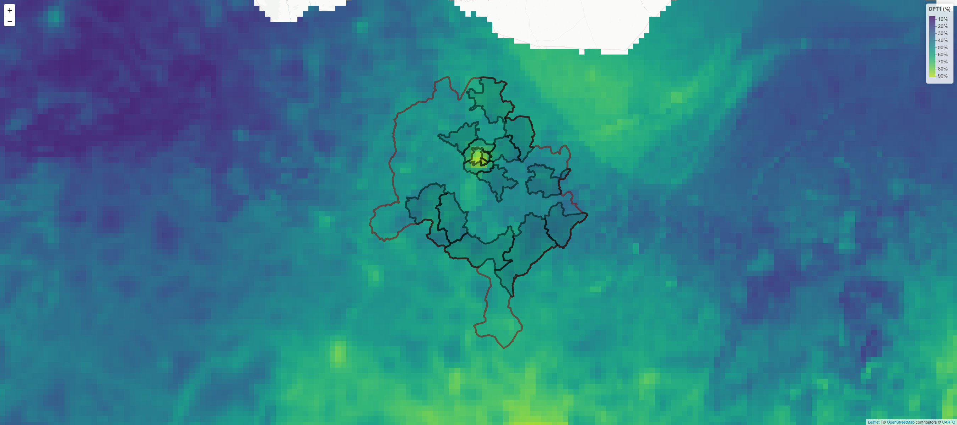
Figure 3.18: NDHS modeled Penta-1 coverage (2018)
For this analysis, we are using the GRID3 estimate of the U1 population as a proxy for the 12-23 month population (Nnanatu et al. 2025). However, several other open-source population surfaces exist that could be used for this purpose, such as data from the GHSL. As described in the supporting GRID3 documentation, their U1 population within any State is estimated by applying a fixed population ratio from 2022 to the overall geospatial population estimate. This means we could have chosen to use a raster layer for the full population and achieved the same results, since the relative weighting scheme will be the same.
The NDHS surface provides an areal model-based estimate of prevalence for each raster cell, while the GRID3 raster provides a spatially detailed distribution of the population at risk. Because the population raster is substantially higher resolution than the NDHS surface, the GRID3 layer is used to weight the NDHS prevalence spatially within each LGA, yielding an LGA-level prevalence that reflects where children actually live within the LGA rather than treating the LGA as uniformly populated.
Before aggregation, the two rasters are made spatially compatible. In practice this means ensuring a consistent Coordinate Reference System (CRS), cell alignment, and extent over the area of interest. Since the NDHS modeled surface is coarser, the analysis is anchored to a common grid so that each location has both a prevalence value and a population weight. This can be implemented either by resampling one raster to the resolution of the other (often bringing the prevalence surface onto the finer GRID3 grid) or by projecting both to a shared intermediate grid. The key requirement is that, for each analysis cell, the modeled prevalence and the population weight refer to the same geographic footprint.
Let $p\left(s\right)∈\left[0,1\right]$ denote the modeled DPT-1 prevalence at location $s$, and let $w\left(s\right)≥0$ denote the population (children under 1) at the same location. For an LGA $A$ (or any defined polygonal region), the population-weighted mean prevalence is defined as
PA = A​ps ws dsA​ws ds
Intuitively, ${\hat{P}}_{A}$ averages the modeled prevalence surface over the LGA while giving more influence to locations with more children. On a geospatial raster grid, this becomes a discrete weighted mean. Index grid cells by $i=1,…,n_{A}$ that fall within LGA $A$. Let $p_{i}$ be the NDHS modeled prevalence in cell $i$, and $w_{i}$ the GRID3 population in cell $i$. Then
PA = i∈A​pi wii∈A​wi.
Different approaches can be devised for handling cells that partially overlap the LGA boundary. With a sufficiently fine-grained raster, it can be reasonable to retain only those cells that have a majority of their surface area in the given LGA of interest. For coarser rasters, an area-fraction term could be included to avoid boundary bias.
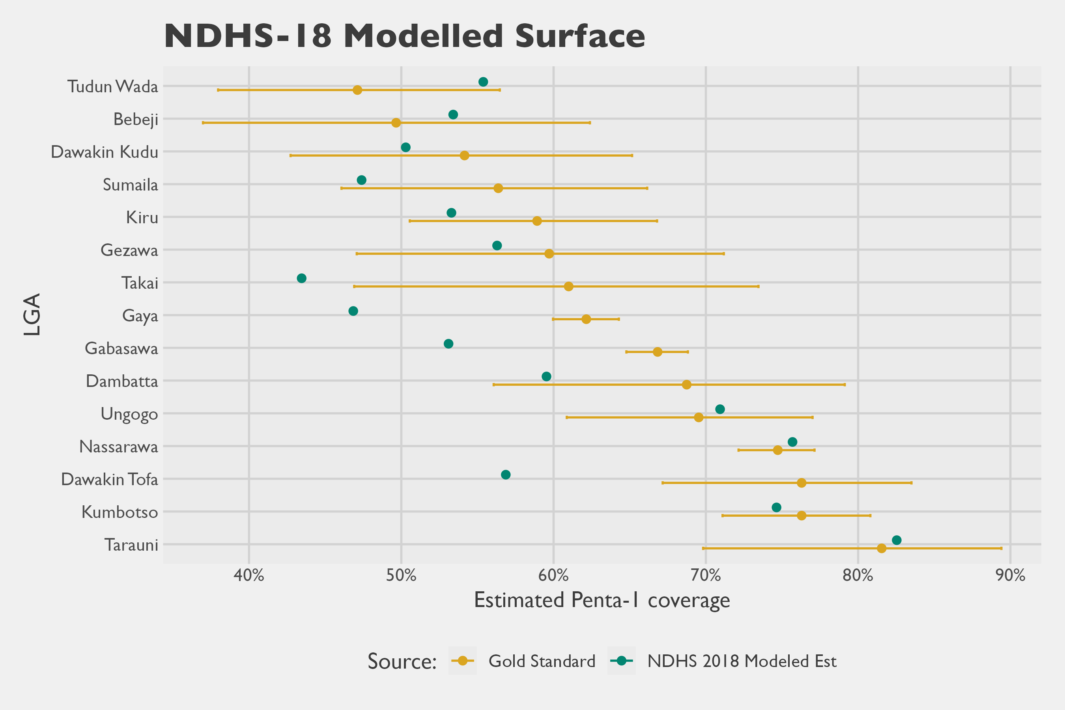
Figure 3.19: Penta-1 Coverage Estimates, Gold Standard vs. modelled NDHS geospatial estimate
The modelers of the NDHS 2018 layers estimated that the DPT-1 estimates had 20% Mean Absolute Error (MAE), as assessed through four-fold cross validation. Using the 15 LGA data points and comparing them to our Gold Standard survey, we calculate an analogous Mean Absolute Difference (MAD) of 7.0% between the estimates.
Table 3.28: Agreement metrics between Penta-1 prevalence estimates from the 2025 Gold Standard and the 2018 NDHS modeled surface (evaluated on 15 LGA-level estimates)
Metric | Estimate | 95% CI
Mean Signed Difference (Bias) | 0.046 | (0.046; 0.087)
Mean Absolute Difference | 0.070 | (0.066; 0.1)
Root Mean Square Error | 0.089 | (0.086; 0.124)
Intraclass Correlation Coefficient (ICC) | 0.728 | (0.374; 0.899)

3.6 Rapid Convenience Monitoring

3.6.1 Overview
RCM is a fast, field-based, non-probability sampling method traditionally used to assess mass vaccination campaign coverage and quality in real-time. Within campaign activities, it is designed to allow vaccination teams to quickly identify missing children and areas requiring follow-up or mop-up action, investigate causes and quickly correct them (World Health Organization 2024). Rather than a random sample, RCM collects information about children’s vaccination status by visiting a convenience sample of households or community spots (e.g., schools, health facilities), typically having enumerators follow a pseudo-random walk from one household to the next. Ordinarily, it also creates an opportunity to refer un-immunized and under-immunized children for vaccination, or immunize them directly on-site.
For this assessment, Mindset followed the RCM methodology as set out in the WHO guidance (World Health Organization 2024). Their template RCM survey instrument is designed to also investigate the reasons why children are not vaccinated or why they missed doses, capturing insights into how caregivers think and feel about vaccination, how social processes influence vaccination decisions, and the practical constraints that affect access and follow-through. Finally, it also collects information on the quality of vaccination records, drawing on what is available in households (e.g., vaccination cards, finger marks) and, where the household can be linked to a health facility, the corresponding vaccination registries.
The WHO guidance is explicit that RCM is a non-probability approach not intended to support statistical population inference, though it does include analysis templates and tools where the proportions of vaccinated and unvaccinated children are tabulated. While the guidance cautions against using RCM as a prevalence-estimation tool, implicit is a claim the data collected in RCM is still broadly informative and useful for decision-making. This creates a tension in interpretation: the guidance appropriately limits inferential claims, yet the standard outputs are naturally read as proportions that summarize conditions beyond the specific households visited. In this head-to-head comparison, we take a pragmatic position that RCM proportions can be treated as at least approximately informative about a defined target area, and we therefore use prevalence as the basis for comparison across methods. Indeed, vaccination prevalence is the primary shared quantity that anchors the entire head-to-head report, and it would be difficult to assess RCM against other methods without a focus on the proportions calculated with RCM data.

3.6.2 Implementation Details

3.6.2.1 RCM Site Selection
As part of the agreed study scope with the GF, resources were allocated for eight RCMs. Sites were selected by drawing a random sample of two health facility catchment areas in each of four strata: Gaya, Gabasawa, Nassarawa, and the non-sentinel stratum. The sampling frame was provided by government counterparts and was intended to reflect settlements believed to have higher numbers of zero-dose children. This focus is consistent with the WHO guidance (2024), which recommends conducting RCM in areas that are difficult to vaccinate due to supply-side barriers (e.g., geography, mobility, conflict, weak service delivery) and demand-side barriers (e.g., distrust, beliefs, low awareness, poverty, time constraints, gender-related barriers). This site-selection step was treated as distinct from the within-site household selection mechanism used during fieldwork.
Site selection drew on zero-dose settlement data from the 2023 LGA database — a state-curated list of settlements flagged by LGA immunization officers as having concentrations of zero-dose children based on routine programmatic monitoring — and a settlement-to-catchment linkage dataset provided with support from the Kano State Primary Health Care Management Board (SPHCMB). The workflow proceeded in four stages:
- Compile the list of zero-dose settlements across the four survey areas;
- Draw a stratified SRS of eight settlements (two per stratum);
- Reconcile selected settlement names to a dataset of catchment areas associated to health facilities, using fuzzy matching; and
- Identify the corresponding facilities, replacing any duplicates with the next randomly drawn settlement.
This produced a final sample of eight unique facilities within Kano State in areas considered likely to have higher zero-dose prevalence. Figure 3.20 shows the LGAs and wards targeted by RCM, and all the wards included in the multistage cluster survey. The final selection of RCMs included settlements in eight administrative wards (Joda, Zugachi, Balan, Kazurawa, Dakata, Hotoro South, Dansoshiya, and Chalawa) across five LGAs (Gabasawa, Gaya, Nassarawa, Kiru, and Kumbotso).
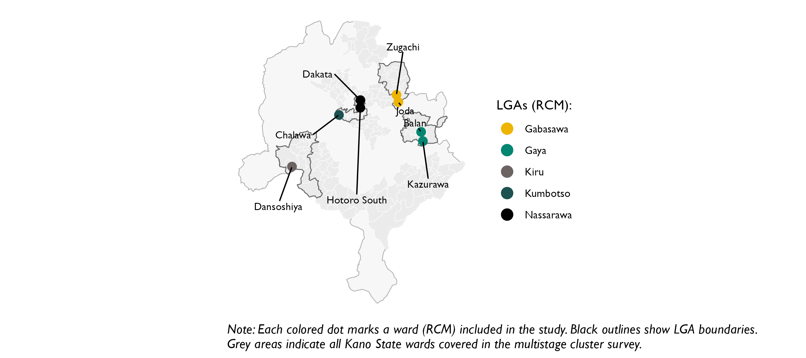
Figure 3.20: LGAs and wards targeted by the RCM study

3.6.2.2 Household Selection
As for most other methods, the operational indicator used to monitor zero-dose children was coverage for the first dose of a Pentavalent (Penta)-1 vaccine (a DPT-containing vaccine). Field teams visited each selected facility to verify the catchment settlements identified as zero-dose. After verification, teams conducted household surveys within those settlements.
Following the WHO guidance recommendation of a 20-child target per RCM (2024), each RCM aimed to enroll 20 children. While the guidance recommends targeting children aged 6–23 months, we applied the same 20-child target to children aged 12–23 months to align with the age group used for indicator calculation in the other methods. This yielded a total sample of 160 children across the eight areas. Household selection was implemented as a pseudo-random systematic walk from a random start point, going house to house until the fixed target of eligible children was achieved. If a specific household was already included in another method, such as the main gold-standard sample, that household was skipped by the RCM field team (but included in the RCM analysis using the data collected from the gold-standard team). In practice, this method concentrated the RCM data along a single route through one contiguous segment of the selected settlement or catchment.

3.6.2.3 Geographic Boundary Definition
Although the WHO guidance encourages implementers to define the target population, it frames this primarily in terms of age eligibility, with little explicit guidance on the geographic bounds over which an RCM result should be interpreted (2024). Later, the document implicitly anchors implementation to geography by noting that at least one RCM should be conducted per health facility and that planning is typically organized around the facility catchment area. In our experience, however, catchment boundaries for health facilities are often fuzzy, overlapping, or simply undocumented, and the implied geographic footprint of an RCM is not necessarily a standard administrative unit such as a ward or LGA. This ambiguity matters for comparability: in a head-to-head evaluation, a central methodological question is how to define an apples-to-apples comparison area for RCM against gold-standard estimates when the intended geographic footprint of inference is not clearly specified.
Even if the guidance does not specify geographic bounds, we can define an explicit comparison boundary for this study to support a meaningful head-to-head assessment. The gold-standard survey used a multistage probability design that–for most LGAs–distributed interviews broadly across ward geography. This coverage allows us to subset the gold-standard data to match a chosen comparison boundary, whether at the LGA level, ward level, or another defined area. In the maps below, we show how the RCM household locations (in green) compared to the gold standard’s household locations (in yellow) for each of the eight wards visited (ward boundaries in blue). The maps show that the area visited by the RCM generally represented a much smaller area than the entire ward. By comparison, the gold standard data collection generally canvassed the entire administrative area. The exception is for non-sentinel LGAs, where the smaller the gold standard method allocated a small sample size of EAs, resulting in a map that clearly shows area within the ward never visited by the field teams. To reduce the risk of identifying specific households, the point locations shown below are randomly displaced by roughly 100 meters for display only.

Gabasawa LGA

Joda Ward
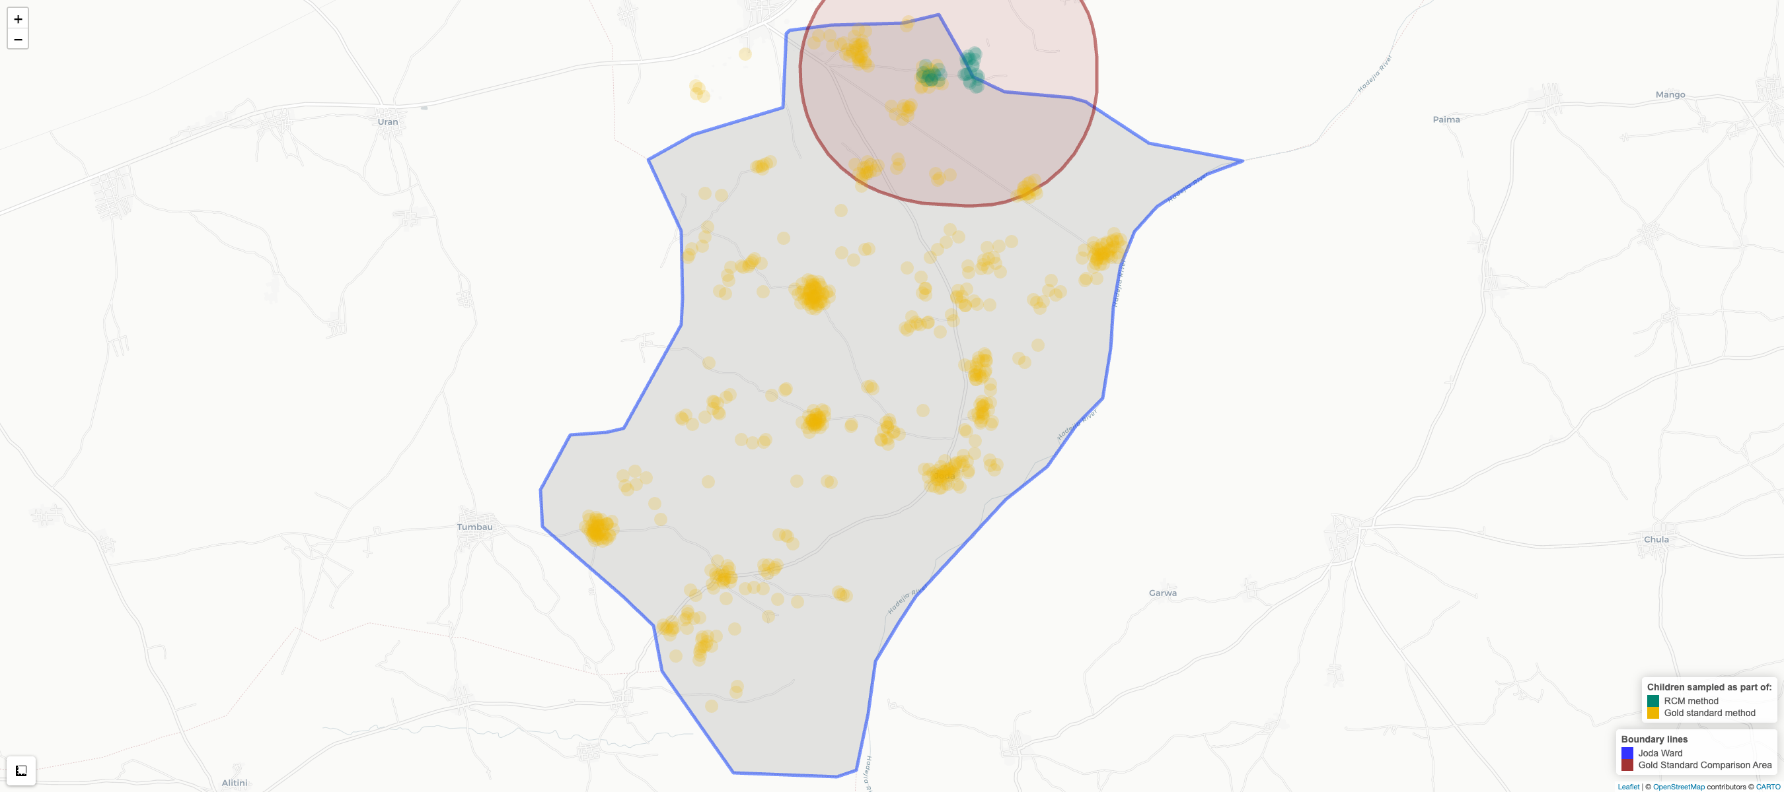
Figure 3.21: Children sampled in Joda ward, by survey method

Zugachi Ward
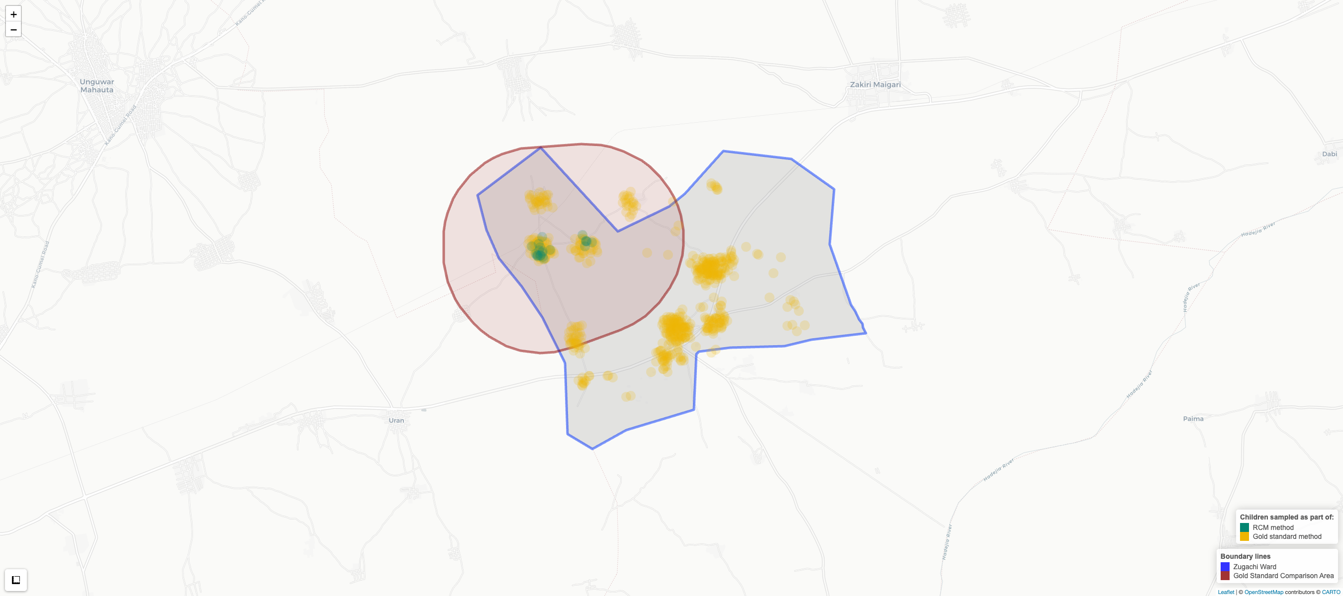
Figure 3.22: Children sampled in Zugachi ward, by survey method

Gaya LGA

Balan Ward
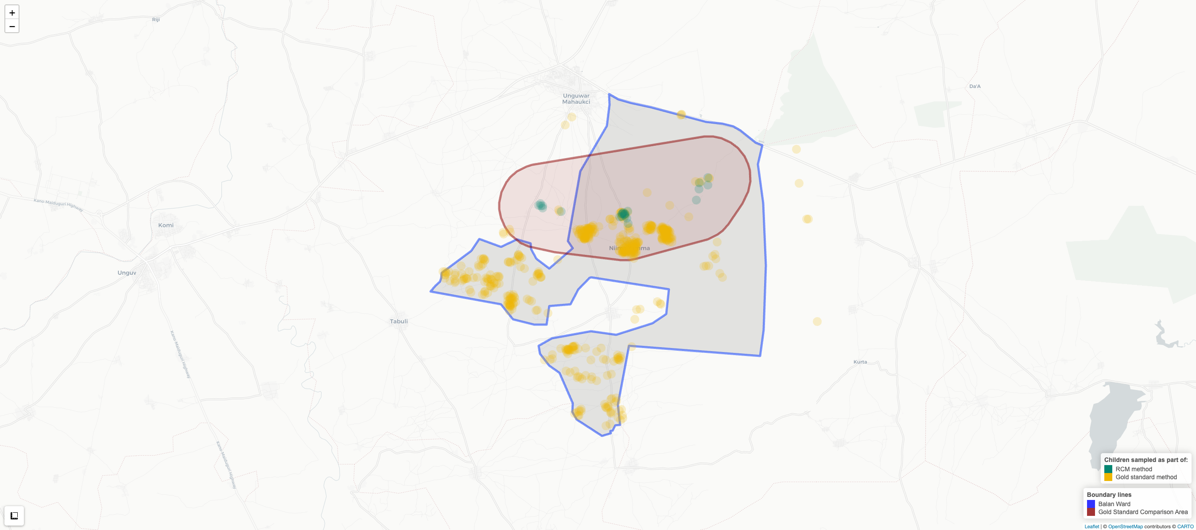
Figure 3.23: Children sampled in Balan ward, by survey method

Kazurawa Ward
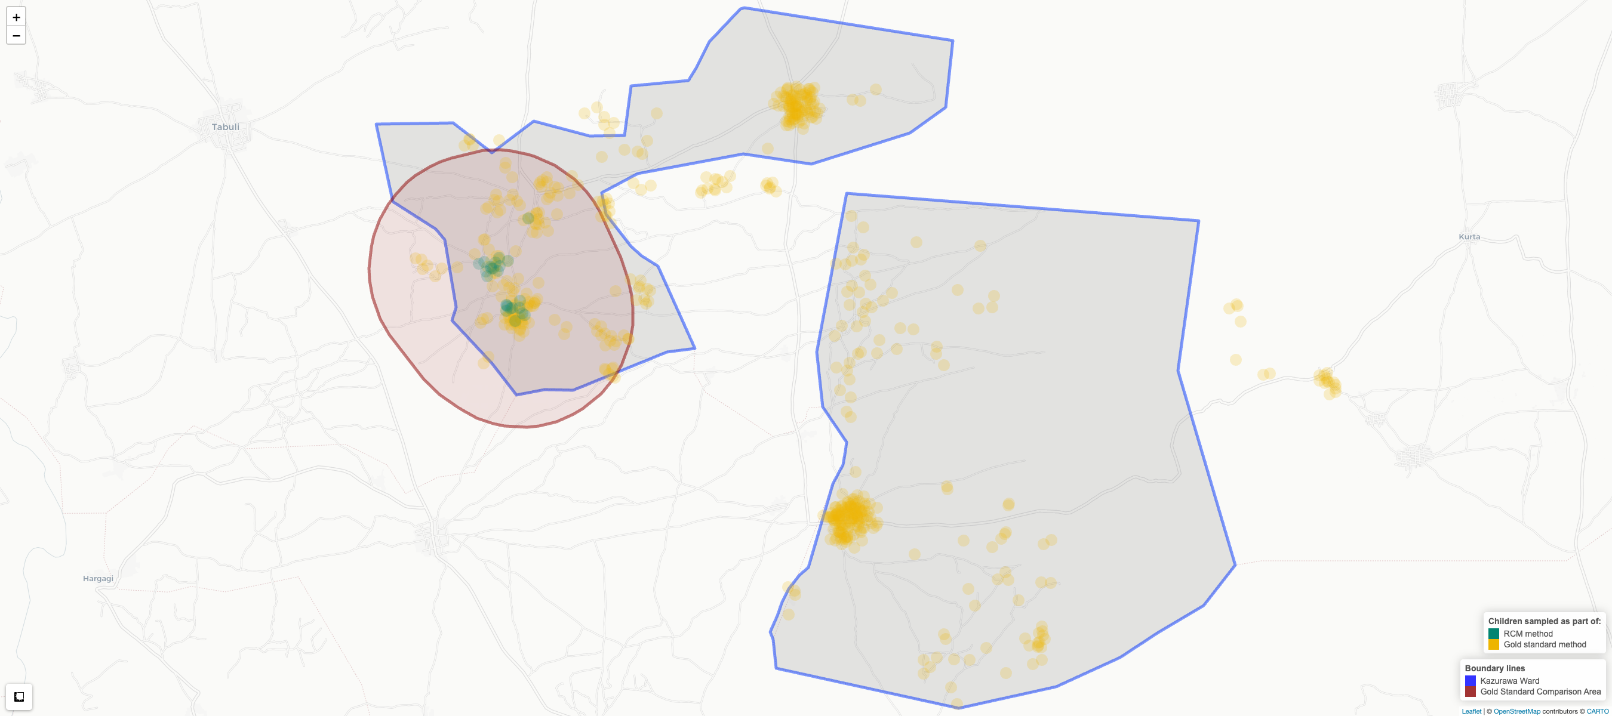
Figure 3.24: Children sampled in Kazurawa ward, by survey method

Nassarawa LGA

Dakata Ward
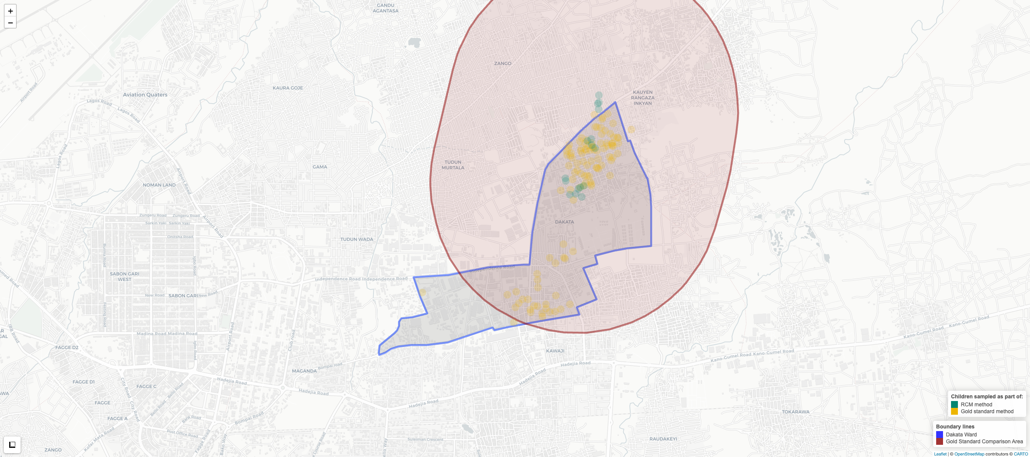
Figure 3.25: Children sampled in Dakata ward, by survey method

Hotoro South Ward
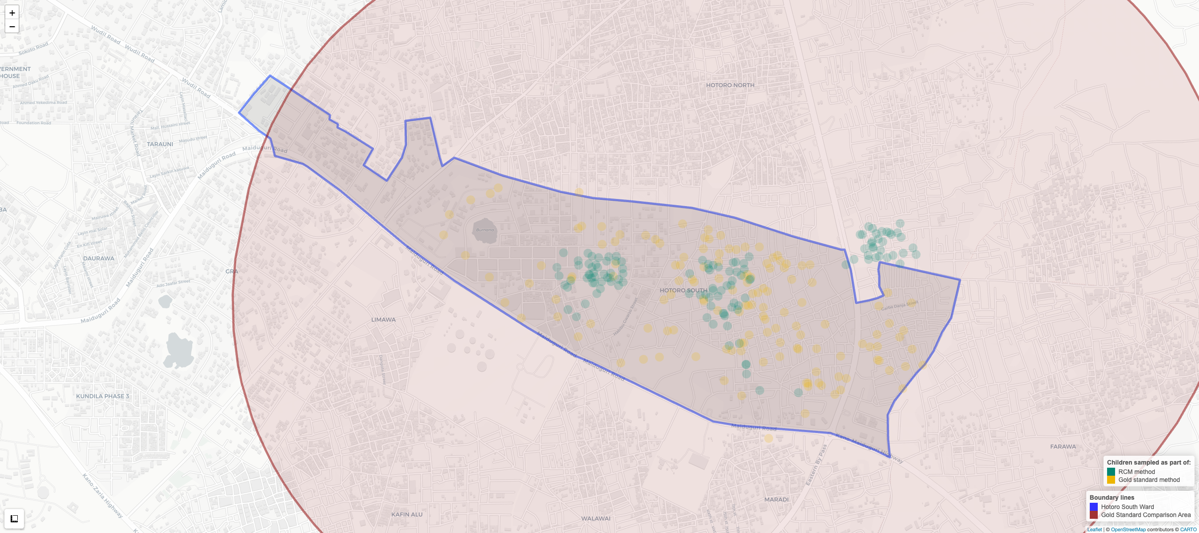
Figure 3.26: Children sampled in Hotoro South ward, by survey method

Non-Sentinel LGAs

Chalawa Ward
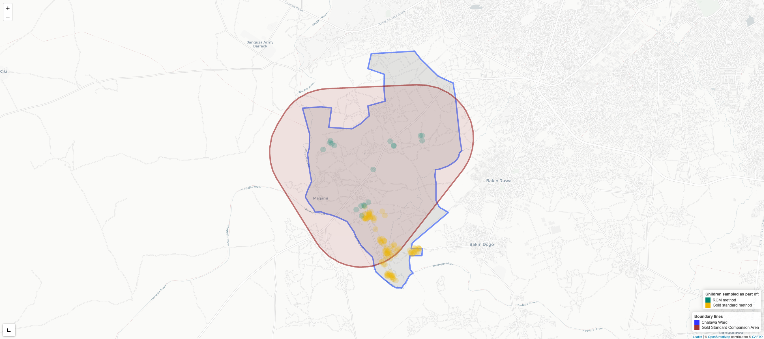
Figure 3.27: Children sampled in Chalawa ward, by survey method

Dansoshiya Ward
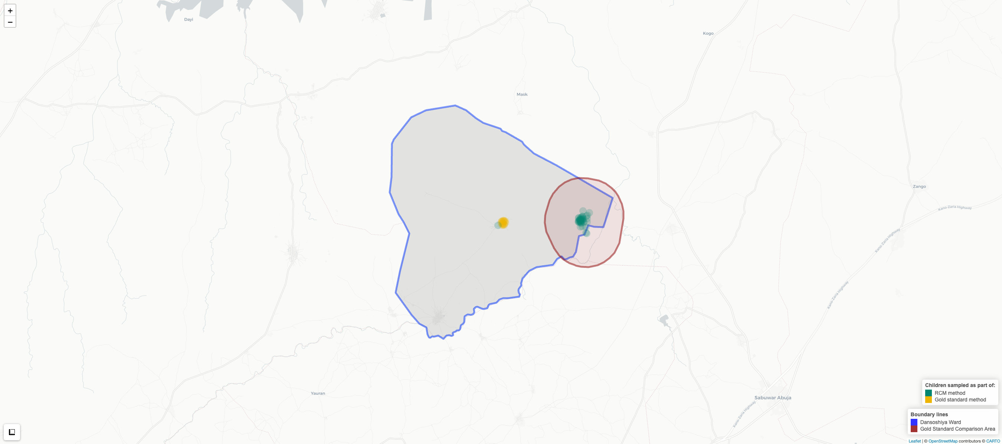
Figure 3.28: Children sampled in Dansoshiya ward, by survey method
From the maps, we can see that direct comparison of ward-level estimates is probably not appropriate. The RCM walk typically traverses a localized segment of a ward along one contiguous path, whereas the gold standard is calculated over the full ward (see Table 3.1 for the precision achievable under probability survey designs at ward and LGA level). Another boundary definition is therefore needed– one that is more suited to the intended catchment area covered by the RCM data collection.
To make the comparison as defensible as possible given these constraints, we therefore backed into an operational definition of the area covered by RCM. Specifically, we compared RCM results to gold-standard data drawn from within a 1.75 km buffer of the observed pseudo-random walk, rather than treating RCM as representative of the full administrative ward. This buffered comparison area is shown with red lines in the maps above. The approach assumes that the catchment is reasonably approximated by the area covered by the RCM pseudo-random walk, an assumption we revisit later.
In the sentinel LGAs, the buffer approach manages to select between 166 and 652 children per area. Because the gold-standard fieldwork achieved near-complete spatial coverage in those LGAs, we generally had sufficient observations to compare outcomes within almost any plausible RCM area of inference, including the specific neighborhoods traversed by the walk. In the non-sentinel areas, however, the sampling fraction was much smaller and the clustered sample resulted in much patchier spatial coverage. As a result, Figure 3.27 and Figure 3.28 show that RCM walks in those areas often occurred in locations that did not overlap with the gold-standard clusters, meaning the two methods were frequently sampling different parts of the ward. When selecting a gold-standard comparison group for those areas, instead of using the same 1.75 km buffer approach, we took the two nearest available EAs. This resulted in comparison cases further than 1.75 km apart. For this reason, for non-sentinel LGA, discrepancies in methods may simply reflect geographic differences in vaccination patterns as much as they reflect methodological differences.
Table 3.29: Maximum distance between visited households along each RCM walk
RCM | Diameter | Path Distance | Date of First  Interview | Date of Final  Interview | Number of Days
Balan | 7,191 [m] | 11,964 [m] | 2025-06-25 | 2025-07-04 | 4
Chalawa | 3,262 [m] | 7,927 [m] | 2025-06-25 | 2025-06-28 | 3
Dakata | 1,083 [m] | 1,616 [m] | 2025-06-25 | 2025-06-28 | 4
Dansoshiya | 1,006 [m] | 3,224 [m] | 2025-06-25 | 2025-06-28 | 3
Hotoro South | 1,780 [m] | 3,594 [m] | 2025-06-25 | 2025-06-29 | 4
Joda | 720 [m] | 1,951 [m] | 2025-06-25 | 2025-07-04 | 4
Kazurawa | 984 [m] | 2,636 [m] | 2025-06-25 | 2025-06-28 | 3
Zugachi | 1,046 [m] | 3,566 [m] | 2025-06-25 | 2025-06-28 | 3
Table 3.29 summarizes the spatial scale of each RCM walk. The walk’s diameter captures how far apart the two most distant visited households were, and indicates that the typical (median) walk covered a footprint with an end-to-end span of 1065 meters. The path distance is the cumulative geodesic distance between successive visited households and serves as an approximation of the total distance travelled; the median path length was 3395 meters. Balan and Chalawa are notable outliers, reflecting longer movements between distinct housing clusters. Finally, the timing columns show that none of the eight RCMs were completed in a single day: fieldwork for each walk spanned 3–4 days.

3.6.3 Results

3.6.3.1 Zero-Dose Prevalence
Figure 3.29 presents the zero-dose prevalence results obtained across the eight locations under the RCM method, compared against the analogous results for buffered comparison area from the gold standard survey. The plot shows that while the estimates are generally close for most areas, there are some stark differences. Dansoshiya is the most extreme example: RCM recorded all sampled children as zero-dose while the gold-standard estimate in the same ward is substantially lower (33%). In Kazurawa, the difference is less pronounced but still apparent: 5% (RCM) vs 27.9% (gold standard).
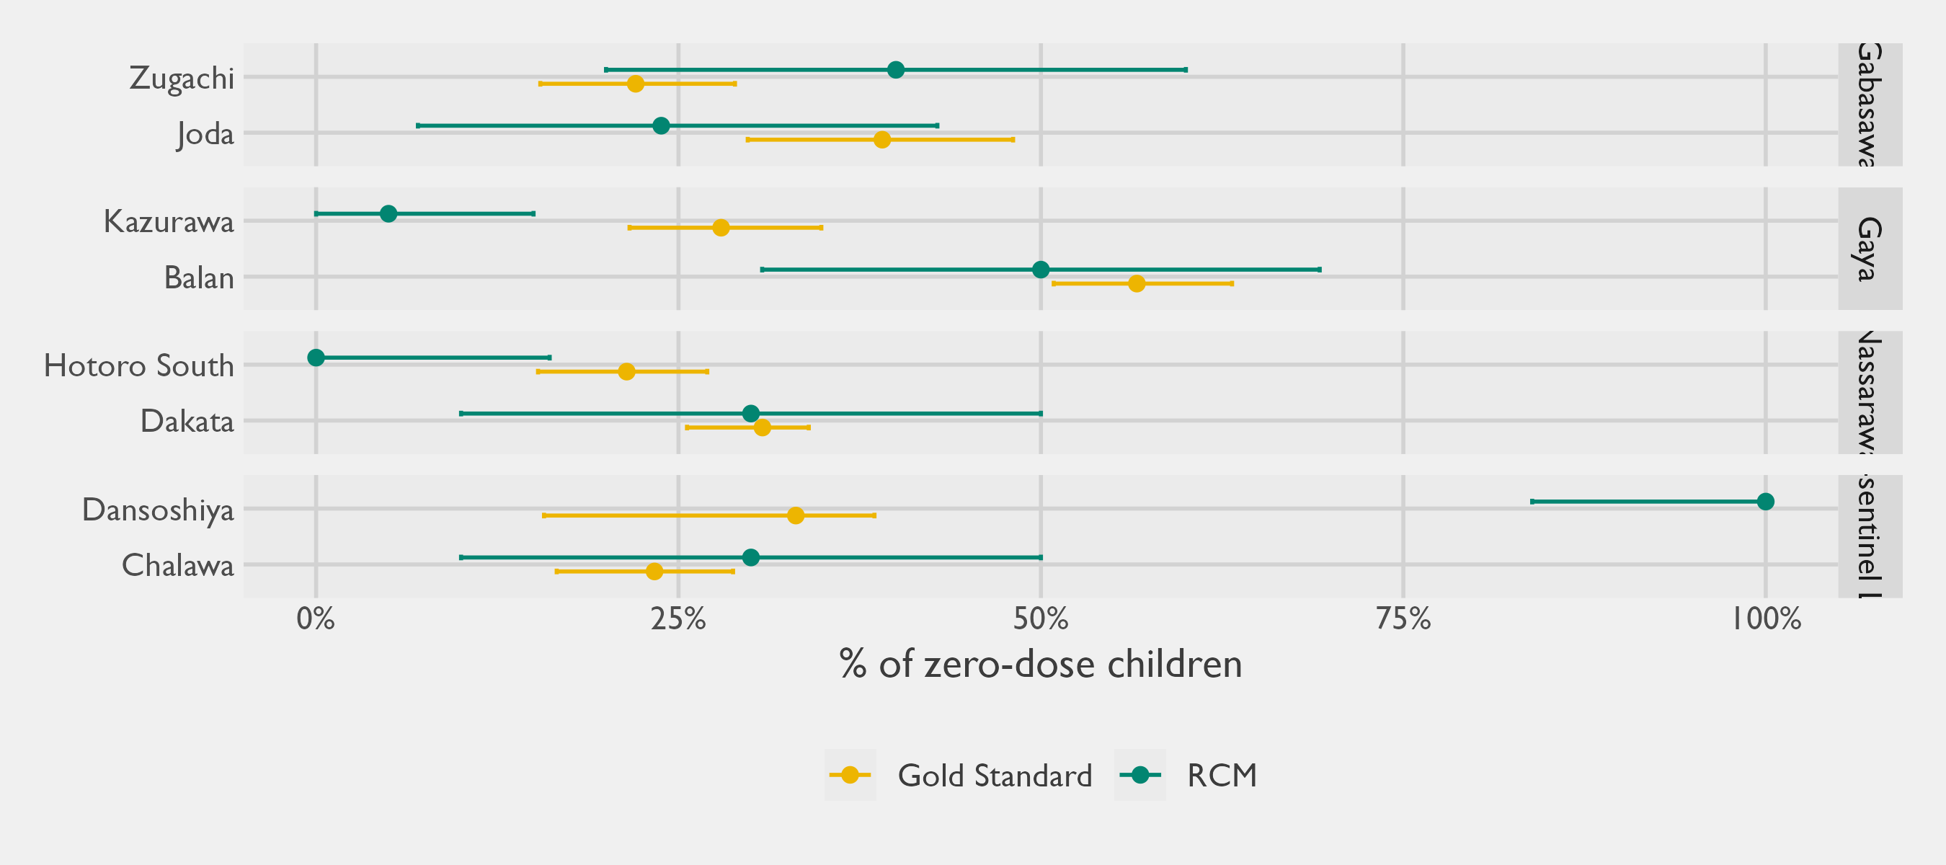
Figure 3.29: Percentage of zero-dose children, by sampling methodology
Table 3.30 presents the same information in tabular format, along with additional statistical information such as sample sizes, CIs, and statistical tests. By design, sample sizes were fixed at 20 children under RCM (with some variability), whereas gold standard sample sizes were determined by the size of the comparison zones, typically ranging from 78 to 652 children. Due to these sample size differences between methods, whereas the gold-standard CIs are modest, we would expect the uncertainty around the RCM estimates to be very wide.
Table 3.30: Zero-dose prevalence estimates under the RCM and gold standard methods
Stratum | RCM | ZDC | # | RCM sample percent zero-dose (95% CI)ª | # | Gold standard sample percent zero-dose (95% CI)^{b} | Absolute difference in percent zero-dose (95% CI) | P-value for difference | Adjusted p-value^{c}
Gabasawa | Zugachi | 8 | 20 | 40.0% (20.0; 60.0) | 217 | 22.0% (15.5; 28.9) | 18.5% (1.3; 39.0) | p=0.046 | p=0.092
Gabasawa | Joda | 5 | 21 | 23.8% (7.0; 42.9) | 166 | 39.1% (29.8; 48.1) | 15.7% (0.8; 34.8) | p=0.104 | p=0.166
Gaya | Balan | 13 | 26 | 50.0% (30.8; 69.2) | 335 | 56.6% (50.9; 63.2) | 10.2% (0.6; 28.2) | p=0.232 | p=0.309
Gaya | Kazurawa | 1 | 20 | 5.0% (0.0; 15.0) | 177 | 27.9% (21.6; 34.9) | 23.4% (9.8; 33.9) | p=0.004 | p=0.011
Nassarawa | Dakata | 6 | 20 | 30.0% (10.0; 50.0) | 410 | 30.8% (25.6; 34.0) | 8.3% (0.3; 23.7) | p=0.480 | p=0.480
Nassarawa | Hotoro South | 0 | 20 | 0.0% (0.0; 16.1) | 652 | 21.4% (15.3; 27.0) | 21.6% (15.3; 27.0) | p<0.001 | p<0.001
Non-sentinel LGAs | Dansoshiya | 20 | 20 | 100.0% (83.9; 100.0) | 78 | 33.1% (15.7; 38.5) | 69.8% (61.5; 84.3) | p<0.001 | p<0.001
Non-sentinel LGAs | Chalawa | 6 | 20 | 30.0% (10.0; 50.0) | 87 | 23.3% (16.6; 28.8) | 10.4% (0.7; 28.9) | p=0.272 | p=0.311
ªProportion of Penta-1 unvaccinated children out of all eligible infants found in the RCM study. 95% CIs are calculated using bootstrap percentiles, with the exception of Dansoshiya (20/20) and Hotoro South (0/20), where Wilson Score intervals are presented instead (due to the lack of variability in the data).
^{b}Proportion of Penta-1 unvaccinated children out of all eligible infants found in the gold-standard study. 95% CIs are calculated based on the multistage random cluster survey, which adjusts standard errors based on the cluster design.
^{c}The adjusted p-value makes an adjustment to control the False Discovery Rate (FDR) that can arise from repeated testing.
Abbreviations: CI = Confidence Interval; RCM = Rapid Convenience Monitoring; ZDC = Zero-dose children
Although RCM is billed as non-probabilistic, we present approximate 95% CIs in Table 3.30 by treating the RCM data as though it was a SRS. While this assumption is unlikely to hold in practice and may be generous, it provides a rough benchmark for the sampling variability that would be expected under an idealized best-case scenario for RCM. This simplifying assumption also allows us to statistically test for differences between the gold standard results and the RCM, the results of which are presented in the adjusted $p$-value column of Table 3.30. This represents the probability of observing a difference in proportions between the methods at least as large in magnitude as that observed in the data, if indeed these methods are independently measuring the same quantity. By convention, values below 0.05 signal that something other than random chance is at play, and we can narrow-in on locations where the adjusted $p$-value is below 0.05 as areas that merit closer attention. This approach singles out Dansoshiya, Hotoro South, and Kazurawa.
In Hotoro South, the RCM walk found no zero-dose children at all (0 out of 20), whereas the gold-standard estimate for the buffered comparison area was 21%. Because the RCM walk covers only a narrow corridor, the most likely explanation is that the walk happened to traverse a pocket with uniformly high vaccination uptake, while the broader comparison area—which extends well beyond the walked path—includes pockets with lower coverage. This is consistent with the spatial heterogeneity observed in other walks and underscores how sensitive RCM results are to the specific route taken.
In the case of Dansoshiya, Figure 3.28 already revealed to us that the areas canvassed under each method were non-overlapping and modestly distant from one another. Whereas the gold standard randomly picked only an EA in the urban municipality of Dansoshiya itself, the Dansoshiya RCM concentrated the walk in the rural, Easternmost part of the ward. Consistent with statewide patterns in Kano, where vaccination coverage is generally higher in urban areas, the gold-standard estimate from the urban municipality would be expected to show a lower zero-dose prevalence than the RCM estimate drawn from a more rural part of the ward. In the case of Dansoshiya, therefore, the difference appears to be largely explained by the fact that the areas compared are physically separated and capture different urban/rural dynamics.
Our probe into Kazurawa must go deeper. By plotting our RCM results against a geospatial estimate of the (Penta-1) zero dose prevalence, we can visually compare how the actual path traveled for RCM compares to the wider comparison area. For Kazurawa, it is evident from Figure 3.33 that the pseudo-random RCM walk concentrated heavily in an area with a high zero-dose prevalence, and that surrounding areas–even close ones included within the 1.75 km buffer zone– had lower zero-dose rates. As in the earlier maps, the plotted point locations and apparent walk path are jittered slightly for privacy, so the path may appear somewhat more haphazard than the field teams’ actual movement.

Gabasawa LGA

Joda Ward
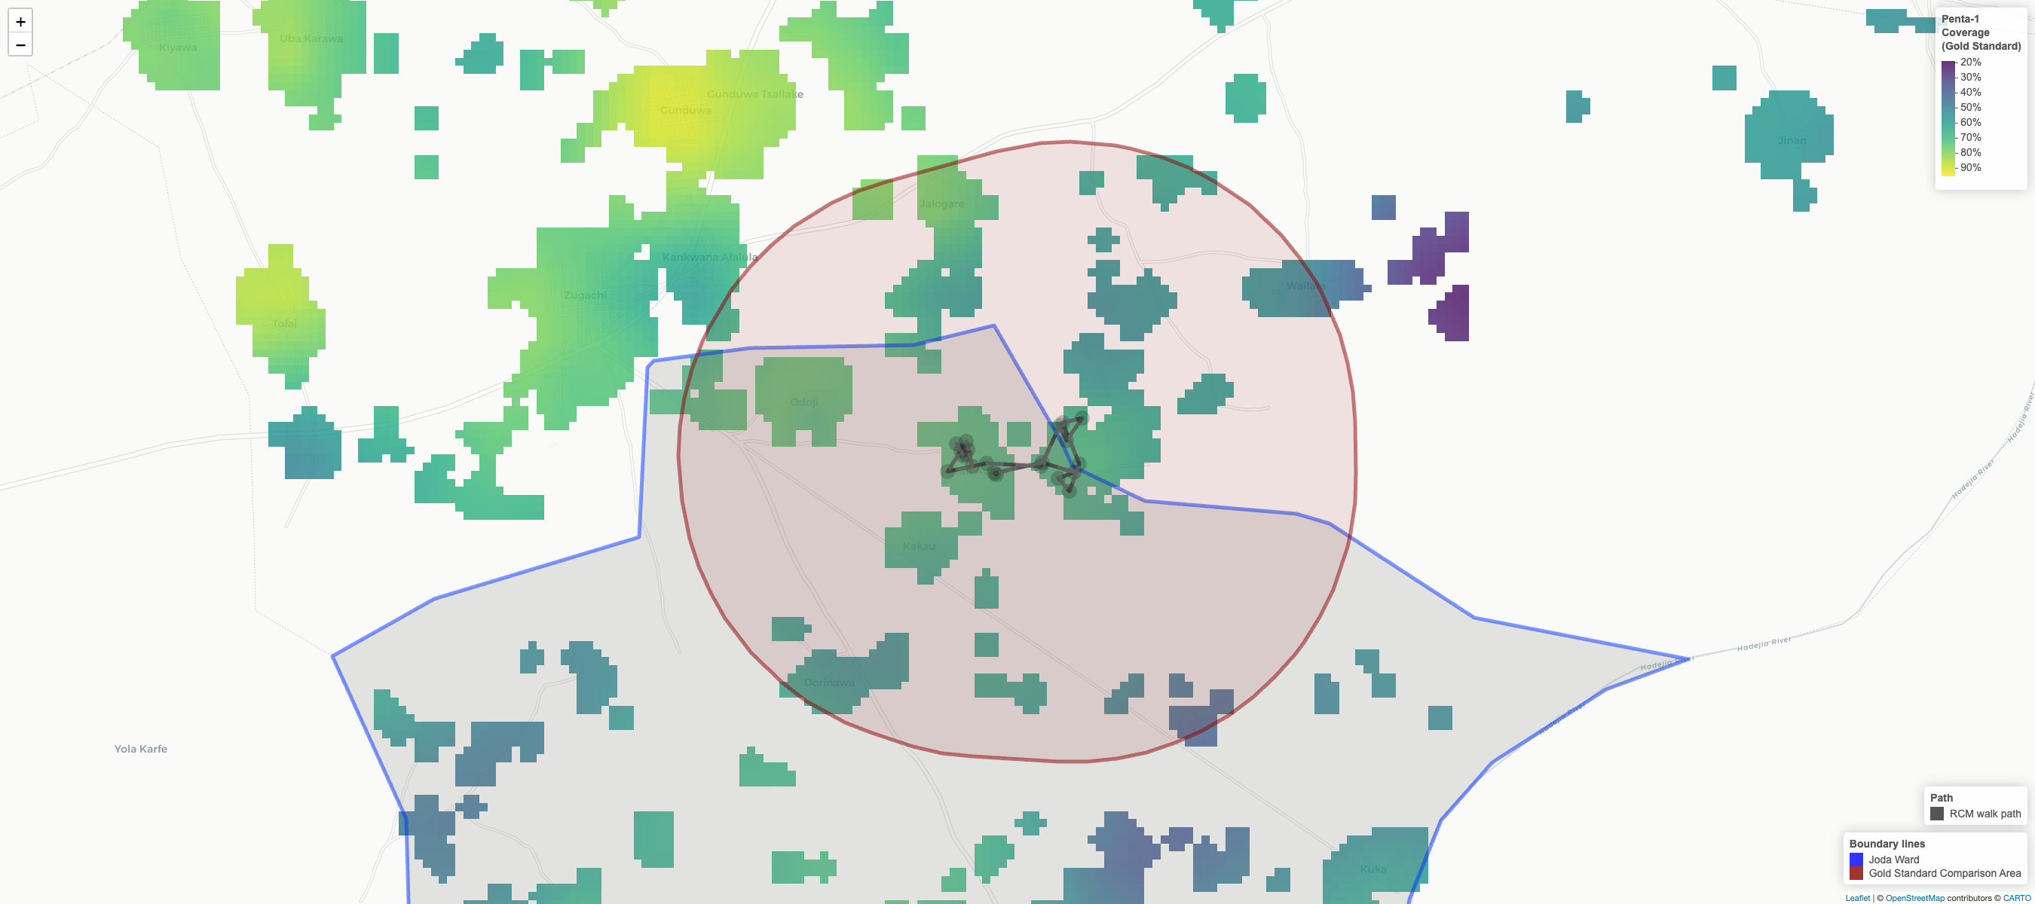
Figure 3.30: Comparing the path of the RCM pseudo-random walk in Joda against the geospatial zero-dose prevalence estimate from the Gold Standard survey

Zugachi Ward
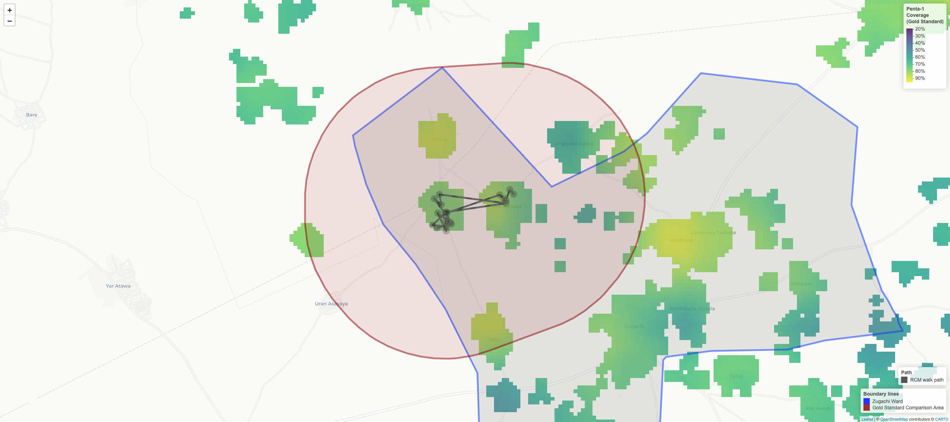
Figure 3.31: Comparing the path of the RCM pseudo-random walk in Zugachi against the geospatial zero-dose prevalence estimate from the Gold Standard survey

Gaya LGA

Balan Ward
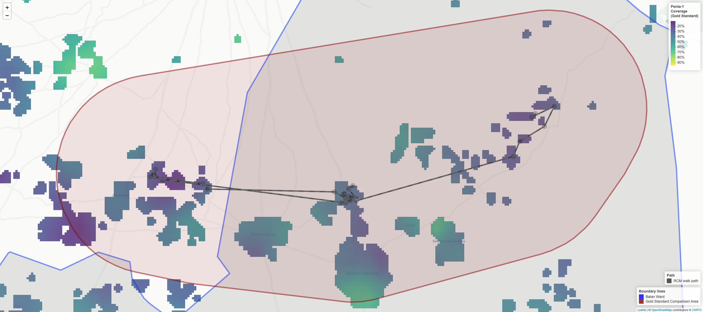
Figure 3.32: Comparing the path of the RCM pseudo-random walk in Balan against the geospatial zero-dose prevalence estimate from the Gold Standard survey

Kazurawa Ward
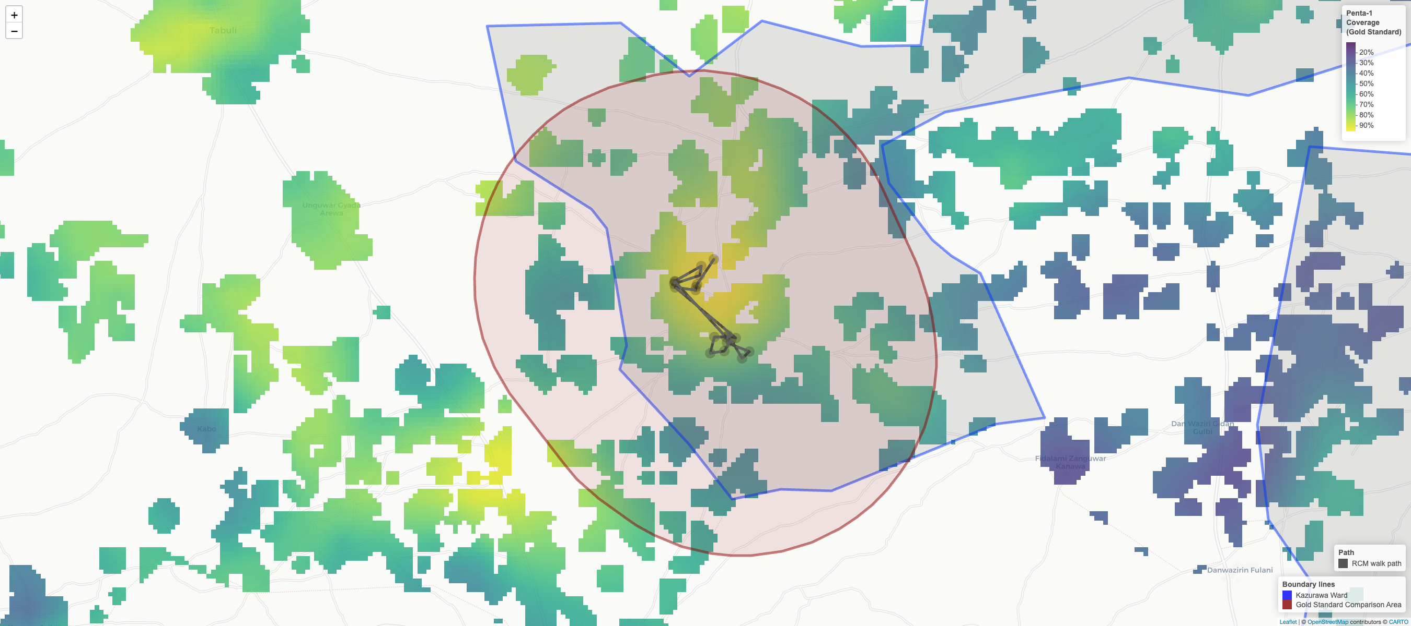
Figure 3.33: Comparing the path of the RCM pseudo-random walk in Kazurawa against the geospatial zero-dose prevalence estimate from the Gold Standard survey

Nassarawa LGA

Dakata Ward
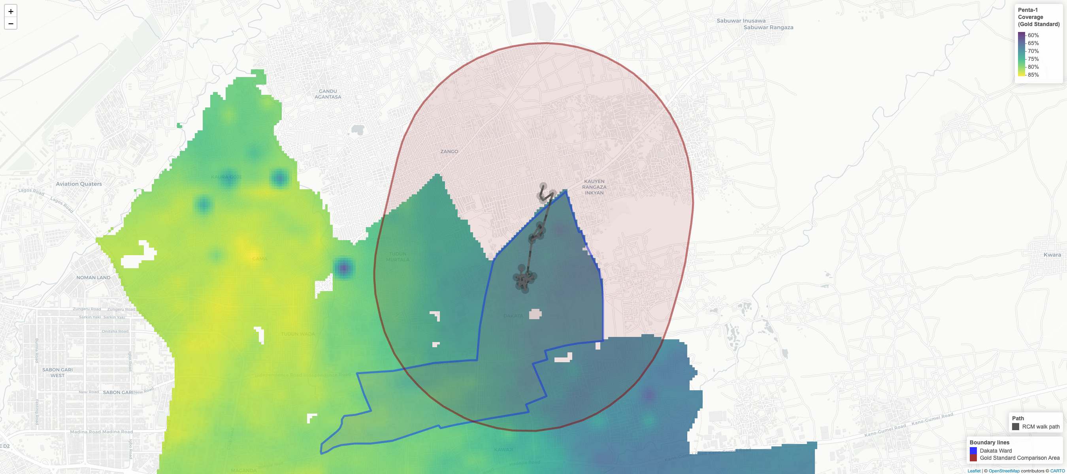
Figure 3.34: Comparing the path of the RCM pseudo-random walk in Dakata against the geospatial zero-dose prevalence estimate from the Gold Standard survey

Hotoro South Ward
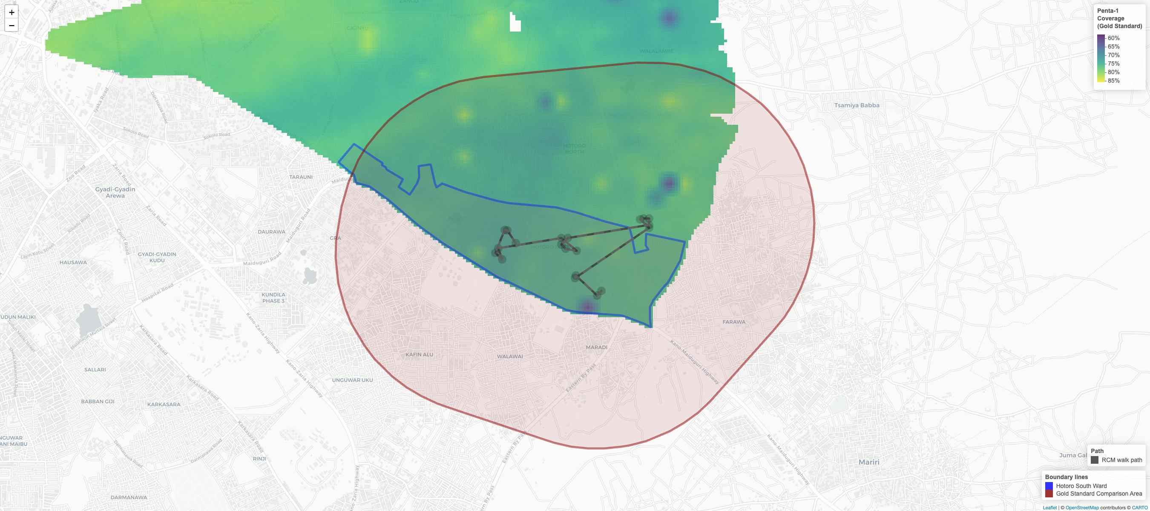
Figure 3.35: Comparing the path of the RCM pseudo-random walk in Hotoro South against the geospatial zero-dose prevalence estimate from the Gold Standard survey
These findings show that even when we back-into a fairly narrow comparison area in the sentinel LGAs, some areas still may not match closely, and that this is not only explained by random chance alone. It suggests that RCMs are quite sensitive to starting point and direction enumerators walk, as zero-dose dynamics can change significantly even at the scale of the distances walked within an RCM. If the catchment areas encapsulate larger areas than those in this study, this problem would likely be even more pronounced, as the distances traveled by an RCM walk would represent an even smaller fraction of the total area.
Table 3.31 summarizes the head-to-head error metrics for RCM. Across the eight RCMs, the mean absolute difference between RCM and the gold standard was 20 percentage points. Because this comparison is based on only eight paired estimates, results should be interpreted cautiously, especially given that two non-sentinel RCMs relied on comparison areas that were geographically separated from the walked corridors. More generally, these metrics are likely to be optimistic relative to typical operational deployments, where the implicit catchment of interest often spans a much larger area than the route covered by a single RCM walk.
Table 3.31: Agreement metrics between RCM and Gold Standard estimates of zero-dose prevalence
Method | Number of estimates (RCMs) | Mean Signed Difference (Bias) | Mean Absolute Difference | Root Mean Square Error | Intraclass Correlation Coefficient (ICC) | ICC p-value
RCM | 8 | -0.03 | 0.20 | 0.28 | 0.28 | 0.221

3.6.3.2 Reasons for Non-Vaccination
A stated benefit of RCM is its ability to capture demand-side barriers alongside coverage data: the WHO guidance specifically positions it as a tool for investigating why children are not vaccinated or why they missed doses (World Health Organization 2024). Because the RCM instrument uses the same reasons-for-non-vaccination questionnaire as the gold standard, the barrier profiles from each walk can be examined alongside the survey-weighted estimates from the corresponding buffered comparison zone.
Table 3.32 presents this comparison for each walk, with responses aggregated to the four domains of the WHO BeSD framework — the coarsest grouping at which a comparison is feasible given the sample sizes involved. Results are shown per walk because RCM is applied and interpreted at that level — walks are not designed to be aggregated across areas, and doing so would mask local variation. Two walks — Kazurawa (Gaya) and Hotoro South (Nassarawa) — are absent because every child encountered was vaccinated, so the reasons questions were never asked. That two entire walks yielded no unvaccinated children underscores how readily a single walk can miss unvaccinated pockets, leaving the team with no barrier data at all.
Table 3.32: Reasons for non-vaccination by BeSD domain, RCM vs gold standard. The wide discrepancies between arms and the small per-walk sample sizes illustrate that RCM is not designed to produce generalisable estimates of vaccination barriers in a catchment area; its value lies in identifying reasons for non-vaccination among the specific children encountered during the walk.
Domain | RCM (%) | RCM (counts) | Gold Standard (%) | Gold Standard (counts) | Difference  (RCM - GS) | p-value for difference
 |  |  |  |  |  | Unadjusted | Adjusted
Joda (Gabasawa)
Access | 0.0% | 0 / 4 | 24.0% | 12 / 58 | -24.0% | .300 | .549
Beliefs | 0.0% | 0 / 4 | 17.4% | 13 / 58 | -17.4% | .412 | .549
Health center | 0.0% | 0 / 4 | 5.0% | 2 / 58 | -5.0% | .888 | .888
Social processes | 0.0% | 0 / 4 | 48.9% | 27 / 58 | -48.9% | .036 | .144
Zugachi (Gabasawa)
Access | 0.0% | 0 / 8 | 18.1% | 6 / 34 | -18.1% | .152 | .320
Beliefs | 12.5% | 1 / 8 | 37.1% | 12 / 34 | -24.6% | .160 | .320
Health center | 0.0% | 0 / 8 | 9.9% | 4 / 34 | -9.9% | .516 | .516
Social processes | 12.5% | 1 / 8 | 28.5% | 9 / 34 | -16.0% | .348 | .464
Balan (Gaya)
Access | 0.0% | 0 / 12 | 20.2% | 36 / 193 | -20.2% | .044 | .176
Beliefs | 41.7% | 5 / 12 | 22.5% | 41 / 193 | 19.1% | .172 | .344
Health center | 0.0% | 0 / 12 | 6.4% | 12 / 193 | -6.4% | .456 | .456
Social processes | 50.0% | 6 / 12 | 38.1% | 81 / 193 | 11.9% | .400 | .456
Dansoshiya (Kiru)
Access | 0.0% | 0 / 3 | 5.3% | 1 / 15 | -5.3% | .724 | .856
Beliefs | 33.3% | 1 / 3 | 10.5% | 2 / 15 | 22.8% | .164 | .656
Health center | 0.0% | 0 / 3 | 0.0% | 0 / 15 | 0.0% | .572 | .856
Social processes | 100.0% | 3 / 3 | 84.2% | 12 / 15 | 15.8% | .856 | .856
Chalawa (Kumbotso)
Access | 0.0% | 0 / 5 | 20.5% | 3 / 15 | -20.5% | .472 | .472
Beliefs | 80.0% | 4 / 5 | 50.6% | 8 / 15 | 29.4% | .272 | .472
Health center | 20.0% | 1 / 5 | 0.0% | 0 / 15 | 20.0% | .120 | .472
Social processes | 40.0% | 2 / 5 | 22.5% | 3 / 15 | 17.5% | .440 | .472
Dakata (Nassarawa)
Access | 33.3% | 1 / 3 | 14.4% | 15 / 83 | 19.0% | .412 | .619
Beliefs | 66.7% | 2 / 3 | 33.2% | 27 / 83 | 33.5% | .216 | .619
Health center | 0.0% | 0 / 3 | 3.1% | 5 / 83 | -3.1% | .704 | .704
Social processes | 0.0% | 0 / 3 | 20.6% | 26 / 83 | -20.6% | .464 | .619
Percentage of unvaccinated children whose caregivers reported at least one reason in each BeSD domain. RCM proportions are unweighted. Gold standard proportions are survey-weighted estimates restricted to the buffered comparison zone around each walk. p-values from a paired bootstrap (500 replicates): Beta posterior draws (Jeffreys prior) for RCM, survey replicate weights for gold standard (with Beta posterior substitution at effective sample size for degenerate 0%/100% cases); adjusted p-values control the false discovery rate across domains within each walk. This is a select-multiple question, so domain proportions do not sum to 100%.
With only 3 to 12 unvaccinated children per walk contributing the data on reasons for non-vaccination, testing for differences between the RCM and gold-standard barrier profiles is not statistically defensible — the comparison is severely underpowered at these sample sizes. The $p$-values in Table 3.32 are included to illustrate this point; a non-significant result should not be read as evidence of agreement, only of insufficient power. Indeed, even setting aside the comparison with the gold standard, the per-walk samples are too small to support any generalisable inference about barrier prevalence in the catchment area: even under the best-case assumption that the children encountered behave as a simple random sample, domain-specific counts of 3 to 12 unvaccinated children yield margins of error too wide to be informative.
The value of collecting such data during RCM walks is therefore limited to the specific children assessed: it tells the research team what barriers prevented those specific children from getting vaccinated, which can directly inform mop-up and referral decisions. Vis-a-vis the wider catchment area, the small number of unvaccinated children per domain are far too few to characterize patterns, even under the generous assumption that the walk behaves as a SRS, and are unlikely to add to what experienced immunisation staff already anticipate.

3.6.4 Discussion
One of the implementation characteristics of RCM is that it collects observations sequentially along a walk-based route via consecutive interviews of adjacent households. While this allows RCM data collection to occur rapidly, it entails that observations are unlikely to be independent: households close to one another often share access barriers, service exposure, and social norms, so vaccination status can be similar for nearby children. Consequently, results can be strongly shaped by the particular segment of the settlement the walk happens to traverse.
This aspect is borne out by the data. By using a regression model, we can test for serial autocorrelation in Penta 1 status along each ward’s RCM walk (Table 3.33). When we add the previous household’s vaccination status as a predictor for the next household (lag1), we find a statistically significant odds ratio of 2.35 ($p=.037$). On the probability scale (with the ward random effect set to its mean), the fitted model implies that if the immediately preceding child was unvaccinated, the next child has an expected 57% probability of being unvaccinated; if the preceding child was vaccinated, the next child has an expected 36% probability of being unvaccinated. In other words, Penta 1 status tended to cluster along the walk, consistent with spatially concentrated sampling. The practical consequence is twofold: the walk may not be representative of the catchment, and the observed serial dependence further reduces the effective sample size, so treating the data as an SRS will overstate precision and can distort inference.
Table 3.33: Logistic mixed-effect model to estimate the serial autocorrelation of a pseudo-random walk
 | Term | OR | 95% CI | p-value
Fixed Effects | Intercept | 0.76 | 0.31–1.86 | 0.551
Fixed Effects | lag1 [Vaccinated] | 2.35 | 1.05–5.25 | 0.037
Random Effects | σ² (residual) | 3.29
Random Effects | τ₀₀ ward | 1.03
Random Effects | ICC | 0.24
Random Effects | N ward | 8
Random Effects | Observations | 159
Random Effects | Marg. R² / Cond. R² |  | 0.041 / 0.269
OR = odds ratio; CI = confidence interval. Bold rows: p < 0.05.
Several additional conclusions follow from the regression output, but the most practical one is about variability across RCM comparison areas. The random-effects structure indicates that baseline Penta 1 coverage differs meaningfully from one RCM comparison area to another, consistent with substantial heterogeneity in local vaccination conditions. This matters because the eight RCMs were drawn from a sampling frame intended to represent areas suspected to have high zero-dose prevalence; under that premise, one might expect the resulting RCM samples to look uniformly high zero-dose. Instead, the observed spread across RCM comparison areas suggests that the risk classification used to prioritize RCM locations does not, at least in these data, reliably produce a set of sites with consistently elevated zero-dose prevalence. The hotspot maps reinforce this interpretation: in several wards, the RCMs walk paths do not intersect the most pronounced zero-dose prevalence hotspots (the deepest purple areas). This calls into question the practical reliability of RCM as a mechanism for consistently identifying the highest-prevalence pockets of zero-dose children.
This heterogeneity also sharpens the interpretive challenge for a head-to-head comparison. When outcomes vary substantially over short distances, any method that concentrates measurement along a single walk corridor becomes highly sensitive to where that corridor falls. That is one reason a key concern is that this backed-in buffer comparison may be too generous to RCM. In effect, an RCM walk that proceeds house-to-house along a contiguous path is closer to a localized enumeration of that neighborhood than to a probability sample from a broader catchment. For the corridor visited, the design-based sampling error is, in principle, small because the walk is attempting to enumerate all eligible households encountered (subject to non-response and eligibility). If the gold-standard comparison area is then defined by tracing that same path and drawing a buffer around it, the comparison is anchored to a population that closely resembles the one observed by RCM, which makes close agreement more likely by construction.
This is not exact in our implementation. Some households were not interviewed, and our 1.75 km buffer intentionally captures an area larger than the literal walk. Even so, the general point remains: by defining the comparison area around what is functionally a localized enumeration, large discrepancies driven by sampling error alone are unlikely. Under this setup, any divergence is more plausibly attributable to measurement differences, non-response patterns, or genuine micro-geographic heterogeneity, rather than to the kind of sampling variability that would matter if RCM were intended to support inference to a clearly defined, wider catchment.
For these reasons, RCM requires cautious interpretation. In the narrow set of circumstances where the area to which conclusions are meant to apply closely aligns with the area actually canvassed by the walk, RCM proportions may be broadly informative, albeit noisy. However, in typical operational use, the implicit catchment of interest is often much larger than the surface area covered before reaching a 20-household quota, even when that catchment is not explicitly defined. In those settings, the risk of misinterpretation increases because the walk represents only a small, potentially unrepresentative slice of a heterogeneous area. The practical concern is that RCM may appear to offer catchment-level insight when it is, in fact, primarily describing conditions along a particular route.
Importantly, this limitation should not be attributed to the quota alone; the more fundamental issue is how the 20 observations are selected in space. A useful observation is that RCM sits much closer in sample size to designs like LQAS that are explicitly probabilistic and come with clearer inferential guarantees. A sample size of 20 children, by itself, need not be dismissed as unscientific or intrinsically inadequate: small samples can still support disciplined decision rules when the sampling mechanism is well defined and the resulting uncertainty is made explicit. The challenge for RCM is not primarily the number 20, but the combination of a small sample with a route-based, convenience mechanism whose error properties are opaque. Rather than billing RCM as an opportunistic walk, a more disciplined protocol could move it closer to roughly representative measurement, even if imperfect. This direction also aligns with the WHO guidance (2024), which already encourages practices meant to reduce bias (for example, standardizing starting procedures, walking clockwise, etc.). Because the main limitations arise from route choice and interpretability rather than the quota itself, the most promising refinements are procedural and reporting-focused. The next section sets out recommendations to strengthen RCM while preserving its intended speed and feasibility.

3.6.5 Recommendations
Based on these findings, and consistent with prior work (V. Dietz et al. 2004; Luman et al. 2007), we advise against using RCM to produce statistically valid estimates of vaccination coverage. The exception is the narrow case where the catchment area of interest is small enough that the pseudo-random walk can reasonably be expected to canvass most or all of it. Instead, RCM should be treated as a rapid, hyper-localized post-campaign follow-up activity that pairs immediate mop-up action with a structured snapshot of the specific corridor traversed by enumerators. Its value lies in identifying and reaching missed children (Rainey et al. 2013; Teixeira et al. 2011) and in characterizing conditions along the walked route, not in supporting general claims about coverage across the wider catchment area.
That said, small design adjustments could make RCM outputs less sensitive to any single walked path while keeping field workload broadly unchanged. These include:
- Defining catchment area boundaries: This is the most important recommendation. The core risk with RCM is that results describe conditions along one walked corridor but are implicitly interpreted as representing a broader catchment area. That risk cannot be mitigated—by multiple walks, interval sampling, or any other protocol adjustment—unless the intended catchment area is explicitly defined at the outset. A clearly defined boundary serves two purposes: it anchors the scope of inference (what area do these results represent?), and it constrains the walk itself (are teams staying within the intended area?). Without it, any statement about the catchment is an extrapolation from a localized corridor, and the scale of that extrapolation is unknown. In practice, catchment boundaries should be specified in advance using map-based polygon definitions, GPS geofencing, or explicit physical landmarks, and field teams should be required to remain within them throughout data collection. Any approach that systematizes movement through space—whether multiple walks or interval sampling—should include this boundary control as a prerequisite.
- Conducting multiple walks per RCM: Instead of relying only on a single walk to reach a pre-determined quota, field-work teams could instead perform three shorter walks of seven households (or four walks of five households), each targeting distinct neighborhoods within the same catchment, while keeping roughly the same total quota between all the walks combined. This is essentially the protocol described by Luman et al. (2007) for rapid house-to-house monitoring. This protocol increases spatial coverage and mitigates serial clustering from consecutive household-to-household interviewing. Because Table 3.29 shows that RCMs typically took 3–4 days to complete, implementing multiple shorter walks would be unlikely to add meaningful operational burden, since teams already make repeated visits to the catchment area.
- Implementing a cascading protocol: Another option is to adopt a cascading RCM protocol, drawing on the system outlined in Luman et al. (2007) for rapid house-to-house monitoring. In this approach, teams begin with a standard first wave of data collection in which they conduct an RCM walk until a fixed initial target is reached (for example, 20 eligible children). At this stage, field teams would tally the number of unvaccinated children, and if the number falls within a pre-specified range, the team would continue their random walk to hit a larger sample size (for example, 30 households in total). The motivation for this is to use a small first wave as a triage step: if results are clearly low-risk or clearly high-risk, teams can stop early and conserve time and resources, but if results fall near a programmatically important threshold (or are otherwise ambiguous), teams can expand the sample to improve precision before drawing conclusions. Put differently, the cascading design concentrates effort where it is most valuable, because a sample of 20 children often yields uncertainty large enough that borderline findings can easily flip with a handful of additional observations. A pre-specified escalation rule also makes the protocol more transparent and defensible, since it acknowledges uncertainty up front and reduces the temptation to treat a small, localized quotient as a stable estimate for decision-making.
- Assessing every $n$th house along the walk: As a complementary technique aimed at increasing spatial spread within a walk, teams could implement a systematic interval rule, visiting, for example, every other house rather than sampling adjacent households. This interval would ideally be set to so as to have field teams canvass the entire catchment area. For example, if it is estimated that the catchment area comprises of 100 households, a rule could be set to approach every fifth house in order to reach 20 children across the entire area. Based on our regression modeling, even an interval of two (every other house) would strip a lot of the serial autocorrelation out of the data. While not a perfect solution, this approach could reduce bias from localized clustering and extend the face validity of the data by extending coverage across a broader swath of the targeted catchment area.
- Reporting an approximate uncertainty bound: Even if RCM is described as non-probabilistic, sampling theory can still provide useful context for interpretation. We recommend that if implementers report a vaccination quotient (as suggested in the WHO guidance (2024)), they also report an approximate MOE or an approximate CI, and label it explicitly as approximate. This should be presented as an idealized, best-case benchmark, derived by treating the 20-child sample as if it were a simple random sample. In practice, localized walking and serial autocorrelation likely reduce the effective sample size below 20, so true uncertainty will typically be larger than this approximate benchmark. Framed this way, the approximate MOE/CI functions as a lower bound on the uncertainty readers should expect, not as a design-based interval for RCM. Providing this benchmark would prevent readers from implicitly treating the reported quotient as more precise than it is.
A practical way to make RCM route selection more disciplined, without turning it into a full survey operation, would be for the international development community to create an online, open-source RCM planning tool that would standardize route definition and documentation. In such a tool, users would define (or draw) the intended catchment boundary in a simple web interface and export that boundary as a map figure for inclusion in field reports, creating a transparent record of the target area. The same tool could then retrieve building footprints within the boundary (for example, from Google’s Open Buildings dataset (Sirko et al. 2021)) and generate an explicit visitation route using a Travelling Salesperson Problem (TSP) style optimization. With a user-specified sampling increment, the tool would place approach points along the route to guide teams on which locations to visit, replacing discretionary walking decisions with a reproducible, auditable path. Such a tool would be equally useful to LQAS implementations, which typically also seek to sample random households within pre-selected EAs.
This approach would be more rigorous than relying on convenience-driven choices about starting location and direction, and it would make the spatial scope of inference clearer. It is also consistent with the practical reality that many field teams will not have specialist geospatial or data-science capacity, and that RCM is positioned as rapid and low-complexity. The purpose of an online tool would be to keep the user workflow simple while embedding the technical steps in the software. With an interface that supports boundary drawing, route generation, increment selection, and export of a map and route file, the method could remain accessible to non-specialists while materially reducing route-selection bias and improving the transparency and defensibility of RCM findings.

3.6.6 Conclusions
Endorsing RCM as suitable for decision-making implies a claim of reliability. The non-probabilistic label can obscure this point: it discourages attention to inferential error while results are still presented as actionable. Proponents may intend RCM results to be broadly informative, yet without a theoretical foundation, that implicit claim remains an assumption, not a demonstrated property. Even under a best-case interpretation in which a 20-child walk is treated as approximately unbiased SRS, sampling variability is large enough that estimates may frequently mislead.
In this head-to-head study, most RCM estimates could be brought into close agreement with the gold standard, but much of that agreement depended on defining comparison areas that closely tracked the walked corridor. When the compared areas did not overlap, the discrepancy was immediate and readily explained. The core operational conclusion is that RCM outputs are hyper-local and highly sensitive to the start point and direction of the walk. If the area decision-makers have in mind is materially larger than the area covered before reaching the quota, representativeness is unlikely, and the risk of confident misinterpretation increases. Some of these limitations can likely be mitigated, at least in part, by adopting more disciplined route and boundary protocols of the kind recommended in this report.
RCM is also often framed as a way to identify localized pockets of missed children. In our experience, however, the walk paths frequently did not intersect the strongest zero-dose hotspots indicated by the gold-standard surfaces, and the largest hotspots were missed altogether. This could reflect limitations of the candidate-site sampling frame rather than an inherent limitation of RCM itself, but it is still operationally relevant: in this implementation, the method did not consistently achieve one of its stated aims. Likewise, the small number of unvaccinated children per walk — a median of 4.5 — made any generalisation of the reasons-for-non-vaccination data beyond the specific children assessed unfeasible.
Overall, RCM can be broadly informative only under a narrow set of conditions where the intended area of inference closely aligns with the area actually canvassed by teams. One such condition is when the objective is simply to learn about the children actually assessed — for example, to mop up missed cases and understand why those children were not reached by an intervention, whether through non-contact or non-conversion — without generalising to the wider catchment area. When the goal extends beyond those children to the wider catchment area, however, RCM should not be interpreted as a catchment-level prevalence estimate unless the walk has been designed to spread observations well across the catchment space. For this reason, proponents should either (i) treat prevalence estimation as an explicit objective and adopt more disciplined protocols and reporting that make uncertainty and geographic scope transparent, or (ii) clearly restrict interpretation to the walked corridor and avoid implied generalization.

4. Cost Analysis

4.1 Overview
Costing analysis is, at heart, an exercise in tracing where resources actually go. Although this study comprises multiple research methods, it was implemented under a single grant with a single topline budget. That structure is convenient for accounting, but it obscures how resources were distributed across methods, phases of work, and other cost centers. Without a defensible decomposition, future stakeholders cannot assess the cost and associated value of any one component.
That accounting convenience becomes an analytic problem when multiple methods share staff, logistics, and overhead. Accounting totals also understate the true resource footprint because plans diverge from reality and some key inputs are only partially captured as financial transactions. Planned budgets and price structures are useful baselines, but they are not the same thing as realized spending. Field plans evolve, priorities shift, and operational realities force re-allocations as work progresses. Even under fixed-price agreements, where some of that financial risk is borne by the data collection firm, the actual pattern of effort and expenditure will rarely match the plan exactly. Some inputs that shape feasibility and scalability, such as staff time, management attention, and operational constraints, may also be only partially captured in expenditure records.
The purpose of this chapter is therefore twofold: first, to decompose total project resources across methods and across the main stages of implementation, so we can identify which components drove higher total financial cost and where variation emerged. Second, to broaden the notion of cost beyond recorded expenditures by taking an economic view of the full resource footprint, including time, effort, and operational constraints. Where possible, we monetize time to express resource use in cost units. Where monetization is not appropriate or not feasible, we report time and constraints directly as non-financial inputs.
To operationalize this broader resource view, we use time-motion measurement to translate day-to-day workflow into quantifiable inputs. The term motion comes from industrial time-and-motion studies, where motion literally meant workers’ physical movements. In this study, it refers both to how enumerators move through geographic space and how teams move through work at a fine grain, including the sequence of operational steps and the time required for each (for example, progress through a questionnaire).
Time-motion analysis is one of the main instruments used here because time is the primary cost driver in this research setting, where personnel time makes up the lion’s share of total expenditure. By decomposing work into discrete steps and measuring their sequence and duration, time-audit records reveal where effort concentrates and where processes stall, repeat, or fragment. Detailed time-stamped records allow the team to reconstruct what happened when, attribute effort step-by-step, and identify high-leverage opportunities for streamlining, standardization, and better task allocation. This lets us allocate labor-intensive activities to methods and stages using observed workflow rather than assumptions. Time and effort can then be mapped to spending, so process changes are evaluated not just for speed but for budget impact.

4.2 Implementation Details
There are few published examples that apply time-motion methods to the operational workflow of vaccination coverage research. This gap is notable because related approaches do exist in studies of the time and cost of delivering health services. It is also notable because modern CAPI platforms increasingly provide turnkey features for questionnaire time-auditing and other automated traces. In practice, many data collection agencies likely use these features to monitor parts of workflow and productivity. What appears to be missing from the literature is an end-to-end treatment that integrates these traces into a fuller accounting of time and cost across the research process.
Time-motion studies are commonly implemented using three complementary measurement modes: direct observation, self-reports, and automated logs. Direct observation records work as it happens, capturing context and informal practices that may not appear in records. Self-reports capture activities that are hard to observe continuously, especially when work is distributed across people, places, or time. Automated logs provide high-resolution timestamps for instrumented steps and help reduce recall error. Studies may use all three modes or only a subset. What unites them is a focus on low-level, atomic tasks and their durations, and on how those micro-patterns accumulate into overall throughput, bottlenecks, and cost across the full production process. Used together, these modes balance coverage, granularity, and validity, since each source has different blind spots and measurement error.
Because there was no published template to follow, the research team adapted classic time-motion principles to this application by defining discrete workflow steps and prioritizing modes compatible with instrumented CAPI processes. As a result, some elements of classic time-motion design transferred cleanly, while others were less relevant or less practical.
In time-motion studies evaluating actual health programs, direct observation is often the natural starting point because many service steps occur in physical space and are not otherwise recorded. For example, an observer might shadow a vaccinator and record the sequence and duration of tasks such as preparing supplies, screening and counseling the client, drawing up the dose, administering the injection, documenting the visit, disposing of sharps, and resetting the station for the next client. In contrast, in a CAPI-based coverage survey, much of the most decision-relevant motion is already instrumented within the data collection software. The tablet records how enumerators progress through the questionnaire and associated workflow at a level of detail that would be costly to capture reliably through observation. Direct observation was therefore not treated as a valuable data source in this study. Observational shadowing can still be valuable for understanding navigation, pacing, and improvisation in the field. However, it is comparatively intrusive and resource-intensive, and it is less well suited to capturing the fine-grained steps that drive much of the workload in digital data collection and analysis.
Given this instrumentation, this study relied mainly on guided self-reporting and automated logs. System logs from the CAPI platform provided high-resolution, time-stamped traces of survey-form sessions down to the question level. These logs captured when forms and individual items were opened, advanced, saved, and submitted. Alongside these traces, Mindset staff and consultants tracked time spent across study phases and core methods. Field teams also recorded a small set of daily checkpoints, such as leaving home, arriving in the field, and ending data collection.
A second measurement mode was self-reporting, used to capture effort and movement that do not reliably appear in system traces. Mindset staff and consultants reported time spent across study phases and core methods. Field teams recorded a small set of daily checkpoints and related operational details, such as leaving home, arriving in the field, ending data collection, and travel metrics such as distance travelled.
Self-reported time reflects subjective judgment and carries risk of error. The research team therefore implemented validation checks and reconciliation steps to improve accuracy and consistency. Where feasible, self-reported subtotals were calibrated against known totals, such as invoiced hours. Data entry tools also included guardrails to prevent illogical records, including impossible timestamp sequences and inconsistent event orderings. Some anomalous records still occurred, so targeted cleaning was used to reconcile sources and remove clear outliers. For distribution-focused visuals, extreme right-tail values were also trimmed within group in a small number of places (for example, keeping values below the 99th percentile by survey section, or below the 99.5th percentile by field activity) so a few anomalous records did not dominate plot scales. These trims were used for interpretability of plots rather than to redefine interview counts or financial apportionment.
These validated time data can be linked to expenditure records to estimate total effort and total cost. The remaining challenge is attribution: assigning shared effort and shared spending to specific methods and phases. Attribution of totals is straightforward for some expenses, such as method-specific field teams, dedicated purchases, or clearly labeled invoices. For many other costs, however, transactions are recorded at a higher level than the operational units that drive them. In those cases, the analysis must relate blanket expenditures to fine-grained elements (methods and research phases) through a defensible apportionment. This matters because methods overlapped in respondents and logistics (Chapter 2), so raw comparisons of method-level time or cost can be misleading. Fieldwork was a joint production process, and many inputs could not be unambiguously attributed to a single method.
The research team therefore apportioned method-level costs using principled rules based on observed outputs. For non-labor expenditures, costs that were clearly linked to a single method were allocated in their entirety to that method. For example, in LQAS, maps purchased from the NPC were used only for LQAS, so that expenditure was fully allocated to LQAS. Shared non-labor costs were split in proportion to the number of successful interviews completed for each method. This proportional rule is principled and produces a fairly weighted allocation of shared spending across methods in a joint production setting. However, it can understate what the financial cost of a given method might look like if that method were run in isolation. In a standalone implementation, fixed overhead would represent a larger share of total cost. Estimating that hypothetical per-method standalone cost would also be unavoidably subjective, because some shared costs do scale with overall scope and because different funders and clients have different appetites for rigor, supervision, and analytic breadth. We therefore apportion shared costs proportionally while being explicit about these limitations. To complement this accounting view, we also present a marginal cost analysis later in the chapter. That analysis provides a more concrete estimate of variable cost per unit, allowing readers to layer their own assumptions about fixed cost structures on top. Labor time required a similar but modified approach. When labor was not credibly associated with any specific method, hours were allocated across all methods using the same proportional interview rule. In many cases, however, staff, consultants, and field teams worked on tasks tied to a subset of methods rather than the full set. The most common grouping was the Gold Standard, NSUM, and AS, which together comprised the core data collection effort. In this chapter, we refer to this integrated stream as the core survey. These methods shared largely the same questionnaire and survey logistics, with NSUM implemented as an added module and AS building directly on the Gold Standard sample. In operational terms, the Gold Standard interviews and the NSUM module generated the initial data used to identify adaptive-sampling hotspots, so this stage functioned as a single shared field effort. As a result, time reported against baseline data collection frequently supported NSUM and AS as well, even when staff did not explicitly label it that way. In these cases, hours attributed in self-reports to the Gold Standard baseline were treated as core effort and allocated proportionally across the Gold Standard, NSUM, and AS according to their successful interview counts. Only the later adaptive supplement was treated as separate, incremental fieldwork.
Table 4.1: Number and proportion of successful interviews by method
Abb. | Method | Number of Survey Instances | Number of Successful Household Interviews | Proportion
GS | Gold Standard | 77,300 | 21,525 | 45.5%
NSUM | Network Scale Up Method | 77,300 | 16,278 | 34.4%
AS | Adaptive Sampling | 33,770 | 8,649 | 18.3%
LQAS | Lot Quality Assurance Sampling | 594 | 594 | 1.3%
RCM | Rapid Convenience Monitoring | 308 | 145 | 0.3%
ARR | Administrative Records Review | 74 | 74* | 0.2%
*For the ARR method, the 74 interviews represent audits of health facility vaccine registers rather than household interviews.
Data collection occurred over three periods. The gold standard, NSUM, and the initial adaptive sampling component were fielded from February to early June 2025. Data collection for ARR occurred roughly in the middle of this period, in March 2025, under a separate fieldwork plan. Finally, LQAS, RCM, and the adaptive supplement were implemented later, in late June and July 2025.

4.3 Results
We connect three dimensions that are often reported separately: time, cost, and precision. While all three matter, time is the primary economic input of the study, and it therefore drives the other two. Some work can be accelerated by adding staff, but many steps remain constrained by the workflow itself, where downstream tasks can only begin once upstream tasks are complete. Because labor is the dominant input, costs largely reflect whose time is required and how much of it is needed, and precision reflects what that time budget allows in sampling, supervision, revisits, and verification. For that reason, we treat time use as the organizing variable and interpret cost and precision as consequences of how that scarce resource is allocated.

4.3.1 Time
This study examines time use at three nested resolutions. First, at the most fine-grained level, we analyze survey time as the time to administer the CAPI questionnaire, measured to the second and decomposed by module or question group. Second, we take an enumerator-day view, tracking field time from when an enumerator leaves home until they return, capturing travel, waiting, interviewing, and downtime in units that are more naturally read in minutes to hours. Third, we widen to a project-wide human-resource view, extending beyond field staff to include support staff, permanent office staff, and consultants. We call this project time. Across all three resolutions, we consider both billable hours that appear in project accounts and unbillable hours that still carry real opportunity costs, a distinction we return to in the cost section.
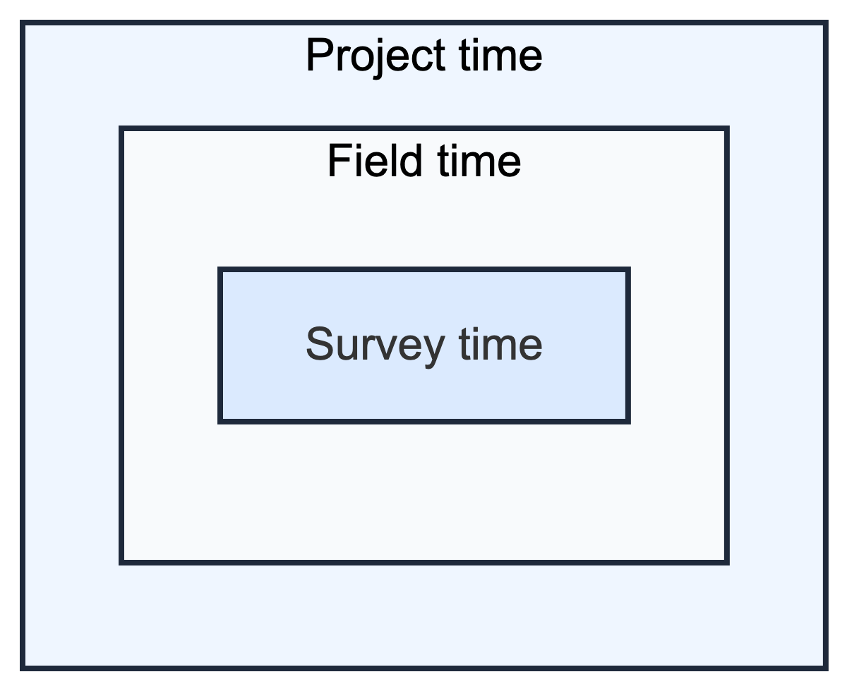
Figure 4.1: Nested analytical time resolutions

4.3.1.1 Survey Time
Survey time is the duration required to administer the CAPI instrument, operationalized using the platform’s automatic timestamps of enumerator actions. We summarize it both as the typical duration of a complete interview and, more granularly, as section-level time that can be compared across key permutations and field contexts that systematically lengthen or shorten administration.
Total survey time is a superset of the respondent-facing time enumerators spend actively asking questions. Enumerators often start the form and complete administrative tasks before knocking on doors, such as capturing geocoordinates, listing dwellings, recording paradata (e.g., wall materials), and identifying the case. We therefore define survey time broadly as the full in-form workflow from form start to submission. This includes completed interviews as well as unsuccessful attempts–refusals, non-contacts, and ineligibles.
Because these measures are generated automatically, they are less vulnerable to recall and reporting bias than self-reported timing. They are not perfectly clean, however. Enumerators may revisit earlier sections or reopen interviews to correct responses, which can create timestamp outliers and disrupt the expected question sequence in section-level analysis. These cases are usually identifiable and can be handled with robustness checks. Overall, the log data are sufficiently reliable and richly indexed (by enumerator and GPS location) to support analysis of how interview duration varies by person, place, and section.
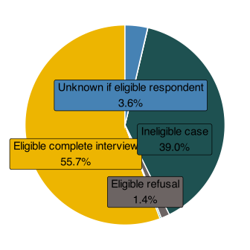
Figure 4.2: Fraction of total survey time by disposition outcome
Table 4.2 summarizes typical survey durations and outcome frequencies for the core Gold Standard (GS)/NSUM/AS survey stream. Parallel summaries for RCM and LQAS are shown in Table 4.3 and Table 4.4. Although successful interviews are a minority of cases, they dominate total CAPI time. Ineligible cases are most common (48.4k; 59%), followed by completed interviews (22.5k; 27%). This reflects how listing and screening were integrated into the form, logging buildings and households separately. Accordingly, ineligible cases cover both non-qualifying households and listing work to identify buildings.
Yet completed interviews take much longer (45m 59s on average), so they dominate total time across all 22.5k cases. The right tail is long: one in five interviews exceeds 1h 03m 54s. Ineligible cases are shorter (8m 50s median; 14m 59s mean) but add up because they’re so frequent. Unknown eligibility cases comprise 10% (8m 08s average), while refusals and non-contacts are rare but still consume minutes per case. Overall, survey time is driven by frequent screen-outs and the long tail of lengthy interviews.

Core Survey
Table 4.2: Survey duration (tablet time) by disposition status (Gold standard, NSUM, and Adaptive Sampling)
Code | Disposition Categoryª | # Cases | Total  (days) | Median  Duration | Average  Duration | 80% Percentile  Duration
I | Eligible complete interview | 22,501 | 718.4 | 0:41:18 | 0:45:59 | 1:03:54
NC | Eligible non-contact | 448 | 3.1 | 0:06:26 | 0:10:05 | 0:12:04
NE | Ineligible case | 48,351 | 503.1 | 0:08:50 | 0:14:59 | 0:25:03
R | Eligible refusal | 2,147 | 17.7 | 0:08:00 | 0:11:53 | 0:16:17
UH | Unknown if eligible household | 91 | 0.5 | 0:04:50 | 0:08:22 | 0:11:57
UO | Unknown if eligible respondent | 8,320 | 47.0 | 0:05:06 | 0:08:08 | 0:10:31
ªCore survey refers to the integrated Gold Standard, NSUM, and initial Adaptive Sampling fieldwork stream. These components were implemented jointly in the field, so separating their time and cost cleanly is often analytically difficult.

RCM
Table 4.3: RCM survey duration (tablet time) by disposition status
Code | Disposition Category | # Cases | Total  (days) | Median  Duration | Average  Duration | 80% Percentile  Duration
Completed | Completed interview | 145 | 4.4 | 0:35:05 | 0:43:16 | 0:59:03
Missing | Not recorded | 90 | 0.3 | 0:01:54 | 0:04:42 | 0:03:26
Refused | Refused | 42 | 0.1 | 0:01:42 | 0:01:57 | 0:02:10
Non-contact | Non-contact | 25 | 0.0 | 0:01:12 | 0:01:56 | 0:02:27
NE | Ineligible case | 8 | 0.0 | 0:01:16 | 0:02:16 | 0:01:59

LQAS
Table 4.4: LQAS survey duration (tablet time) by disposition status
Code | Disposition Category | # Cases | Total  (days) | Median  Duration | Average  Duration | 80% Percentile  Duration
Missing | Not recorded | 520 | 21.4 | 0:52:04 | 0:59:24 | 1:14:42
I | Eligible complete interview | 47 | 1.9 | 0:53:28 | 0:59:30 | 1:14:54
NE | Ineligible case | 21 | 1.1 | 0:55:06 | 1:12:40 | 1:20:56
R | Eligible refusal | 2 | 0.0 | 0:35:43 | 0:35:43 | 0:36:42
UO | Unknown if eligible respondent | 4 | 0.1 | 0:30:06 | 0:29:08 | 0:34:16
Figure 4.3 shows the distribution of interview duration for completed cases using frequency histograms with an empirical density overlay. Most interviews cluster at shorter times, while a smaller share run much longer, producing a right-skewed tail. This pattern is expected. There is a practical lower bound on interview duration, but field conditions–interruptions, case complexity, translation needs, and connectivity issues–can extend interviews unpredictably. A small number of long interviews absorbs a disproportionate share of time and drives variability in workload.

Overall
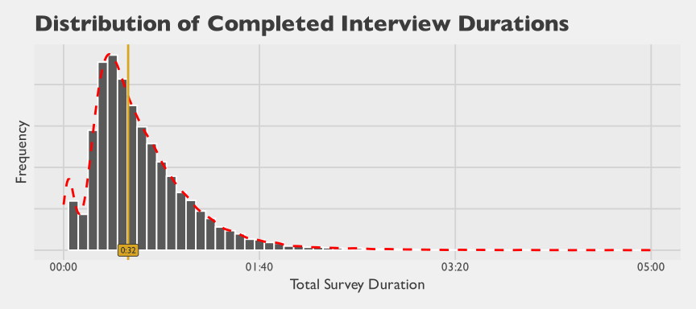
Figure 4.3: Distribution of completed interview durations

By Section
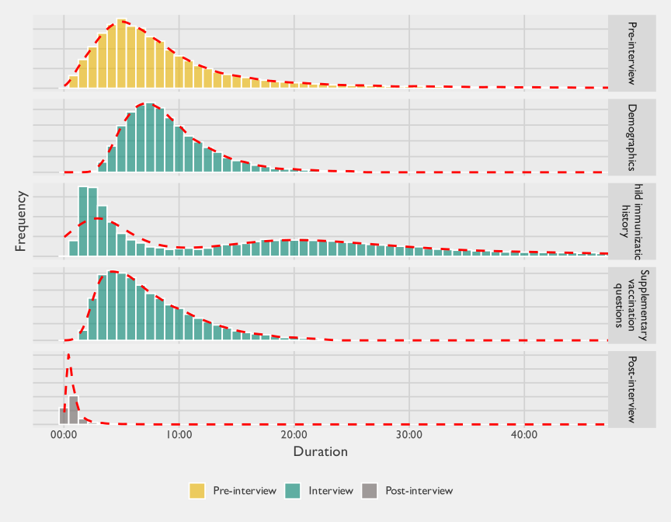
Figure 4.4: Distribution of section durations

4.3.1.1.0.1 By Method
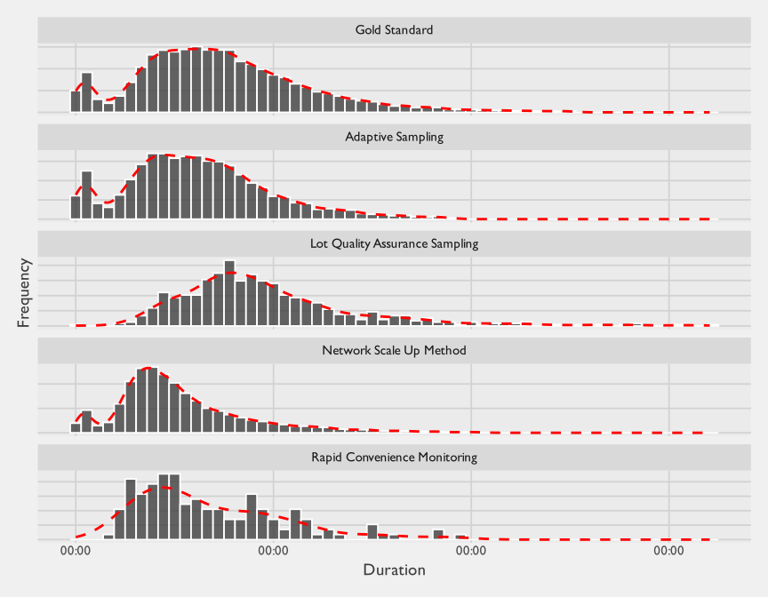
Figure 4.5: Distribution of total interview durations by method
Figure 4.4 further decomposes this total time into key sections and shows that both central tendency and variability differ sharply across modules. Median durations are modest for post-interview steps (about 0m 37s), NSUM (2m 17s), and supplementary vaccination questions (6m 32s), while pre-interview tasks (7m 10s) and demographics (8m 23s) are more substantial. The child immunization history section stands out as the dominant time component (median about 16m 31s) and also exhibits the heaviest right tail, indicating that a minority of cases require much more time in this module. Taken together, the figures suggest that overall interview length is primarily driven by a mix of predictable fixed overhead (pre-interview and demographics) and highly variable case complexity concentrated in immunization history. For readability in this faceted distribution plot, the top 1% of durations within each section are trimmed.
Typical durations by survey section are summarized in Table 4.5 using the average, median, and 80th percentile for each section of the survey instrument.
Table 4.5: Typical durations of survey components
 | Average | Median | 80% Percentile
Pre-interview | 10M 24S | 7M 10S | 13M 6S
Setup | 1M 38S | 44S | 1M 26S
Geofenced GPS capture | 5M 9S | 2M 8S | 6M 34S
Listing and building metadata | 1M 28S | 57S | 2M 15S
Informed consent | 1M 59S | 1M 27S | 2M 51S
Eligibility screening | 19S | 10S | 26S
Demographics | 9M 20S | 8M 23S | 11M 55S
Respondent demographics | 3M 25S | 2M 58S | 4M 30S
HH characteristics | 5M 55S | 5M 8S | 7M 34S
Child immunization history | 19M 46S | 16M 31S | 30M 46S
Child immunization history | 19M 46S | 16M 31S | 30M 46S
Supplementary vaccination questions | 7M 40S | 6M 32S | 10M 46S
Cost of vaccination | 1M 50S | 1M 32S | 2M 36S
Other | 49S | 34S | 1M 12S
Access and barriers | 1M 23S | 1M 11S | 1M 55S
KAP | 1M 54S | 1M 32S | 2M 46S
Pathways Typing tool | 1M 14S | 1M 5S | 1M 42S
NSUM | 2M 43S | 2M 17S | 4M 2S
Post-interview | 1M 4S | 37S | 1M 13S
Closeout | 1M 4S | 37S | 1M 13S
Total | 39M 18S | 32M 58S | 55M 42S
* Tabulated statistics comprise all successful interviews from the gold-standard and NSUM surveys, including the adaptive sampling study, but excluding the LQAS and RCM studies.
Table 4.5 summarizes the mean, median, and 80th percentile for each section. Two points stand out. First, pre-interview time is substantial: median 7m 10s and mean 10m 24s, indicating a right tail. GPS capture dominates (2m 08s median, 5m 09s mean), with smaller shares for setup, metadata, and consent. Eligibility screening is negligible (seconds), so pre-interview time mostly reflects operational and documentation work, not screening.
Second, demographics takes a large share (8m 23s median, 9m 20s mean), driven mainly by household and respondent data, plus the typing tool. But immunization history dominates overall duration: 16m 31s median, 30m 46s at the 80th percentile. It accounts for the largest share of both typical length and the long tail. This makes sense: enumerators collect detailed histories for each child using home records when available, which increases effort and variability.
The child immunization history section shows the widest variation in duration, driven in part by the availability of Home-based records (HBRs). When enumerators could see the card, this module took a median of 24.2 minutes (n = 12,852 interviews); when the card was absent, the median was 3 minutes (n = 7,924). The difference reflects the fact that interviews with an available HBR require recording a more complete immunization history, including doses that may be omitted under caregiver recall, while also adding card-specific steps such as reviewing and photographing the card. This disparity also creates the potential for enumerators to discourage respondents from presenting the card, or even to misreport HBR availability, in order to substantially reduce interview time.

Figure
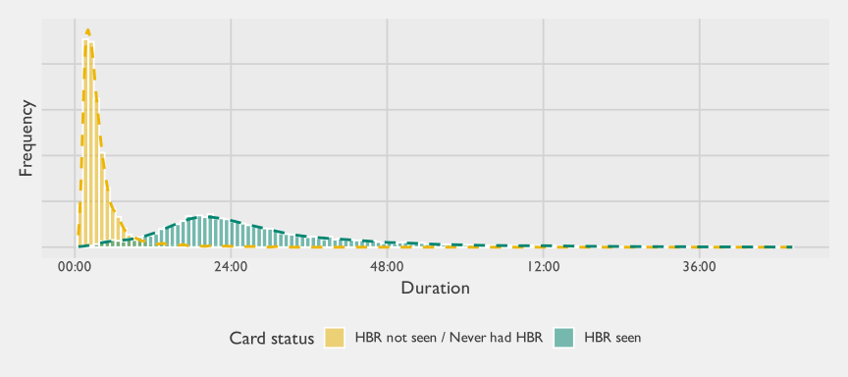
Figure 4.6: Distribution of immunization module duration by vaccination card (HBR) availability. Duration in mm:ss.

Table
Table 4.6: Summary statistics for immunization module duration by HBR card status. All durations in minutes.
HBR Card Status | # Cases | Average  Duration | Median  Duration | 80th Percentile  Duration
HBR not seen / Never had HBR | 7,924 | 4.5 | 3.0 | 5.1
HBR seen | 12,852 | 29.4 | 24.2 | 38.8
In sum, differences in total and survey length will therefore vary greatly on aspects like the number of children to be assessed, as well as other factors such as whether the sampled adult NSUM participant participated in the NSUM module. Figure 4.7 plots these average survey durations for different subsets of respondents.
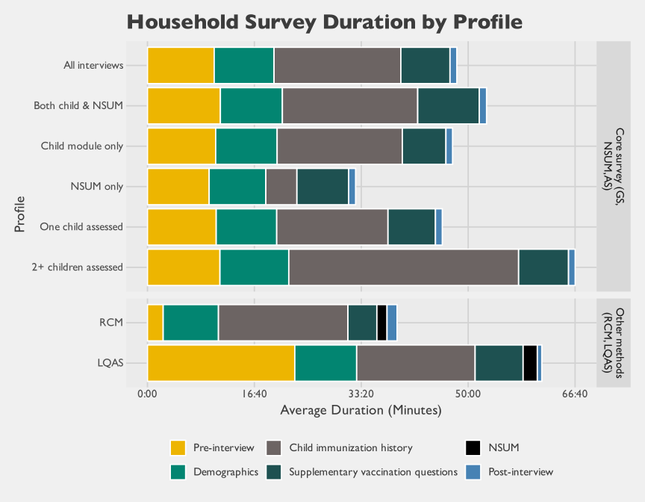
Figure 4.7: Survey duration by profile
The LQAS bar shows a notably large pre-interview share compared to other methods. This reflects a design difference in the LQAS CAPI form: enumerators walked door-to-door within a lot until they completed a single interview with an age-eligible household, logging all screening activity within the same form instance. In contrast, enumerators using the other CAPI forms opened and closed a new form instance for each address attempted — whether or not it resulted in a completed interview — so that pre-interview screening time was distributed across many short instances rather than accumulated in one.
This survey time is both a draw on the time of the paid enumerator conducting the interview and on the respondent, who is not paid by the project for participating. From an economic perspective, respondent time carries an opportunity cost because those hours could otherwise be allocated to paid work, domestic production, care work, or other activities. Using the same time-audit traces, we can describe where those respondent-hours concentrate across household and interview profiles. The tabbed figures below show this concentration by wealth and employment, by Pathways type and employment, and by interview profile and employment. We then monetize those hours in the cost section.

Wealth x Employment
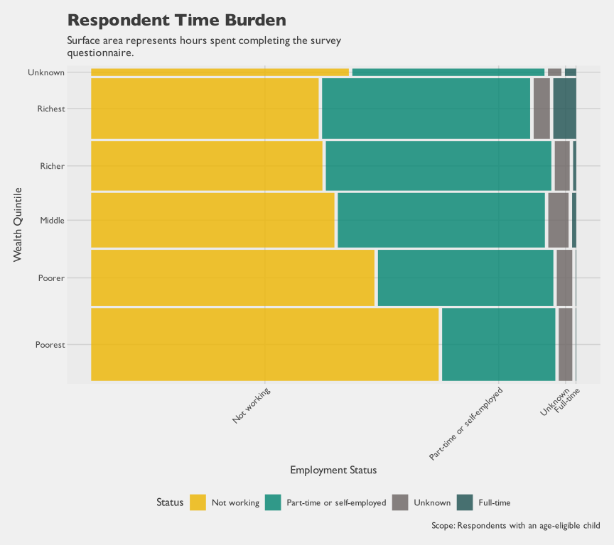
Figure 4.8: Respondent hours by wealth quintile and employment status

Pathways Type x Employment
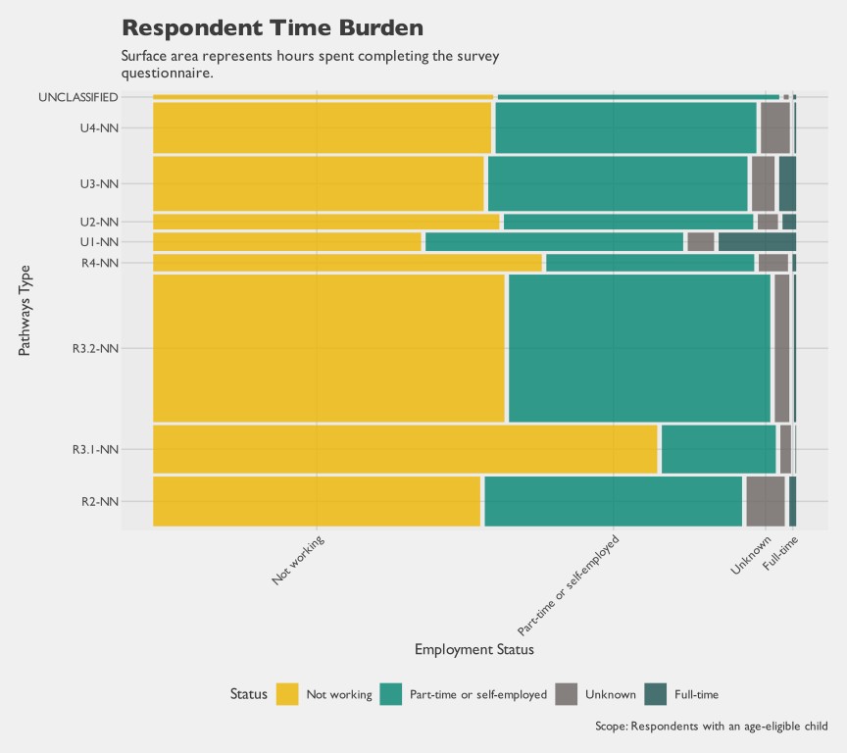
Figure 4.9: Respondent hours by Pathways type and employment status

Interview Profile x Employment
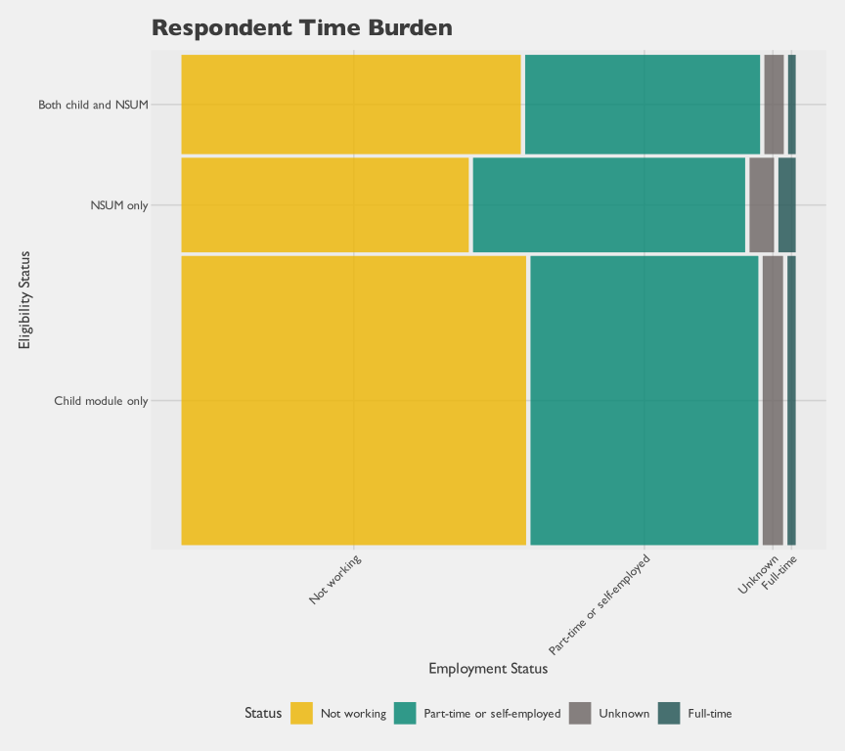
Figure 4.10: Respondent hours by employment status and interview eligibility status
Figure 4.8 shows that respondent time is concentrated among people who report not working. Part-time or self-employed respondents account for most of the remaining hours. Full-time respondents contribute a much smaller share of total interview hours across wealth quintiles. This pattern is consistent with the Gold Standard sampling frame, which targets caregivers of infants and therefore tends to capture respondents with lower full-time labor-force attachment. Figure 4.10 shows that the NSUM-only interview profile has a somewhat higher share of fully employed respondents than profiles that include the child module, although this is still a small sliver of total respondent hours.
Table 4.7: Total respondent interview hours by method
Method | Method Name | Interview Instances | Total Respondent Hours | Share of Total Respondent Hours
GS | Gold Standard | 19,855 | 9,282 | 57.7%
NSUM | Network Scale Up Method | 15,094 | 4,403 | 24.3%
AS | Adaptive Sampling | 7,769 | 2,067 | 14.8%
LQAS | Lot Quality Assurance Sampling | 594 | 508 | 2.7%
RCM | Rapid Convenience Monitoring | 145 | 90 | 0.5%
Beyond typical times, the CAPI data reveal how duration varies by enumerator, location, and stage of fieldwork. Because each action is timestamped and linked to a specific enumerator and location, duration changes can be tracked as enumerators gain experience. This shifts from static description to dynamics: where time goes, what slows or speeds interviews, and how teams improve with experience.
This analysis reveals economies of scale in survey administration time. Using local regression curves, survey duration decreases as enumerators gain experience. Figure 4.11 shows this: a typical enumerator spends 67 minutes on the first interview, 45 minutes by the 50th, and stabilizes around 38 minutes. Testing of other variables–training scores, prior experience–revealed that they added no predictive power.
While specific to this instrument and context, the learning curve is useful for planning: it quantifies predictable improvements that can be budgeted. Planners should treat duration as variable, not fixed. Build in ramp-up time: longer early interviews, structured training, and monitoring for stabilization, not day-one targets. The curve informs staffing and scheduling: how quickly to scale, how many interviews before steady-state productivity, and whether to address early inefficiency through coaching and logistics, not pressure.

Overall Duration
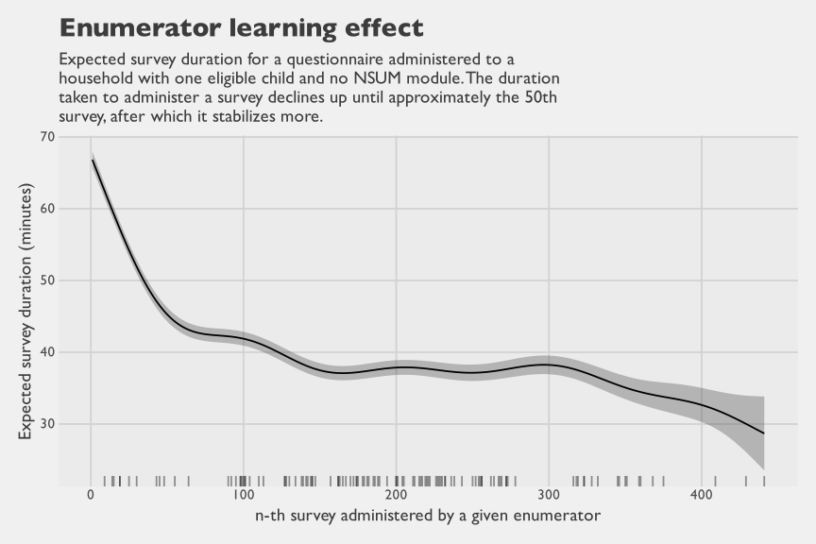
Figure 4.11: Expected overall survey duration as enumerator experience increases

Duration By Section
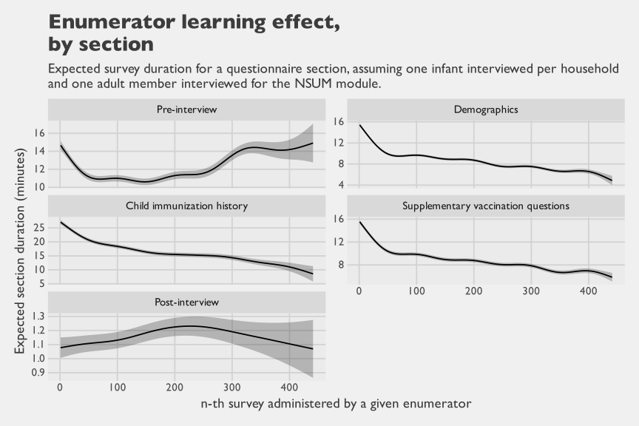
Figure 4.12: Expected survey duration by survey section and sequence

Duration By Subsection
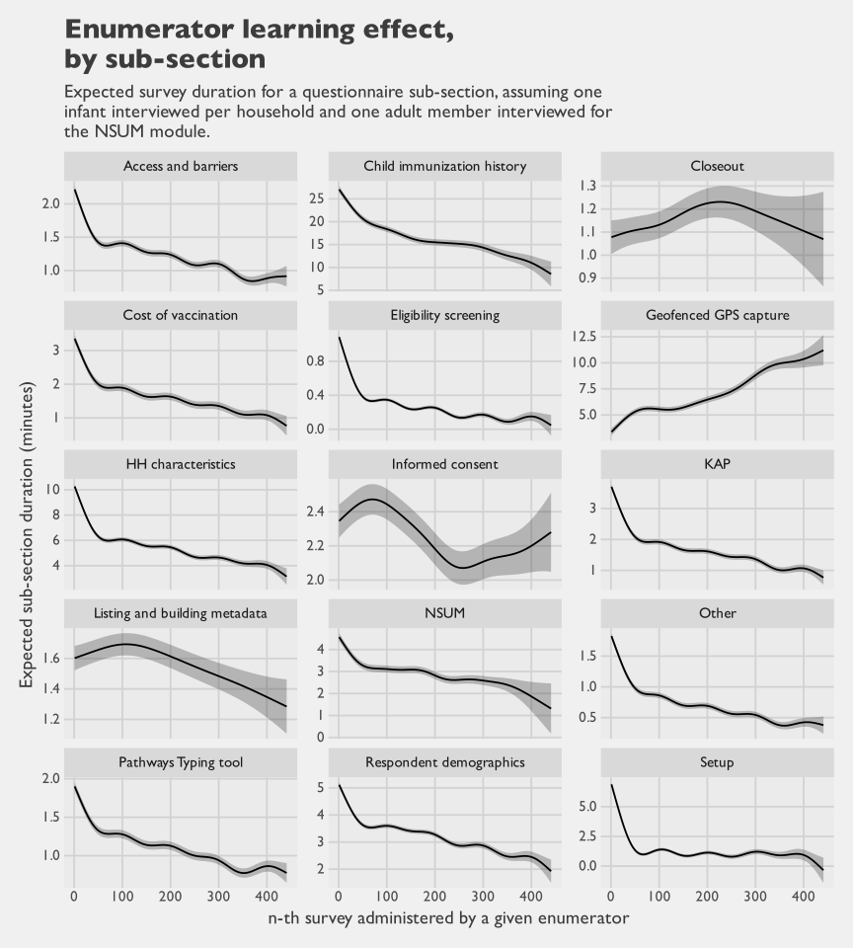
Figure 4.13: Expected survey duration by survey sub-section and sequence
The learning curve summarises how the same enumerator’s expected duration evolves as they accumulate experience. The same multilevel model also estimates a random intercept for each of the 114 enumerators in the analysis, capturing how much an individual’s typical duration sits above or below the population mean once experience and case mix are accounted for. Figure 4.14 orders enumerators from fastest to slowest by their estimated deviation, with vertical bars marking ±1 conditional standard deviation around each estimate. The estimated between-enumerator standard deviation is roughly 8.7 minutes; the gap between the 10th and 90th percentile enumerators is approximately 18.3 minutes (from -9.1 to 9.2 minutes relative to the population mean) on a comparable interview, and the full range spans -15.6 to 34.8 minutes. Persistent between-enumerator differences of this magnitude sit alongside the within-enumerator learning effect: an experienced enumerator at the slow end of the distribution can take longer than a novice at the fast end on an otherwise identical interview.
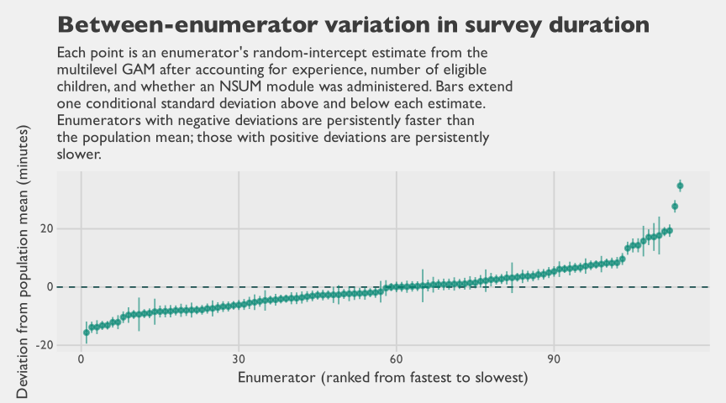
Figure 4.14: Enumerator random-intercept deviations from the overall duration model
Figure 4.13 shows some noteworthy patterns by survey sub-section. While the time to administer subsections decreases for almost all subsections as enumerators progress along their fieldwork, the one clear exception is the time to capture GPS coordinates. This step involves both the task of finding the intended location as well as the task of recording GPS coordinates at a minimum level of accuracy (which can take time if cell reception is poor). While this step starts at approximately four minutes in duration when enumerators start conducing surveys, it gradually increases to approximately 10 minutes by the 300th interview. The most compelling explanation is that in a true probabilistic survey where units are pre-selected, it is common for more difficult cases to be skipped or abandoned by field teams who instead continue with neighboring areas that are easier to find. As the fieldwork progresses, mop-up visits are scheduled with more experienced and trusted enumerators who have proven their skill and competence by completing many other surveys. These skilled enumerators then complete previously missed/skipped cases, but may still find that this takes time as these cases may be more difficult to reach and may be in more remote areas where GPS systems are weaker. As the more difficult cases are re-attempted after initial failed attempts, this duration increase aligns with the enumerator’s experience.
Enumerator learning effects do affect interview duration, but productivity does not increase monotonically over time. Field teams typically complete easier, more accessible cases first; more remote or otherwise difficult cases are deferred and often require repeat visits. Daily yields also fluctuate because eligibility and respondent availability are partly random, so teams may not complete all assigned cases within a day. This creates the need for “mop-up” work, where teams return to previously visited communities to finish a small number of outstanding interviews, increasing travel time and economic cost.
Figure 4.15 illustrates this pattern modeled for Gaya LGA. A regression smoother shows successful interviews per day rising from roughly 3.5 early in fieldwork to about 4.5 midstream as teams gain familiarity, then falling to around 2.5 as remaining cases become more financially costly to complete near the end of data collection. These dynamics illustrate that implementers can sit at very different points on a spectrum of rigor and that this would have implications on time and financial cost. Teams running disciplined probability surveys incur a high financial tail cost from re-attempts and revisits needed to faithfully complete a predetermined sample, while convenience- or quota-based approaches often avoid that tail by substituting easier cases and/or moving on to the neighboring household, potentially introducing selection bias. The result is a structural difference in time and financial cost, and one that is directly linked to the validity of the realized sample.
The informed consent subsection in Figure 4.13 shows a noisier pattern than most other sections. Its error bands are wider largely because this is a very short activity, so small absolute differences translate into larger relative uncertainty, as with other brief steps such as listing and closeout. The fitted trend also suggests a possible increase after roughly 200 interviews, but the uncertainty intervals are wide enough that this could easily be a spurious pattern. A plausible alternative explanation is selection: the most competent enumerators are often assigned harder late-stage cases, and those respondents may require more time and explanation before consenting.
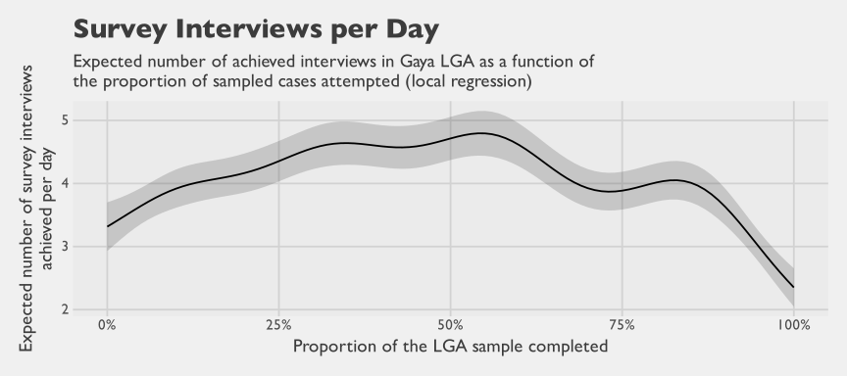
Figure 4.15: Number of daily successful interviews by proportion of sampled cases completed

4.3.1.2 Field Time
Field time tracks an enumerator’s workday outside the survey form. It follows a sequence of operational checkpoints: leaving home, meeting at an assembly point, traveling to the EA, leaving the EA at the end of the day, and returning home. This captures travel and coordination at a scale useful for planning and budgeting.
Enumerators logged checkpoints throughout the day using a CAPI form that captured timestamps, GPS, and vehicle mileage. Because logging was manual, these data are semi-self-reported and prone to missingness or timing errors compared to system-generated timestamps. However, the form was designed to prevent errors: checkpoint times defaulted to current time, GPS was captured automatically, and logic blocked impossible sequences (leaving home after arrival, for example). These safeguards ensured that the data remained clean for day-level analysis.
The daily work-time distribution in Figure 4.16 pools all enumerator-days across the study. Because GS, NSUM, and AS were fielded jointly as a single integrated operation (March 2024–July 2025) with shared logistics, their enumerators share the same daily time profile — referred to here as the Core Survey group. LQAS and RCM were fielded separately (May 2025–July 2025) under distinct operational arrangements; their enumerators’ daily time profiles may therefore differ from the Core Survey. For ARR, enumerators did not complete time-motion forms for the PHC data collection method. A typical administrative method would also be largely desk-based rather than field-based. We therefore exclude ARR from the method-specific estimates.
The Core Survey and LQAS distributions look broadly similar. The RCM distribution is different: enumerators spent an average of 8.4 hours per day, which is much closer to the expected 8-hour workday. That pattern is consistent with the operational design. RCM field workers did not move in teams, so they did not face the same delays from waiting for colleagues to finish interviews. Because RCM used a convenience sample that moved from one nearby household to the next, enumerators also likely spent less time traveling between locations. Nevertheless, not all RCM field days ended at or shortly after 8 hours. Some extended well beyond that point, while others were considerably shorter. The shorter days likely reflect enumerators reaching the 20-child target for that RCM round. The reasons for the longer RCM days are less clear.

All Enumerator-Days
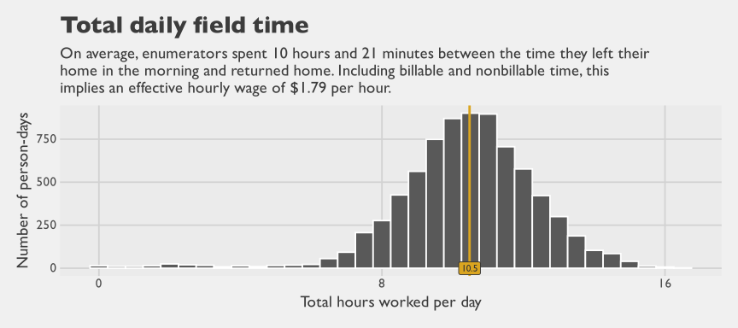
Figure 4.16: Distribution of total daily field time

By Method Group
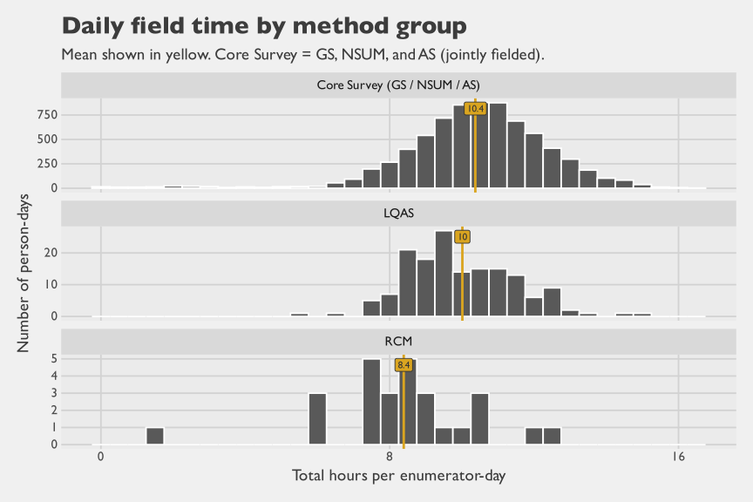
Figure 4.17: Distribution of total daily field time by method group
Table 4.8: Summary of daily field time by method group
Method Group | Enumerator-Days | Mean (hrs)† | Median (hrs) | SD (hrs)
Core Survey (GS / NSUM / AS) | 7,461 | 10.37 | 10.49 | 2.06
LQAS | 157 | 10.01 | 9.73 | 1.55
RCM | 27 | 8.39 | 8.36 | 2.08
†37 enumerator-days in the time-motion data matched to more than one survey method via enumerator ID and date. These mixed days are excluded from per-method distributions and the method summary table.
Figure 4.18 shows when the typical workday began and ended: enumerators left home at 07:41, met the team at 08:20, and departed for the field at 08:40. Table 4.9 then shows how that day was allocated across steps. Enumerators typically spent 7 hours in the EA, but the full workday stretched beyond that once travel and coordination time were included. Morning times were consistent, but end-of-day times varied widely.
Three factors likely explain this end-of-day variability. First, teams typically start the day at a fixed time, but they account for travel time when deciding when to leave the EA. Teams working in more distant EAs often wrap up fieldwork early to allow enough time to return home. Second, teams may extend the day slightly if only one or two scheduled surveys remain in the EA, to avoid making a return visit. Third, although teams can depart immediately in the morning, they often must wait at the end of the day for in-progress interviews to finish before returning home. A typical team consists of a driver and three enumerators; if two enumerators finish near the target end time but the third has just started a 45-minute interview, the others must wait. Together, these factors make return time less predictable.
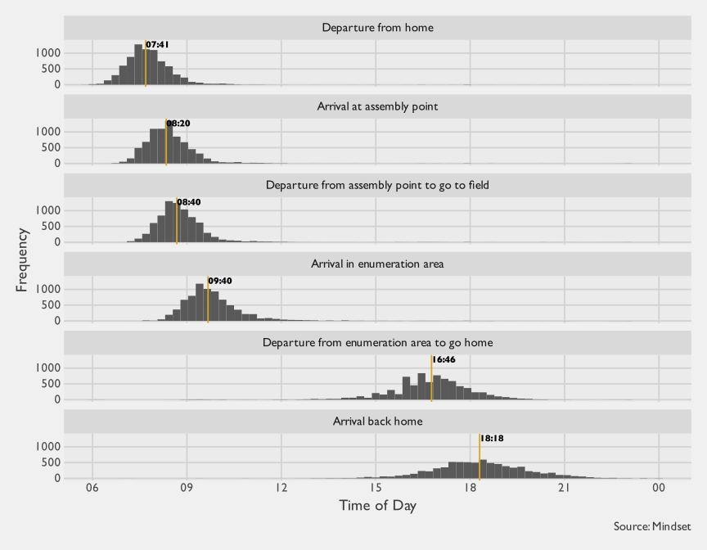
Figure 4.18: Distribution of start times for different processes
Table 4.9: Typical duration for different fieldwork steps within an enumerator’s work day
Step | Median | Mean | 80%  Percentile | Standard  Deviation | 50% Highest Density Interval |  | Weibull fit
 |  |  |  |  | Lower bound | Upper bound | Shape | Scale
Travel to assembly point | 35 min | 39 min | 56 min | 27 min | 14 min | 41 min | 1.85 | 43.04
Waiting time at assembly point | 14 min | 22 min | 36 min | 30 min | 0 min | 14 min | 1.05 | 22.98
Travel time to enumeration area | 54 min | 63 min | 90 min | 57 min | 13 min | 61 min | 1.44 | 68.60
Fieldwork in enumeration area | 7.0 hours | 6.9 hours | 8.0 hours | 94 min | 6.1 hours | 7.7 hours | 5.70 | 443.73
Travel time to go home/hotel | 87 min | 96 min | 2.2 hours | 67 min | 44 min | 103 min | 1.92 | 106.96
Table 4.9 is the main summary table for the enumerator workday. It shows that the day was dominated by work in the EA: the median time in the field was 7 hours, with a mean of 6.9 hours. The 50% Highest Density Interval (HDI) shows where the middle half of durations clustered, which for fieldwork was 6.1 hours to 7.7 hours. The 80th percentile helps show the upper-tail burden relevant for staffing and transport planning: fieldwork reached 8 hours, and travel home reached 2.2 hours.
The table also shows that total day length was not driven by interviewing alone. Travel to the EA typically took 54 min, while the return trip home was longer at 87 min and more variable. Waiting at the assembly point was smaller, with a median of 14 min, so it contributed less to day length than either travel segment or in-EA work.
Figure 4.20 shows the same data as histograms with Weibull curves overlaid. Weibull distribution is used because duration data are positive and right-skewed; it captures both the bulk and tail with two parameters.

Fixed scale
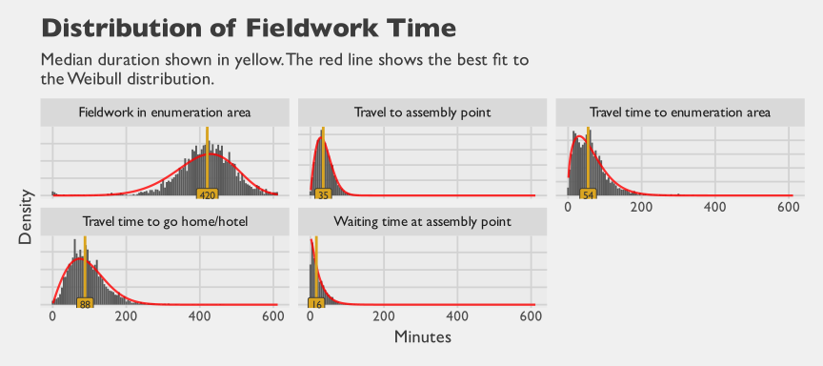
Figure 4.19: Distribution of fieldwork time by component

Free scale
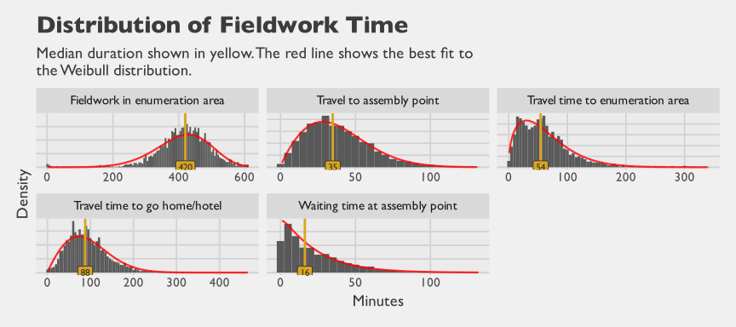
Figure 4.20: Distribution of fieldwork time by component

4.3.1.3 Project Time
Total staff time across the entire project was compiled, including enumerators, permanent staff, and consultants across all phases: planning, data collection, quality control, analysis, and dissemination.
Multiple sources contributed to this compilation. For consultants, billed hours were converted to Level of Effort (LOE), with one LOE unit representing an 8-hour day; for field teams, days were recorded at their daily rate; for permanent staff, budgeted allocations were cross-checked against self-reported time by phase and method, and discrepancies were resolved with finance, aligning permanent-staff totals to reported time.
Allocation detail varies by person and role. For some–consultants with timekeeping software–breakdowns are precise. For others, recall and estimates were used. Total LOE by cadre is well-supported; method-level breakdowns are approximate.
Many activities were shared across methods, especially common research infrastructure. Developing the survey instrument supported all but one method; this work could not be attributed to any single approach. Training had the same pattern. Although some methods required shorter refreshers or protocol-specific components (for example, RCM walk procedures versus pre-selected household visits in the Gold Standard design), much of training time covered shared questionnaire administration, field protocols, and logistics used across methods. Therefore, an ‘All methods’ category was created for shared time.
Two approaches were used to allocate shared time and cost by method. For field teams, time was split proportionally to successful interviews. Field time for NSUM, GS, and AS was split by the proportion of interviews for each. For staff, ‘All methods’ time was split proportionally to their reported allocation for other categories. For instance, if someone reported 2 days as ‘All methods’, 4 for NSUM, and 6 for RCM, the 2 days would be split as follows: 40% to NSUM, 60% to RCM.
Figure 4.21 shows staff by method and employment. Mosaic plots visualize two categorical variables: the width of each slice shows the frequency of one variable, and the height of rectangles within it shows conditional proportions of the other. Area represents share of observations, so larger blocks mean more cases. Similarities across slices suggest independence; shifts suggest association.
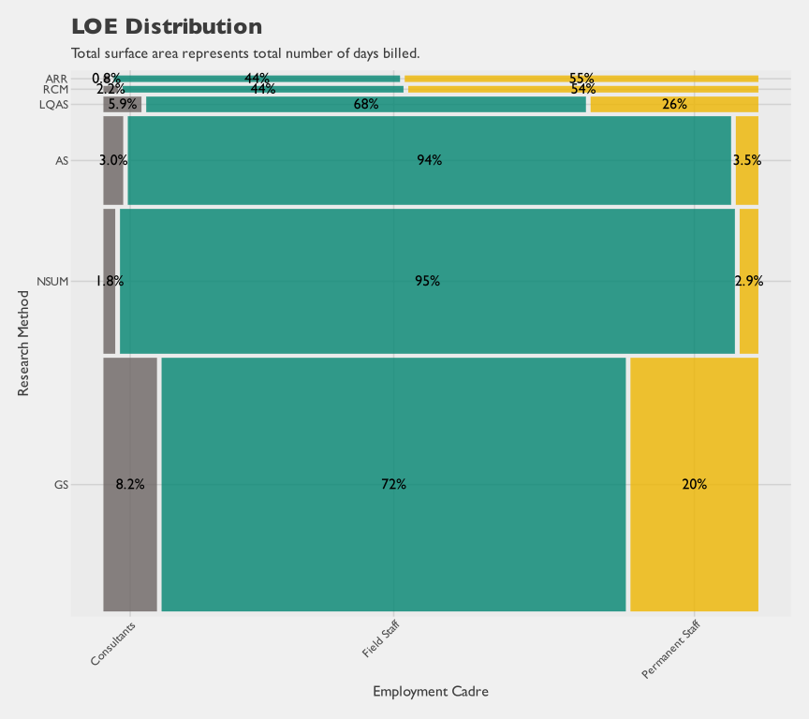
Figure 4.21: Level-of-Effort Distribution for All Employment Cadres
Field teams dominate: roughly three-quarters of overall effort, consistently across methods. Consultants and permanent staff take a larger share in Gold Standard and LQAS.
To see differences among non-field staff, Figure 4.22 excludes field teams and breaks effort by phase. Non-field time spreads more evenly across phases, with smaller shares for monitoring, QA, and dissemination. Phase shares are stable across methods, but consultants contribute less to collection and QA, more to analysis and dissemination.
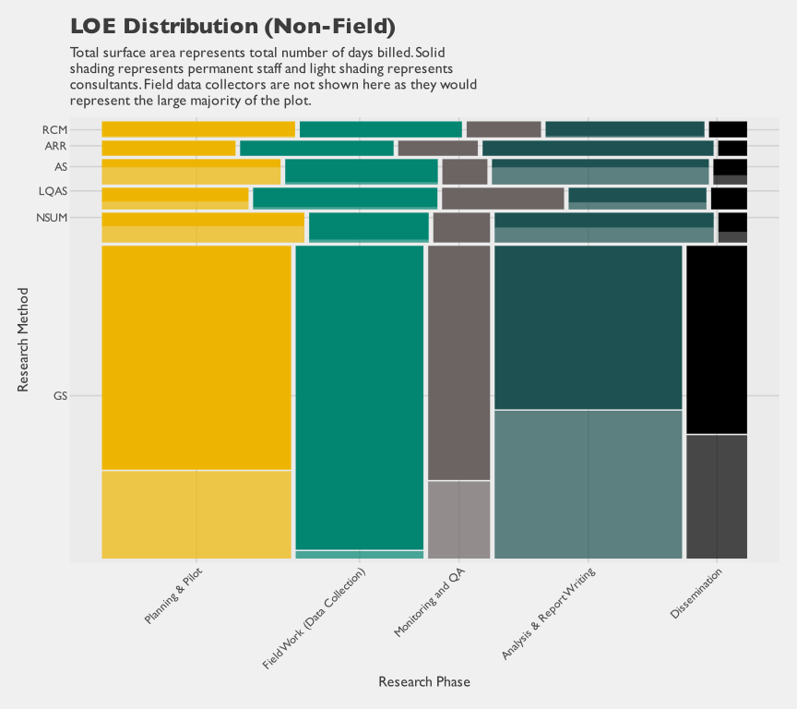
Figure 4.22: Level-of-Effort Distribution for Permanent Staff and Consultants

4.3.2 Cost
Expenditures cover transactions from 2023-04-13 to 2025-12-25. Because nomenclature differs across studies and industries, we stipulate definitions up front and use them consistently throughout. The analyses are organized using two cost distinctions: financial versus economic and total versus marginal. These dimensions clarify both what resources are counted and how costs change as output scales.
The first dimension is about what is counted in furtherance of the research work. Financial cost is what can be traced back to Mindset’s accounting ledger (expenditures, amortization, and other allocated charges). Non-financial cost captures resources consumed that do not appear in Mindset’s ledger, including unpaid staff overtime, unbilled consultant time, and time contributed by stakeholders such as government officials. In principle, definitions of non-financial cost can be broader still, for example including the opportunity cost to respondents of participating in the survey. This chapter includes an estimate of respondent opportunity cost using observed questionnaire duration and respondent socioeconomic proxies. In this study, the sum of financial and non-financial costs is termed the economic cost, reflecting the full mix of paid and unpaid resources required to complete the research.
The second dimension is about what change is being measured. Total cost is the full resource burden of delivering a method at the observed scale, expressed as a summation of costs. Marginal cost is the additional cost of producing one more unit of research output holding fixed costs constant (for example, an additional child measured, household interviewed, or cluster). In practice, marginal cost is an average cost over a specified number of units of output. Marginal cost multiplied by quantity provides a simple variable-cost approximation, which, when added to fixed costs, recovers the corresponding total cost.
$$\text{Total Cost}≈\text{Fixed Cost}+\text{Unit Quantity}×\text{Marginal Cost} \left(4.1\right)$$
Table 4.10 summarizes the terminology and provides concrete examples for each quadrant.
Table 4.10: Cost terminology used in this study
 | (A) | (B) | (A + B)
 | Financial Cost | Non-financial Cost | Economic Cost
Total Cost | Total financial cost consists of the sum of (i) cash expenditures and (ii) amortized capital costs, both taken from Mindset's accounting records and, where needed, fractionally allocated to methods or implementation phases. Matches what the accounting ledger would show for the method at the study scale. Example components: Wages, salaries, fuel costs, amortization of electronic tablets | Total non-financial cost comprises resources consumed in furtherance of the research but not paid by Mindset. Examples: enumerator travel time from/to home; overtime beyond the presumptive 8-hour day; government stakeholder time in meetings; unbilled consultant support; respondent opportunity cost of participation. | Total economic cost comprises the total financial cost plus the total non-financial cost. It is interpreted as the full resource burden of delivering the method at the study scale.
Marginal Cost  (a.k.a., incremental, per-unit) | Marginal financial cost is the expected (i.e., average) per-unit expenditure needed to add one more unit of output (one more respondent, one more cluster, etc.).  Example components: Wages of field enumerators and supervisors (excluding training/pilot), transportation and accommodation costs associated with data collection. | Marginal non-financial cost comprises expected resources consumed but not paid by Mindset for every additional unit of output. Examples: enumerator overtime (beyond 8 hours). In this chapter, we also include respondents' opportunity cost of participation. | Marginal economic cost is the expected (i.e., average) per-unit resources needed to add one more unit of output, whether borne to Mindset or not. Interpreted as the incremental resource burden of scaling output.
A third dimension concerns budgeted versus actual costs. We do not emphasize this distinction here because we do not compare budgets to actuals; all results in this section use actual costs.
Each dimension has its own utility. A budget-to-actuals comparison is most useful for assessing how well plans matched reality, and for quantifying cost uncertainty and the risk of under-budgeting. Within the actual-cost framework used here, total financial cost is most informative for how donors and implementers can price and contract for studies of this type, since it reflects realized expenditures; unit costs can still vary materially with scale and scope. For that reason, marginal cost complements total cost for forward planning and scale-up scenarios, because it approximates how total cost changes with output and helps separate fixed overhead from the additional resources required to add interviews, clusters, or field-days. Finally, total economic cost helps characterize the full resource burden, including unpaid and externally borne time costs.

4.3.2.1 Total Cost
Figure 4.23 displays total financial costs by category. Labor dominates: $910,676, representing 78% of total and substantially exceeding all other categories. Figure 4.24 shows the same breakdown with labor removed, making the smaller non-labor categories easier to compare. Most of these non-labor costs are shared overhead, allocated proportionally to successful interviews by method (Table 4.1). Exceptions include EA map acquisition (specifically for LQAS).

All financial costs
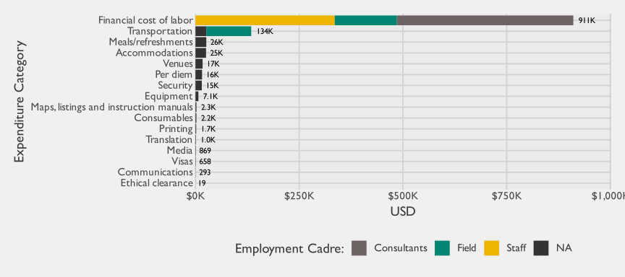
Figure 4.23: Total financial cost by category

Non-labor financial costs
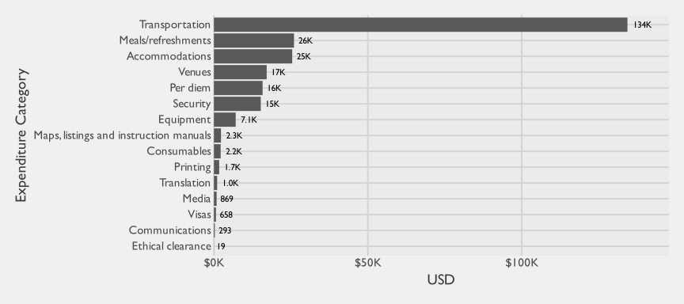
Figure 4.24: Total financial cost by category, excluding labor costs
The next breakdown shifts from cost category totals to where those costs were incurred in field implementation. It decomposes financial spending jointly by method and research phase to show how each method draws on setup, training, and implementation activities.
Table 4.11: Breakdown of total financial costs, apportioned by method and research phase
method | Planning & Pilot | Monitoring and QA | Analysis & Report Writing | Field Work (Data Collection) | Dissemination | Total
GS | $210,706 | $47,550 | $218,123 | $188,647 | $107,198 | $772,224
NSUM | $57,150 | $2,515 | $26,543 | $94,500 | $3,020 | $183,728
LQAS | $11,497 | $4,171 | $8,865 | $16,238 | $1,340 | $42,111
AS | $38,849 | $1,786 | $26,316 | $55,109 | $2,932 | $124,991
ARR | $3,730 | $1,757 | $6,738 | $4,582 | $749 | $17,557
RCM | $5,716 | $1,746 | $5,604 | $6,053 | $1,033 | $20,152
Total | $327,648 | $59,524 | $292,189 | $365,130 | $116,272 | $1,160,763
The table reports the rounded USD values. Because shared analytic and operational effort within the core survey (gold standard, NSUM, and AS) was apportioned across these methods in proportion to successful interview counts, the phase totals index allocated spend per method rather than per-unit analytic or operational difficulty. In particular, the lower analysis-phase spend shown for AS than for the gold standard does not imply that AS is analytically simpler: AS builds on the gold standard’s sample frame, weights, and design-based variance estimation, and a standalone implementation would have to carry that infrastructure on its own. The mosaic that follows emphasizes composition by plotting each method’s phase shares as proportional area.
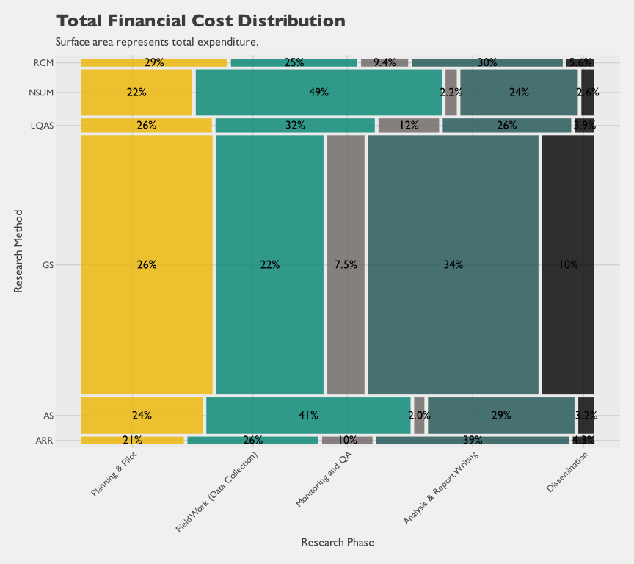
Figure 4.25: Total financial costs by method and research phase
The integrated summary below consolidates economic costs, counts, and per-unit averages in one table.
Table 4.12: Summary of economic costs of head-to-head methods
label | GS | NSUM | AS | LQAS | RCM | ARR
Economic Costs
A. Permanent Staff & Consultants | $573,194 | $63,764 | $60,077 | $30,680 | $17,524 | $16,099
B. Field staff (economic cost) | $146,161 | $110,532 | $60,249 | $11,487 | $3,004 | $1,684
C. Stakeholder (gov't) and respondents | $4,621 | $1,359 | $829 | $150 | $27 | $0
D. Non-labor cost (expenditures + amortization) | $134,162 | $70,908 | $35,500 | $7,713 | $1,647 | $157
Total economic cost (A + B + C + D) | $858,137 | $246,563 | $156,656 | $50,030 | $22,202 | $17,941
Counts
Number of Respondents (Households) | 21,525 | 16,278 | 8,649 | 594 | 145 | 74
Number of Clusters | 1,814 | 1,747 | 330 | 594 | 8 | 74
Averages
Average Cost/Respondent (HH) | $40 | $15 | $18 | $84 | $153 | $242
Average Cost/Cluster | $473 | $141 | $475 | $84 | $2,775 | $242
Table 4.12 reports economic costs, defined here as the sum of financial and non-financial costs, including costs not borne by Mindset. The grouped rows highlight three patterns. First, labor dominates total economic cost, with permanent staff and consultants forming the largest component for most methods and field labor adding a substantial second layer. Second, the stakeholder and respondent component is smaller in dollar terms but still non-negligible, making explicit that implementation draws on unpaid time outside Mindset’s financial ledger. Third, average cost per respondent and per cluster depends strongly on scale. Methods with small operational footprints can show higher per-unit costs because fixed and semi-fixed effort is spread over fewer completed units. RCM illustrates this most clearly: at $2,775 per cluster and $153 per household, its averages are well above those of the other methods, but the underlying drivers are denominator effects rather than expensive fieldwork. The design covered only 8 facility catchment areas (two per stratum), and the pseudo-random walks produced roughly 18 completed households per facility, so fixed overhead, training, supervision, travel, and the geospatial work needed to define each walk corridor are amortized over very small denominators. At the margin, by contrast, RCM costs $16 per additional household and $14 per child assessed—broadly in line with the field rates seen for the larger methods (see Table 4.21). For interpretation, total and average metrics should therefore be read together rather than in isolation.

4.3.2.2 Cost of Labor
Labor is the largest cost and merits detailed attention. The distribution of time across activities and roles is examined, along with how that drives differences in cost and efficiency.

4.3.2.2.1 Financial cost of labor
Figure 4.26 shows financial labor cost by method and cadre.
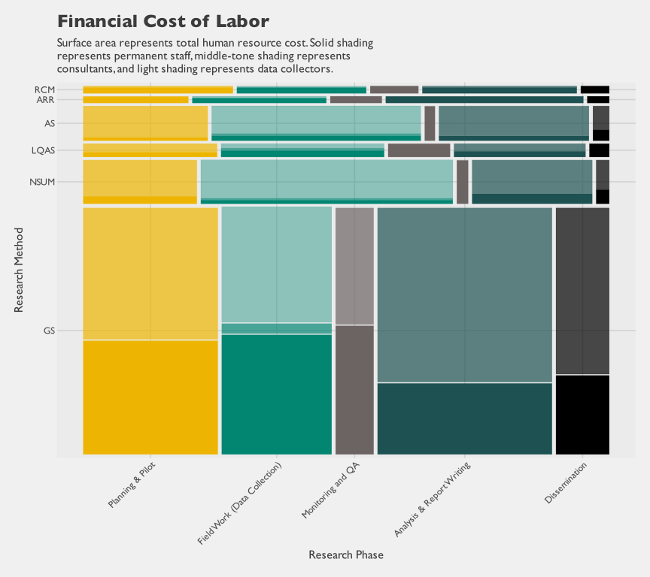
Figure 4.26: Labor cost distribution, by method and employment cadre
Figure 4.27 shows the same data differently, emphasizing method-by-cadre patterns: NSUM and adaptive sampling used more consultants; RCM and ARR relied more on permanent staff.
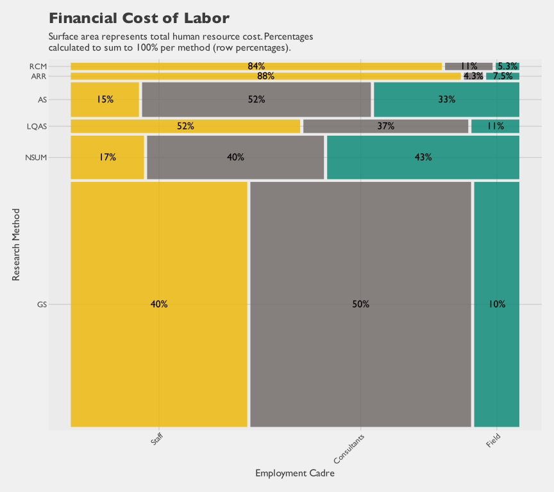
Figure 4.27: Labor cost distribution, by method and employment cadre

4.3.2.2.2 Non-financial cost of labor
Direct and indirect labor costs can be examined. Direct costs capture billable time; indirect costs capture hidden time (unbilled hours, uncompensated participation). This includes unbilled consultant hours, stakeholder time (e.g., government employees), and fieldwork time beyond the 8-hour assumption.
For enumerators, the nominal wage was calculated as $18.50 per day divided by 8 hours, yielding $2.31 per hour. However, actual fieldwork time (including travel to and from home) averaged 10.36 hours per day. As Table 4.9 shows, only 7 hours of a typical day was spent in the EA; the remainder reflected travel to the assembly point, waiting, travel to the EA, and the longer trip home. Dividing the daily wage of $18.50 by those actual hours yields the lower effective hourly wage of $1.79.
The effective hourly wage varies by method because GS/NSUM/AS, LQAS, and RCM were fielded under different operational arrangements with potentially different daily field durations. Table 4.14 shows the method-specific effective wages derived from matched time-motion data.

Overall
Table 4.13: Nominal vs effective hourly wages for enumerators
Type | Components | Formula | Amount (USD)
Nominal hourly wage | billable | $18.5 per day / 8 hours | $2.31
Effective hourly wage | billable + non-billable | $18.5 per day / 10.36 hours | $1.79

By method
Table 4.14: Nominal vs effective hourly wages by method, using per-method field time
Method | Time-Motion Group | Enumerator-Days | Mean Daily Hours | Nominal Wage (USD/hr) | Effective Wage (USD/hr)
Gold Standard | Core | 7,461 | 10.37 | $2.31 | $1.78
NSUM | Core | 7,461 | 10.37 | $2.31 | $1.78
Adaptive Sampling | Core | 7,461 | 10.37 | $2.31 | $1.78
LQAS | LQAS | 157 | 10.01 | $2.31 | $1.85
RCM | RCM | 27 | 8.39 | $2.31 | $2.21
Table 4.15 compares the two: the direct financial cost of $257,178 increases substantially to $332,448 when hidden enumerator time is included, using method-specific field hour estimates.
Table 4.15: Financial cost, non-financial (hidden) cost, and total economic cost of field labor, using per-method effective hours
Method | Billable hours | Non-billable hours | Time-motion-adjusted hours  (billable + non-billable) | Financial cost  (A) | Non-financial cost  (B) | Total economic cost  (A+B) | Mean field hours  (used)
GS | 28,051 | 8,316 | 36,368 | $112,841 | $33,454 | $146,295 | 10
NSUM | 21,213 | 6,289 | 27,502 | $85,335 | $25,299 | $110,634 | 10
AS | 12,719 | 3,771 | 16,490 | $46,514 | $13,790 | $60,304 | 10
LQAS | 1,608 | 405 | 2,013 | $8,868 | $2,231 | $11,100 | 10
RCM | 424 | 21 | 445 | $2,320 | $113 | $2,432 | 8
ARR | 416 | 123 | 539 | $1,300 | $384 | $1,684 | 10
Total | 64,432 | 18,924 | 83,356 | $257,178 | $75,270 | $332,448
Stakeholder time also contributes meaningfully to total labor input, especially from government agencies participating in training, engagement, supervision, and technical sessions. To make those contributions visible, we summarize stakeholder-reported hours and their implied USD value using the stakeholder costing target. In the terminology used in this report, stakeholder labor is a non-financial cost when it is not paid by Mindset but is still required to execute the work. When that time is valued in USD, it contributes to economic cost rather than direct financial cost.
Mindset attempted to quantify this non-financial stakeholder contribution using project records. The Mindset project manager estimated stakeholder-by-stakeholder participation time from meeting minutes, attendance records, training records, and related engagement documentation. For government stakeholders, role-linked pay scales are publicly accessible, so time could be valued using salary levels aligned to the reported role grade. Those values are treated as economic opportunity cost rather than financial expenditure, because Mindset did not directly pay those government salaries. In total, stakeholders contributed an estimated 971 hours of non-financial labor input, valued at approximately $1,401 in economic-cost terms across 45 individuals from 8 organizations. Most of this value came from government participants, who accounted for 99.4% of the estimated stakeholder USD contribution. For reporting stability, agencies with fewer than five observations are grouped into an “other” category, yielding 3 agency groups in the table below. The largest contributing named agencies were the SPHCMB and Kano Bureau of Statistics (KNBS). These results indicate that stakeholder participation was not limited to nominal attendance. Reported time concentrated in operationally relevant activities such as training and monitoring, engagement meetings, technical sessions, and dissemination support.
Table 4.16: Estimated non-financial stakeholder labor contribution by agency
Contributor Type | Agency | Individuals | Total Hours | Estimated Economic Value (USD) | Share of Stakeholder Value
Government | SPHCMB | 32 | 621 | $1,080 | 77.0%
Government | KNBS | 7 | 280 | $200 | 14.3%
Government | Other | 5 | 65 | $113 | 8.1%
Non-government | Other | 1 | 5 | $8 | 0.6%
The agency table identifies who contributed the largest share of stakeholder time. The activity table then shows what that time was used for. Most engagement time was concentrated in meetings and coordination activities, with training also representing a meaningful secondary share.
Table 4.17: Estimated non-financial stakeholder labor contribution by primary activity
Primary Activity | Individuals | Total Hours | Estimated Economic Value (USD) | Share of Stakeholder Value
Engagement Meeting | 38 | 691 | $1,201 | 85.7%
Training/Monitoring | 7 | 280 | $200 | 14.3%
Respondent time is also a non-financial input to the study. The 37,529 completed interviews in this costing set account for 17,909 respondent hours in total. From an economic perspective, these hours represent respondent opportunity cost. That opportunity cost is not identical across households and is not limited to observed cash earnings. Many respondents are women with limited formal labor-force participation, but their time still has substantial economic value through childcare, household production, and other unpaid work. Estimating household-specific non-market time value is a separate research exercise, so this chapter uses a simpler, transparent, tractable valuation rule for comparative costing. The base hourly benchmark uses the NGN 70,000 federal minimum monthly wage (National Salaries, Incomes and Wages Commission (NSIWC) (2024)), converted to hourly terms and then adjusted by wealth quintile. Wealth multipliers are calibrated to national deflated consumption quintile means from the Nigeria Living Standards Survey (NLSS) 2019–2020 (National Bureau of Statistics (NBS) (2020)), normalized to the middle quintile. Because the household wealth index is estimated from the completed child-module household frame, many NSUM-only interviews do not have an estimable wealth quintile and are classified as unknown in these respondent-cost summaries.
Table 4.18: Wealth multipliers used in respondent opportunity-cost valuation
Wealth Quintile | Multiplier
Poorest | 0.438x
Poorer | 0.715x
Middle | 1.000x
Richer | 1.400x
Richest | 2.615x
Unknown | 1.000x
The assumptions table is intentionally narrow and only reports the wealth multipliers used in the base valuation. The next table applies those multipliers to observed respondent minutes and reports the resulting implied economic values overall and by method.
Table 4.19: Estimated respondent opportunity cost overall and by method (base valuation)
Method | Method Name | Completed Interviews | Respondent Hours | Estimated Economic Value (USD) | Implied USD per Hour | Share of Respondent Value^{b}
ALL | All methods (total) | 37,529 | 17,909 | $6,053 | $0.34 | 100.0%
GS | Gold Standard | 19,855 | 9,282 | $3,228 | $0.35 | 57.7%
NSUM | Network Scale Up Method | 15,094 | 4,403 | $1,359 | $0.31 | 24.3%
AS | Adaptive Sampling | 7,769 | 2,067 | $829 | $0.40 | 14.8%
LQAS | Lot Quality Assurance Sampling | 594 | 508 | $150 | $0.29 | 2.7%
RCM | Rapid Convenience Monitoring | 145 | 90 | $27 | $0.30 | 0.5%
^{b}Method shares are normalized across method rows and sum to 100%; overlapping interviews/modules are apportioned across methods.
Table 4.19 apportions respondent time across interview modules and reports both the all-method total and method-specific values in one table. When a completed case contains both child and NSUM interviews, time is split equally across those two modules for method-level accounting.
Table 4.20: Estimated respondent opportunity cost by wealth quintile (base scenario)
Wealth Quintile | Completed Interviews | Respondent Hours | Estimated Economic Value (USD) | Share of Base-Scenario Value
Richest | 3,880 | 2,586 | $1,996 | 33.0%
Richer | 3,280 | 2,101 | $868 | 14.3%
Middle | 3,690 | 2,325 | $686 | 11.3%
Poorer | 4,011 | 2,385 | $503 | 8.3%
Poorest | 5,420 | 3,097 | $400 | 6.6%
Unknown | 17,248 | 5,416 | $1,599 | 26.4%
As discussed in Section 4.4.3, these USD valuations should be interpreted as exchange-rate contingent. They are useful for cross-method comparability in a single reporting frame, but macroeconomic shifts in the naira can materially change the USD expression of the same local-currency effort.

4.3.2.2.3 Total economic cost of labor
Financial and non-financial labor costs can be read together as total economic labor cost. For each method, we combine:
- permanent staff and consultant labor (financial),
- direct billable field labor (financial),
- hidden field labor from non-billable time (non-financial), and
- stakeholder and respondent opportunity cost (non-financial).
Figure 4.28 shows how the composition shifts across methods. Across all methods combined, financial labor remains the larger share, while non-financial labor still contributes a visible portion of total labor cost.
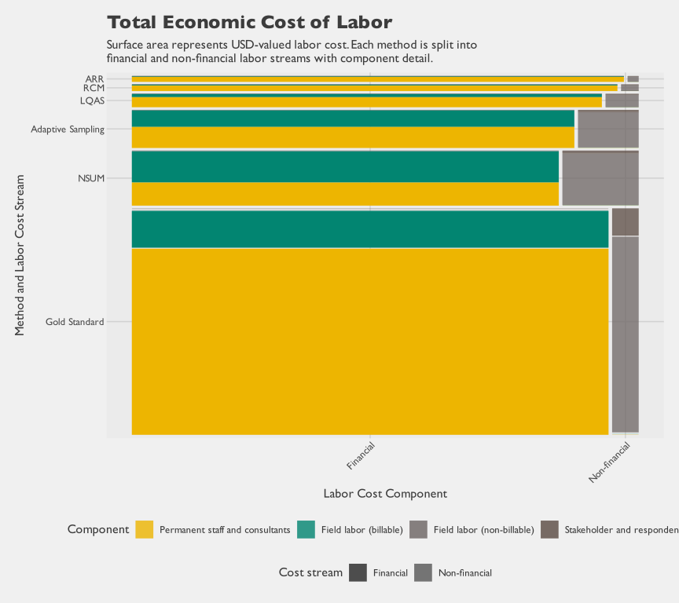
Figure 4.28: Total economic labor cost composition by method (financial and non-financial)

4.3.2.3 Marginal Cost
Previous sections reported total and average costs. However, averages incorporate fixed costs (questionnaire design, overhead) that do not scale with sample size. Marginal costs isolate what actually scales: the variable field effort to interview additional cases and visit additional clusters. These support future planning and scenarios.
Table 4.21 reports marginal costs per additional child, household, and cluster. It also reports per-LGA averages of the same direct field costs, to support coarser, funder-oriented budget comparisons. These isolate variable field costs–what actually changes with sample size–excluding fixed components like planning, training, programming, and analysis.
Marginal rates should be interpreted as averages, not constants. Fieldwork speed varies: teams accelerate after training, then slow again near the end (mop-up work). Despite this variation, marginal costs are useful for planning: they enable estimation of variable costs for different sample sizes.
Unit-level costs do not differ substantially across methods. Large differences in total cost arise from sample size and operational scope, not marginal rates. This distinction is important for planning: resource constraints and precision goals may imply very different sample sizes than those used in this study. For an interactive planning tool that integrates empirical findings from this chapter with sample size assumptions to estimate expected cost, see the sample-size calculator in Appendix B. For adaptive sampling, the row labeled “Adaptive Sampling (Supplement)” in Table 4.21 represents only the adaptive supplement (the additional hotspot-directed visits after the initial sample). The initial sample draw is grouped under the core survey because those households were visited through the same shared Gold Standard + NSUM fieldwork that also generated the hotspot inputs for adaptive targeting.
Table 4.21: Marginal financial costs of completing interviews
Method | Level of Effort for Field Staff | Marginal Financial Costª | Children Assessed |  | Households Interviewed | Clusters Visited | Children Assessed per Cluster | Marginal Financial Cost per...
Method | Level of Effort for Field Staff | Marginal Financial Costª | 12-23 mo | 0-23 mo | Households Interviewed | Clusters Visited | Children Assessed per Cluster | Child  (0-23) | Child  (12-23) | HH | Cluster | Lot  (Ward) | LGA | Facility | RCM
Method | days | USD | # | # | # | # | # | USD | USD | USD | USD | USD | USD | USD | USD
Core (Conventional + NSUM) | 7,408 | $238,400 | 11,263 | 23,617 | 21,525 | 2,097 | 11.3 | $10.09 | $21.17^{b} | $11.08 | $113.69 |  | $15,893.33
Adaptive Sampling (Supplement) | 340 | $6,290 | 531 | 1,063 | 976 | 45 | 23.6 | $5.92 | $11.85^{b} | $6.44 | $139.78 |  | $524.17
LQAS | 201 | $8,868 | 594 |  | 594 | 594 | 1.0 |  | $14.93 | $14.93 | $14.93 | $277.14 | $2,956.17
RCM | 53 | $2,320 | 167 |  | 145 |  |  |  | $13.89 | $16.00 |  |  | $331.36 |  | $289.94
ARR | 52 | $1,300 |  |  |  |  |  |  |  |  |  |  | $76.47 | $17.57
ªMarginal financial costs include wage payments made to enumerators and supervisors for field work related to listing, interviewing, and quality assurance. It includes costs for travel and accommodation necessary for field work, but excludes training costs for field staff, and excludes overhead.
^{b}Marginal costs for children 12-23 for the core and adaptive sample are over-estimates, as they do not net out costs incurred by enumerators assessing children aged 0-11 months.
^{c}LGA denominators reflect each method's design scope. LQAS's n=3 covers only the sentinel LGAs by design. ARR's n=17 includes the 15 study LGAs plus 2 (Kano Municipal and Makoda) that were withdrawn from the study after data collection had already begun.

4.3.3 Precision
The decision objective is to compare methods on accuracy relative to resource use. Accuracy, however, has two components: bias and precision. Bias reflects systematic error and does not necessarily improve with larger sample sizes. Precision reflects random sampling error and does improve predictably as sample size increases.
For this comparison, we treat the Gold Standard as the best available benchmark against which the other methods are evaluated. Among the methods studied, it has both the most extensive protocols for limiting bias and a sample large enough to make the resulting estimate highly precise; together these properties make it the closest available approximation to true coverage. No household survey is entirely free of instrumentation or recall error, but the alternatives here depart from plausibility by a different order of magnitude: ARR can imply coverage above 100% in some clusters, and NSUM estimates diverge substantially from the Gold Standard. The precision-cost analysis that follows therefore focuses on the Gold Standard, whose larger sample also supports the more detailed analyses; under explicit assumptions, it asks how much uncertainty can be reduced for a given budget. The NSUM precision curves are shown for theoretical context, but they are not the basis of the planning conclusions that follow. A useful starting point is the theoretical relationship between precision and sample size under negligible bias. Figure 4.29 isolates sampling error and shows how margins of error decline as sample size increases under different design-effect assumptions. This establishes a baseline from statistical theory before the next subsection adds cost.

Proportions
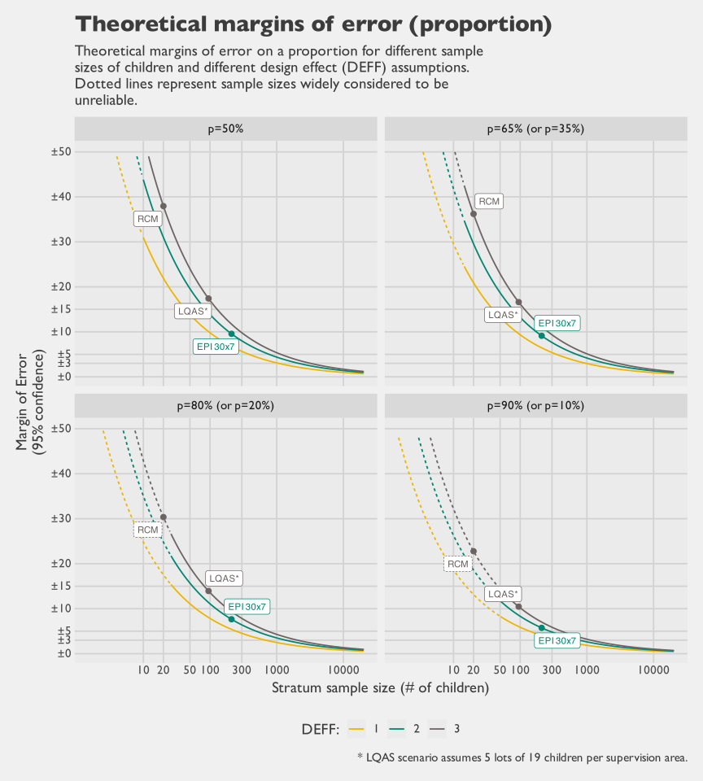
Figure 4.29: Theoretical margins of error on a proportion (95% confidence level)
This panel provides a lower-bound planning view under idealized assumptions. The next panel applies the same logic to NSUM, where effective information depends on both respondent count and reported network degree.

NSUM Estimates
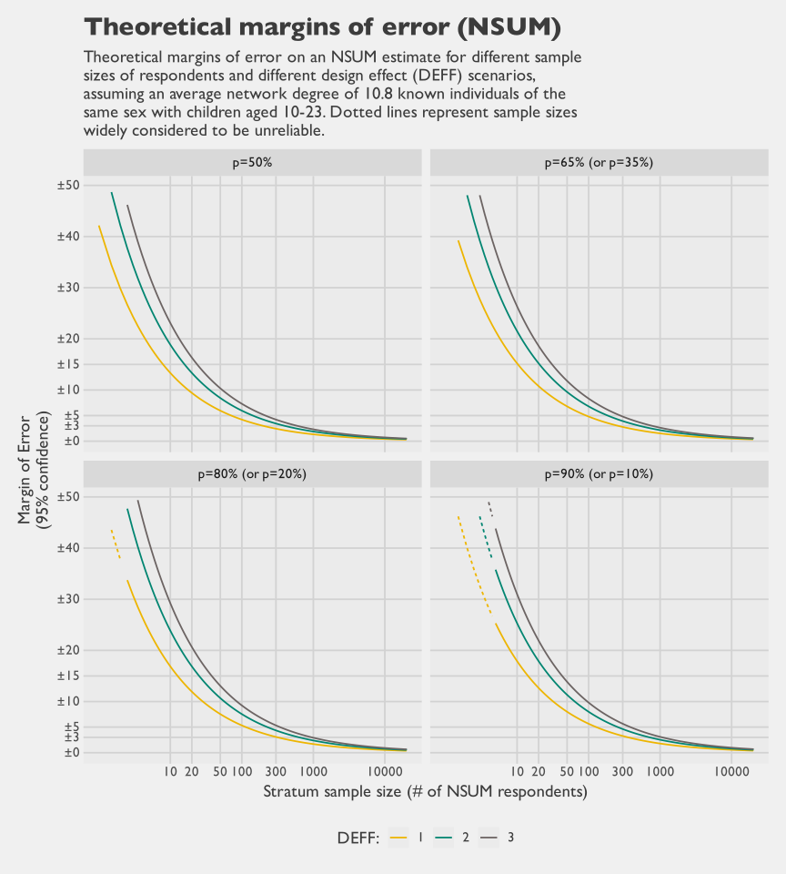
Figure 4.30: Theoretical margins of error on an NSUM estimate (95% confidence level)
Taken together, the proportion and NSUM curves show the same structural tradeoff. Meaningful gains in precision require rapidly increasing sample sizes once margins of error move into low single digits.

4.3.3.1 Precision Relative to Cost
The theoretical curves above isolate how sampling error scales with sample size. Planning decisions, however, are made in budget space rather than sample-size space. To connect the two, we map theoretical precision to expected cost under two accounting perspectives. The marginal perspective uses direct field implementation cost per additional completed interview. The total perspective uses total financial cost from project expenditure records. This subsection is therefore a financial-cost planning view and does not include non-financial cost components (for example, respondent and stakeholder time valuation). This framing makes diminishing returns explicit and helps distinguish choices that are cost-feasible from those that are only statistically desirable in principle. For this subsection, we narrow the operational precision-cost analysis to the Gold Standard design and parameterize uncertainty with design effects of 1.5, 2, and 3. All other methods are excluded from the precision-cost analysis for method-specific reasons. NSUM and administrative approaches are excluded because the empirical results in this study showed substantial bias. RCM is excluded because it is operationally anchored to a fixed sample size of 20, so sample-size scaling is not decision-relevant. LQAS is excluded because planning is usually based on lot-classification error properties, and pooled prevalence precision additionally requires lot-population structure and representativeness inputs that vary by application. Figure 4.31 and Figure 4.32 then show the precision-cost tradeoff curves under marginal and total financial perspectives. Figure 4.33 shows how much additional precision each increment of spending buys as sample size scales.

Marginal Cost Tradeoff
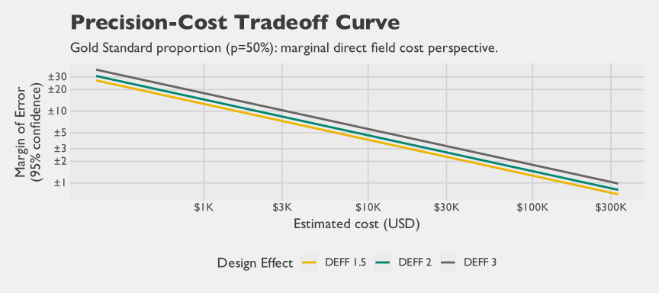
Figure 4.31: Precision-cost tradeoff curve for Gold Standard proportion estimands (marginal direct-field cost perspective)

Total Cost Tradeoff
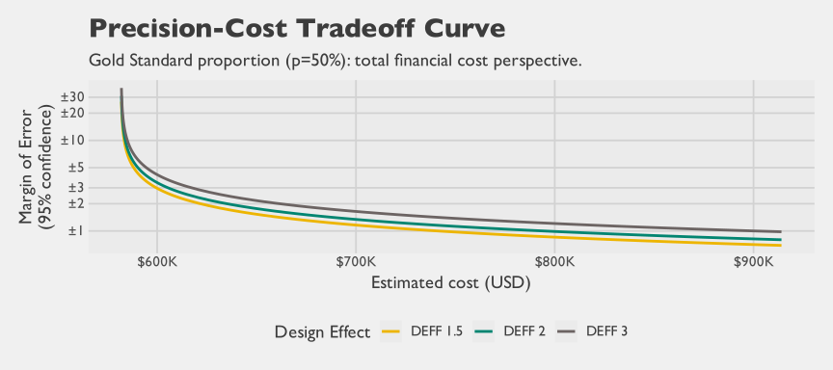
Figure 4.32: Precision-cost tradeoff curve for Gold Standard proportion estimands (total financial-cost perspective)

Proportion Incremental Gain per USD
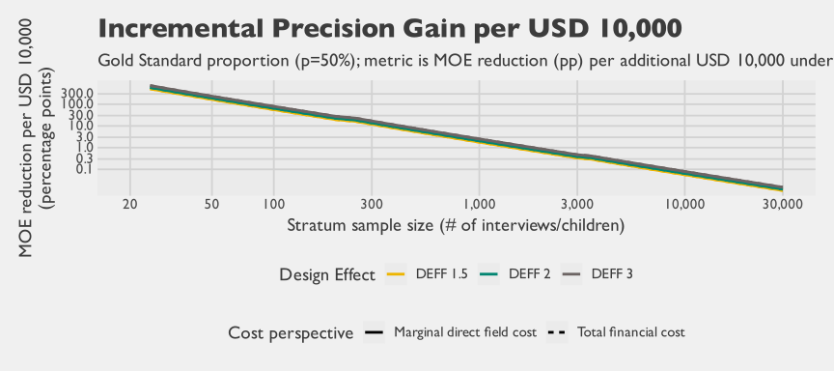
Figure 4.33: Incremental precision gain per USD as sample size scales (Gold Standard proportion estimands; marginal direct-field vs total financial cost)
The tradeoff curves in Figure 4.31 and Figure 4.32 show the same qualitative pattern as the sample-size curves, but in more decision-relevant units. Moving from high uncertainty to moderate uncertainty is comparatively inexpensive. Moving from moderate uncertainty to low single-digit margins requires disproportionately larger resources. The incremental-gain curve in Figure 4.33 quantifies that same pattern as an efficiency curve. Early increments in sample size buy relatively large information gains per dollar, while later increments buy progressively less. The log-scaled axes make this curvature easier to see across low- and high-cost ranges in a single view, and the DEFF curves show the sensitivity of requirements to clustering.
To keep the chapter readable, Table 4.22 presents a compact Gold Standard view under the total financial-cost perspective with DEFF sensitivity, including a ±3% MOE target. Expanded Gold Standard tables (including marginal direct-field and total financial perspectives across all thresholds and budgets) are provided in the Technical Details appendix of the full methodological report. Fixed and overhead cost structures can vary substantially across implementing agencies and across funder preferences for quality assurance intensity. The values in Table 4.22 are calibrated to the observed financial cost structure in this study, which was relatively cost-intensive under the Gold Standard implementation model. For scenario planning under alternative assumptions, use the interactive calculator in Appendix B to vary cost structure, marginal cost, and DEFF inputs.
Table 4.22: Cost implications of selected precision thresholds (Gold Standard, total financial-cost perspective)
DEFF | Target MOE (95% CI) | Required n | Fixed Financial Cost (USD) | Variable Financial Cost (USD) | Total Financial Cost (USD) | Incremental Total Financial Cost from Previous Threshold (USD)
1.5 | 15.0% | 65 | $581,797 | $720 | $582,517 | $310
2.0 | 15.0% | 86 | $581,797 | $952 | $582,749 | $410
3.0 | 15.0% | 129 | $581,797 | $1,429 | $583,225 | $620
1.5 | 10.0% | 145 | $581,797 | $1,606 | $583,403 | $886
2.0 | 10.0% | 193 | $581,797 | $2,138 | $583,934 | $1,185
3.0 | 10.0% | 289 | $581,797 | $3,201 | $584,997 | $1,772
1.5 | 7.5% | 257 | $581,797 | $2,846 | $584,643 | $1,240
2.0 | 7.5% | 342 | $581,797 | $3,788 | $585,584 | $1,650
3.0 | 7.5% | 513 | $581,797 | $5,682 | $587,478 | $2,481
1.5 | 5.0% | 577 | $581,797 | $6,391 | $588,187 | $3,544
2.0 | 5.0% | 769 | $581,797 | $8,517 | $590,314 | $4,729
3.0 | 5.0% | 1,153 | $581,797 | $12,770 | $594,567 | $7,088
1.5 | 3.0% | 1,601 | $581,797 | $17,732 | $599,528 | $11,341
2.0 | 3.0% | 2,135 | $581,797 | $23,646 | $605,443 | $15,129
3.0 | 3.0% | 3,202 | $581,797 | $35,464 | $617,260 | $22,694
These estimates depend on two simplifying assumptions. First, fixed costs are allocated from observed project totals and treated as method-specific constants over the planning range. Second, variable cost is treated as linear in achieved interviews. Both assumptions are useful for transparent planning, but both can shift in new settings where staffing models, logistics, or supervision structures differ.
Taken together, these views show that precision-performance cannot be interpreted without a cost frame. In operational settings, a method may appear attractive by sample-size theory alone but become infeasible once fixed and semi-fixed economic costs are recognized. Conversely, some high-uncertainty designs may still be efficient for screening or supervisory use when decision thresholds are coarse and speed is prioritized.

4.4 Discussion

4.4.1 Time and Cost Drivers
The analysis shows that total cost differences across methods were driven more by scope and fixed effort than by large differences in marginal field effort per interview. Methods with broader implementation footprints and larger setup demands accumulated higher total costs even when per-unit field costs were closer. This pattern is visible in the apportioned phase-by-method breakdown, where preparation, management, and analytical work remain substantial contributors alongside interviewing.
Labor structure also matters as much as labor volume. Field implementation contributes most hours, but specialist analytical and technical roles account for a disproportionate share of financial expenditure. For planning and comparison, this means that reducing interview duration alone cannot fully control budgets if higher-cost analytical phases remain unchanged.

4.4.2 Economic Cost Framing
This chapter estimates economic cost as the sum of financial expenditure and non-financial labor contributions from respondents and stakeholders. That broader framing changes interpretation. A method that appears less expensive in budget terms can still impose substantial unpaid time costs on households and government partners.
Respondent burden is especially important in this setting. Survey participation consumes real time from caregivers who are not paid by the project, so that time has an opportunity cost even when no financial transaction occurs. Including these inputs makes cross-method comparisons more transparent about total resource use from society’s perspective, not only the implementing agency’s accounts.

4.4.3 Exchange Rates
Interpreting costs in USD requires care in a period when the naira-to-dollar exchange rate moved sharply and domestic prices were also rising. Nigeria’s official exchange rate rose from about 426 naira per dollar in 2022 to 645 in 2023 and 1,479 in 2024, implying a large decline in the naira’s USD value over a short period (World Bank 2026b). At the same time, annual Consumer Price Index (CPI) inflation was also elevated, rising from 18.8 percent in 2022 to 24.7 percent in 2023 and 33.2 percent in 2024 (World Bank 2026a). The foreign exchange market reforms initiated in 2023, including window unification and the willing-buyer willing-seller approach, were part of this macroeconomic transition (Central Bank of Nigeria 2025; International Monetary Fund 2024).
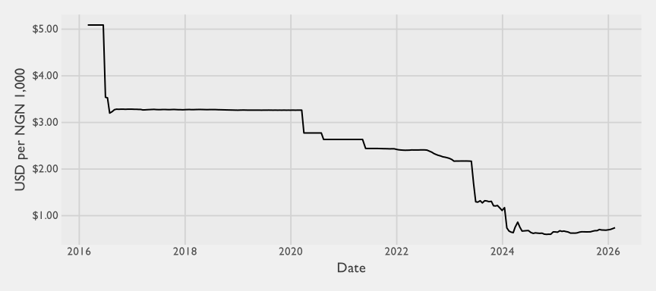
Figure 4.34: Daily naira-to-dollar exchange rate over time (USD value of NGN 1,000)
The trend in Figure 4.34 is based on a daily middle-rate series.
These shifts affect interpretation in two directions. First, for naira-denominated inputs, conversion to USD is highly sensitive to the exchange rate year used. In this report, we use a fixed exchange rate of 0.00074 USD per naira (equivalently, about 1,347 naira per USD). Second, inflation means that naira costs themselves were changing over time, so comparing USD totals across years without deflation or normalization can mix price-level effects with real resource use. The International Monetary Fund (IMF)’s 2024 and 2025 Article IV communications also emphasize this joint movement of exchange-rate adjustment and high inflation in the transition period (International Monetary Fund 2024, 2025).
A simpler way to read magnitudes is to compare exchange-rate levels directly. As shown in Figure 4.34, the shift is not a small year-to-year fluctuation but a large structural change over a short period. In this series, the naira’s USD value a few years ago (around 2022) was roughly three times higher than in 2024–2026 levels. Relative to the mid-2010s, it was roughly six to seven times higher. The same local-currency cost can therefore look about 3x larger in USD under 2022 rates, and about 6–7x larger under mid-2010s rates. For a project like this one, where labor costs span borders and some inputs are paid directly in USD while others are paid in naira, this can materially distort interpretation of relative cost structure. A composition that appears consultant-heavy or internationally expensive under one exchange-rate frame may have looked very different a few years earlier under a different naira-dollar regime.
For planning and budgeting, USD conversion still serves a practical purpose because real project expenditures are often settled in dollars, especially when donor funding is denominated in USD. At the same time, interpretation requires two cautions. First, the external validity of USD-denominated findings depends on exchange-rate stability. For example, if the same observed enumerator time inputs had been valued under 2015 exchange-rate conditions, the USD cost of field data collection alone would have appeared roughly six to seven times larger. Given that enumerator time is a dominant operational input, a roughly six- to seven-fold difference in dollar conversion would materially change the apparent cost structure and the narrative of what drives total cost. Large exchange-rate movements can materially change expected totals and the apparent distribution of financial cost across cost categories. Second, interpretation changes depending on whether burden is expressed as time or as USD. When local respondent or stakeholder time is monetized in naira and converted to dollars, its USD value can appear very small relative to non-Nigerian labor inputs, even when the underlying time burden is substantial. Hours and days are much less sensitive to macroeconomic valuation shifts. Neither lens is complete on its own, so this chapter reports both time burden and USD-valued burden.

4.4.4 Interpretation Limits
Several results in this chapter are descriptive accounting summaries rather than causal estimates. Observed differences across methods combine design choices, implementation scale, and operational context, so they should not be interpreted as pure method effects in isolation.
Respondent opportunity-cost valuation also depends on explicit assumptions. Interview duration is a practical proxy for respondent time, and wealth-based multipliers anchor relative valuation, but these are still approximations. The estimates are most useful for order-of-magnitude comparison and transparency about burden, not for claiming a precise market value of each respondent hour.
Coverage of module-specific metadata also varies across methods. Some diagnostics are cleaner for the core survey streams than for other approaches, which is one reason this chapter occasionally reports core-survey and non-core methods separately.

4.5 Conclusions
- Labor is the dominant cost driver, with different implications for time and budget. Field teams account for most person-time, while analysis and technical review account for a large share of financial cost because those activities are concentrated among higher-cost specialists. Cost control therefore depends on both operational efficiency in fieldwork and realistic budgeting for analytical labor.
- Total cost differences are driven more by scope and fixed overhead than by marginal field cost. Across methods, marginal field costs per additional unit are more similar than total costs. Large total-cost gaps are driven mainly by implementation scope, sample size, and fixed overhead.
- Economic costing changes interpretation by including unpaid time inputs. Non-financial labor from respondents and stakeholders contributes materially to the full resource burden. Interpreting only financial expenditures understates the total social opportunity cost of implementation.

4.6 Recommendations
- Plan budgets around labor structure, not only interview counts. Budget models should explicitly separate field labor, analysis labor, and overhead. This makes cost projections more realistic and reduces the risk of under-budgeting technically intensive phases.
- Use total and marginal costs together for planning decisions. Total cost is the relevant metric for contracting and implementation choices at a given scale. Marginal cost is the relevant metric for scenario analysis when adding interviews, clusters, or field-days.
- Track non-financial inputs as part of routine reporting. Including respondent and stakeholder time in reporting improves transparency about full economic burden and supports more complete comparisons across implementation options.
Broader cross-method recommendations are consolidated in the report conclusion chapter.

5. Methods Comparison
The preceding chapters presented detailed findings for each of the five alternative methods evaluated in this study — NSUM, AS, LQAS, ARR, and RCM — alongside the gold-standard multistage cluster coverage survey. This chapter compares the methods against the gold standard and each other, and draws conclusions about their suitability for routine zero-dose measurement in settings like Kano. The gold standard yielded Penta-1 coverage estimates of 66.8% in Gabasawa, 62.1% in Gaya, 74.7% in Nassarawa, and 61.7% in the combined non-sentinel stratum; these figures are the benchmark throughout.

5.0.1 Evaluation Framework
Comparing methods that were not designed for identical purposes requires an explicit evaluative lens. We assess each method against six criteria that capture the practical and statistical trade-space programs must navigate when choosing a measurement approach.
Statistical criteria cover three dimensions: bias (are estimates systematically above or below the gold standard?), precision (how tightly bounded are the estimates?), and efficiency (how much precision does the method deliver per unit of cost relative to a direct probability sample?). Logistical criteria cover three more: scale and time (the minimum geographic scope the method requires, and the calendar time from commissioning to results), analytic complexity (the statistical expertise required to design, implement, and correctly analyze the method), and operational burden (field logistics, training, and cost, both per-interview and total). A method may perform well on one dimension while failing on another; the appropriate choice always depends on the programme decision at hand.

5.0.2 Overview of Results

5.0.2.1 Method Profiles
Table 5.1 summarizes each method’s estimand, inferential basis, and primary programmatic use.
Table 5.1: Method summary
Method | Estimand | Inferential basis | Primary use
GS | Vaccine coverage / zero-dose prevalence + count estimate | Design-based probability sampling | Vaccine coverage and/or ZD prevalence estimation; more generally multipurpose (many questions/indicators)
NSUM | Percentage and number of households with an unvaccinated child | Design-based probability sampling + network scale-up | ZD prevalence and count estimation
AS | Vaccine coverage / zero-dose prevalence + count estimate | Advanced design-based probability sampling | Conditional efficiency gains for clustered zero-dose totals
LQAS | Ward coverage classification; LGA-level prevalence (ZD or coverage) | Small-sample hypothesis test per lot; secondary pooled estimate | Supervisory pass/fail classification
ARR | Vaccine coverage / zero-dose prevalence + count estimate | Relies on correctness of physical registers and accurate geospatial population | Desk-based prevalence estimation (i.e., low- or no primary data collection); Trend tracking
RCM | Number/proportion of ZD children found | Non-probability (not generalisable beyond the walked corridor) | Operational gap identification and mop-up referral

5.0.2.2 Performance Against the Gold Standard
Table 5.2 summarizes how each method performed across the evaluation criteria.
Table 5.2: Comparative performance across the evaluation criteria
Method | Bias vs gold standard | Precision | Efficiency | Scale / time | Analytic complexity | Operational burden
NSUM | High - VF-adjusted variant overcorrects; estimates diverge and not as a stable offset | Medium - low; Precision decreases quickly due to respondent's reporting of network | Medium - When it is unbiased, a network size of 10.8 is more efficient than the GS but less efficient than other NSUM applications with larger networks | Medium - NSUM's selling point is a lower sample size requirement | Medium - Point estimation is simple but variance estimation requires survey software | Medium - households must be sampled probabilistically, but typically with lower sample sizes
AS | Small - field estimates broadly tracked the gold-standard benchmark; sentinel simulation was approximately unbiased | Medium - Field AS lowered standard error versus preliminary estimates in most LGAs; original sentinel simulation often tied matched-budget PPS, while Empirical Bayes Adaptive Sampling improved precision in most sentinel comparisons | Medium - Potential gains depend strongly on adaptive rule; Empirical Bayes Adaptive Sampling was more efficient in simulation but adds complexity | Medium - Can be designed at coverage-survey budgets, but requires a preliminary and adaptive phase | High - Expert statistical analyst required | Moderate to high; real-time analytic capacity and adaptive field routing are binding constraints
LQAS | Medium - Unbiased in theory, but found modest differences with GS unexplained by chance alone | Low - LQAS problems are typically not powered to find small effects with high confidence | High for classification relative to cost; low for prevalence estimation | Medium - Sample size of 19 is considered small, but 1-child per EA slows data collection | Moderate - When weighted classification is used, survey software is typically needed | Low - LQAS generally quick and simple to implement
ARR | High - systematic differences from gold standard made estimates unusable | Not applicable — no sampling uncertainty quantified; values sometimes exceed 100% | Not applicable — no children sampled. | Low - Desk-based estimation (or with lite audit data collection) makes the method fast | Low - Basic GIS skills may be needed to calculate denominator | Low - The low/no-data collection aspect reduces burden substantially
RCM | High - Likely high bias unless catchment area is very small and well-canvassed by enumerator's walk | Low - Even in the best case scenario where sampling bias is zero, a sample of 20 children has very high sampling error | Low - Serial autocorrelation of walking path suggests efficiency lower than a simple random sample | Low - Data collection is very fast (3-4 days per RCM, less if multiple enumerators are deployed simultaneously) | Low - Very simple tabulation templates | Low - Very low logistical footprint
 Warning
The interactive methods comparison app is available only in the online report version. This Word version includes a fixed snapshot for Bias versus Speed. More axis combinations are available online at: https://zd-head2head.netlify.app.

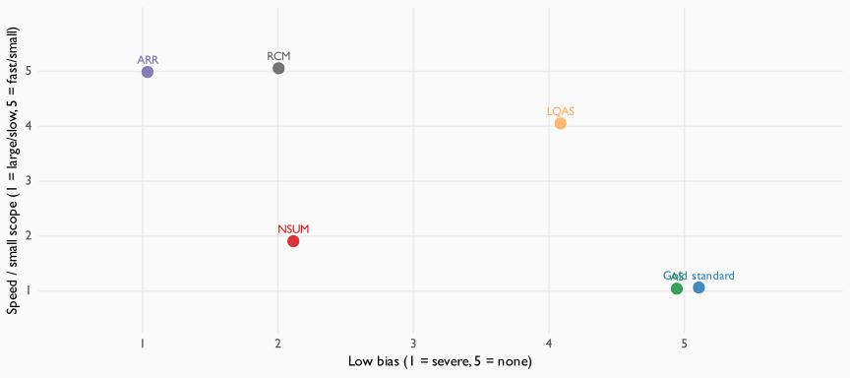
Figure 5.1: Methods comparison snapshot (Bias versus Speed, DOCX only)

5.0.3 The Missing Middle
A striking structural finding emerges when the five methods are viewed together: they cluster at the extremes of the scale–accuracy spectrum. At one end sits our gold-standard multistage cluster survey — a large, rigorously designed probability sample powered to detect small changes for sentinel-LGA coverage evaluation. At the other end are the rapid, small-sample methods: RCM visits 20 children per ward, and LQAS in its classification mode draws only 19. LQAS is often perceived as occupying a middle tier between full-scale probability surveys and rapid methods, and when lots are treated as strata and aggregated to produce a coverage estimate — as in the present study — that perception has some merit. However, the primary objective of LQAS is lot-level classification, not coverage estimation; not all implementations are even designed to support aggregation, and when they are it remains a secondary objective. The operational parameters that follow from that classification objective — small per-lot samples and relaxed error tolerances — place it squarely at the small-sample end of the spectrum with regard to classification.
The two methods that seemed most promising for closing this gap — NSUM and ARR — were unfortunately the two that fared worst on statistical validity. NSUM was expected to borrow information from respondents’ social networks, reducing the required sample size; ARR appealed because the data already exist and require no fieldwork. Both promises proved difficult to keep. NSUM was hampered by a restricted effective network (roughly 11 eligible alters per respondent) and pervasive transmission errors — respondents frequently could not report the vaccination status of contacts’ children. ARR was hampered by inflated DHIS2 numerators and imprecise population denominators, leaving even the best-performing variant ≈24 percentage points above the gold standard. Some of these data-quality limitations were well documented before the study began and could have been anticipated ex ante. Open questions remained, however, as to whether the innovations the study introduced — in particular, geospatial population estimates for the denominator and PHC-register audits to calibrate inflated DHIS2 numerators — would be sufficient to close the gap. The findings give a clear answer: those innovations were not enough.
The conclusion is not that a true middle ground is impossible; rather, it points to a tendency to underestimate how much can be achieved by re-parameterizing probability sampling itself. A cluster coverage survey with a smaller sample or narrower geographic scope is still a probability survey — it simply yields wider intervals or covers fewer domains. LQAS, itself a probability method, illustrates the point: by fixing inference to a classification question, it achieves actionable outputs with n = 19 per ward. The distinction between the gold standard and rapid alternatives is better understood as a continuum of probability designs, not a gap between paradigms. The classical WHO 30-cluster, 7-child EPI coverage survey is one illustration of a design that sits between these extremes: a medium-sized probability survey targeting a single-round coverage estimate with roughly ±10-percentage-point precision under standard design assumptions — smaller than the powered-for-change gold standard implemented here, but substantially larger per domain than LQAS or RCM. Detecting change between rounds, rather than estimating a single round, is a distinct requirement that depends on the combined variance of both rounds and generally calls for larger per-round samples than the 30×7 design provides.

5.0.4 Method-by-Method Assessment

5.0.4.1 Gold Standard
The gold standard — a PPS multistage cluster design — remains the only method with full design-based validity across all domains and estimands evaluated. Its principal limitation is scale and cost: the Kano baseline required over $870,000 and three months of field work, driven by the study’s dual objective of establishing a baseline and powering future impact evaluation in sentinel LGAs. Smaller or more targeted probability surveys can achieve the same inferential legitimacy at lower cost.

5.0.4.2 Adaptive Sampling
AS produced two distinct kinds of evidence. The non-sentinel field implementation showed that the adaptive step could use information collected during fieldwork. For zero-dose totals, the adaptive sampling estimator had a lower estimated standard error than the preliminary estimator in 10 of 12 non-sentinel LGAs. Across all 12 LGAs, the average estimated standard-error reduction was about 6%; among the 10 LGAs where the adaptive sampling estimator had lower estimated standard error, the average reduction was about 14%. That is a within-design comparison, not a comparison with a conventional survey of the same total size.
The simplified sentinel resampling simulation asks the planning question more directly. In Nassarawa, where zero-dose children were more spatially clustered, the adaptive sampling estimator beat a matched-budget conventional PPS sample in several low-budget, mid-$ϕ$ designs. Outside that coherent Nassarawa pattern, most sentinel simulation cells were near ties or conventional-better. A few Gabasawa and Gaya cells also favored AS, but the wins were narrower and less stable.
A retrospective variant of the design — Empirical Bayes Adaptive Sampling — was much more competitive in the same sentinel exercise. It updates the PPS size measure using preliminary zero-dose risk, rather than routing purely on local neighbors, so the adaptive draw retains a population-scaled baseline. This variant was not fielded and was tested only retrospectively, so it should be read as a promising direction for prospective validation rather than as a settled recommendation. It does, however, indicate that the modest gains of the fielded rule reflect that specific design rather than a general limit of adaptive sampling.
The practical appeal of the fielded AS design therefore depends on conditions that are hard to verify before the survey. The adaptive supplement helps only when the preliminary sample detects enough spatial signal to route effort toward high-yield neighboring PSUs. That signal depends on the spatial correlation structure of zero-dose status at the PSU scale, which is rarely known well in advance. The design also carries a substantial complexity penalty: real-time estimation, adaptive field routing, Rao-Blackwell reordering, and careful variance diagnostics all require specialist statistical capacity. This complexity is not visible in the apportioned cost breakdown in Table 4.11, which shows lower analysis-phase spend for AS than for the gold standard: shared analytic infrastructure for the core survey (sample frame construction, weighting, and design-based variance estimation) was apportioned across the gold standard, NSUM, and AS in proportion to successful interview counts (Chapter 4), so the gold standard absorbed the larger share of work that AS also depended on. A standalone AS implementation would have to carry that infrastructure on its own.
Some of this analytic complexity is tractable through better tooling, but not all of it. Variant choice matters: classical adaptive cluster sampling, for example, does not control final sample size in the same way as the adaptive web sampling rule used here, and other adaptive families carry their own implementation pitfalls. Off-the-shelf software for adaptive designs is also limited, so teams have often built bespoke analytic pipelines, and tooling is improving only gradually. Planning and analysis therefore still benefit from skilled survey-statistician input.
In the implementation tested here, AS is best viewed as a conditional option for clustered zero-dose totals, not as a routine replacement for same-size conventional PPS sampling.

5.0.4.3 LQAS
LQAS performed as designed, classifying 32 wards in the three sentinel LGAs as acceptable or potentially unacceptable relative to a 50% Penta-1 coverage threshold (n = 19 per ward; decision threshold d* = 13; both error rates < 10%). Eight wards were flagged as potentially unacceptable (two in Gabasawa, five in Gaya, one in Nassarawa). Pooled aggregate estimates were reasonably close to the gold standard for most strata, although one stratum (Nassarawa) was considerably off.
Use of weighted classification bounds (rather than simple decision rules) is likely needed to allow estimates to be credible given the complex sampling design. Both address longstanding implementation fidelity concerns without materially increasing cost.

5.0.4.4 ARR
Every ARR variant materially over- or under-estimated Penta-1 coverage relative to the gold standard. Even the strongest configuration, using PHC-audit calibrated numerators with geospatial denominators, had a mean absolute difference of 24 percentage points and showed no meaningful agreement. As a result, ARR estimates are not suitable as standalone measures of coverage. This finding is consistent with a broader body of work that has reached similar conclusions across other settings.

5.0.4.5 RCM
In this head-to-head exercise, most of the sentinel-area RCM estimates could be made to track the gold standard, but only when we defined the comparison area to hug the walked corridor (a buffered path around the route). That is an appropriate way to evaluate what RCM actually observed, and it also exposes the central limitation: a single walk produces a route-defined snapshot whose meaning does not automatically extend to the wider catchment area decision-makers may care about. Vaccination status also clusters along the walk (serial autocorrelation; OR ≈ 2.35), which further shrinks the effective information in a 20-child sample and makes any best case precision assumptions optimistic.
These results do not support RCM as a generally useful method for program decisions. The likely real-world use case is precisely where its weaknesses bite hardest: catchment areas larger than the corridor covered before hitting a 20-child quota, where bias can be substantial and uncertainty remains large even under generous assumptions. In relation to the objective of finding zero-dose pockets, the hotspot comparisons reinforce the same message: in several wards, the walked paths did not intersect the strongest zero-dose hotspots, so a single walk cannot be relied on to locate the places that matter most. Even with sensible refinements to reduce bias, the method is constrained by corridor dependence, small sample size, and ambiguity about the bounds of inference.
At best, RCM may be acceptable as a purely operational tool for mop-up activities: walking, identifying unvaccinated children encountered, and facilitating immediate referral or vaccination. The intended user in that case is health facility staff working within a small, well-defined catchment area where the walked corridor can plausibly cover the population of interest — not program managers seeking representative estimates for higher administrative levels. But under the implementation tested here (a single walk to a 20-child quota), it is not well-suited to support any statement about the catchment area beyond the narrow corridor actually traversed.

5.0.4.6 NSUM
NSUM is theoretically appealing as a way to extract more information per respondent by leveraging social network reports. In Kano, however, the results suggest that core NSUM assumptions were strained. The most likely explanation is transmission error: respondents often could not reliably report the vaccination status of contacts’ children, and the visibility-factor correction appeared to overcorrect, yielding estimates that diverged from the gold standard without settling into a stable, calibratable bias. A second factor may be barrier effects: respondents’ named alters may not be representative of households more broadly, so the alter distribution can systematically differ from the population distribution in ways that are not easily repaired.
Even setting those sources of bias aside, the expected efficiency gains were limited by network scale. The effective network denominator was only about 11 eligible alters per respondent. That is far below the large alter networks (often 100+) where NSUM tends to deliver its biggest payoff. In other words, even under optimistic assumptions, NSUM might still offer some informational advantage over a direct probability sample per interview, but the magnitude of that advantage would likely be modest in this setting simply because the observed networks were small. In short, NSUM is not a viable approach to immunization coverage estimation in the foreseeable future: the conditions it depends on — alters whose vaccination status is reliably visible to respondents, and personal networks large and representative enough to deliver real efficiency gains — are not features of immunization that look likely to change in the populations where coverage measurement is most needed. We therefore do not recommend NSUM as a substitute for probability-based coverage measurement.

5.0.5 Conclusions and Recommendations

5.0.5.1 Overall Assessment
The gold-standard multistage cluster coverage survey and LQAS strike the most defensible balance between statistical rigor and operational feasibility. Both are probability-based designs with controlled error, and they serve complementary objectives: the gold standard provides precise benchmark prevalence estimates; LQAS provides rapid, ward-level pass/fail classification for supervisory decisions. Used together, they support both strategic planning and routine program monitoring.
AS occupies a narrower position than the within-design gains alone suggested. The non-sentinel field implementation supports feasibility and within-design gains. The sentinel simulation is more relevant for choosing between AS and conventional PPS: AS can outperform conventional sampling when zero-dose children are spatially clustered enough for the adaptive step to exploit, as seen in parts of the Nassarawa simulation grid. Across the sentinel simulation as a whole, however, the gains were modest and uneven once AS was compared against a same-total-budget conventional PPS sample. The method also requires advanced statistical capacity in the field and a more complex operational workflow. For routine zero-dose measurement, those costs will often outweigh the expected gain unless prior data, pilot work, or strong contextual knowledge point to useful spatial clustering.
ARR and NSUM are not recommended for zero-dose prevalence estimation. Both methods showed unstable bias relative to the gold standard, and neither produced estimates that could serve as reliable benchmarks for program planning. We do not see a clear path forward for either method in this context.
RCM is a distinct case. While it is not suitable as a general-purpose coverage estimator under the implementation tested here, it has promise for hyper-local assessment provided that the catchment area is clearly defined and that mild methodological adjustments are made (for example, tighter specification of the inferential area to the walked corridor, and recognition that serial autocorrelation along the route reduces effective sample size). Under the current single-walk, 20-child-quota implementation, RCM occupies a narrow legitimate niche for operational mop-up activities, but is unlikely to be representative of the catchment area it is intended to represent unless this area is very small or unless more random walks are added. Even then, a sample size of 20 children — while potentially sufficient for coverage classification — would generally still be considered too noisy for coverage point estimation. Implementation choices vary substantially across organizations, even when they use the same method name. Differences in sampling discipline, supervision, and quality-assurance practice can materially change both statistical performance and practical cost footprint. Method comparisons should therefore be interpreted as comparisons of implemented designs, not only nominal method labels.

5.0.5.2 Cost and Time Implications
The time-motion findings show that labor is the dominant resource input across methods. Fieldwork contributes most person-time, but analysis and technical review are major financial drivers because they are concentrated among higher-cost specialists. For budgeting, this means total financial cost cannot be reduced substantially without either narrowing analytic scope or reducing analytic capacity.
Marginal field costs per additional unit are more similar across methods than total costs. Large total-cost differences are driven mainly by sample size, fixed overhead, and implementation scope. For planning, method choice is therefore less about a simple low-cost versus high-cost dichotomy and more about matching a method’s full cost structure to the required inferential precision.
A related implication is that sample-size reduction is a bounded lever for total cost. Because planning, supervision, analysis, and technical review do not scale linearly with sample size — and, in the Kano cost structure, are concentrated in higher-priced specialist time while enumerator labor is comparatively inexpensive — halving sample size does not come close to halving total cost. The precision-versus-cost tradeoff is also asymmetric along the precision curve. At the small-sample end, modest upward adjustments yield outsized precision gains — moving from 20 to 40 children, for instance, halves the variance and cuts the standard error by about 29% (a factor of $1/\sqrt{2}$) before design effects — so the productive direction of movement for rapid designs is upward, not downward. At very large sample sizes, by contrast, the precision loss from modest reductions is small, but the cost savings are also modest because specialist overhead dominates. In settings where field labor is expensive relative to specialist time, the balance shifts and sample-size reduction regains more of its force. A productive reframe, then, is right-sizing: growing very small samples where a modest boost yields outsized precision gains, and trimming very large samples where resources are constrained — rather than treating uniform sample-size reduction as the primary cost lever.
Implementation quality also drives both time and cost. Disciplined probability-based execution requires callbacks, revisits, supervision, and documentation, which increase workload but protect validity. Comparisons across implementers should therefore be interpreted as comparisons of both price and rigor, not price alone.

5.0.5.3 A Path Toward Model-Assisted Probability Sampling
Beyond method selection, this study points to a practical opportunity: integrating open-source geospatial data into probability survey design and implementation. Two gains are available.
The first is sampling efficiency: NDHS-derived modeled coverage surfaces and building footprint datasets can stratify clusters before sampling, concentrating effort in areas likely to contain zero-dose children. Model-assisted stratification reduces sampling variance without introducing bias, since estimates remain design-based with appropriate weights.
The second is operational efficiency: georeferenced building footprint data enable sampling designs that approximate simple random sampling without multi-stage cluster selection and household listing. GPS-verified building assignments and geofencing create a cleaner audit trail and reduce implementation drift — the silent bias source visible in this study’s RCM results.
Together, these advances support a tiered measurement strategy that places probability sampling at the center but deploys it more intelligently:
- Invest in periodic probability surveys to establish and refresh coverage benchmarks, using adaptive variants only when prior evidence suggests enough spatial clustering to justify the added complexity.
- Use LQAS for routine supervisory classification at the ward or supervision area level.
- Use model-assisted stratification and building footprint sampling to improve efficiency and implementation fidelity.
- Use existing free resources such as the NDHS modeled surfaces to estimate zero-dose prevalence at the LGA level when no data is otherwise available. While this information may not be recent (e.g., dating back to 2018), it can still provide a useful prevalence estimate when no other information is available at that level of granularity. In this study, the 2018 NDHS modeled surface agreed with the 2025 gold-standard LGA estimates within roughly 7 percentage points on average (mean absolute difference; ICC 0.73 across 15 Kano LGAs; see Figure 3.19 and Table 3.28).
Concrete methodological and Monitoring and Evaluation (M&E) recommendations are set out in Chapter 6. Endline and impact-measurement design — including the recommended pre-post structure, timing, age cohort, indicator definition, and sampling implications — is treated in the baseline report (Mindset 2025).

6. Recommendations
The preceding chapter assessed each method against statistical and logistical criteria and identified where each method fits. This chapter translates that assessment into two complementary sets of recommendations. The methodological recommendations answer how zero-dose prevalence should be measured well — design choices, sampling frame, estimation strategy, and the analytic capacity those choices imply. The M&E recommendations answer the downstream question: once a measurement system is in place, what should programmes in Kano (and comparable Northern Nigerian states) routinely track to know whether the zero-dose burden is moving, where it is moving, and why. A concrete pathway for measuring intervention impact at endline is taken up separately in the baseline report’s Endline and Impact-Measurement Design section (Mindset 2025).

6.1 Methodological Recommendations
Five methodological recommendations follow from the comparative findings. They apply whether the next measurement event is a routine round, a hotspot re-check, or the endline that closes out the current programme cycle.
- M1. Use NDHS modeled surfaces for sample size planning. Open-source data such as the NDHS modeled surfaces can already produce fine-grained coverage estimates before fieldwork, making sample size planning more evidence-based even when the priors are several years old. The 2018 NDHS modeled surface agreed with our 2025 gold-standard LGA estimates within roughly 7 percentage points on average — already comparable in magnitude to the ±10-percentage-point single-round precision target of the classical WHO 30-cluster, 7-child EPI survey under standard design assumptions.
- Our own planning illustrates the cost of not using such priors: lacking LGA-specific coverage estimates for Gabasawa, Gaya, Nassarawa, and the other sentinel areas, sample-size calculations had to assume the most cautious scenario — a change centred around 50% prevalence (for example, 45% to 55% for a 10-point change), which is the scenario that requires the largest sample. With informative LGA-level priors from the 2018 NDHS surface, the calculations could have been anchored to each LGA’s likely prevalence band, and the resulting targets would have been smaller and better right-sized to each area.
- M2. Sample directly via building footprints. Open-source building footprint datasets create a path to sampling designs that approach the operational simplicity of a simple random sample — single-stage, frame-based, list-driven — without the logistical overhead of multi-stage cluster selection and household listing. A decade ago, resources like this were rare; today they offer a practical way to partially fill a perennial gap in survey work: the absence of a usable, up-to-date sampling frame. Care is still needed to handle ineligible units (for example, non-residential structures) and to address the multiplicity problem: multiple footprints can point to the same household. Our experience in this baseline study found this harder than expected in practice — both to adjust for analytically and to elicit reliably from respondents. Even so, these data can be downloaded and sampled with a few lines of R or Python, and that changes what is practical. They also strengthen implementation fidelity. Because sampled points are georeferenced, teams can geofence assignments and use Global Positioning System (GPS) traces to verify that enumerators actually visited the intended locations, rather than substituting more convenient households — an audit trail this study put into practice and reports on in the baseline’s protocol-deviations annex (Mindset 2025). That kind of audit trail reduces several common sources of non-sampling error — enumerator bias toward more accessible or cooperative households, protocol drift, and outright fabrication.
- This approach is especially attractive for small-sample methods such as LQAS and RCM, which already rely on pseudo-random field procedures. Sampling from building footprints fits that tradition while reducing reliance on PPS cluster designs and listing operations. Footprints can also complement existing field procedures rather than replace them outright — our own LQAS implementation, for instance, used footprints to pre-specify the visitation order of a pseudo-random walk, substituting a reproducible itinerary for enumerator discretion. There can be some frame undercoverage if the building layer is outdated and new construction is missing, but in many settings this is likely a smaller concern than other dominant error sources (for example, nonresponse, measurement error, or implementation deviations). In many contexts, the net result may be a faster, cheaper, and more standardized workflow with a more defensible link between the design and what was actually implemented.
- A pragmatic middle path uses building footprints as a seed list for a listing-and-enumeration step, rather than as the direct sampling frame. Listers visit the footprints, classify each structure’s residential status and household composition, and the survey then samples from the resulting cleaned list. Multiplicity is largely resolved at the listing stage, and the design retains probability-sample properties without forcing respondents to answer complex multiplicity-adjustment questions in the main interview.
- M3. Use model-based and model-assisted estimation where assumptions hold. Going beyond strictly design-unbiased estimation can produce more precise results from the same resources, by drawing on what established survey methodology already provides. Two related but distinct families are relevant here, and they have different epistemic profiles. Model-assisted methods (calibration, generalized regression / Generalized Regression Estimator (GREG), ratio estimation) use a working model to reduce variance but remain design-consistent if the model is wrong — the auxiliary information improves precision without putting the headline estimator at risk. Model-based methods (Fay-Herriot, Battese-Harter-Fuller, multilevel shrinkage and other small-area estimators) trade design-consistency for borrowed strength across related areas, and therefore depend on explicit model diagnostics for credibility. Practical options include more informative stratification, stronger use of calibration and ratio estimation, and other techniques that combine primary survey data with credible auxiliary information. When estimates are required across many domains or small areas, model-based approaches can also borrow strength across related areas and improve the stability of sub-aggregate estimates.
- Practitioners should not shy away from methods that deliberately trade a small amount of bias for substantial variance reduction — Bayesian, shrinkage, and multi-level models are common examples. The relevant objective is minimizing total error (mean squared error), not unbiasedness per se. With transparent diagnostics and validation, such methods deliver more useful estimates without requiring prohibitively large sample sizes in every stratum. This logic underpins our own NDHS modeled layer analysis (Section 3.5.7.1), which uses a model-based prevalence surface to produce credible LGA-level coverage estimates where direct survey data alone are too noisy.
- In Nigeria, this opportunity is likely to expand further as the country moves toward its long-delayed population and housing census. Government and the NPC have continued to signal readiness and ongoing preparations, with timing subject to a formal presidential proclamation. Once the census is completed, it should provide refreshed population totals and small-area control figures that make calibration, post-stratification, and small-area estimation more defensible and more effective, especially when users need reliable estimates below the national or state level.
- M4. Price analytical complexity explicitly in method selection. Methods often presented as simple in teaching materials can require advanced design-based analysis in real implementation. Budgets should reflect the true analytical demands of weighting, variance estimation, and implementation diagnostics. Several methods in this comparison illustrate the gap concretely: NSUM requires custom estimators and uncertainty propagation that no off-the-shelf survey package delivers; RCM relies on bespoke capture-recapture analysis with non-standard assumptions; and even LQAS — often presented as a simple supervisory rule — needed a weighted, design-consistent reanalysis here to recover defensible classifications from a complex sample. Treating complex designs as simple tabulations creates apparent savings at the expense of validity.
- M5. Right-size designs rather than defaulting to either extreme. The right question is right-sizing, not uniform reduction: modest upward adjustments for already-small designs where precision gains are steep, and measured downward adjustments for large gold-standard-style designs where marginal precision is cheap. The design space between very small-sample rapid tools and large benchmark surveys is wide, and programmes can tune design parameters to match decisions and constraints, rather than defaulting to perceived “cheap” options or assuming only full gold-standard designs are viable. These tradeoffs should be made explicitly, with clear statements about expected precision and bias — the alternative is binary thinking about scale and rigor, where the only available choices are “rapid and cheap” or “benchmark and expensive.”

6.2 Monitoring & Evaluation Recommendations
The M&E recommendations draw on evidence from two sources: the baseline report (Mindset 2025), which provides the numerator, denominator, hotspot, and missed-opportunity findings that define what to monitor; and this head-to-head comparison, which provides the cost-precision-timeliness trade-offs that define how to monitor it — without having to rebuild a benchmark survey every year.
The recommendations are organised in three themes:
- Tracking zero-dose prevalence over time — where are the zero-dose children, and how is that pattern changing?
- Tracking intervention performance — are programmes converting effort into vaccinated children, and why are coverage indicators moving the way they are?
- Matching measurement methods to monitoring use cases — which instrument is right-sized for which monitoring question?
These themes sit inside the Monitor/Measure stage of Gavi’s Identify, Reach, Monitor, Measure, and Advocate (IRMMA) framework (Gavi, the Vaccine Alliance 2021). The specific demand-, supply-, and access-side interventions whose performance these indicators help monitor are set out in the baseline report’s Prioritized Intervention Strategies section (Mindset 2025).

6.2.1 Tracking Zero-Dose Prevalence over Time
Ideally, routine monitoring of zero-dose prevalence works best when it is organized around the geographic resolution at which programmes actually make decisions (NPHCDA 2021), rather than a single national or state headline figure. The baseline established Penta-1 coverage benchmarks for the three sentinel LGAs — 66.8% in Gabasawa, 62.1% in Gaya, 74.7% in Nassarawa — plus a combined non-sentinel benchmark of 61.7% covering the remaining twelve LGAs (Mindset 2025). The design was powered to produce defensible benchmarks at this four-stratum level.
Annual or semi-annual full re-measurement of all 15 LGAs at gold-standard precision is neither necessary nor affordable, and shorter intervals framed as universal requirements tend to overstate what programmes can realistically resource. A more practical approach treats the full gold-standard design as a periodic anchor, aligned where possible to NDHS or MICS rounds (WHO 2018), and uses lighter, classification-oriented instruments to fill the years in between.
- E1. Pace the anchor benchmark to programme cycles, not the calendar. The two headline indicators — zero-dose prevalence and Penta-1 coverage, both reported with 95% confidence intervals — should be refreshed against a full benchmark roughly once per programme cycle. Where resources allow, that means every three to five years, timed to coincide with the next NDHS or MICS round where possible (WHO 2018).
- Treating a fixed three-year interval as a binding default risks working against how programmes actually plan and budget for measurement. It is better presented as a target to argue toward. Within any given cycle, the anchor round is what calibrates the lighter monitoring instruments described below; skipping a planned anchor to fund routine activity is inadvisable, because the rest of the architecture depends on having a recent benchmark to calibrate against.
- E2. Report at the right strata, and label uncertainty honestly at lower levels. The reporting levels below reflect the strata this baseline was powered for; studies designed for different purposes will have their own defensible reporting levels. For the Kano programme, three levels carry decision relevance.
- At the state and stratum level, report zero-dose prevalence and Penta-1 coverage with 95% confidence intervals against the four baseline benchmarks — the three sentinel LGAs and the combined non-sentinel stratum. These are the only four LGA-level estimates the baseline established with usable precision, and are therefore the defensible pre-post comparators.
- At the LGA level for the remaining twelve non-sentinel LGAs, point estimates are noisier and should be reported with their uncertainty interval rather than as standalone figures.
- At the ward level, the right approach depends on whether the survey was powered for ward-level point estimates. For the sentinel LGAs in this baseline, where wards were oversampled, ward-level coverage estimates with confidence intervals are defensible (Mindset 2025). For other settings, including the non-sentinel LGAs in this study and routine monitoring rounds not designed for ward-level point estimation, supervisory classification is the more appropriate framing: each ward should be flagged as acceptable, marginal, or potentially unacceptable against a programme-relevant threshold (see E9 on LQAS).
- E3. Decompose hotspots into prevalence and absolute-burden categories. A single hotspot definition obscures a planning decision that comes down to programme theory. Prevalence hotspots — wards or 1 km cells with high zero-dose rates — are the right target when the theory of change rests on local immunity: closing a high-prevalence pocket protects the surrounding population. Absolute-burden hotspots — areas with the largest counts of zero-dose children regardless of rate — are the right target when the theory of change is to reach the most children for the least cost, which often points to dense, lower-prevalence settlements.
- The baseline identified clusters of elevated zero-dose prevalence that can span ward boundaries within a sentinel LGA (Mindset 2025). Routine monitoring should preserve a hotspot layer — refreshed when new data are available — and report indicator values both inside and outside the current hotspots, decomposing results into both categories so that planning decisions can be defended on either theory of change (Utazi et al. 2024). A single LGA-level number that averages over a hotspot and its surroundings will mask exactly the variation programmes most need to see (Utazi et al. 2024).

6.2.2 Tracking Intervention Performance
Coverage and zero-dose prevalence are downstream outcomes. Programmes also need process indicators that move on a faster cadence and can tell managers why outcomes are changing (Gavi, the Vaccine Alliance 2021). The baseline organised barriers along three drivers — demand, supply, and access — and that structure carries naturally into the monitoring backbone.
- E4. Demand-side indicators, with Kano-specific calibration on missed opportunities. The most actionable demand-side indicators are caregiver-reported reasons for non-vaccination and proxies for community engagement intensity. For the former, the WHO BeSD framework organises reasons into four domains — social norms, beliefs, access, and health-facility issues — with social norms dominating in this baseline (cited by around 41% of caregivers), followed by beliefs (23%), access (15%), and health-facility issues (5%) (Mindset 2025). For community engagement, useful proxies include trainings delivered to traditional and religious leaders and community meetings held; trial evidence suggests that structured community engagement can shift vaccination outcomes such as timeliness and dropout even when effects on full coverage are null (Oyo-Ita et al. 2021).
- The missed-opportunity rate — any contact with health services by an unvaccinated or partially vaccinated child that does not result in receipt of all recommended doses (Adamu et al. 2019) — straddles both demand and supply: it reflects a caregiver who reached the facility and a service that failed to convert the contact. In principle it is a useful indicator. In Kano specifically, however, the headroom from fixing missed opportunities alone is modest: the baseline’s counterfactual DPT-1 analysis shows that eliminating Missed Opportunities for Simultaneous Vaccination (MOSVs) and early doses would raise overall DPT-1 coverage by only around 1.8 percentage points — roughly 2.7 pp in Nassarawa, where missed-opportunity rates run highest (Mindset 2025). That limited headroom is reason enough to treat missed-opportunity correction as a quality-of-service indicator and a defaulter-tracing trigger, rather than a primary coverage lever in this setting. Where the monitoring instrument already captures full vaccine history per child, programmes should track the rate on that basis.
- E5. Supply-side indicators, narrowly scoped and admin-data-aware. The most defensible supply-side indicator is session-level fidelity — sessions actually held against sessions planned in the microplan — because it is reported at the operational unit where corrective action lives: the facility-month. Process targets here should be benchmarked against the state’s own microplanning expectations, not against any external standard.
- We do not recommend building a routine indicator around DHIS2-derived administered doses, stockout days or cold-chain functionality as standalone monitoring signals. This study’s findings and the broader literature give us low confidence in administrative numerators as a reliable signal of vaccination coverage (Cutts et al. 2016). These should be tracked operationally at the facility level for management purposes, but they do not belong in the headline M&E dashboard.
- E6. Access-side indicators are where the spatial signal lives. The indicators that emerged most clearly from the baseline are the rural–urban gradient in coverage and the caregiver-education gradient (Mindset 2025); the access section also documents marked variation in service-availability awareness — zero-dose children’s caregivers are substantially more likely to not know whether vaccination is offered at their nearest facility — and heterogeneity in facility distance across LGAs that the geospatial travel-time maps capture for the three sentinel LGAs.
- The baseline’s rural–urban and education gradients were strong enough to merit separate reporting tracks; treating them as routine equity disaggregations rather than annex-only analysis keeps equity visible to programme staff (Sato 2023; Akwataghibe et al. 2019). Where the partner has the geospatial analytic capacity, travel time and distance should be tracked off the geospatial layer — building footprints plus facility list. Where caregiver-reported access measures are used instead, programmes should interpret them with the caveat that they conflate distance with willingness to travel.
- E7. A small number of cross-cutting equity indicators. Alongside the coverage headline, three equity gaps in zero-dose prevalence are worth tracking routinely: between rural and urban residents, between children of caregivers with and without secondary education, and between the bottom and top wealth quintiles (Arsenault et al. 2017). All three are derived from the anchor probability survey (E8) on a programme-cycle cadence.
- The rural–urban and caregiver-education gradients are cheap to elicit (a single survey question each) and reflect the two largest movers in the baseline’s vaccination-ladder model — settlement type and caregiver education — with rural–urban being the practical binary collapse of settlement type (Mindset 2025). The wealth-quintile gradient has long been a core Gavi equity-monitoring dimension (Arsenault et al. 2017), but it requires a full DHS-style asset roster and the associated respondent and analytic burden; programmes should weigh that cost before including it. Other equity cuts (e.g., caregiver age, household size, religion) are worth exploring but do not need to live in the routine dashboard.

6.2.3 Matching Measurement Methods to Monitoring Use Cases
The head-to-head comparison provides the basis for a tiered measurement architecture (see Table 5.1 and Table 5.2). The underlying principle is that no single method should carry all the monitoring load: each instrument has a use case where it is right-sized, and the cost should be paid where it buys the most information (WHO 2018).
- E8. Anchor benchmark layer: a gold-standard probability survey at programme-cycle cadence. The anchor benchmark — a gold-standard multistage cluster survey — belongs on a programme-cycle cadence (see E1), sized to the strata that drive funding decisions (Table 5.1; Table 5.2). This is the only layer of the architecture that produces defensible point estimates for the state and stratum headline indicators (Lohr 2021).
- E9. Routine supervisory monitoring: LQAS done as full-coverage ward classification. LQAS is the right tool for the supervisory pass-fail question at the ward level, refreshed annually or semi-annually (Valadez et al. 2002; Rhoda et al. 2010). At $n=19$ per ward, it is cheap enough to repeat.
- However, the recommendation is contingent on two implementation requirements. First, wards must be used as strata and the entire LGA must be covered: cherry-picking a few wards breaks the inference and produces figures that cannot be aggregated to the LGA level. Second, the classification threshold should be set by the state task force against an explicit numeric coverage target per stratum, not adopted by default from the 50% cutoff used in this study.
- The DIM programme implemented by AFENET shows that this every-ward-as-a-lot approach is operationally feasible at scale. The Kumbotso pilot fielded 19 interviews in each of the LGA’s 11 wards — 209 interview locations in total — and was designed to scale to eight LGAs across Kano, Bauchi, Borno, and Sokoto States (Attahiru et al. 2025). The subsequent Round 3 multi-state rollout covered 107 wards across all 8 LGAs, each sampled as its own LQAS lot (Zero Dose Learning Hub Nigeria 2025). Programmes that cannot match that resource intensity should report classifications only for the wards actually fielded, rather than presenting partial-coverage LQAS as an LGA-level signal.
- Importantly, LQAS is not the right tool for ward-level coverage point estimation. Reporting aggregated LQAS coverage figures alongside the gold-standard benchmark risks conflating two inferential products that answer different questions.
- E10. Use model-assisted approaches for hotspot identification and re-checks. This layer has two steps. First, to identify candidate hotspots between anchor surveys, use NDHS-style modelled coverage surfaces of the kind produced by Utazi et al. (2023) and Sbarra et al. (2021), and refresh them whenever new DHS or MICS rounds are released. The work is desk-based — no fresh field data needed. Second, before committing resources to a deployment in a candidate hotspot, run a small probability sub-sample using the building-footprint frame to confirm the hotspot is still active. This is a quick verification step at the hotspot scale, not a coverage survey of the LGA.
- Both steps feed the prevalence-vs-absolute-burden decomposition in E3, and both are designed for decision moments — specifically, when a programme is choosing where to concentrate next-quarter mop-up effort — rather than for routine reporting.
- E11. A hybrid LQAS–RCM variant as a future-study candidate. The single-walk, 20-child-quota RCM tested here is not a monitoring instrument (see Section 3.6), and NSUM is not a viable substitute for probability-based coverage measurement in this setting (see Section 3.2). Neither belongs in the routine monitoring backbone.
- A more interesting question is whether a systematic RCM variant could earn a place. The vaccination-coverage literature documents one that overlays LQAS decision rules on a door-to-door frame: enumerators canvass blocks until they reach 20 eligible children, and the supervisory call follows from the count of unvaccinated children found (Vance Dietz et al. 2004). A hybrid of this kind would be a practical complement to the ward-level LQAS layer (E9) — it keeps the door-to-door speed while replacing the informal “did the team see enough vaccinated children” judgement with a pre-specified acceptance rule with a known classification error rate.
- We did not field this hybrid in the head-to-head comparison, and the classification thresholds in (Vance Dietz et al. 2004) were derived for a specific operating point — zero unvaccinated children as the classification target — that may not transfer to a different programme-defined threshold without re-derivation. On that basis, we recommend the hybrid LQAS–RCM variant as a future-study candidate rather than as a current-cycle deployment.
- E12. Build a central data repository and feed research findings back into routine priors. A recurring gap in this work is that field data is scattered: routine RCM mop-ups, LQAS supervisory rounds, and ad hoc surveys funded by donors or partners all end up in separate systems held by whoever ran the collection. That fragmentation makes it harder than it should be to update programme priors about where unvaccinated children are, and it forces each new study to rediscover what previous studies have already established.
- A central holder for routinely-collected zero-dose datasets would pay off well above its cost — likely a Gavi-coordinated role, or another entity with the convening authority and data-stewardship capacity to take it on. The scope of what lives there should extend beyond routine programme data to include research outputs: NDHS-aligned modelled surfaces, de-identified study microdata, and the codebooks needed to make that data reusable.

References
Adamu, Abdu A., Olalekan A. Uthman, Muktar A. Gadanya, and Charles S. Wiysonge. 2019. “Implementation and Evaluation of a Collaborative Quality Improvement Program to Improve Immunization Rate and Reduce Missed Opportunities for Vaccination in Primary Health-Care Facilities: A Time Series Study in Kano, Nigeria.” Expert Review of Vaccines 18 (9): 969–91. https://doi.org/10.1080/14760584.2019.1647782.
Akerele, Adekunle, Ramatu Obansa, Oluwasegun Joel Adegoke, Suleiman Haladu, Olorunsogo Bidemi Adeoye, Nnamdi Usifoh, Sulaiman Etamesor, Belinda Uba, and Ndadilnasiya Endie Waziri. 2020. “Determinants of Improved Data Consistency Across Routine Immunization Data Tools for Health Facilities in Kano State, Nigeria.” Pan African Medical Journal 36 (148). https://doi.org/10.11604/pamj.2020.36.148.20498.
Akwataghibe, Ngozi N., Elijah A. Ogunsola, Jacqueline E. W. Broerse, Oluwafemi A. Popoola, Adanna I. Agbo, and Marjolein A. Dieleman. 2019. “Exploring Factors Influencing Immunization Utilization in Nigeria—a Mixed Methods Study.” Frontiers in Public Health 7: 392. https://doi.org/10.3389/fpubh.2019.00392.
Arsenault, Catherine, Sam Harper, Arijit Nandi, José M. Mendoza Rodríguez, Peter M. Hansen, and Mira Johri. 2017. “An Equity Dashboard to Monitor Vaccination Coverage.” Bulletin of the World Health Organization 95 (2): 128–34. https://doi.org/10.2471/BLT.16.178079.
Attahiru, Adam, Yahaya Mohammed, Fiyidi Mikailu, Hyelshilni Waziri, Ndadilnasiya Endie Waziri, Mustapha Tukur, Bashir Sunusi, et al. 2025. “Decentralized Immunization Monitoring: Lessons Learnt from a Pilot Implementation in Kumbotso LGA, Kano State, Nigeria.” Vaccines 13 (7). https://doi.org/10.3390/vaccines13070664.
Benjamini, Yoav, and Yosef Hochberg. 1995. “Controlling the False Discovery Rate: A Practical and Powerful Approach to Multiple Testing.” Journal of the Royal Statistical Society: Series B (Methodological) 57 (1): 289–300.
“Benjamini–Hochberg and Benjamini–Yekutieli Tests.” n.d. Real Statistics; Real Statistics Using Excel. Accessed August 28, 2025. https://real-statistics.com/hypothesis-testing/familywise-error/benjamini-hochberg-and-benjamini-yekutieli-tests/.
Blackwell, David. 1947. “Conditional Expectation and Unbiased Sequential Estimation.” The Annals of Mathematical Statistics 18 (1): 105–10. https://doi.org/10.1214/aoms/1177730497.
Bosch-Capblanch, Xavier, K. Banerjee, and A. Burton. 2012. “Unvaccinated Children in Years of Increasing Coverage: How Many and Who Are They? Evidence from 96 Low- and Middle-Income Countries.” Tropical Medicine & International Health 17 (6): 697–710. https://doi.org/10.1111/j.1365-3156.2012.02989.x.
Brown, J. A., and B. J. F. Manly. 1998. “Restricted Adaptive Cluster Sampling.” Environmental and Ecological Statistics 5 (1): 49–63. https://doi.org/10.1023/A:1009607403647.
Casella, George, and Roger L. Berger. 2002. Statistical Inference. 2nd ed. Pacific Grove, CA: Duxbury.
Central Bank of Nigeria. 2025. “Reforms.” https://www.cbn.gov.ng/Reforms/foreign-exchange-management-system.
Chao, Chang Tai, and Steven K. Thompson. 2001. “Optimal Adaptive Selection of Sampling Sites.” Environmetrics 12 (6): 517–38. https://doi.org/10.1002/env.477.
Chen, Sixia, and Keith Rust. 2017. “An Extension of Kish’s Formula for Design Effects to Two- and Three-Stage Designs with Stratification.” Journal of Survey Statistics and Methodology 5 (2): 111–30. https://doi.org/10.1093/jssam/smw036.
Chipeta, Michael G., Dianne J. Terlouw, Kamija S. Phiri, and Peter J. Diggle. 2016. “Adaptive Geostatistical Design and Analysis for Prevalence Surveys.” Spatial Statistics 15: 70–84. https://doi.org/10.1016/j.spasta.2015.12.004.
Cicchetti, Domenic V. 1994. “Guidelines, Criteria, and Rules of Thumb for Evaluating Normed and Standardized Assessment Instruments in Psychology.” Psychological Assessment 6 (4): 284–90. https://doi.org/10.1037/1040-3590.6.4.284.
Cochran, William G. 1977. Sampling Techniques. 3rd ed. New York: John Wiley & Sons.
Cutts, F. T., P. Claquin, M. C. Danovaro-Holliday, and D. A. Rhoda. 2016. “Monitoring Vaccination Coverage: Defining the Role of Surveys.” Vaccine 34 (35): 4103–9. https://doi.org/10.1016/j.vaccine.2016.06.053.
Daskalakis, Constantinos, Ilias Diakonikolas, and Rocco A. Servedio. 2013. “Learning Poisson Binomial Distributions.” In Proceedings of the Forty-Fifth Annual ACM Symposium on Theory of Computing, 709–28. STOC ’13. New York, NY, USA: Association for Computing Machinery. https://doi.org/10.1145/2488608.2488707.
Dietz, Vance, Linda Venczel, Héctor Izurieta, George Stroh, Elizabeth R. Zell, Edgar Monterroso, and Gina Tambini. 2004. “Assessing and Monitoring Vaccination Coverage Levels: Lessons from the Americas.” Revista Panamericana de Salud Pública / Pan American Journal of Public Health 16 (6): 432–42. https://iris.paho.org/handle/10665.2/8027.
Dietz, V., L. Venczel, H. Izurieta, G. Stroh, E. R. Zell, E. Monterroso, and G. Tambini. 2004. “Assessing and Monitoring Vaccination Coverage Levels: Lessons from the Americas.” Revista Panamericana de Salud Publica 16 (6). https://doi.org/10.1590/s1020-49892004001200013.
Douc, Randal, and Christian P. Robert. 2011. “A Vanilla Rao–Blackwellization of Metropolis–Hastings Algorithms.” The Annals of Statistics 39 (1): 261–77. https://doi.org/10.1214/10-AOS838.
Dryver, Arthur L., and Steven K. Thompson. 2005. “Improved Unbiased Estimators in Adaptive Cluster Sampling.” Journal of the Royal Statistical Society. Series B (Statistical Methodology) 67 (1): 157–66.
Dunkle, S. E., A. S. Wallace, A. MacNeil, M. Mustafa, A. Gasasira, D. Ali, H. Elmousaad, F. Mahoney, and H. S. Sandhu. 2014. “Limitations of Using Administratively Reported Immunization Data for Monitoring Routine Immunization System Performance in Nigeria.” Journal of Infectious Diseases 210 (Suppl 1). https://doi.org/10.1093/infdis/jiu373.
Dwivedi, Laxmi Kant, Bidhubhusan Mahaptra, Anjali Bansal, Jitendra Gupta, Abhishek Singh, and T. K. Roy. 2023. “Intra-Cluster Correlations in Socio-Demographic Variables and Their Implications: An Analysis Based on Large-Scale Surveys in India.” SSM - Population Health 21: 101317. https://doi.org/10.1016/j.ssmph.2022.101317.
“FDR Online Calculator.” 2010. SDM Project (Seed-based d Mapping); SDM Project Web Utilities. https://www.sdmproject.com/utilities/?show=FDR.
Feehan, Dennis, and Matthew Salganik. 2014. The Networkreporting Package. http://cran.r-project.org/package=networkreporting.
Felix-Medina, Martín H., and Steven K. Thompson. 2004. “Adaptive Cluster Double Sampling.” Biometrika 91 (4): 877–91.
FMoHSW, NPC, and ICF. 2024. “Nigeria Demographic and Health Survey 2023–24: Key Indicators Report.” Abuja, Nigeria,; Rockville, Maryland, USA: Federal Ministry of Health and Social Welfare of Nigeria (FMoHSW); National Population Commission (NPC) [Nigeria]; ICF.
Freedman Ellis, Greg, and Ben Schneider. 2026. Srvyr: Dplyr-Like Syntax for Summary Statistics of Survey Data. http://gdfe.co/srvyr/.
Gao, Peter, Ben Schneider, and Stas Kolenkikov. 2026. Survey: Analysis of Complex Survey Samples. http://r-survey.r-forge.r-project.org/survey/.
Gavi, the Vaccine Alliance. 2021. “Guidance on Use of Gavi Support to Reach Zero Dose Children and Missed Communities.” Gavi, the Vaccine Alliance. https://www.gavi.org/sites/default/files/support/Gavi_Zero-dose_FundingGuidelines.pdf.
Gavi Zero-Dose Learning Hub. 2023. “Nigeria Zero-Dose Situation Analysis.” https://zdlh.gavi.org/.
Gelman, Andrew, and Jennifer Hill. 2006. Data Analysis Using Regression and Multilevel/Hierarchical Models. Cambridge: Cambridge University Press. https://doi.org/10.1017/CBO9780511790942.
Gelman, Andrew, and Thomas C. Little. 1997. “Poststratification into Many Categories Using Hierarchical Logistic Regression.” Survey Methodology 23 (2): 127–35.
Glynn, Peter W., and Ward Whitt. 1992. “The Asymptotic Efficiency of Simulation Estimators.” Operations Research 40 (3): 505–20. https://doi.org/10.1287/opre.40.3.505.
Haddad, S., A. Bicaba, M. Feletto, P. Fournier, and M. V. Zunzunegui. 2010. “Heterogeneity in the Validity of Administrative-Based Estimates of Immunization Coverage Across Health Districts in Burkina Faso: Implications for Measurement, Monitoring and Planning.” Health Policy and Planning 25 (5). https://doi.org/10.1093/heapol/czq007.
Heeringa, Steven G., Brady T. West, and Patricia A. Berglund. 2017. Applied Survey Data Analysis. 2nd ed. Boca Raton, FL: CRC Press.
Hill, Russell A., and Robin I. M. Dunbar. 2003. “Social Network Size in Humans.” Human Nature 14 (1): 53–72. https://doi.org/10.1007/s12110-003-1016-y.
Hong, Yili, and R Core Team. 2024. Poibin: The Poisson Binomial Distribution.
Hora, Rhythm, Arindam Ray, Imkongtemsu Longchar, GR Rio, Rashmi Mehra, Seema Singh Koshal, Amrita Kumari, Syed F Quadri, Amanjot Kaur, and Arup Deb Roy. 2024. “Lot Quality Assurance Sampling for Coverage Evaluation of a New Vaccine: A Pilot Study.” Vaccine: X 21: 100578.
International Monetary Fund. 2024. “IMF Executive Board Concludes 2024 Article IV Consultation with Nigeria.” https://www.imf.org/en/News/Articles/2024/10/03/pr24353-nigeria-imf-executive-board-concludes-2024-article-iv-consultation.
———. 2025. “IMF Executive Board Concludes 2025 Article IV Consultation with Nigeria.” https://www.imf.org/en/News/Articles/2025/06/27/pr25234-nigeria-imf-executive-board-concludes-2025-article-iv-consultation.
IST Research, University of California, Los Angeles, and Global Fund to End Modern Slavery. 2020. “Estimating the Prevalence of Child Sex Trafficking in Maharashtra, India.” https://www.gfems.org/wp-content/uploads/2022/03/Estimating-the-Prevalence-of-Child-Sex-Trafficking-in-Maharashtra-2020-Final-2.pdf.
Jeffery, C., M. Pagano, J. Hemingway, and J. J. Valadez. 2018. “Hybrid Prevalence Estimation: Method to Improve Intervention Coverage Estimations.” Proceedings of the National Academy of Sciences of the United States of America 115 (51). https://doi.org/10.1073/pnas.1810287115.
Kabaghe, Alinune N., Michael G. Chipeta, Robert S. McCann, Kamija S. Phiri, Michèle van Vugt, Willem Takken, Peter Diggle, and Anja D. Terlouw. 2017. “Adaptive Geostatistical Sampling Enables Efficient Identification of Malaria Hotspots in Repeated Cross-Sectional Surveys in Rural Malawi.” PLOS ONE 12 (2): e0172266. https://doi.org/10.1371/journal.pone.0172266.
Killworth, Peter D., Eugene C. Johnsen, Christopher McCarty, Gene A. Shelley, and H. Russell Bernard. 1998. “A Social Network Approach to Estimating Seroprevalence in the United States.” Social Networks 20 (1): 23–50.
Kish, Leslie. 1965. Survey Sampling. New York: John Wiley & Sons.
Koo, Terry K., and Mae Y. Li. 2016. “A Guideline of Selecting and Reporting Intraclass Correlation Coefficients for Reliability Research.” Journal of Chiropractic Medicine 15 (2): 155–63. https://doi.org/10.1016/j.jcm.2016.02.012.
Korn, Edward L, and Barry I Graubard. 1998. “Confidence Intervals for Proportions with Small Expected Number of Positive Counts Estimated from Survey Data.” Survey Methodology 24: 193–201.
Lohr, Sharon L. 2021. Sampling: Design and Analysis. 3rd ed. Chapman; Hall/CRC.
Lovasi, Gina S., David S. Fink, Stephen J. Mooney, and Bruce G. Link. 2017. “Model-Based and Design-Based Inference Goals Frame How to Account for Neighborhood Clustering in Studies of Health in Overlapping Context Types.” SSM - Population Health 3: 600–608. https://doi.org/10.1016/j.ssmph.2017.07.005.
Luman, Elizabeth T, K Lisa Cairns, Robert Perry, Vance Dietz, and David Gittelman. 2007. “Use and Abuse of Rapid Monitoring to Assess Coverage During Mass Vaccination Campaigns.” Bulletin of the World Health Organization. https://doi.org/10.2471/BLT.07.045328.
Maltiel, Ruth, and Alan J. Baraff. 2015. NSUM: Network Scale up Method. https://CRAN.R-project.org/package=NSUM.
Maltiel, Ruth, Adrian E. Raftery, Tyler H. McCormick, and Alan J. Baraff. 2016. “Estimating Population Size Using the Network Scale up Method.” The Annals of Applied Statistics 9 (3): 1247.
McCarty, Christopher, Peter D. Killworth, H. Russell Bernard, Eugene C. Johnsen, and Gene A. Shelley. 2001. “Comparing Two Methods for Estimating Network Size.” Human Organization 60 (1): 28–39.
Mindset. 2025. “Kano Zero-Dose Baseline Survey Report.” https://zd25.netlify.app/.
MOMENTUM. 2024. Rapid Convenience Monitoring (RCM): Monitoring Non- and Under-Immunized Communities (version 2024-07-31). MOMENTUM.
Moturi, Angela K., Moses M. Musau, Samuel K. Muchiri, Peter M. Macharia, Robert W. Snow, and Emelda A. Okiro. 2025. “Concordance of Coverage Estimates from Routine and Survey Data of Measles Second Dose Vaccine in Western Kenya.” Frontiers in Epidemiology 5: 1663372. https://doi.org/10.3389/fepid.2025.1663372.
National Bureau of Statistics (NBS). 2020. “NLSS Poverty Tables 2019–2020: Poverty and Inequality.” National Bureau of Statistics. https://nigerianstat.gov.ng/resource/Nlss_povety%20tables%202019-2020_NBS%20poverty%20and%20inequality%20only.xlsx.
National Salaries, Incomes and Wages Commission (NSIWC). 2024. “Implementation of the New Minimum Wage in the Federal Public Service (CONPSS).” 2024. https://nsiwc.gov.ng/download/2-implementation-of-the-new-minimum-wage-in-the-federal-public-service-the-consolidated-public-service-salary-structure-conpss/.
Neyman, Jerzy. 1938. “Contribution to the Theory of Sampling Human Populations.” Journal of the American Statistical Association 33 (201): 101–16. https://doi.org/10.1080/01621459.1938.10503378.
Ngo-Bebe, D., F. N. Kwilu, J. N. Konde, D. K. Ishoso, F. Langwana, C. Mwanga, L. M. Kinuani, et al. 2025. “Reasons for over-Reporting of Routine Immunization Administrative Data in the Democratic Republic of Congo: A Mixed Cross-Sectional Study to Determine Explanatory Factors for Poor Data Quality.” BMC Public Health 25 (1). https://doi.org/10.1186/s12889-025-24639-3.
Nnanatu, C. C., A. Gadiaga, T. J. Abbott, H. Chamberlain, A. N. Lazar, and A. J. Tatem. 2025. “Modelled Gridded Population Estimates for Nigeria 2025 Version 3.0.” WorldPop, University of Southampton. https://doi.org/10.5258/SOTON/WP00782.
NPHCDA. 2021. “Nigeria Strategy for Immunisation and PHC System Strengthening Version 2.0 (2021–2024): A Companion Document to Nigeria Strategy for Immunisation and PHC System Strengthening [NSIPSS 2018–2028].” National Primary Health Care Development Agency (NPHCDA).
Ocampo, A., J. J. Valadez, B. Hedt-Gauthier, and M. Pagano. 2022. “How to Estimate Health Service Coverage in 58 Districts of Benin with No Survey Data: Using Hybrid Estimation to Fill the Gaps.” PLOS Global Public Health 2 (5). https://doi.org/10.1371/journal.pgph.0000178.
Oyo-Ita, Angela, Xavier Bosch-Capblanch, Amanda Ross, Afiong Oku, Ekpereonne Esu, Soter Ameh, Olabisi Oduwole, Dachi Arikpo, and Martin Meremikwu. 2021. “Effects of Engaging Communities in Decision-Making and Action Through Traditional and Religious Leaders on Vaccination Coverage in Cross River State, Nigeria: A Cluster-Randomised Control Trial.” PLOS ONE 16 (4): e0248236. https://doi.org/10.1371/journal.pone.0248236.
R Core Team. 2025. R: A Language and Environment for Statistical Computing. Vienna, Austria: R Foundation for Statistical Computing. https://www.R-project.org/.
Rainey, Jeanette J, David Sugerman, Muireann Brennan, Jean Ronald Cadet, Jackson Ernsly, François Lacapére, M Carolina Danovaro-Holliday, Jean-Claude Mubalama, and Robin Nandy. 2013. “Rapid Monitoring in Vaccination Campaigns During Emergencies: The Post-Earthquake Campaign in Haiti.” Bulletin of the World Health Organization. https://doi.org/10.2471/BLT.12.117044.
Rao, C. R. 1945. “Information and the Accuracy Attainable in the Estimation of Statistical Parameters.” Bulletin of the Calcutta Mathematical Society 37 (3): 81–91.
Rapley, V. E., and Alan H. Welsh. 2008. “Model-Based Inferences from Adaptive Cluster Sampling.” Bayesian Analysis 3 (4): 717–36. https://doi.org/10.1214/08-BA327.
Rhoda, Dale A., Soledad A. Fernandez, David J. Fitch, and Stanley Lemeshow. 2010. “LQAS: User Beware.” International Journal of Epidemiology 39 (1): 60–68. https://doi.org/10.1093/ije/dyn366.
Robert, Christian P., and Gareth O. Roberts. 2021. “Rao–Blackwellisation in the Markov Chain Monte Carlo Era.” International Statistical Review 89 (2): 237–49. https://doi.org/10.1111/insr.12463.
Robertson, S. E., M. Anker, A. J. Roisin, N. Macklai, K. Engstrom, and F. M. LaForce. 1997. “The Lot Quality Technique: A Global Review of Applications in the Assessment of Health Services and Disease Surveillance.” World Health Statistics Quarterly. Rapport Trimestriel de Statistiques Sanitaires Mondiales 50 (3-4): 199–209.
Roesch, Jr., Francis A. 1993. “Adaptive Cluster Sampling for Forest Inventories.” Forest Science 39 (4): 655–69. https://doi.org/10.1093/forestscience/39.4.655.
Salehi, M. M. 1999. “Rao–Blackwell Versions of the Horvitz–Thompson and Hansen–Hurwitz in Adaptive Cluster Sampling.” Environmental and Ecological Statistics 6 (2): 183–95. https://doi.org/10.1023/A:1009670205509.
Särndal, C. E., B. Swensson, and J. Wretman. 1992. Model Assisted Survey Sampling. Springer Verlag.
Sato, Ryoko. 2023. “Zero-Dose, Under-Immunized, and Dropout Children in Nigeria: The Trend and Its Contributing Factors over Time.” Vaccines 11 (1): 181. https://doi.org/10.3390/vaccines11010181.
Sbarra, A. N., S. Rolfe, J. Q. Nguyen, L. Earl, N. C. Galles, A. Marks, et al. 2021. “Mapping Routine Measles Vaccination in Low- and Middle-Income Countries.” Nature 589 (7842): 415–19. https://doi.org/10.1038/s41586-020-03043-4.
Seber, G. A. F., and M. M. Salehi. 2013. Adaptive Sampling Designs: Inference for Sparse and Clustered Populations. SpringerBriefs in Statistics. Springer. https://doi.org/10.1007/978-3-642-33657-7.
Sirko, Wojciech, Sergey Kashubin, Marvin Ritter, Alfred Annkah, Yacine S. E. Bouchareb, Yann Dauphin, Daniel Keysers, Mark Neumann, Moustapha Cisse, and John A. Quinn. 2021. “Continental-Scale Building Detection from High Resolution Satellite Imagery.” https://arxiv.org/abs/2107.12283.
Spatial Data Repository, and The Demographic and Health Surveys Program. n.d. “Modeled Surfaces: NG2018DHS_CHVACCCDP1_MS_v01.” https://spatialdata.dhsprogram.com/modeled-surfaces/#survey=NG|2018|DHS; ICF International. Accessed January 12, 2026.
Stashko, L. A., M. Gacic-Dobo, L. B. Dumolard, and M. C. Danovaro-Holliday. 2019. “Assessing the Quality and Accuracy of National Immunization Program Reported Target Population Estimates from 2000 to 2016.” PLOS ONE 14 (7). https://doi.org/10.1371/journal.pone.0216933.
Teixeira, A. M. S., S. A. Samad, M. A. Souza, T. C. Segatto, A. Morice, and B. Flannery. 2011. “Brazilian Experience with Rapid Monitoring of Vaccination Coverage During a National Rubella Elimination Campaign.” Rev Panam Salud Publica.
Thompson, S. 1990. “Adaptive Cluster Sampling.” Journal of the American Statistical Association 85 (412): 1050–59.
———. 2006. “Adaptive Web Sampling.” Biometrics 62 (4): 1224–34.
Thompson, S., and G. A. F. Seber. 1996. Adaptive Sampling. Wiley Series in Probability and Statistics. New York: Wiley.
Utazi, C. Edson, Justice M. K. Aheto, Adelle Wigley, Natalia Tejedor-Garavito, Amy Bonnie, Christopher C. Nnanatu, John Wagai, et al. 2023. “Mapping the Distribution of Zero-Dose Children to Assess the Performance of Vaccine Delivery Strategies and Their Relationships with Measles Incidence in Nigeria.” Vaccine 41 (1): 170–81. https://doi.org/10.1016/j.vaccine.2022.11.026.
Utazi, C. Edson, Iyanuloluwa D. Olowe, H. M. Theophilus Chan, Winfred Dotse-Gborgbortsi, John Wagai, Jamila A. Umar, Sulaiman Etamesor, et al. 2024. “Geospatial Variation in Vaccination Coverage and Zero-Dose Prevalence at the District, Ward and Health Facility Levels Before and After a Measles Vaccination Campaign in Nigeria.” Vaccines 12 (12): 1299. https://doi.org/10.3390/vaccines12121299.
Valadez, Joseph J., William Weiss, Corey Leburg, and Robb Davis. 2002. Assessing Community Health Programs: A Participant’s Manual and Workbook—Using LQAS for Baseline Surveys and Regular Monitoring. CORE Group. https://coregroup.org/wp-content/uploads/2020/03/Assessing-Community-Health-Programs_A-Participants-Manual-and-Workbook.pdf.
Wang, Shaohua, and Ting Yang. 2024. “Research on Adaptive Cluster Sampling Method Based on PPS.” Journal of Applied Mathematics and Physics 12 (5): 1668–81. https://doi.org/10.4236/jamp.2024.125104.
WHO. 2018. Vaccination Coverage Cluster Surveys: Reference Manual. Geneva: World Health Organization. https://www.who.int/publications/i/item/WHO-IVB-18.09.
World Bank. 2026a. “Inflation, Consumer Prices (Annual %) - Nigeria (FP.CPI.TOTL.ZG).” https://api.worldbank.org/v2/country/NGA/indicator/FP.CPI.TOTL.ZG?format=json&per_page=200.
———. 2026b. https://api.worldbank.org/v2/country/NGA/indicator/PA.NUS.FCRF?format=json&per_page=200.
World Health Organization. 2018. “Vaccination Coverage Cluster Surveys: Reference Manual.” WHO/IVB/18.09. Geneva, Switzerland: World Health Organization. https://iris.who.int/handle/10665/272820.
———. 2024. “Rapid Convenience Monitoring: Monitoring Un- and Under-Immunized Communities.” TechNet-21; World Health Organization. December 20, 2024. https://www.technet-21.org/en/resources/guidance/rapid-convenience-monitoring-monitoring-un-and-under-immunized-communities.
Yi, Huang, Kristen Vincent, David Okech, Jody Clay-Warner, Jing Li, Takeshi Kawashima, Timothy G. Edgemon, Lydia Aletraris, and Foday Hassan Konteh. 2023. “An Empirical Comparison of a Traditional Strategy and Network Scale-up Method for Prevalence Estimation of Child Trafficking in Sierra Leone.” Crime & Delinquency.
Zero Dose Learning Hub Nigeria. 2025. “Decentralized Immunization Monitoring: Round 3 Summary.” Gavi Zero-Dose Learning Hub Nigeria, in collaboration with AFENET; the Africa Health Budget Network. https://zdlh.gavi.org/sites/default/files/2025-12/Nigeria_ZDLH_Decentralized_Immunization_Monitoring_Report_Summary_2025.pdf.
Zheng, Tian, Matthew J. Salganik, and Andrew Gelman. 2006. “How Many People Do You Know in Prison? Using Overdispersion in Count Data to Estimate Social Structure in Networks.” Journal of the American Statistical Association 101 (474): 409–23.

Appendix A — Technical Details

A.1 Adaptive Sampling

A.1.1 Reordering estimator
There are two components of the sample: (1) the preliminary component, drawn by a conventional gold-standard-style sampling design, and (2) the adaptive component, drawn by the adaptive selection rule. For the remainder of this annex, “preliminary” is reserved for this initial component of the AS sample, and “conventional” is reserved for the matched-budget single-phase comparator design introduced in Section A.1.2.
Let the realized ordered sample be $r_{0}=\left(s_{0,C},s_{0,A}\right)$, where $s_{0,C}$ is the preliminary component (subscript $C$ retained for legacy notation) and $s_{0,A}$ is the adaptive component. The unordered combined sample is $s=s_{0,C}∪s_{0,A}$, viewed as the set of selected PSUs together with their observed values.
Rao–Blackwellization evaluates every admissible reordering of the same unordered sample. Let $R\left(s\right)$ denote the set of ordered partitions $r=\left(s_{r,C},s_{r,A}\right)$ with $s_{r,C}∪s_{r,A}=s$, $\left|s_{r,C}\right|=\left|s_{0,C}\right|$, and $\left|s_{r,A}\right|=\left|s_{0,A}\right|$ that could have produced the observed unordered sample under the adaptive rule. For each $r∈R\left(s\right)$, let $p_{r}=Pr\left(R=r\right)$ be the marginal design probability of that ordered path. Orderings that could not have produced $s$ have $p_{r}=0$ and are excluded from $R\left(s\right)$. The conditional probability of reordering $r$ given the unordered combined sample is
qr ≡ PrR=r∣S=s = prr′∈Rs​pr′. A.1
For each admissible reordering $r$, let ${\hat{μ}}_{r}$ be the Horvitz–Thompson estimate of the population quantity $μ$ computed from the preliminary component $s_{r,C}$ using the first-order inclusion probabilities implied by that reordering. Let $\hat{Var}\left({\hat{μ}}_{r}\right)$ be the corresponding design-variance estimator. The realized preliminary estimate is ${\hat{μ}}_{\text{prelim}}={\hat{μ}}_{r_{0}}$. The adaptive sampling estimate is the conditional expectation of the preliminary estimator over the admissible reorderings:
μRB ≡ E​μprelim∣S=s = r∈Rs​qrμr = r∈Rs​prμrr∈Rs​pr. A.2
The usual Rao–Blackwell variance estimator conditions the preliminary variance estimator on $s$ and subtracts the conditional variance of the preliminary point estimates (Thompson 1990, 2006):
Var​μRB = r∈Rs​qrVarμr − r∈Rs​qrμr−μRB2. A.3
The weights in Equation A.3 are conditional probabilities and therefore sum to one. Equivalently, formulas written with the unnormalized $p_{r}$ must divide each sum by r′∈Rs​pr′. The subtraction term explains why the adaptive-sampling variance estimator can be negative in finite samples when the estimated within-reordering gain is larger than the average conditional variance estimate.
Exact enumeration of $R\left(s\right)$ is computationally expensive, so the implementation approximates the conditional distribution $\{q_{r}\}$ by Markov Chain Monte Carlo (MCMC). Let $M$ be the number of retained chain states. Suppose the current state is reordering $r$. The chain proposes $r^{*}$ by swapping one randomly selected PSU from $r$’s preliminary component with one randomly selected PSU from $r$’s adaptive component. This proposal is symmetric on the fixed-size reordering graph, so the Metropolis–Hastings acceptance probability is
$$α\left(r,r^{*}\right) = min​\left\{\frac{p_{r^{*}}}{p_{r}},1\right\}, \left(A.4\right)$$
with $p_{r^{*}}=0$ for inadmissible proposed reorderings. If the retained chain states are $r_{1},…,r_{M}$, the Monte Carlo approximations are
$$\tilde{μ} = \frac{1}{M}\sum_{m=1}^{M}{{\hat{μ}}_{r_{m}}}, \tilde{Var}​\left(\tilde{μ}\right) = \frac{1}{M}\sum_{m=1}^{M}{\hat{Var}}\left({\hat{μ}}_{r_{m}}\right) − \frac{1}{M}\sum_{m=1}^{M}{{\left({\hat{μ}}_{r_{m}}−\tilde{μ}\right)}^{2}}. \left(A.5\right)$$

A.1.2 Break-even rule
A natural comparator for the adaptive design is a conventional PPS-without-replacement sample of the same total PSU budget — the question raised in Section 3.3.4.2. Let $B$ and $n_{C}$ be positive integers and write $ϕ=n_{C}/B∈(0,1]$. At fixed total budget $B$, the adaptive design allocates $n_{C}=ϕB$ PSUs to the preliminary component and $n_{A}=B−n_{C}=\left(1−ϕ\right)B$ PSUs to the adaptive component. The matched-budget conventional comparator allocates all $B$ PSUs to a single-phase PPS-Without Replacement (WoR) draw on the same population size measure. This subsection proves a leading-order variance-scaling identity that determines when the adaptive sampling estimator beats matched-budget conventional. The claim is exact for the Rao–Blackwell step and exact for the composition once the stated $1/n$ variance-scaling assumption is imposed; in this application the $1/n$ step is an approximation because the sampling fractions are not negligible.
Throughout this subsection, let ${\hat{μ}}_{\text{prelim}}$ be the Horvitz–Thompson estimator computed on the $n_{C}$-PSU preliminary component of the adaptive design alone. Let ${\hat{μ}}_{\text{RB}}$ be the Rao–Blackwellized adaptive sampling estimator obtained by averaging ${\hat{μ}}_{\text{prelim}}$ over the reorderings of the realized combined sample $s$. Let ${\hat{μ}}_{\text{Conv}}\left(n\right)$ be the Horvitz–Thompson estimator under a single-phase PPS-WoR sample of $n$ PSUs on population size, applied to the same finite population. The two relevant estimators are ${\hat{μ}}_{\text{RB}}$ (the adaptive sampling estimator) and ${\hat{μ}}_{\text{Conv}}\left(B\right)$ (the matched-budget conventional).
Proposition. Assume that:
- the preliminary component of the adaptive design is drawn by the same PPS-WoR mechanism used by the single-phase conventional design at sample size $n_{C}$;
- ${\hat{μ}}_{\text{prelim}}$ is design-unbiased and has positive finite variance;
- ${\hat{μ}}_{\text{RB}}=E\left[{\hat{μ}}_{\text{prelim}}∣S\right]$, where $S$ is the unordered combined sample generated by the adaptive design;
- the conventional PPS-WoR variance obeys the leading-order scaling $Var\left({\hat{μ}}_{\text{Conv}}\left(n\right)\right)≈V_{\text{pop}}/n$ for the estimator or its Taylor-linearized form.
Then
$$\frac{SE\left({\hat{μ}}_{\text{RB}}\right)}{SE\left({\hat{μ}}_{\text{Conv}}\left(B\right)\right)} ≈ \sqrt{\frac{1−R}{ϕ}},$$
where $R$ is the within-design Rao–Blackwell variance-reduction fraction defined in Equation A.8. Under the same approximation, the adaptive sampling estimator has lower standard error than matched-budget conventional if and only if $R>1−ϕ$.
Proof. First condition on the unordered combined sample $S=s$. For this adaptive design, the conditional distribution over reorderings depends only on the observed PSU labels, observed values, and known design rule. The conditional expectation is therefore the weighted-reordering estimator in Equation A.2. Define the Rao–Blackwellized estimator ${\hat{μ}}_{\text{RB}}≡E\left[{\hat{μ}}_{\text{prelim}}∣S\right]$.
By the law of total variance (Casella and Berger 2002, Thm. 4.4.7) applied with conditioning on $S$,
$$Var\left({\hat{μ}}_{\text{prelim}}\right) = E​\left[Var\left({\hat{μ}}_{\text{prelim}}∣S\right)\right]+Var​\left(E\left[{\hat{μ}}_{\text{prelim}}∣S\right]\right). \left(A.6\right)$$
Substituting ${\hat{μ}}_{\text{RB}}=E\left[{\hat{μ}}_{\text{prelim}}∣S\right]$ and rearranging,
$$Var\left({\hat{μ}}_{\text{RB}}\right) = Var\left({\hat{μ}}_{\text{prelim}}\right)−E​\left[Var\left({\hat{μ}}_{\text{prelim}}∣S\right)\right]. \left(A.7\right)$$
This is the variance-reduction form associated with Rao–Blackwellization (Rao 1945; Blackwell 1947): conditioning an estimator on the observed unordered sample produces an estimator with variance no greater than the original, with the gap equal to the expected within-equivalence-class variance.
Both terms on the right of Equation A.6 are non-negative ($Var\left(⋅∣S\right)≥0$ pointwise, so its expectation is non-negative; the second term is itself a variance), so the within-design Rao–Blackwell variance-reduction fraction
$$R ≡ \frac{E​\left[Var\left({\hat{μ}}_{\text{prelim}}∣S\right)\right]}{Var\left({\hat{μ}}_{\text{prelim}}\right)} \left(A.8\right)$$
satisfies $R∈\left[0,1\right]$. Equation A.7 then gives $Var\left({\hat{μ}}_{\text{RB}}\right)=\left(1−R\right) Var\left({\hat{μ}}_{\text{prelim}}\right)$, and taking square roots,
$$\frac{SE\left({\hat{μ}}_{\text{RB}}\right)}{SE\left({\hat{μ}}_{\text{prelim}}\right)} = \sqrt{1−R}. \left(A.9\right)$$
Second, use the leading-order sample-size scaling for PPS-WoR. Let $U=\{1,…,N_{\text{frame}}\}$ index the frame PSUs, with size measures $p_{k}>0$ normalized so k∈U​pk=1, and PSU-level totals $T_{k}$ of the variable of interest. For a fixed-population PPS-WoR design at sample size $n$ with first-order inclusion probabilities $π_{k}≈np_{k}$ and $π_{k}≤1$, the Horvitz-Thompson (HT) estimator of the population total T=k∈U​Tk has variance, to first order in the sampling fraction $f=n/N_{\text{frame}}$ (Särndal, Swensson, and Wretman 1992, ch. 2; Seber and Salehi 2013),
VarμConvn ≈ 1n Vpop, Vpop = k∈U​pkTkpk−T2. A.10
$V_{\text{pop}}$ is a population-level constant: it depends on the PSUs-level totals $T_{k}$ and the size measures $p_{k}$, but not on the sample size $n$. The same $1/n$ scaling carries through to HT-linear functionals of the total — including the ratio (prevalence) estimator used in this study, via Taylor linearization (Särndal, Swensson, and Wretman 1992, sec. 5.6) — with $V_{\text{pop}}$ replaced by the corresponding linearized population constant.
Equation A.10 is the Hansen–Hurwitz with-replacement form, which approximates the PPS-WoR variance by dropping the finite-population correction $\left(1−f\right)$. The approximation is exact in the limit $f→0$. The full ratio retaining the FPC is
$$\frac{SE\left({\hat{μ}}_{\text{Conv}}\left(B\right)\right)}{SE\left({\hat{μ}}_{\text{Conv}}\left(n_{C}\right)\right)} ≈ \sqrt{\frac{n_{C}}{B}⋅\frac{1−B/N_{\text{frame}}}{1−n_{C}/N_{\text{frame}}}}; \left(A.11\right)$$
because $B>n_{C}$ the FPC factor is less than 1, so the matched-budget conventional comparator gains a small additional precision boost that the no-FPC approximation below does not capture. In the universe-grid exercise the LGA frames hold roughly 500–750 PSUs and $B$ ranges up to 60 (sampling fractions of about 5–13%), so the FPC is non-negligible and the leading-order identity below should be read as optimistic for the adaptive sampling estimator.
Dropping the FPC and taking square roots,
$$\frac{SE\left({\hat{μ}}_{\text{Conv}}\left(B\right)\right)}{SE\left({\hat{μ}}_{\text{Conv}}\left(n_{C}\right)\right)} ≈ \sqrt{\frac{n_{C}}{B}} = \sqrt{ϕ}. \left(A.12\right)$$
Third, compose the two identities. The AS preliminary estimator is, by construction, the Horvitz–Thompson estimator on $n_{C}$ PSUs drawn via PPS-WoR on population size. The preliminary component is drawn by the same mechanism as a single-phase conventional sample of size $n_{C}$, so ${\hat{μ}}_{\text{prelim}}$ and ${\hat{μ}}_{\text{Conv}}\left(n_{C}\right)$ have the same distribution under the design measure and therefore the same standard error:
$${\hat{μ}}_{\text{prelim}} \overset{d}{=} {\hat{μ}}_{\text{Conv}}\left(n_{C}\right), SE\left({\hat{μ}}_{\text{prelim}}\right) = SE\left({\hat{μ}}_{\text{Conv}}\left(n_{C}\right)\right). \left(A.13\right)$$
Combining Equation A.9 and Equation A.12 via Equation A.13,
$$\frac{SE\left({\hat{μ}}_{\text{RB}}\right)}{SE\left({\hat{μ}}_{\text{Conv}}\left(B\right)\right)} = \underset{= \sqrt{1−R}}{\underset{⏟}{\frac{SE\left({\hat{μ}}_{\text{RB}}\right)}{SE\left({\hat{μ}}_{\text{prelim}}\right)}}} ⋅ \underset{≈ 1/\sqrt{ϕ}}{\underset{⏟}{\frac{SE\left({\hat{μ}}_{\text{Conv}}\left(n_{C}\right)\right)}{SE\left({\hat{μ}}_{\text{Conv}}\left(B\right)\right)}}} ≈ \sqrt{\frac{1−R}{ϕ}}. \left(A.14\right)$$
This proves the displayed identity.
Break-even condition. Under the same no-FPC approximation, the ratio in Equation A.14 is less than $1$ if and only if $\left(1−R\right)/ϕ<1$, i.e.,
$$R > 1−ϕ. \left(A.15\right)$$
That is: the within-design Rao–Blackwell variance reduction $R$ must exceed the fraction of total budget diverted from the preliminary phase to the adaptive phase.
Retaining the common FPC term gives the stricter finite-frame approximation
$$\frac{SE\left({\hat{μ}}_{\text{RB}}\right)}{SE\left({\hat{μ}}_{\text{Conv}}\left(B\right)\right)} ≈ \sqrt{\frac{1−R}{ϕ\left\{\left(1−B/N_{\text{frame}}\right)/\left(1−ϕB/N_{\text{frame}}\right)\right\}}} \left(A.16\right)$$
so the corresponding break-even condition is
$$R > 1−ϕ\left\{\frac{1−B/N_{\text{frame}}}{1−ϕB/N_{\text{frame}}}\right\}. \left(A.17\right)$$
Because the factor in braces is less than one when $B>n_{C}$, the FPC-adjusted condition requires a larger Rao–Blackwell gain than $R>1−ϕ$.
Under the no-FPC condition, at $ϕ=0.5$ the design needs $R>0.5$ (a $50\%$ within-design variance reduction) to break even; at $ϕ=0.85$ it needs $R>0.15$; at $ϕ=0.95$ it needs only $R>0.05$. The condition becomes easier to satisfy as $ϕ$ increases, but the of Rao–Blackwell variance reduction $R$ available shrinks alongside $ϕ$. Heuristically: as $n_{A}=\left(1−ϕ\right)B$ shrinks, the equivalence class of orderings producing the same unordered combined sample $s$ collapses (at the extreme $n_{A}=0$, there is a single ordering compatible with $s$ and $Var\left({\hat{μ}}_{\text{prelim}}∣s\right)=0$), so the conditional distribution of ${\hat{μ}}_{\text{prelim}}$ given $s$ concentrates and the numerator of Equation A.8 shrinks — the chain has less reordering material to exploit. Using the model variance estimates from the current universe-grid exercise, the empirical diagnostic $R_{\text{est}}=1−{\overset{‾}{V}}_{\text{Imp}}/{\overset{‾}{V}}_{\text{Prelim}}$ ranges, in the median across LGAs, from about $0.13$ at $ϕ=0.9$ to about $0.38$ at $ϕ=0.5$. The largest LGA-level value is about $0.41$ in Nassarawa at $ϕ=0.5$. Those values are consistent with Figure 3.8: adaptive-sampling/conventional ratios drop below $1$ only in selected cells, mostly in Nassarawa and in a few near-tie cells elsewhere.
Positioning in the literature. The variance decomposition in Equation A.14 is elementary: it composes the Rao–Blackwell variance decomposition with the $1/n$ scaling of finite-population HT variance. Both ingredients are textbook material (Casella and Berger 2002; Särndal, Swensson, and Wretman 1992; Seber and Salehi 2013), yet we have not located the composite identity stated explicitly in published adaptive-sampling work. A plausible explanation is that the adaptive-sampling literature has historically compared adaptive designs against simple random sampling, against fixed-network adaptive variants, or against the preliminary estimator within the same design — not against a matched-budget PPS-WoR single-phase comparator (Thompson 1990, 2006; Brown and Manly 1998; Salehi 1999; Felix-Medina and Thompson 2004; Dryver and Thompson 2005). The matched-budget comparator is the natural question for a survey practitioner deciding between two designs at a fixed total cost, but it is the wrong comparator for a methodologist defending the design against the “no information” simple-random baseline. The identity above makes the practitioner-level comparison transparent: at fixed budget, adaptive sampling pays off under the leading-order approximation when clustering in the outcome is strong enough, via the size measure, to drive the within-design $R$ above $1−ϕ$.
The same gap is not specific to adaptive sampling. The Rao–Blackwell theorem is a within-design variance ordering at fixed realized data (Rao 1945; Blackwell 1947); it does not say that the adaptive sampling estimator dominates the original at fixed budget once the cost of obtaining the conditioning structure is paid. Two adjacent literatures have flagged this explicitly. In simulation methodology, Glynn and Whitt (1992) frame estimator efficiency as $1/\left(\text{variance}×\text{cost}\right)$ rather than as variance alone, and the Rao–Blackwellised-MCMC literature has noted that conditional estimators can have lower variance per draw yet be dominated on a cost-matched basis by the unconditional estimator run longer (Douc and Robert 2011; Robert and Roberts 2021). In survey sampling, the cost-constrained form of the same question is two-phase sampling: whether to spend budget on auxiliary or validation measurements that enable a better estimator, or on more phase-one units — the framing introduced by Neyman (1938) and developed in Cochran (1977, ch. 12). The matched-budget identity in Equation A.14 is the same kind of statement, with the “cost” of the conditioning paid as reallocation of PSUs from a single-phase to a two-phase design rather than as a separately priced measurement.

A.1.3 Diagnostics
Table A.1 checks whether the simulation results are stable enough to support the interpretation in Section 3.3.4.2. The bias column shows whether the estimates recover the sentinel-sample universe on average. The $5$–$95\%$ spread shows how much estimates vary from one simulated survey to another. The SE/SD column compares the reported standard error with the empirical variability across replicates. Values close to $1$ suggest that uncertainty is being reported at about the right scale.
Table A.1: Universe-grid bias and variance diagnostics for the zero-dose total, per LGA × budget: mean relative bias, 5th-to-95th percentile spread of replicate-level relative error, and ratio of mean model SE to empirical replicate SD. Shown at three reference φ: 1.0 (conventional baseline), the best adaptive sampling φ, and 0.7 (mid-range adaptive).
LGA | Budget B | Design | Relative bias | 5–95% spread of (Ť − T)/T | SE / SD | Coverage 95%
Gabasawa | 30 | Conv (φ = 1) | 0.9% | 58.4% | 0.97 | 95%
Gabasawa | 30 | Best Improved (φ = 0.9) | -0.1% | 60.5% | 0.89 | 90%
Gabasawa | 30 | Improved (φ = 0.7) | 0.2% | 60.9% | 0.91 | 90%
Gabasawa | 40 | Conv (φ = 1) | 1.6% | 45.6% | 1.02 | 94%
Gabasawa | 40 | Best Improved (φ = 0.9) | 0.2% | 45.1% | 1.03 | 94%
Gabasawa | 40 | Improved (φ = 0.7) | 1.4% | 46.6% | 0.99 | 94%
Gabasawa | 50 | Conv (φ = 1) | 1.0% | 43.9% | 0.95 | 94%
Gabasawa | 50 | Best Improved (φ = 0.9) | 1.0% | 40.7% | 0.97 | 94%
Gabasawa | 50 | Improved (φ = 0.7) | 2.2% | 45.1% | 1.00 | 93%
Gabasawa | 60 | Conv (φ = 1) | -0.2% | 35.0% | 1.03 | 95%
Gabasawa | 60 | Best Improved (φ = 0.9) | 0.7% | 38.8% | 0.98 | 95%
Gabasawa | 60 | Improved (φ = 0.7) | 1.2% | 35.3% | 1.01 | 94%
Gaya | 30 | Conv (φ = 1) | 0.0% | 50.0% | 1.09 | 94%
Gaya | 30 | Best Improved (φ = 0.9) | -0.1% | 52.4% | 1.01 | 93%
Gaya | 30 | Improved (φ = 0.7) | -0.1% | 53.4% | 1.01 | 92%
Gaya | 40 | Conv (φ = 1) | 0.0% | 45.5% | 1.02 | 94%
Gaya | 40 | Best Improved (φ = 0.9) | -0.4% | 38.6% | 1.05 | 95%
Gaya | 40 | Improved (φ = 0.7) | -0.7% | 42.3% | 1.13 | 93%
Gaya | 50 | Conv (φ = 1) | -0.5% | 42.2% | 0.98 | 91%
Gaya | 50 | Best Improved (φ = 0.8) | 0.6% | 49.5% | 0.92 | 91%
Gaya | 50 | Improved (φ = 0.7) | -0.6% | 38.2% | 1.15 | 97%
Gaya | 60 | Conv (φ = 1) | -0.3% | 39.1% | 0.98 | 90%
Gaya | 60 | Best Improved (φ = 0.9) | -0.1% | 35.8% | 1.07 | 93%
Gaya | 60 | Improved (φ = 0.7) | -0.1% | 39.4% | 0.98 | 92%
Nassarawa | 30 | Conv (φ = 1) | 1.8% | 87.6% | 0.88 | 87%
Nassarawa | 30 | Best Improved (φ = 0.7) | -2.3% | 91.5% | 0.86 | 89%
Nassarawa | 30 | Improved (φ = 0.7) | -2.3% | 91.5% | 0.86 | 89%
Nassarawa | 40 | Conv (φ = 1) | 4.4% | 78.3% | 0.92 | 90%
Nassarawa | 40 | Best Improved (φ = 0.7) | 0.7% | 78.0% | 0.88 | 91%
Nassarawa | 40 | Improved (φ = 0.7) | 0.7% | 78.0% | 0.88 | 91%
Nassarawa | 50 | Conv (φ = 1) | 4.0% | 68.0% | 0.95 | 91%
Nassarawa | 50 | Best Improved (φ = 0.7) | 1.0% | 61.8% | 0.98 | 92%
Nassarawa | 50 | Improved (φ = 0.7) | 1.0% | 61.8% | 0.98 | 92%
Nassarawa | 60 | Conv (φ = 1) | 3.2% | 56.9% | 0.97 | 93%
Nassarawa | 60 | Best Improved (φ = 0.9) | 3.4% | 57.6% | 0.97 | 94%
Nassarawa | 60 | Improved (φ = 0.7) | 1.1% | 59.8% | 0.93 | 92%

A.2 Precision-Cost Tables
This section provides expanded table views for the precision-cost analysis in Section 4.3.3.1. It includes both marginal direct-field and total financial-cost perspectives for Gold Standard proportion assumptions (p=50%) across threshold values used in this chapter, with DEFF sensitivity shown at 1.5, 2, and 3. RCM is intentionally excluded because it is operationally anchored to a fixed sample size of 20. LQAS is intentionally excluded because application-specific lot planning and representativeness conditions govern whether pooled prevalence precision calculations are meaningful. NSUM is intentionally excluded because the empirical estimates in this study were highly biased and unstable, so cost-linked precision summaries would not support decision use.
Table A.2: Expanded Gold Standard precision threshold table (marginal direct-field and total financial-cost perspectives)
DEFF | Cost Perspective | Target MOE (95% CI) | Required n | Fixed Financial Cost (USD) | Variable Financial Cost (USD) | Total Financial Cost (USD) | Incremental Total Financial Cost from Previous Threshold (USD)
1.5 | Marginal direct field cost | 20.0% | 37 | $0 | $410 | $410
2.0 | Marginal direct field cost | 20.0% | 49 | $0 | $543 | $543
3.0 | Marginal direct field cost | 20.0% | 73 | $0 | $809 | $809
1.5 | Marginal direct field cost | 15.0% | 65 | $0 | $720 | $720 | $310
2.0 | Marginal direct field cost | 15.0% | 86 | $0 | $952 | $952 | $410
3.0 | Marginal direct field cost | 15.0% | 129 | $0 | $1,429 | $1,429 | $620
1.5 | Marginal direct field cost | 10.0% | 145 | $0 | $1,606 | $1,606 | $886
2.0 | Marginal direct field cost | 10.0% | 193 | $0 | $2,138 | $2,138 | $1,185
3.0 | Marginal direct field cost | 10.0% | 289 | $0 | $3,201 | $3,201 | $1,772
1.5 | Marginal direct field cost | 7.5% | 257 | $0 | $2,846 | $2,846 | $1,240
2.0 | Marginal direct field cost | 7.5% | 342 | $0 | $3,788 | $3,788 | $1,650
3.0 | Marginal direct field cost | 7.5% | 513 | $0 | $5,682 | $5,682 | $2,481
1.5 | Marginal direct field cost | 5.0% | 577 | $0 | $6,391 | $6,391 | $3,544
2.0 | Marginal direct field cost | 5.0% | 769 | $0 | $8,517 | $8,517 | $4,729
3.0 | Marginal direct field cost | 5.0% | 1,153 | $0 | $12,770 | $12,770 | $7,088
1.5 | Marginal direct field cost | 3.0% | 1,601 | $0 | $17,732 | $17,732 | $11,341
2.0 | Marginal direct field cost | 3.0% | 2,135 | $0 | $23,646 | $23,646 | $15,129
3.0 | Marginal direct field cost | 3.0% | 3,202 | $0 | $35,464 | $35,464 | $22,694
1.5 | Total financial cost | 20.0% | 37 | $581,797 | $410 | $582,206
2.0 | Total financial cost | 20.0% | 49 | $581,797 | $543 | $582,339
3.0 | Total financial cost | 20.0% | 73 | $581,797 | $809 | $582,605
1.5 | Total financial cost | 15.0% | 65 | $581,797 | $720 | $582,517 | $310
2.0 | Total financial cost | 15.0% | 86 | $581,797 | $952 | $582,749 | $410
3.0 | Total financial cost | 15.0% | 129 | $581,797 | $1,429 | $583,225 | $620
1.5 | Total financial cost | 10.0% | 145 | $581,797 | $1,606 | $583,403 | $886
2.0 | Total financial cost | 10.0% | 193 | $581,797 | $2,138 | $583,934 | $1,185
3.0 | Total financial cost | 10.0% | 289 | $581,797 | $3,201 | $584,997 | $1,772
1.5 | Total financial cost | 7.5% | 257 | $581,797 | $2,846 | $584,643 | $1,240
2.0 | Total financial cost | 7.5% | 342 | $581,797 | $3,788 | $585,584 | $1,650
3.0 | Total financial cost | 7.5% | 513 | $581,797 | $5,682 | $587,478 | $2,481
1.5 | Total financial cost | 5.0% | 577 | $581,797 | $6,391 | $588,187 | $3,544
2.0 | Total financial cost | 5.0% | 769 | $581,797 | $8,517 | $590,314 | $4,729
3.0 | Total financial cost | 5.0% | 1,153 | $581,797 | $12,770 | $594,567 | $7,088
1.5 | Total financial cost | 3.0% | 1,601 | $581,797 | $17,732 | $599,528 | $11,341
2.0 | Total financial cost | 3.0% | 2,135 | $581,797 | $23,646 | $605,443 | $15,129
3.0 | Total financial cost | 3.0% | 3,202 | $581,797 | $35,464 | $617,260 | $22,694

Appendix B — Sample Size Calculator
This online sample size calculator lets users adjust assumptions about project structure to estimate the sample size their study requires.
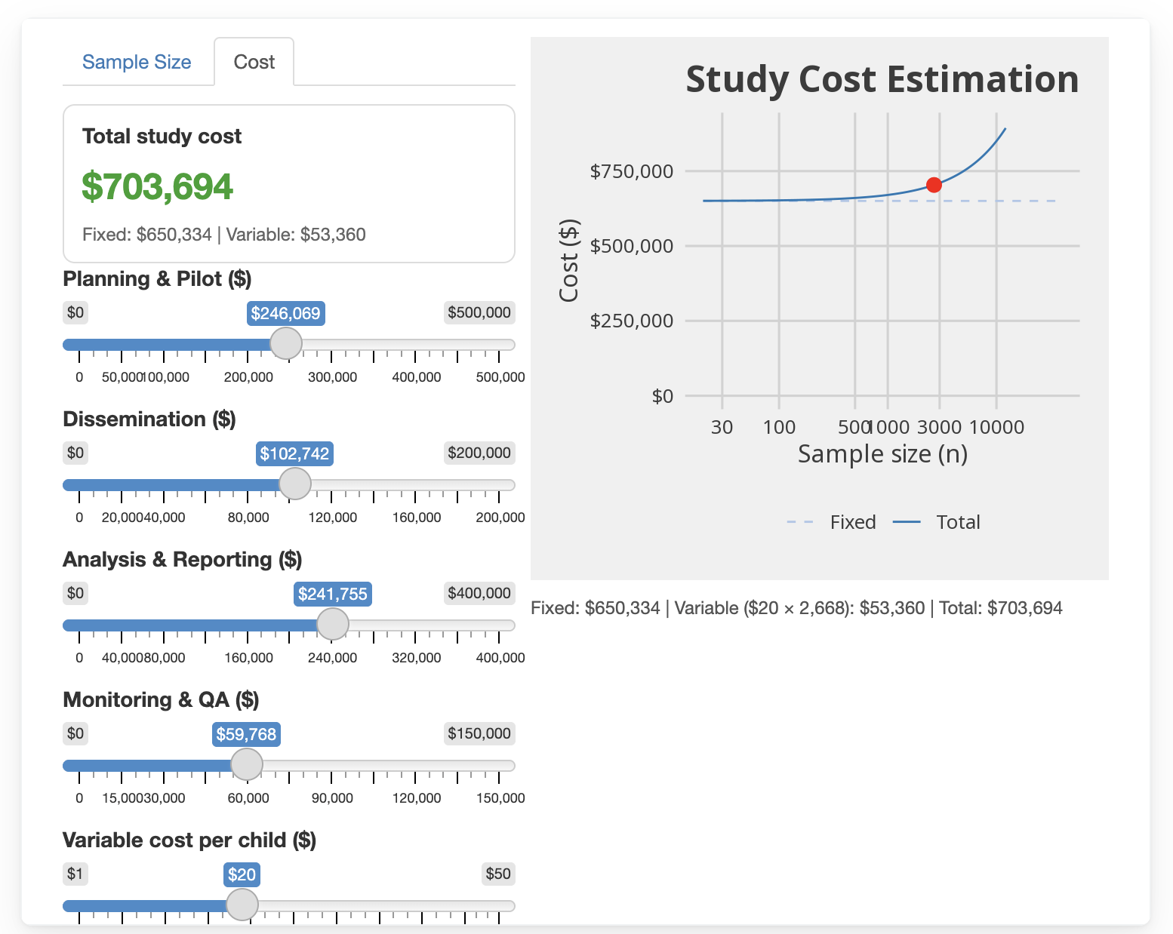
Figure B.1: Sample-size calculator (online interactive version snapshot)
Warning
The interactive sample-size calculator is available only in the online report version. Access it at: https://zd-head2head.netlify.app.

Appendix C — Intraclass Correlation
This annex quantifies baseline ICC-style diagnostics for Penta-1 coverage at the household, cluster, ward, and LGA levels. It uses the baseline multistage cluster survey (gold standard) as the empirical reference for design planning.
In survey operations, ICC matters because clustering inflates variance relative to simple random sampling (Kish 1965; Heeringa, West, and Berglund 2017). Values of ICC near 0 indicate weak within-group similarity at that level, while larger values indicate stronger local dependence. Knowing plausible ICC values helps set sample sizes to reach target precision. For planning, these estimates can replace default values for DEFF with context-specific DEFF calculations based on the empirical ICC. When researchers control how many households to interview per cluster, increasing households per cluster usually increases DEFF when within-cluster correlation is positive, while reducing households per cluster and adding clusters usually improves precision at a fixed total sample size. That precision gain is not free: adding clusters increases travel, listing, supervision, and other field costs. These ICC-style diagnostics therefore support scenario-based budgeting to choose a households-per-cluster value that balances precision targets against operational cost constraints.
The term ICC has multiple definitions, so this annex states its definition explicitly before presenting results. For single-stage cluster designs, those definitions are often easier to reconcile because both reduce to a within-cluster correlation or equivalent variance-share parameter (Gelman and Hill 2006; Heeringa, West, and Berglund 2017). In multilevel modeling, level-specific ICC values are treated as additive variance shares from one nested random-effects model with a common variance denominator. In design-based survey practice, ICC is typically interpreted as the expected within-cluster correlation for a given sampling design (Lovasi et al. 2017). Even within the design-based survey community, most sampling-theory treatments and common complex-survey software routines use ICC in this single-stage sense. With two-stage and three-stage designs, differences become more apparent because dependence accumulates across nested levels and can be expressed either as decomposed level-specific components or as cumulative within-group correlation patterns (Chen and Rust 2017).
For each grouping variable, we compute a weighted variance-share statistic separately:
$$ρ_{g}^{*}=\frac{B_{g}}{B_{g}+W_{g}}, \left(C.1\right)$$
where $B_{g}$ is the weighted between-group sum of squares and $W_{g}$ is the weighted within-group sum of squares for grouping variable $g$. We then recompute $ρ_{g}^{*}$ across generalized-bootstrap replicate weights to obtain a replicate distribution, a replicate-mean point estimate, and percentile uncertainty intervals. Because each level is estimated in a separate one-way decomposition, lower-level estimates are cumulative with respect to higher-level dependence. For example, the cluster-level ICC includes dependence shared through ward and LGA, and the ward-level ICC includes LGA-level dependence. These values are therefore not expected to sum to 1 across levels.
Figure Figure C.1 shows the replicate distributions for each level, and Table Table C.1 reports the corresponding replicate means and percentile intervals. The dominant result is the household estimate (0.936), which is much larger than the cluster (0.171), ward (0.095), and LGA (0.034) estimates. That pattern is consistent with strong within-household concordance in vaccination status and with the estimator property that households with one sampled child contribute no within-household sum of squares. Comparable large-scale survey analyses also find meaningful household and local-area clustering for immunization outcomes (Dwivedi et al. 2023). For design, this means that adding children within the same household usually contributes less independent information than adding households.
Under a simplified single-stage planning assumption, consistent with the ultimate-cluster variance approximation used in many survey software implementations, the usual formula is $\text{DEFF}≈1+\left(m−1\right)ρ$ with cluster size $m$. This approximation treats the sampled cluster as the primary unit of correlation and does not separately model lower-level nesting within clusters. If we use only the empirical cluster-level estimate from this annex and assume $m=7$ children per cluster, then the implied DEFF is approximately 2.02. This example is deliberately simplified and is intended only to show how an empirical ICC can be mapped into a working DEFF assumption.
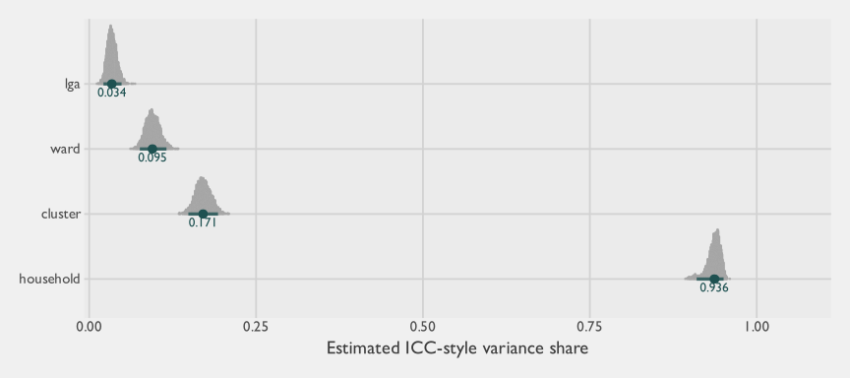
Figure C.1: Replicate distribution of baseline ICC-style estimates by grouping level
Table Table C.1 presents the same results in compact numeric form for planning use.
Table C.1: Baseline Penta-1 ICC-style variance-share summary by grouping level
Level | Mean ICC | 95% lower | 95% upper
Household | 0.936 | 0.910 | 0.950
Cluster | 0.171 | 0.149 | 0.193
Ward | 0.095 | 0.076 | 0.116
LGA | 0.034 | 0.021 | 0.048
These diagnostics are descriptive design inputs rather than a standalone model of data-generating structure. The uncertainty intervals come from the generalized-bootstrap replicate design already used in the baseline pipeline. For each replicate weight vector, we recompute the ICC statistic at each level using the same weighted between-group and within-group decomposition. This yields the empirical replicate distributions in Figure C.1. The point estimates in Table C.1 are replicate means, and lower and upper limits represent a 95% bootstrap confidence interval. This bootstrap approach propagates complex-survey design uncertainty into the ICC diagnostics without requiring normal-approximation assumptions for the ICC statistic.

C.1 Stratum-Specific ICC
The pooled ICC estimates in Table C.1 combine data from both sentinel and non-sentinel strata. Because these strata used different first-stage sampling strategies, their clustering properties may differ in ways that matter for survey planning.
In the sentinel LGAs (Gabasawa, Gaya, Nassarawa), the gold-standard survey drew a direct stratified sample of building footprints rather than a first-stage cluster sample of enumeration areas, achieving broad spatial coverage within each LGA. By contrast, the non-sentinel stratum used a probability-proportional-to-size (PPS) first-stage selection of gridded enumeration areas, which is closer to the design a typical EPI-style survey would follow. To ensure an apples-to-apples comparison, Table C.2 uses the same gridded enumeration area unit as the cluster-level grouping in both strata, rather than the operational workload clusters used for field logistics in sentinel areas. The non-sentinel gridded-EA ICC is a more appropriate empirical reference for planning a conventional survey design such as the EPI 30 $×$ 7 benchmark, because it reflects the between-cluster variance encountered under genuine first-stage probability sampling.
Table C.2 presents the ICC estimates separately for sentinel and non-sentinel strata at the household, gridded enumeration area, and ward levels.
Table C.2: Baseline Penta-1 ICC by stratum type and grouping level
Stratum | Level | Mean ICC | 95% lower | 95% upper
Non-sentinel | Household | 0.941 | 0.909 | 0.957
Non-sentinel | Gridded EA | 0.152 | 0.126 | 0.178
Non-sentinel | Ward | 0.104 | 0.082 | 0.128
Sentinel | Household | 0.914 | 0.905 | 0.922
Sentinel | Gridded EA | 0.315 | 0.301 | 0.329
Sentinel | Ward | 0.037 | 0.030 | 0.045

C.2 Cost-Optimal Cluster Size
The ICC estimates above describe the statistical cost of within-cluster homogeneity. Pairing them with the operational cost structure recovered from the time-motion study yields an empirical estimate of the cost-optimal number of child interviews to conduct per cluster. Throughout this section $m$ refers to the number of children 0–23 mo interviewed per cluster, which is the unit at which the empirical ICC is estimated and at which the per-interview cost denominator from this study’s cost decomposition is defined. The classic EPI $30×7$ benchmark is also specified in children (7 children aged 12–23 mo per cluster), so both quantities are on the same scale.
Kish (1965) showed that, for a single-stage cluster design with linear cost structure
$$C=c_{1}a+c_{2}am, \left(C.2\right)$$
where $a$ is the number of clusters and $m$ is the number of within-cluster interviews (here, children 0–23 mo), the cluster size that minimizes total cost at a fixed effective sample size (or equivalently, maximizes effective sample size at fixed cost) is
$$m_{\text{opt}}=\sqrt{\frac{c_{1} \left(1−ρ\right)}{c_{2} ρ}}, \left(C.3\right)$$
where $c_{1}$ is the cost of adding a new cluster (transport, listing, supervision), $c_{2}$ is the cost of interviewing one additional child within an existing cluster, and $ρ$ is the cluster-level ICC of the outcome. The expression is symmetric in $ρ$ and the cost ratio: large $ρ$ (high within-cluster homogeneity) pushes $m_{\text{opt}}$ down, while a large $c_{1}/c_{2}$ (cluster overhead dominates per-interview cost) pushes $m_{\text{opt}}$ up (Kish 1965; Heeringa, West, and Berglund 2017).
We estimate $c_{1}/c_{2}$ in two ways to bracket the structural uncertainty in how field costs decompose between cluster overhead and within-cluster interview effort.
Decomposition A (time-weighted, all costs). We split the observed per-cluster field cost from Table 4.21 by the time fraction spent on non-interview work. From the time-motion event log, the median enumerator-day breaks down into roughly 204 minutes of overhead (assembly, travel, return) and 420 minutes of fieldwork inside the enumeration area, so the overhead share of the field day is approximately 33%. Applied to the Gold-Standard core (Conventional + NSUM) marginal cost of $113.69 per cluster and 11.3 children per cluster, this gives $c_{1}≈$ $37.18 and $c_{2}≈$ $6.77, a ratio of $c_{1}/c_{2}≈$ 5.5. Under this decomposition, every dollar of daily cost is treated as proportional to where the day’s minutes are spent. This time-weighting is a planning-grade allocation of total observed cost, not a strict cost elasticity in $m$: in particular, supervisor labour is paid as a daily rate rather than per interview, so its share is partly cluster-fixed. Decomposition B addresses this directly.
Decomposition B (supervisor as cluster-fixed). The supervisor day rate ($70) is paid once per team-day and includes vehicle and fuel, so adding interviews to an existing cluster-day does not increase it. Treating the supervisor-and-transport line item as fully cluster-fixed and time-weighting only the enumerator labor yields $c_{1}≈$ $81.39 and $c_{2}≈$ $2.86, a ratio of $c_{1}/c_{2}≈$ 28.5. Under this decomposition, per-cluster supervision and transport costs are fixed regardless of how many interviews are added to an existing cluster-day.
Table C.3 presents the resulting cost-optimal cluster size under each ICC source and each cost decomposition. The headline estimate uses the non-sentinel gridded-EA ICC for $ρ$, since that is the empirical reference most appropriate for planning a conventional first-stage PPS design (see the framing in Table C.2).
Table C.3: Cost-optimal cluster size $m_{opt}$ under empirical ICC and cost ratios
ICC source | ρ (cluster ICC) | Decomp. A  (c₁/c₂ ≈ 5.5) | Decomp. B  (c₁/c₂ ≈ 28.5)
Pooled (cluster) | 0.171 | 5.2 | 11.8
Non-sentinel (gridded EA) | 0.152 | 5.5 | 12.6
Sentinel (gridded EA) | 0.315 | 3.5 | 7.9
Under the non-sentinel gridded-EA ICC of 0.152, the cost-optimal cluster size is approximately 6 children under Decomposition A and 13 children under Decomposition B. The conventional EPI $30×7$ design specifies 7 children per cluster, which sits inside this range and is broadly consistent with the empirical inputs from this study. Decomposition B implies that, once supervisor and transport overhead are accounted for as genuinely cluster-fixed, fewer clusters with somewhat larger size can be cost-efficient under typical Penta-1 ICC values. For lower-ICC outcomes or in strata with weaker within-cluster homogeneity (such as the non-sentinel pattern observed here), $m_{\text{opt}}$ rises further, but the marginal precision gain from increasing cluster size is shallow once the design is past the elbow of the cost-precision curve (Kish 1965; Heeringa, West, and Berglund 2017).
Both headlines hold under the two main analytic sensitivity checks. Substituting mean time-fraction shares for the median shares shifts the overhead share from 33% to 35% and moves $m_{\text{opt}}^{A}$ from 5.55 to 5.80 — well within the rounding bin. Propagating the 95% bootstrap interval on the non-sentinel gridded-EA ICC (0.126–0.178) gives $m_{\text{opt}}^{A}∈$ [5.04, 6.18] and $m_{\text{opt}}^{B}∈$ [11.49, 14.06]; the qualitative interpretation — that the optimum brackets the EPI $30×7$ benchmark of 7 children per cluster — does not change at either bound.
Three caveats apply. First, the formula assumes a single-stage cluster design with simple-random sampling within each cluster, so it abstracts from listing strategies, multi-stage sampling, and adaptive elements actually used in this study. Second, the cost decomposition relies on time-motion medians; field productivity varies by team and over the course of fieldwork, so $c_{1}/c_{2}$ should be interpreted as a planning-grade average rather than a constant. Third, the formula optimizes a single outcome at a time. Vaccination coverage surveys typically report several indicators, and the optimal $m$ differs across them when their ICC values differ, so survey designers should treat $m_{\text{opt}}$ as a starting point for scenario analysis rather than a single fixed recommendation. The calculator in Appendix B covers scenario analysis across these inputs.

Appendix D — Survey Instrument
The questionnaire below is the gold-standard household survey instrument fielded during data collection. The questionnaire was largely identical across methods; differences were programmatic rather than respondent-facing (e.g., LQAS ran one continuous form per enumeration area, while the gold-standard assigned individual households and opened a separate form instance per household). Including the gold-standard instrument is therefore sufficient.
This annex reproduces the gold-standard household survey instrument used during data collection. Calculated, sensor, and device-metadata fields are omitted; only respondent-facing questions, notes, and group/repeat structure are shown. Personally identifiable information from the field-team rosters has been redacted.
The instrument is split by section. Within each section, the Variable column gives the field name, Question the text shown to (or read aloud for) the respondent (with any enumerator hint below), Response the type and inline choice list, and Asked when the skip-pattern expression that determines whether the question is shown.
Enumerator Information
Variable | Question | Response | Asked when
enumerator_id | Please insert your National identification number | Free text (required) | ---
block_id | [Asked when ${enumerator_confirm}!=1] The entered ID is not in our records. Please contact your supervisor.
credential_confirm | Entered ID belongs to ${enumerator_name} Please confirm | Single choice: 1 = I confirm, this is my name.; 2 = No, this is incorrect information. (required) | ---
supervisor_id | Please insert your supervisor National identification number | Single choice --- 37 entries redacted (personal data) (required) | ---
block_id_supervisor | [Asked when ${supervisor_confirm}!=2] The entered ID is not in our records. Please contact your supervisor to get his right NIN.
credential_confirm_supervisor | Entered ID belongs to ${supervisor_name} supervisor, Please confirm | Single choice: 1 = Yes; 0 = No (required) | ---
qn | Please enter the QN of the survey | Free text (required) | ---
sn | Please enter the SN of the survey | Free text (required) | ---
block_qn | [Asked when ${sn_check}!=${sn}] The entered credentials are not in our records. Please go back and check the entered numbers.
block_qn_duplicate | [Asked when ${check_qn_duplicate}=1] This household has already been surveyed before. You cannot proceed.
lga_w | This questionnaire should take place in ${lga_name}. Are you currently in that LGA? | Single choice: 1 = Yes; 0 = No (required) | ---
current_location | Geopoint (automatically recorded variable) | GPS point (required) | ---
warning | [Asked when ${geopoint_accuracy} > 5] Please go back and give the tablet enough time to collect the right accuracy, the current accuracy is ${geopoint_accuracy}
already_randomize | [Asked when ${check_randomized_conducted}>0] The randomization of this building is already conducted
Enumerator Information > Not Lqs
Variable | Question | Response | Asked when
go_here | If you do not have an internet connection, press on "View or Change GeoTrace" and then compare your current location (the blue circle) to the target location, which is represented by the red icon. If you have an internet connection, press here to navigate to the target location. Based on your current location, you are ${distance_between_locations} meters away from the required location. You must be within 20 meters of the required location. | GPS trace (required) | ${distance_between_locations}>30
location_block | [Asked when ${distance_between_locations}>30] You are not in the correct location. Press here for the right location. You are ${distance_between_locations} meters away from the needed location. You must be within 20 meters of the needed location. If you are sure that you are within the correct location, check the accuracy of the location when you recorded it.
Pre-Interview
Variable | Question | Response | Asked when
building_type | Please specify the type of the building | Single choice: 1 = Residential; 2 = Commercial; 3 = Industrial; 4 = Mixed-Use; 5 = This building belongs to another building that has already been visited.; 6 = Health Facility; -96 = Other; -99 = Do not know (required) | ---
building_type_other | Please specify the type of the building | Free text (required) | ${building_type}=-96
residential_type | What is the type of the residential building? | Single choice: 1 = Traditional Compound / Blocks of Flats/Apartments; 2 = Bungalow; 3 = Duplex (Uptairs); 4 = Mud house; 5 = Mansion; 6 = Palace; -96 = Others (required) | ${building_type}=1 or ${building_type}=4
residential_type_other | Please specify the type of the residential building | Free text (required) | ${residential_type}=-96
belong_to | Based on the map you have, which building does this one belong to? Please specify the number of the original building. | Free text (required) | ${building_type}=5
count_apartments | Please enter the number of apartments of the current building. | Integer (required) | ${residential_type}=1
apartmentnum_2_apartments | [Asked when ${count_apartments}=2] In case there are only 2 apartment in this building you have to survey both of them
appartment1 | [Asked when (${apartment1_calc}!=null and ${residential_type}=1) and ${count_apartments}!=2] The selected apartments are: The first apartment is apartment number ${apartment1_calc} The second apartment is apartment number ${apartment2_calc}
apartmentnum | Which Apartment do you want to visit? | Single choice --- 30 options (full list in original questionnaire) (required) | count-selected(${already_visited})>=0 and (${residential_type}=1 or ${check_randomized_conducted}=1)
block_apartment | [Asked when ${check_duplicate}=1] This apartment has already been surveyed before. You cannot proceed.
Informed Consent
Variable | Question | Response | Asked when
check_availability | Did they open the door for you? | Single choice: 1 = Yes; 0 = No (required) | ---
intro1 | [Asked when ${check_availability}=1] Good day. Your household is invited to participate in a research study conducted by Mindset on behalf of Kano State Bureau of Statistics, Kano Ministry of Health and Kano State Primary Health Care Management Board funded by Gates Foundation. The purpose of this study is to gather information about vaccination coverage among children and identify barriers to immunization.
q001 | We are seeking to speak to households with children aged ${target_age_range} months. Does your household have any children aged ${target_age_range} months? | Single choice: 1 = Yes; 2 = No; -97 = Don't know (DO NOT READ); -98 = Refusal by host to proceed (required) | ${check_availability}=1
q002 | May we speak to the primary caregiver of this child / these children? If the primary caregiver is not present, may we speak with the household member best suited to answer questions about the health status of the child? | Single choice: 1 = Yes - I am the primary caregiver present; 2 = Yes - Other household member is present who is familiar about the health status of the child/children 0-23 months; 3 = No one currently present with knowledge on the health status of the child/children (Revisit); -98 = Refusal by host to proceed (required) | selected(${q001},'1')
q004 | To enumerator: Please record the gender of the respondent  [Hint] no need to ask the respondent; just record | Single choice: 1 = Male; 2 = Female (required) | ${check_availability}=1
intro2 | [Asked when selected(${q002},'1') or selected(${q002},'2')] Before you decide whether to participate, I will explain why this research is being conducted, what it will involve, and answer any questions you may have. Please listen carefully to the information provided. procedures_text: If you agree to participate: I will ask you questions about your household, the health and vaccination history of children in the household, and your access to healthcare services. The interview will take approximately [30 minutes]. Your responses will be recorded anonymously, and no personal identifying information will be shared. risk_benefits_text: Risks: There are no significant risks associated with participating in this study. Benefits: Your participation will contribute to the development of programs to improve immunization coverage and health services in your community. confidentiality_text: All information collected will be kept strictly confidential and used only for research purposes. Your identity will not be disclosed in any reports or publications. Data will be stored securely and accessed only by authorized research team members. compensation_text: You will not receive any monetary compensation for participating in this study. However, information collected will be used by the government and stakeholders to improve the health of children. Please inform the respondent that the survey is recorded for quality purposes contact_info_text: If you have any questions about this study, your rights as a participant, or if you have any complaints, you can contact: [Name of Research Coordinator: redacted] [Email Address: redacted] [Phone Number: redacted]
q003 | Although your household does not have any infants within our target age range, we still wish to ask a member of this household some questions. May we speak to the person aged 18 or older who most recently celebrated their birthday? | Single choice: 1 = Yes - individual present; 2 = No - individual not present; -98 = Refusal by host to proceed (required) | selected(${q001},'2') or selected(${q001},'-97') or ${q002}=-98
person_name_nsum | What is the name of the person in this household who is 18 or older and most recently celebrated their birthday? | Free text (required) | selected(${q002},'1') or selected(${q002},'2') or ${q003}=1
check_available_to_nsum | Is ${person_name_nsum} available to answer some questions in one section of the interview? | Single choice: 1 = Yes; 0 = No (required) | selected(${q002},'1') or selected(${q002},'2') or ${q003}=1
gender_to_nsum | q004: To enumerator: Please record the gender of ${person_name_nsum} | Single choice: 1 = Male; 2 = Female (required) | selected(${q002},'1') or selected(${q002},'2') or ${q003}=1
agree_nsum | We would like to ask ${person_name_nsum} about the community of people that ${person_name_nsum} knows. Think of the ${men_women} that you have had either face to face contact or phone communication with in the past seven days, and of which you would recognize by face and by name and they would recognize you by face and by name. That section will take less than 7 minutes. Does ${person_name_nsum} agree to participate? | Single choice: 1 = Yes; 0 = No (required) | ${check_available_to_nsum}=1
agree_nsum_inform | [Asked when (selected(${q002},'1') or selected(${q002},'2')) and ${check_available_to_nsum}=1] We will mention ${person_name_nsum} once we reach the required section where he/she should start answers the questions.
consent | Do you consent to participate in this survey? | Single choice: 1 = Yes; 0 = No (required) | selected(${q002},'1') or selected(${q002},'2') or ${agree_nsum}=1
dwelling_roof | To the enumerator: Observe the dwelling. What is the main material of the roof?  [Hint] record observation | Single choice: 1 = No roof; 2 = Natural roofing (thatch /palm leaf or sod); 3 = Rudimentary roofing (rustic mat, palm / bamboo, wood planks, cardboard); 4 = Finished roofing (metal / tin, wood calamine / cement fibre, ceramic tile, cement or roofing shingles); -96 = Other (specify); -97 = Don't know or cannot be determined from outside (required) | ---
dwelling_roof_other | Other (Please Specify):  [Hint] to the enumerator: please avoid repeating any option from the previous choices | Free text (required) | selected(${dwelling_roof},'-96')
exterior_walls | To the enumerator: Observe the dwelling. What are the main materials of the exterior walls?  [Hint] record observation. | Single choice: 1 = No walls; 2 = Natural walls (cane / palm / trunks or dirt); 3 = Rudimentary walls (bamboo, with mud, stone with mud, uncovered adobe, plywood, cardboard, reused wood ); 4 = Finished walls (cement stone with lime / cement, bricks, cement blocks, covered adobe, wood planks / shingles); -96 = Other (specify); -97 = Don't know or cannot be determined from outside (required) | ---
qexterior_walls_other | Other (Please Specify):  [Hint] to the enumerator: please avoid repeating any option from the previous choices | Free text (required) | selected(${exterior_walls},'-96')
Interview > Respondent Eligibility
Variable | Question | Response | Asked when
another_building | For the enumerator: Please show the respondent the map. Please take a look at the map you have and let me know: Are there any other buildings on this map that belong to you? | Single choice: 1 = Yes; 0 = No (required) | ---
another_building_count | How many buildings belong to you (your household) inside this map? | Integer (required) | ${another_building}=1
confirm_main | Now, we will start the survey with the caregiver or a family member who is familiar with the health status of the child/children (0-23 months). Please confirm that you are starting the survey with the needed person. NOT ${person_name_nsum} | Single choice: 1 = I confirm (required) | selected(${q001},'1')
q101 | How many children are aged ${target_age_range} months in this household? | Integer (required) | selected(${q001},'1')
q102 | Are you the primary caregiver to any of the children aged ${target_age_range} months? | Single choice: 1 = Yes; 2 = No; -98 = Refuse to answer (DO NOT READ) (required) | selected(${q001},'1')
q103 | Is there another adult in this household who is the primary caregiver to children aged ${target_age_range} months?  [Hint] if yes terminate the current respondent and request to speak to the caregiver | Single choice: 1 = Yes; 2 = No; -98 = Refuse to answer (DO NOT READ) (required) | selected(${q102},'2')
Interview > Respondent Eligibility > Other_building_list (repeating section)
Variable | Question | Response | Asked when
building_code | Please enter the number/code of the ${bu_index} building that the respondent said it belong to her/him _ You will find the number above each building in the map  [Hint] Or insert -99, if the number is not readable | Free text (required) | ---
Interview > Respondent Demographics
Variable | Question | Response | Asked when
q201 | What is your name?  [Hint] this information is captured for follow-up purposes and will be kept confidential. | Free text (required) | ---
q201.1 | What is ${q201} phone number? | Free text (required) | ---
q201.1.c | q201.1: Please re-enter the phone number. | Free text (required) | ${q201.1}!=99
mobile_owner | Who does this phone number belong to? | Single choice: 1 = For the respondent; 2 = For my husband/wife; 3 = For my daughter/son; -96 = Other (Specify) (required) | ${q201.1}!=99
mobile_owner_other | Other (Please Specify): | Free text (required) | ${mobile_owner}=-96
marital_status | What is your marital status? | Single choice: 1 = Never married; 2 = Married; 3 = Divorced; 4 = Widowed; 5 = Separated; -96 = Other (required) | ---
marital_status_other | Please specify your marital status | Free text (required) | ${marital_status}=-96
infant_single_explanation | You previously mentioned that you are the caregiver for ${q101} children, but then you selected that you are single. Please explain this discrepancy. If you are not single please go back and correct your answer | Free text (required) | ${marital_status}=1 and ${q101}>0
q202 | q202b: How old are you as of your last birthday?  [Hint] Please insert -99 in case of Do not know | Integer (required) | ---
q202_month | What month was your last birthday?  [Hint] Please insert -99 in case of Do not know | Integer (required) | ---
q203 | Were you born in Kano State? | Single choice: 1 = Yes; 2 = No; --97 = Don't know (DO NOT READ); -98 = Refuse to answer (DO NOT READ) (required) | ---
q204 | How long have you been living continuously in ${lga_name}? | Single choice: 1 = Years; 2 = Less than a year; 3 = Always 'Since born'; 4 = Visitor (required) | ---
q205 | How many years have you been living in ${lga_name}?  [Hint] If the respondent was born and has lived their whole life in Kano, please go back to the previous question and select "Always. | Integer (required) | ${q204}=1
q206 | In general, would you say your health is very good, good, moderate, bad, or very bad? | Single choice: 1 = Very Good; 2 = Good; 3 = Moderate; 4 = Bad; 5 = Very bad; -97 = Don't know (DO NOT READ); -98 = Refuse to answer (DO NOT READ) (required) | ---
q207 | Have you ever attended school? | Single choice: 1 = Yes; 2 = No; -98 = Refuse to answer (DO NOT READ) (required) | ---
q208 | What is the highest level of school you attended: primary, secondary, or higher? | Single choice: 1 = No Formal Education; 2 = Primary Education (Basic 1–6); 3 = Junior Secondary Education (JSS 1–3); 4 = Senior Secondary Education (SSS 1–3); 5 = National Certificate in Education (NCE); 6 = Ordinary National Diploma (OND); 7 = Higher National Diploma (HND); 8 = Bachelor’s Degree (BSc, BA, BEng, etc.); 9 = Postgraduate Diploma (PGD); 10 = Master’s Degree (MSc, MBA, M.Ed, etc.); 11 = Doctorate (PhD); 12 = Vocational / Technical Training (required) | ${q207}=1
q209 | What is the highest level you completed? | Single choice: 0 = None; 1 = No Formal Education; 2 = Primary Education (Basic 1–6); 3 = Junior Secondary Education (JSS 1–3); 4 = Senior Secondary Education (SSS 1–3); 5 = National Certificate in Education (NCE); 6 = Ordinary National Diploma (OND); 7 = Higher National Diploma (HND); 8 = Bachelor’s Degree (BSc, BA, BEng, etc.); 9 = Postgraduate Diploma (PGD); 10 = Master’s Degree (MSc, MBA, M.Ed, etc.); 11 = Doctorate (PhD); 12 = Vocational / Technical Training (required) | ${q207}=1
check_read | Are you able to read? | Single choice: 1 = Yes; 0 = No (required) | ---
cannot_read_explain | You mentioned before that you have attended school, but you also mentioned that you cannot read. Please explain that. | Free text (required) | ${check_read}=0 and ${q207}=1
q210 | Now I would like you to read this sentence to me in any language you prefer. The sentence in english is "I live in Kano" The sentence in Hausa is "Ina zaune a Kano"  [Hint] to the enumerator: show card to respondent. if respondent cannot read whole sentence, probe: can you read any part of the sentence to me? pick the appropriate choice She/he should read it in any language not both languages | Single choice: 1 = Cannot read at all; 2 = Able to read only part of the sentence; 3 = Able to read whole sentence; 4 = No card with required language; 5 = Blind/visually impaired; -98 = Refused/declined to read (DO NOT READ) (required) | ${check_read}=1
q210_explain | Why he/she could not read | Free text (required) | ${q210}=1
q211 | Do you read a newspaper or magazine at least once a week, less than once a week or not at all? | Single choice: 1 = At least once a week; 2 = Less than once a week; 3 = Not at all; -97 = Don't know (DO NOT READ); -98 = Refuse to answer (DO NOT READ) (required) | ${q210}=2 or ${q210}=3 or ${q210}=-98 or ${check_read}=1
q212 | Do you listen to the radio at least once a week, less than once a week or not at all? | Single choice: 1 = At least once a week; 2 = Less than once a week; 3 = Not at all; -97 = Don't know (DO NOT READ); -98 = Refuse to answer (DO NOT READ) (required) | ---
q213 | Do you watch television at least once a week, less than once a week or not at all? | Single choice: 1 = At least once a week; 2 = Less than once a week; 3 = Not at all; -97 = Don't know (DO NOT READ); -98 = Refuse to answer (DO NOT READ) (required) | ---
q214 | Do you own a mobile phone? | Single choice: 1 = Yes; 2 = No; -97 = Don't know (DO NOT READ); -98 = Refuse to answer (DO NOT READ) (required) | ---
q215 | Is your mobile a Smart Phone (internet enabled)? | Single choice: 1 = Yes; 2 = No; -97 = Don't know (DO NOT READ); -98 = Refuse to answer (DO NOT READ) (required) | ${q214}=1
q216 | Have you ever used the Internet from any location on any device? | Single choice: 1 = Yes; 2 = No; -97 = Don't know (DO NOT READ); -98 = Refuse to answer (DO NOT READ) (required) | ---
q217 | In the last 12 months, have you used the Internet?  [Hint] if necessary, probe for use from any location, with any device. | Single choice: 1 = Yes; 2 = No; -97 = Don't know (DO NOT READ); -98 = Refuse to answer (DO NOT READ) (required) | ${q216}=1
q218 | In the last 30 days, how often did you use the Internet: almost every day, at least once a week, less than once a week, or not at all? | Single choice: 1 = Almost every day; 2 = At least once a week; 3 = Less than once a week; 4 = Not at all; -98 = Refuse to answer (DO NOT READ) (required) | ${q217}=1
employment_status | What is your current employment status? | Single choice: 1 = Employed full-time; 2 = Employed part-time; 3 = Self-employed; 4 = Unemployed; 5 = Student; 6 = Retired; -96 = Other: ____ (required) | ---
employment_status_other | Please specify your employment | Free text (required) | ${employment_status}=-96
q219 | What is your occupation? That is, what kind of work do you mainly do? Or if you currently retired what was your occupation? | Single choice: 2 = Farmer; 3 = Trader; 4 = Civil servant; 5 = Work in private sector; -96 = Other; -98 = Refuse to answer (DO NOT READ) (required) | selected(${employment_status},'1') or selected(${employment_status},'2') or selected(${employment_status},'3') or selected(${employment_status},'6')
q219_other | Other (Please Specify):  [Hint] to the enumerator: please avoid repeating any option from the previous choices | Free text (required) | selected(${q219},'-96')
q220 | What is your religion? | Single choice: 1 = -Islam; 2 = - Catholic; 3 = - Other Christian; 4 = - Traditionalist; 5 = - Other; -98 = Refuse to answer (DO NOT READ) (required) | ---
q221 | What is your ethnic group? | Single choice: 1 = Hausa; 2 = Fulani; 3 = Kanuri; 4 = Nupe; 5 = Yoruba; 6 = Igbo; -96 = Other; -98 = Refuse to answer (DO NOT READ) (required) | ---
q221_other | Other (Please Specify):  [Hint] to the enumerator: please avoid repeating any option from the previous choices | Free text (required) | selected(${q221},'-96')
Interview > Household Composition and Socio-Economic Indicators
Variable | Question | Response | Asked when
q301 | How many people currently live in this household? | Integer (required) | ---
q301_adult | How many people currently live in this household above or equal 18? | Integer (required) | ${q301}>1
q302 | Does the household include any individuals with disabilities? | Single choice: 1 = Yes; 2 = No; -97 = Don't know (DO NOT READ); -98 = Refuse to answer (DO NOT READ) (required) | ---
q303 | What is the type of disability? | Multiple choice: 1 = Physical disabilities; 2 = Visual impairment; 3 = Hearing impairment; -96 = Other; -97 = Don't know (DO NOT READ); -98 = Refuse to answer (DO NOT READ) (required) | ${q302}=1
q303_other | Other (Please Specify): | Free text (required) | selected(${q303},'-96')
q304 | How many rooms do members of this household usually use for sleeping? | Integer (required) | ---
q305 | What is the main material of the dwelling floor?  [Hint] record observation. if observation is not possible, ask the respondent to determine the material of the dwelling floor. | Single choice: 1 = Natural floor (earth / sand or dung); 2 = Rudimentary floor (wood plank or palm / bamboo); 3 = Finished floor (parquet or polished wood, vinyl or asphalt strips, ceramic tiles, cement, carpet; -96 = Other (specify); -97 = Don't know (DO NOT READ); -98 = Refuse to answer (DO NOT READ) (required) | ---
q305_other | Other (Please Specify):  [Hint] to the enumerator: please avoid repeating any option from the previous choices | Free text (required) | selected(${q305},'-96')
check_electricity | Does this household receive electricity at any time? | Single choice: 1 = Yes; 0 = No (required) | ${q309_field_list_1}=2
source_electricity | What is the main source of electricity for this household? | Single choice: 1 = National grid; 2 = Generator; 3 = Solar power; 4 = Inverter/battery; -96 = Other (please specify) (required) | ${q309_field_list_1}=1 or ${check_electricity}=1
source_electricity_other | Please specify the main source of electricity | Free text (required) | ${source_electricity}=-96
no_electricity | What does the household mainly use for lighting at night? | Single choice: 1 = Kerosene lamp; 2 = Candle; 3 = Battery-powered torch/flashlight; 4 = Solar lamp; 5 = Firewood; -96 = Other (please specify) (required) | ${check_electricity}=0
no_electricity_other | Please specify what mainly use for lighting at night. | Free text (required) | selected(${no_electricity},'-96')
q311 | Do you or someone living in this household own this dwelling? | Single choice: 1 = Yes; 2 = No; -97 = Don't know (DO NOT READ); -98 = Refuse to answer (DO NOT READ) (required) | ---
q311a | Do you rent this dwelling from someone not living in this household? | Single choice: 1 = Yes; 2 = No; -97 = Don't know (DO NOT READ); -98 = Refuse to answer (DO NOT READ) (required) | selected(${q311},'2')
q311_explain | Please explain how you live in a dwelling that is neither owned nor rented. | Free text (required) | selected(${q311},'2') and selected(${q311a},'2')
q312 | Does any member of this household own any land that can be used for agriculture? | Single choice: 1 = Yes; 2 = No; -97 = Don't know (DO NOT READ); -98 = Refuse to answer (DO NOT READ) (required) | ---
q312a | How many hectares of agricultural land do members of this household own?  [Hint] one hectare is defined as 100 meters by 100 meters | Single choice: 1 = Less than 1 hectare; 2 = 1 hectare or more (Specify):; -97 = Unsure (DO NOT READ); -98 = Refuse to answer (DO NOT READ) (required) | ${q312}=1
q312b | How many hectares of agricultural land do members of this household own? | Integer (required) | ${q312a}=2
q313a_animals_other | q313a_other: Other (Please Specify the other animal):  [Hint] to the enumerator: please avoid repeating any option from the previous choices | Free text (required) | selected(${q313_animals_other},'1')
q313_animals_livestock_count | q313a: How many of the following livestock do members of your household own? | Integer (required) | ${q313_animals_livestock}=1
q313_animals_herds_count | q313a: How many of the following Herds do members of your household own? | Integer (required) | ${q313_animals_herds}=1
q313_animals_poultry_count | q313a: How many of the following Poultry do members of your household own? | Integer (required) | ${q313_animals_poultry}=1
q313_animals_other_count | q313a: How many of the following ${q313a_animals_other} do members of your household own? | Integer (required) | ${q313_animals_other}=1
Interview > Household Composition and Socio-Economic Indicators > Q309 Field List
Variable | Question | Response | Asked when
q309_field_list_note | Does your household have:  [Hint] Functioning devices | Single choice: 1 = Yes; 2 = No | ---
q309_field_list_1 | Electricity | Single choice: 1 = Yes; 2 = No (required) | ---
q309_field_list_2 | A radio | Single choice: 1 = Yes; 2 = No (required) | ---
q309_field_list_3 | A television | Single choice: 1 = Yes; 2 = No (required) | ---
q309_field_list_4 | A fixed telephone line | Single choice: 1 = Yes; 2 = No (required) | ---
q309_field_list_5 | A computer | Single choice: 1 = Yes; 2 = No (required) | ---
q309_field_list_6 | A refrigerator | Single choice: 1 = Yes; 2 = No (required) | ---
Interview > Household Composition and Socio-Economic Indicators > Q310 Field List
Variable | Question | Response | Asked when
q310_field_list_note | Does any member of this household own: | Single choice: 1 = Yes; 2 = No | ---
q310_field_list_1 | A watch | Single choice: 1 = Yes; 2 = No (required) | ---
q310_field_list_2 | A mobile phone | Single choice: 1 = Yes; 2 = No (required) | ---
q310_field_list_3 | A computer or tablet | Single choice: 1 = Yes; 2 = No (required) | ---
q310_field_list_4 | A motorcycle or motor scooter | Single choice: 1 = Yes; 2 = No (required) | ---
q310_field_list_5 | A fixed telephone line | Single choice: 1 = Yes; 2 = No (required) | ---
q310_field_list_6 | An animal drawn cart | Single choice: 1 = Yes; 2 = No (required) | ---
q310_field_list_7 | A car or truck | Single choice: 1 = Yes; 2 = No (required) | ---
q310_field_list_8 | A boat with a motor | Single choice: 1 = Yes; 2 = No (required) | ---
Interview > Household Composition and Socio-Economic Indicators > Q313 Animals
Variable | Question | Response | Asked when
q313_animals_note | q313: Does this household own any of the following: | Single choice: 1 = Yes; 0 = No | ---
q313_animals_livestock | Livestock  [Hint] Refers to domesticated animals raised for agricultural purposes, such as for meat, milk, wool, or labor. | Single choice: 1 = Yes; 0 = No (required) | ---
q313_animals_herds | Herds  [Hint] "Herd" typically describes animals that naturally group together, such as cattle, sheep, or goats. | Single choice: 1 = Yes; 0 = No (required) | ---
q313_animals_poultry | Poultry | Single choice: 1 = Yes; 0 = No (required) | ---
q313_animals_other | other farm animals | Single choice: 1 = Yes; 0 = No (required) | ---
Interview
Variable | Question | Response | Asked when
intro_child_identification_and_immunization_status | [Asked when selected(${q001},'1')] Now I would like to ask some questions about vaccinations received by your children aged ${target_age_range} months. We will talk about each separately, starting with the youngest.
confirm_nsum | Now, we will start the section with ${person_name_nsum}. Please confirm that you are asking the remaining questions to ${person_name_nsum}. | Single choice: 1 = I confirm (required) | ${agree_nsum}=1
final_message_participant | [Asked when selected(${consent},'1')] Thank you very much for taking the time to participate in the survey.
final_message_nonparticipant | [Asked when selected(${consent},'0')] Thank you very much for your time and have a good day.
current_location_end | Geopoint (automatically recorded variable) | GPS point (required) | ---
warning_end | [Asked when ${geopoint_accuracy_end} > 5] Please go back and give the tablet enough time to collect the right accuracy, the current accuracy is ${geopoint_accuracy_end}
comment_check | Do you have any comments | Multiple choice: 1 = All good; 2 = Technical issue; 3 = Questions issue; 4 = Translation Issue; 5 = Respondent issue; 6 = Logistical issue; 7 = Data issue; -96 = Other (required) | ---
comment | Please write your comment | Free text (required) | selected(${comment_check},'2') or selected(${comment_check},'3') or selected(${comment_check},'4') or selected(${comment_check},'5') or selected(${comment_check},'6') or selected(${comment_check},'7') or selected(${comment_check},'-96')
Interview > Child Identification and Immunization Status (repeating section)
Variable | Question | Response | Asked when
q401 | What is the given name of the ${child_index_la} child?  [Hint] Please insert -91 in case the child is not named yet | Free text (required) | ---
q402 | Gender of ${childname}? | Single choice: 1 = Male; 2 = Female (required) | ---
q403 | What is your relationship to the ${childname} | Single choice: 1 = Mother; 2 = Father; 3 = Grandparent; -96 = Other (Specify); -98 = Refuse to answer (DO NOT READ) (required) | ---
q403_other | Other (Please Specify): | Free text (required) | ${q403}=-96
q403_check_mother | Can we ask his mother the following questions? | Single choice: 1 = Yes; 0 = No (required) | ${q403}!=1
name_check_mother | What is your name? | Free text (required) | ${q403_check_mother}=1
q404a | What is the date of birth of ${childname} | Date (required) | ---
q404a_confirm | q404a: Please re-select the date of birth of ${childname} | Date (required) | ---
block_age | [Asked when ${birth_month}>23] The child's age should be less than 24 months, but the selected date indicates that his/her age is more than 23 months.
q404 | Please confirm the age of ${childname} is ${birth_month} month/s? | Single choice: 1 = That's True; 2 = That's Not True (required) | ---
q405 | What is the birth order of ${childname}? | Single choice: 1 = Youngest; 2 = 2nd; 3 = 3rd; 4 = 4th; 5 = 5th; 6 = 6th; 7 = 7th; 8 = 8th; 9 = 9th; 10 = 10th; 11 = 11th; 12 = 12th; 13 = 13th; 14 = 14th; 15 = 15th; -96 = Other (required) | ---
q405_other | Other (Please Specify):  [Hint] to the enumerator: please avoid repeating any option from the previous choices | Free text (required) | selected(${q405},'-96')
child_disability | Does ${childname} have any disabilities? | Single choice: 1 = Yes; 2 = No; -97 = Don't know (DO NOT READ); -98 = Refuse to answer (DO NOT READ) (required) | ---
child_disability_type | child_disability: What is the type of disability? | Multiple choice: 1 = Physical disabilities; 2 = Visual impairment; 3 = Hearing impairment; -96 = Other; -97 = Don't know (DO NOT READ); -98 = Refuse to answer (DO NOT READ) (required) | ${child_disability}=1
child_disability_type_other | child_disability: Other (Please Specify): | Free text (required) | selected(${child_disability_type},'-96')
q406 | Is ${childname} a twin? | Single choice: 1 = Yes; 2 = No (required) | ---
q407 | What is the child birth registration status? | Single choice: 1 = Registered; 2 = Not Registered; -97 = Don't know (DO NOT READ) (required) | ---
q408 | Where was the place of birth of ${childname}? | Single choice: 1 = Home; 2 = Public Health facility; 3 = Private health facility; -96 = Other (required) | ---
q408_other | Other (Please Specify):  [Hint] to the enumerator: please avoid repeating any option from the previous choices | Free text (required) | selected(${q408},'-96')
q409 | Has ${childname} received any vaccinations?  [Hint] think about any vaccines your child might have received, either at a health facility, during a vaccination campaign, or from a health worker at home. | Single choice: 1 = Yes; 2 = No; -97 = Don't know (DO NOT READ) (required) | ---
q409_confirm | We would like to confirm your answer to ensure accuracy. This information is very important for understanding vaccination coverage. Can you please confirm that ${childname} has not received any vaccinations? | Single choice: 1 = Yes; 0 = No (required) | ${q409}=2
vaccinations_acceptance | Nigeria has a schedule of recommended vaccines for children. Do you want your child to get none of these vaccines, some of these vaccines or all of these vaccines? | Single choice: 1 = None; 2 = Some; 3 = All (required) | ${q409}=2 or ${q409}=-97
q428 | Nigeria has a schedule of recommended vaccines. What is the main reason(s) ${childname} did not get vaccine(s)]?  [Hint] select all that apply. to the enumerator: do not read options (mindset) | Multiple choice (same options as bcg_notvac) (required) | ${q409}=2
q428_other | Other (Please Specify):  [Hint] to the enumerator: please avoid repeating any option from the previous choices | Free text (required) | selected(${q428},'-96')
q428_permession | Please specify the type of the permission that you need to vaccinate your child | Free text (required) | selected(${q428},'30')
friend_relative_reason | You mentioned that your family or friends don't support vaccination. Could you please specify who exactly does not support it? | Multiple choice: 1 = Family; 2 = Father; 3 = Mother; 4 = Husband / Wife; 5 = Son / Daughter; 6 = Brother / Sister; 7 = Grandparent; 2 = Friends; -96 = Other (specify) (required) | selected(${q428},'28')
friend_relative_reason_other | Other (Please Specify): | Free text (required) | selected(${friend_relative_reason},'-96')
friend_relative_effect | You mentioned that Family or friends don't support vaccination, please explain this point in detail | Free text (required) | selected(${q428},'28')
Interview > Child Identification and Immunization Status > Immunization Records (repeating section)
Variable | Question | Response | Asked when
facility_vac | What is the type of the facility where he/she got the vaccine? | Single choice: 1 = Public Health facility; 2 = Private health facility; -96 = Other (required) | ---
facility_vac_other | Other (Please Specify) | Free text (required) | ${facility_vac}=-96
q410 | Do you have a National Child Immunisation Record, immunisation records from a private health provider or any other document where ${childname}'s vaccinations are written down? | Single choice: 1 = Yes, has only card(s); 2 = Yes, has only other document; 3 = Yes, has card(s) and other document; 4 = No, has no card and no other document (required) | ---
q411 | Did you ever have a National Child Immunisation Record or immunisation records from a private health provider for ${childname}? | Single choice: 1 = Yes; 2 = No (required) | ---
q412 | May I see the card(s) (and/or) other document? | Multiple choice: 1 = Yes, I can see the card(s); 2 = Yes, I can see the other document(s); 3 = No, no card and no other document seen (required) | selected(${q410},'1') or selected(${q410},'2') or selected(${q410},'3') or selected(${q411},'1')
q413.a | q411: Are you able to see the date of birth of ${childname} from the card and/or other document? | Single choice: 1 = Yes; 2 = No, date missing; 3 = No, date illegible; 4 = No, date is nonsensical; 5 = No, date is incomplete (required) | selected(${q412},'1') or selected(${q412},'2')
q413 | Record date of birth from the card and/or other document. | Date (required) | ${q413.a}=1
birth_month_card_explain | Please explain the reason for that difference between the DOB provided by the respondent and the DOB shown in the card. | Free text (required) | (${birth_age_card}!=${birth_age}) and ${birth_age_card}!=null
opv_block | [Asked when (${opv3}=1 and ${opv2}=0) or (${opv2}=1 and ${opv1}=0) or (${opv1}=1 and ${opv0}=0)] You have a discrepancy in receiving the OPV vaccines. Vaccines must be received in sequence—for example, you cannot receive OPV 3 if you have not received OPV 2.
dpt_block | [Asked when (${dpt3}=1 and ${dpt2}=0) or (${dpt2}=1 and ${dpt1}=0)] You have a discrepancy in receiving the DPT vaccines. Vaccines must be received in sequence—for example, you cannot receive DPT 3 if you have not received DPT 2.
pcv_block | [Asked when (${pcv3}=1 and ${pcv2}=0) or (${pcv2}=1 and ${pcv1}=0)] You have a discrepancy in receiving the PCV vaccines. Vaccines must be received in sequence—for example, you cannot receive PCV 3 if you have not received PCV 2.
rv_block | [Asked when (${rv3}=1 and ${rv2}=0) or (${rv2}=1 and ${rv1}=0)] You have a discrepancy in receiving the ROTA vaccines. Vaccines must be received in sequence—for example, you cannot receive ROTA 2 if you have not received ROTA 1.
mcv_block | [Asked when (${mcv2}=1 and ${mcv1}=0)] You have a discrepancy in receiving the MCV vaccines. Vaccines must be received in sequence—for example, you cannot receive MCV 2 if you have not received MCV 1.
vac_but_without_specify | You mentioned that your child has received vaccinations, but you selected all of the listed vaccines as "not vaccinated." Please explain the discrepancy. | Free text (required) | ${bcg}!=1 and  ${hepb}!=1 and  ${opv0}!=1 and  ${opv1}!=1 and  ${opv2}!=1 and  ${opv3}!=1 and  ${ipv}!=1 and  ${dpt1}!=1 and  ${dpt2}!=1 and  ${dpt3}!=1 and  ${pcv1}!=1 and  ${pcv2}!=1 and  ${pcv3}!=1 and  ${rv1}!=1 and  ${rv2}!=1 and  ${rv3}!=1 and  ${mcv1}!=1 and  ${mcv2}!=1 and  ${vita}!=1
extra_recall | In addition to what is recorded on (this document/these documents), did ${childname} receive any other vaccinations, including vaccinations received in campaigns or immunization days or child health days? | Single choice: 1 = Yes; 2 = No; -97 = Don't know (DO NOT READ); -98 = Refuse to answer (DO NOT READ) (required) | ---
Interview > Child Identification and Immunization Status > Immunization Records > Undocumented_immunizations: Undocumented Immunizations (repeating section)
Variable | Question | Response | Asked when
q414_1 | q414: Has ${childname} ever received a BCG vaccination against tuberculosis, that is, an injection in the arm or shoulder that usually causes a scar? | Single choice: 1 = Yes; 2 = No; -97 = Don't know (DO NOT READ); -98 = Refuse to answer (DO NOT READ) (required) | ---
q415_1 | q415: At or soon after birth, did ${childname} receive a Hepatitis B vaccination, that is, an injection in the thigh to prevent Hepatitis B? | Single choice: 1 = Yes; 2 = No; -97 = Don't know (DO NOT READ); -98 = Refuse to answer (DO NOT READ) (required) | ---
q415b_1 | q415b: Did ${childname} receive it within 24 hours of birth? | Single choice: 1 = Within 24 hours of birth; 2 = Later; -97 = Don't know (DO NOT READ); -98 = Refuse to answer (DO NOT READ) (required) | ${q415_1}=1
q416_1 | q416: Has ${childname} ever received oral polio vaccine, that is, about two drops in the mouth to prevent polio? | Single choice: 1 = Yes; 2 = No; -97 = Don't know (DO NOT READ); -98 = Refuse to answer (DO NOT READ) (required) | ---
q416b_1 | q416b: Did ${childname} receive the first oral polio vaccine in the first 2 weeks after birth or later? | Single choice: 1 = First two weeks; 2 = Later; -97 = Don't know (DO NOT READ); -98 = Refuse to answer (DO NOT READ) (required) | ${q416_1}=1
q417_1 | q417: How many times was the oral polio vaccine received? | Integer (required) | ${q416_1}=1
q418_1 | q418: Has ${childname} ever received an injected polio vaccine, that is, an injection in the arm to protect against polio?  [Hint] probe by indicating that this vaccine is often called ipv, and that the injection can be given at the same time as the oral polio vaccine and/or other injections. | Single choice: 1 = Yes; 2 = No; -97 = Don't know (DO NOT READ); -98 = Refuse to answer (DO NOT READ) (required) | ---
q419_1 | q419: How many times was the injected polio vaccine received? | Integer (required) | ${q418_1}=1
q420_1 | q420: Has ${childname} ever received a Pentavalent vaccination, that is, an injection in the thigh to prevent (him/her) from getting tetanus, whooping cough, diphtheria, Hepatitis B disease, and Haemophilus influenzae type b?  [Hint] probe by indicating that the pentavalent vaccination is sometimes given at the same time as the polio drops. | Single choice: 1 = Yes; 2 = No; -97 = Don't know (DO NOT READ); -98 = Refuse to answer (DO NOT READ) (required) | ${birth_age}>=28
q421_1 | q421: How many times was the pentavalent vaccine received? | Integer (required) | ${q420_1}=1
q422_1 | q422: Has ${childname} ever received a pneumococcal vaccination, that is, an injection in the thigh to prevent pneumonia? | Single choice: 1 = Yes; 2 = No; -97 = Don't know (DO NOT READ); -98 = Refuse to answer (DO NOT READ) (required) | ${birth_age}>=28
q423_1 | q423: How many times did ${childname} receive the pneumococcal vaccine? | Integer (required) | ${q422_1}=1
q424_1 | q424: Has ${childname} ever received a MMR/MR vaccine, that is, an injection in the arm to prevent (him/her) from getting measles, mumps, and rubella? | Single choice: 1 = Yes; 2 = No; -97 = Don't know (DO NOT READ); -98 = Refuse to answer (DO NOT READ) (required) | ${birth_age}>=220
q425_1 | q425: How many times was the measles/MMR vaccine received? | Integer (required) | ${q424_1}=1
q426_1 | q426: Has ${childname} ever received a rotavirus vaccination, that is, liquid in the mouth to prevent diarrhea? | Single choice: 1 = Yes; 2 = No; -97 = Don't know (DO NOT READ); -98 = Refuse to answer (DO NOT READ) (required) | ${birth_age}>=28
q427_1 | q427: How many times did ${childname} receive the rotavirus vaccine? | Integer (required) | ${q426_1}=1
other_vacc | Do you remember any other vaccine that has not been mentioned before? | Single choice: 1 = Yes; 0 = No (required) | ---
other_vacc_specify | Other (Please Specify) | Free text (required) | ${other_vacc}=1
Interview > Child Identification and Immunization Status > Immunization Records > Documented Vaccinations (repeating section)
Variable | Question | Response | Asked when
vaccinations_note | Select all immunizations for which documentation is shown for ${childname}. | Single choice: 1 = Yes; 0 = No | ---
bcg | BCG | Single choice: 1 = Yes; 0 = No (required) | ---
hepb | HEPATITIS B AT BIRTH | Single choice: 1 = Yes; 0 = No (required) | ---
opv0 | ORAL POLIO VACCINE (OPV) 0 (BIRTH DOSE) | Single choice: 1 = Yes; 0 = No (required) | ---
opv1 | ORAL POLIO VACCINE (OPV) 1 | Single choice: 1 = Yes; 0 = No (required) | ${birth_age}>=28
opv2 | ORAL POLIO VACCINE (OPV) 2 | Single choice: 1 = Yes; 0 = No (required) | ${birth_age}>=56
opv3 | ORAL POLIO VACCINE (OPV) 3 | Single choice: 1 = Yes; 0 = No (required) | ${birth_age}>=84
ipv | INACTIVATED POLIO VACCINE (IPV) | Single choice: 1 = Yes; 0 = No (required) | ${birth_age}>=28
dpt1 | DPT-HEP.B-HIB (PENTAVALENT) 1 | Single choice: 1 = Yes; 0 = No (required) | ${birth_age}>=28
dpt2 | DPT-HEP.B-HIB (PENTAVALENT) 2 | Single choice: 1 = Yes; 0 = No (required) | ${birth_age}>=56
dpt3 | DPT-HEP.B-HIB (PENTAVALENT) 3 | Single choice: 1 = Yes; 0 = No (required) | ${birth_age}>=84
pcv1 | PNEUMOCOCCAL (PCV) 1 | Single choice: 1 = Yes; 0 = No (required) | ${birth_age}>=28
pcv2 | PNEUMOCOCCAL (PCV) 2 | Single choice: 1 = Yes; 0 = No (required) | ${birth_age}>=56
pcv3 | PNEUMOCOCCAL (PCV) 3 | Single choice: 1 = Yes; 0 = No (required) | ${birth_age}>=84
rv1 | ROTAVIRUS (Rota ) 1 | Single choice: 1 = Yes; 0 = No (required) | ${birth_age}>=28
rv2 | ROTAVIRUS (Rota) 2 | Single choice: 1 = Yes; 0 = No (required) | ${birth_age}>=56
rv3 | ROTAVIRUS (Rota) 3 | Single choice: 1 = Yes; 0 = No (required) | ${birth_age}>=84
mcv1 | MEASLES CONTAINING VACCINE (MCV) 1 | Single choice: 1 = Yes; 0 = No (required) | ${birth_age}>=220
mcv2 | MEASLES CONTAINING VACCINE (MCV) 2 | Single choice: 1 = Yes; 0 = No (required) | ${birth_age}>=400
vita | VITAMIN A (First Dose) | Single choice: 1 = Yes; 0 = No (required) | ${birth_age}>=140
vita2 | VITAMIN A (Second Dose) | Single choice: 1 = Yes; 0 = No (required) | ${birth_age}>=320
ipv2 | IPV2 | Single choice: 1 = Yes; 0 = No (required) | ${birth_age}>=84
yellow_fever | Yellow fever | Single choice: 1 = Yes; 0 = No (required) | ${birth_age}>=220
meningitis | Meningitis | Single choice: 1 = Yes; 0 = No (required) | ${birth_age}>=220
Interview > Child Identification and Immunization Status > Immunization Records > Notvac Reason (repeating section)
Variable | Question | Response | Asked when
bcg_notvac | Please select the reasons for not getting the BCG vaccine. | Multiple choice: 1 = Not contacted about being due for vaccination; 2 = Didn’t know or forgot when due for vaccination; 3 = Not available to get vaccinated (busy, away from home, or child was sick); 4 = Didn’t know where to go for vaccination; 5 = His Age not eligible to that vaccine; 6 = Could not afford the cost at the health center (e.g., payment for services); 7 = Could not afford other costs related to vaccination (e.g., transport to health center, taking time away from work, childcare, recovery time); 8 = Unsafe to travel to the vaccination site (may be due to weather, crime, conflict, or disaster); 9 = Health center is hard to get to; 10 = Health center has inconvenient opening times; 11 = Health center turns people away (vaccines not available, session cancelled); 12 = Health center has long waiting times; 13 = Health center is not clean; 14 = Health workers were missing skills; 15 = Health workers were not respectful; 16 = Health workers do not spend enough time with people; 17 = Not concerned about the disease(s) that the vaccine prevents; 18 = Vaccine not important / needed / effective; 19 = Vaccine not safe / concerned about side effects; 20 = Heard rumours or something bad about vaccines; 21 = Don’t trust health workers who give vaccines; 22 = Pain or distress from injection; 23 = Decided to delay vaccination; 24 = Prefer traditional or alternative approaches; 25 = Health worker didn’t recommend vaccination; 26 = Family or friends don’t get vaccinated (themselves or their children); 27 = Family or friends don’t support vaccination; 28 = Religious leaders don’t support vaccination; 29 = Community leaders don’t support vaccination; 30 = Needed permission to take child for vaccination; -96 = Other reason; -97 = Don't know (DO NOT READ); -98 = Refuse to answer (DO NOT READ) (required) | ${bcg}=0
bcg_notvac_other | Please specify the other reason/s | Free text (required) | selected(${bcg_notvac},-96)
hepb_notvac | Please select the reasons for not getting the HEPATITIS B AT BIRTH vaccine. | Multiple choice (same options as bcg_notvac) (required) | ${hepb}=0
hepb_notvac_other | Please specify the other reason/s | Free text (required) | selected(${hepb_notvac},-96)
opv0_notvac | Please select the reasons for not getting the ORAL POLIO VACCINE (OPV) 0 (BIRTH DOSE) vaccine. | Multiple choice (same options as bcg_notvac) (required) | ${opv0}=0
opv0_notvac_other | Please specify the other reason/s | Free text (required) | selected(${opv0_notvac},-96)
opv1_notvac | Please select the reasons for not getting the ORAL POLIO VACCINE (OPV) 1 vaccine. | Multiple choice (same options as bcg_notvac) (required) | ${opv1}=0
opv1_notvac_other | Please specify the other reason/s | Free text (required) | selected(${opv1_notvac},-96)
opv2_notvac | Please select the reasons for not getting the ORAL POLIO VACCINE (OPV) 2 vaccine. | Multiple choice (same options as bcg_notvac) (required) | ${opv2}=0
opv2_notvac_other | Please specify the other reason/s | Free text (required) | selected(${opv2_notvac},-96)
opv3_notvac | Please select the reasons for not getting the ORAL POLIO VACCINE (OPV) 3 vaccine. | Multiple choice (same options as bcg_notvac) (required) | ${opv3}=0
opv3_notvac_other | Please specify the other reason/s | Free text (required) | selected(${opv3_notvac},-96)
ipv_notvac | Please select the reasons for not getting the INACTIVATED POLIO VACCINE (IPV) vaccine. | Multiple choice (same options as bcg_notvac) (required) | ${ipv}=0
ipv_notvac_other | Please specify the other reason/s | Free text (required) | selected(${ipv_notvac},-96)
dpt1_notvac | Please select the reasons for not getting the DPT-HEP.B-HIB (PENTAVALENT) 1 vaccine. | Multiple choice (same options as bcg_notvac) (required) | ${dpt1}=0
dpt1_notvac_other | Please specify the other reason/s | Free text (required) | selected(${dpt1_notvac},-96)
dpt2_notvac | Please select the reasons for not getting the DPT-HEP.B-HIB (PENTAVALENT) 2 vaccine. | Multiple choice (same options as bcg_notvac) (required) | ${dpt2}=0
dpt2_notvac_other | Please specify the other reason/s | Free text (required) | selected(${dpt2_notvac},-96)
dpt3_notvac | Please select the reasons for not getting the DPT-HEP.B-HIB (PENTAVALENT) 3 vaccine. | Multiple choice (same options as bcg_notvac) (required) | ${dpt3}=0
dpt3_notvac_other | Please specify the other reason/s | Free text (required) | selected(${dpt3_notvac},-96)
pcv1_notvac | Please select the reasons for not getting the PNEUMOCOCCAL (PCV) 1 vaccine. | Multiple choice (same options as bcg_notvac) (required) | ${pcv1}=0
pcv1_notvac_other | Please specify the other reason/s | Free text (required) | selected(${pcv1_notvac},-96)
pcv2_notvac | Please select the reasons for not getting the PNEUMOCOCCAL (PCV) 2 vaccine. | Multiple choice (same options as bcg_notvac) (required) | ${pcv2}=0
pcv2_notvac_other | Please specify the other reason/s | Free text (required) | selected(${pcv2_notvac},-96)
pcv3_notvac | Please select the reasons for not getting the PNEUMOCOCCAL (PCV) 3 vaccine. | Multiple choice (same options as bcg_notvac) (required) | ${pcv3}=0
pcv3_notvac_other | Please specify the other reason/s | Free text (required) | selected(${pcv3_notvac},-96)
rv1_notvac | Please select the reasons for not getting the ROTAVIRUS (Rota ) 1 vaccine. | Multiple choice (same options as bcg_notvac) (required) | ${rv1}=0
rv1_notvac_other | Please specify the other reason/s | Free text (required) | selected(${rv1_notvac},-96)
rv2_notvac | Please select the reasons for not getting the ROTAVIRUS (Rota) 2 vaccine. | Multiple choice (same options as bcg_notvac) (required) | ${rv2}=0
rv2_notvac_other | Please specify the other reason/s | Free text (required) | selected(${rv2_notvac},-96)
rv3_notvac | Please select the reasons for not getting the ROTAVIRUS (Rota) 3 vaccine. | Multiple choice (same options as bcg_notvac) (required) | ${rv3}=0
rv3_notvac_other | Please specify the other reason/s | Free text (required) | selected(${rv3_notvac},-96)
mcv1_notvac | Please select the reasons for not getting the MEASLES CONTAINING VACCINE (MCV) 1 vaccine. | Multiple choice (same options as bcg_notvac) (required) | ${mcv1}=0
mcv1_notvac_other | Please specify the other reason/s | Free text (required) | selected(${mcv1_notvac},-96)
mcv2_notvac | Please select the reasons for not getting the MEASLES CONTAINING VACCINE (MCV) 2 vaccine. | Multiple choice (same options as bcg_notvac) (required) | ${mcv2}=0
mcv2_notvac_other | Please specify the other reason/s | Free text (required) | selected(${mcv2_notvac},-96)
vita_notvac | Please select the reasons for not getting the VITAMIN A (MOST RECENT) vaccine. | Multiple choice (same options as bcg_notvac) (required) | ${vita}=0
vita_notvac_other | Please specify the other reason/s | Free text (required) | selected(${vita_notvac},-96)
vita2_notvac | Please select the reasons for not getting the VITAMIN A (Second Dose) vaccine. | Multiple choice (same options as bcg_notvac) (required) | ${vita2}=0
vita2_notvac_other | Please specify the other reason/s | Free text (required) | selected(${vita2_notvac},-96)
ipv2_notvac | Please select the reasons for not getting the IPV2 vaccine. | Multiple choice (same options as bcg_notvac) (required) | ${ipv2}=0
ipv2_notvac_other | Please specify the other reason/s | Free text (required) | selected(${ipv2_notvac},-96)
yellow_fever_notvac | Please select the reasons for not getting the yellow fever vaccine. | Multiple choice (same options as bcg_notvac) (required) | ${yellow_fever}=0
yellow_fever_notvac_other | Please specify the other reason/s | Free text (required) | selected(${yellow_fever_notvac},-96)
meningitis_notvac | Please select the reasons for not getting the meningitis vaccine. | Multiple choice (same options as bcg_notvac) (required) | ${meningitis}=0
meningitis_notvac_other | Please specify the other reason/s | Free text (required) | selected(${meningitis_notvac},-96)
Interview > Child Identification and Immunization Status > Immunization Records > Documented Immunizations > Vax Start (repeating section)
Variable | Question | Response | Asked when
doc_info | Indicate what information is available on the ${vax} document/card for ${childname}. | Single choice: 1 = Document/card show date of vaccination; 2 = Document/card show that the vaccination was given but no date recorded; 3 = Document/card is blank for the dose (required) | ---
doc_date | What is the date for ${vax} vaccination from the documents for ${childname}. | Date (required) | selected(${doc_info},'1')
vax_photo_permission | Ask the respondent for permission to photograph vaccination card or other documents where vaccinations are written. If permission is granted, photograph card. | Single choice: 1 = Permission granted; 2 = Permission denied; -96 = Photograph not taken (other reason) (required) | ${vax_check}=1
vax_photo_permission_other | Please specify reason why a photograph was not possible | Free text (required) | selected(${vax_photo_permission},'-96')
vax_photo | Please take a photo of the vaccination card/document  [Hint] Capturing unclear pictures is prohibited | Image capture (required) | selected(${vax_photo_permission},'1')
vax_photo_name | Please take a photo of the vaccination card/document showing the name of the child.  [Hint] Capturing unclear pictures is prohibited | Image capture (required) | selected(${vax_photo_permission},'1')
vax_facility | If available in the lookup list, please specify the name of the health facility for which vaccination documentation was available. | Single choice --- 591 options (full list in original questionnaire) (required) | ${vax_check}=1
vax_facility_other | Please name the facility | Free text (required) | ${vax_facility}=-96
Interview > Child Identification and Immunization Status > Immunization Records > Undocumented Immunizations (repeating section)
Variable | Question | Response | Asked when
q414_2 | q414: Has ${childname} ever received a BCG vaccination against tuberculosis, that is, an injection in the arm or shoulder that usually causes a scar? | Single choice: 1 = Yes; 2 = No; -97 = Don't know (DO NOT READ); -98 = Refuse to answer (DO NOT READ) (required) | ${bcg}!=1
q415_2 | q415: At or soon after birth, did ${childname} receive a Hepatitis B vaccination, that is, an injection in the thigh to prevent Hepatitis B? | Single choice: 1 = Yes; 2 = No; -97 = Don't know (DO NOT READ); -98 = Refuse to answer (DO NOT READ) (required) | ${hepb}!=1
q415b_2 | q415b: Did ${childname} receive it within 24 hours of birth? | Single choice: 1 = Within 24 hours of birth; 2 = Later; -97 = Don't know (DO NOT READ); -98 = Refuse to answer (DO NOT READ) (required) | ${q415_2}=1
q416_2 | q416: Has ${childname} ever received oral polio vaccine, that is, about two drops in the mouth to prevent polio? | Single choice: 1 = Yes; 2 = No; -97 = Don't know (DO NOT READ); -98 = Refuse to answer (DO NOT READ) (required) | ${ipv}!=1
q416b_2 | q416b: Did ${childname} receive the first oral polio vaccine in the first 2 weeks after birth or later? | Single choice: 1 = First two weeks; 2 = Later; -97 = Don't know (DO NOT READ); -98 = Refuse to answer (DO NOT READ) (required) | ${q416_2}=1
q417_2 | q417: How many times was the oral polio vaccine received? | Integer (required) | ${q416_2}=1
q418_2 | q418: Has ${childname} ever received an injected polio vaccine, that is, an injection in the arm to protect against polio?  [Hint] probe by indicating that this vaccine is often called ipv, and that the injection can be given at the same time as the oral polio vaccine and/or other injections. | Single choice: 1 = Yes; 2 = No; -97 = Don't know (DO NOT READ); -98 = Refuse to answer (DO NOT READ) (required) | ${ipv}!=1
q419_2 | q419: How many times was the injected polio vaccine received? | Integer (required) | ${q418_2}=1
q420_2 | q420: Has ${childname} ever received a Pentavalent vaccination, that is, an injection in the thigh to prevent (him/her) from getting tetanus, whooping cough, diphtheria, Hepatitis B disease, and Haemophilus influenzae type b?  [Hint] probe by indicating that the pentavalent vaccination is sometimes given at the same time as the polio drops. | Single choice: 1 = Yes; 2 = No; -97 = Don't know (DO NOT READ); -98 = Refuse to answer (DO NOT READ) (required) | (${dpt1}!=1 or  ${dpt2}!=1 or  ${dpt3}!=1) and ${birth_age}>=28
q421_2 | q421: How many times was the pentavalent vaccine received? | Integer (required) | ${q420_2}=1
q422_2 | q422: Has ${childname} ever received a pneumococcal vaccination, that is, an injection in the thigh to prevent pneumonia? | Single choice: 1 = Yes; 2 = No; -97 = Don't know (DO NOT READ); -98 = Refuse to answer (DO NOT READ) (required) | (${pcv1}!=1 or  ${pcv2}!=1 or  ${pcv3}!=1) and ${birth_age}>=28
q423_2 | q423: How many times did ${childname} receive the pneumococcal vaccine? | Integer (required) | ${q422_2}=1
q424_2 | q424: Has ${childname} ever received a MMR/MR vaccine, that is, an injection in the arm to prevent (him/her) from getting measles, mumps, and rubella? | Single choice: 1 = Yes; 2 = No; -97 = Don't know (DO NOT READ); -98 = Refuse to answer (DO NOT READ) (required) | (${mcv1}!=1 or  ${mcv2}!=1) and ${birth_age}>=220
q425_2 | q425: How many times was the measles/MMR vaccine received? | Integer (required) | ${q424_2}=1
q426_2 | q426: Has ${childname} ever received a rotavirus vaccination, that is, liquid in the mouth to prevent diarrhea? | Single choice: 1 = Yes; 2 = No; -97 = Don't know (DO NOT READ); -98 = Refuse to answer (DO NOT READ) (required) | (${rv1}!=1 or  ${rv2}!=1 or  ${rv3}!=1) and ${birth_age}>=28
q427_2 | q427: How many times did ${childname} receive the rotavirus vaccine? | Integer (required) | ${q426_2}=1
Interview > Cost of Vaccination
Variable | Question | Response | Asked when
q501 | How many people in your household traveled for the most recent vaccination visit? | Single choice: 1 = 1; 2 = 2; 3 = 3; 4 = 4 or more (required) | ---
q502 | How many children from your household were vaccinated during this most recent visit? | Single choice: 1 = 1; 2 = 2; 3 = 3; 4 = 4 or more (required) | ---
q503 | How much did your household pay for registration or service fees during the most recent vaccination visit?  [Hint] In Naira | Free text (required) | ---
q504 | How much did your household spend on medications, such as paracetamol, to manage symptoms after the most recent vaccination visit?  [Hint] In Naira | Free text (required) | ---
q505 | How much did your household spend on food or other services while waiting for the most recent vaccination at the health facility?  [Hint] In Naira | Free text (required) | ---
q506 | How much did your household spend on vaccination supplies, such as syringes, during the most recent vaccination visit?  [Hint] In Naira | Free text (required) | ---
q508 | How much did your household spend to obtain a vaccination card for the most recent vaccination?  [Hint] In Naira | Free text (required) | ---
q509 | What was the total amount your household spent during the most recent vaccination visit for transportation to the healthcare facility? (in NGN) | Free text (required) | ---
q510 | What was the total amount your household spent during the most recent vaccination visit, including transportation, fees, and other expenses? | Free text (required) | ---
q511 | How much time (hours) did it take for you and your family members to travel from your home to the vaccination delivery site for the most recent vaccination? | Single choice: 1 = Less than 1 hour; 2 = 1–2 hours; 3 = 2–4 hours; 4 = 4–6 hours; 5 = More than 6 hours; -97 = Don't know (DO NOT READ) (required) | ---
q512 | How much time (hours) did you spend waiting to get the vaccination at the health facility for the most recent vaccination? | Single choice: 1 = Less than 1 hour; 2 = 1–2 hours; 3 = 2–4 hours; 4 = 4–6 hours; 5 = More than 6 hours; -97 = Don't know (DO NOT READ) (required) | ---
q513 | How much additional time (hours) did you spend at the vaccination delivery site after receiving the most recent vaccination? | Single choice: 1 = Less than 1 hour; 2 = 1–2 hours; 3 = 2–4 hours; 4 = 4–6 hours; 5 = More than 6 hours; -97 = Don't know (DO NOT READ) (required) | ---
q514 | For the most recent vaccination, how much time (hours) did it take for you and your family members to travel back home from the vaccination delivery site? | Single choice: 1 = Less than 1 hour; 2 = 1–2 hours; 3 = 2–4 hours; 4 = 4–6 hours; 5 = More than 6 hours; -97 = Don't know (DO NOT READ) (required) | ---
q515 | Approximately how many days of work (in total for all family members) were missed due to traveling for and attending the most recent vaccination visit? | Single choice: 1 = No work missed; 2 = Less than 1 day; -97 = Don't know (DO NOT READ); -96 = Specify (required) | ---
q515_other | q516_other: Other ( Please Specify):  [Hint] to the enumerator: please avoid repeating any option from the previous choices | Free text (required) | selected(${q515},'-96')
q516 | Compared to the highest cost you have previously paid for vaccination service, was the most recent cost more, less, or about the same?  [Hint] select the option that best describes their response. | Single choice: 1 = Much more than the previous cost; 2 = Slightly more than the previous cost; 3 = About the same as the previous cost; 4 = Slightly less than the previous cost; 5 = Much less than the previous cost; -95 = Not applicable (required) | ---
Interview > Behavioral and Social Drivers
Variable | Question | Response | Asked when
q601 | How important do you think vaccines are for your child's health? Would you say it is not at all important, a little important, moderately important, or very important? | Single choice: 1 = Not at all important; 2 = A little important; 3 = Moderately important; 4 = Very important; -97 = Don't know (DO NOT READ); -98 = Refuse to answer (DO NOT READ) (required) | ---
q602 | Do you feel that most people who are important to you think you should get your child vaccinated? | Single choice: 1 = Yes; 2 = No; -97 = Don't know (DO NOT READ); -98 = Refuse to answer (DO NOT READ) (required) | ---
q603 | Nigeria has a schedule of recommended vaccines for children. Do you want your child to get none of these vaccines, some of these vaccines or all of these vaccines? | Single choice: 1 = None; 2 = Some; 3 = All; -97 = Don't know (DO NOT READ); -98 = Refuse to answer (DO NOT READ) (required) | ${sum_q409_calc}>0
q604 | Do you know where to go to get your child vaccinated? | Single choice: 1 = Yes,; 2 = No; -98 = Refuse to answer (DO NOT READ) (required) | ${sum_q409_calc}>0
q605 | How easy is it to pay for vaccination? When you think about the cost, please consider any payments to the clinic, the cost of getting there, plus the cost of taking time away from work. Would you say it is not at all easy, a little easy, moderately, easy, or very easy? | Single choice: 1 = Not at all easy; 2 = A little easy; 3 = Moderately easy; 4 = Very easy; -97 = Don't know (DO NOT READ); -98 = Refuse to answer (DO NOT READ) (required) | ---
Interview > Access to Healthcare and Barriers to Vaccination
Variable | Question | Response | Asked when
q701 | What type of healthcare facility is closest to your household? | Single choice: 1 = Government hospital or tertiary facility; 2 = Government health center or clinic; 3 = Private hospital or clinic; 4 = Community health post; 5 = Pharmacy or drug store; 6 = Traditional healer; -96 = Other; -97 = Don't know (DO NOT READ); -98 = Refuse to answer (DO NOT READ) (required) | ---
q701_other | Other (Please Specify):  [Hint] to the enumerator: please avoid repeating any option from the previous choices | Free text (required) | selected(${q701},'-96')
q702 | How far is the nearest healthcare facility from your household? | Single choice: 1 = 10 minutes (less than 1 Km); 2 = 30 - 60 minutes (1 - 5 Km); 3 = 1 - 2 hours (6 - 10 Km); 4 = More than 3 hours (more than 10 Km); -97 = Don't know (DO NOT READ); -98 = Refuse to answer (DO NOT READ) (required) | ---
q702b | If known and available in the lookup list, please specify the name of the health facility offering vaccination closest to you. | Single choice --- 591 options (full list in original questionnaire) (required) | ${q702}!=-98 and ${q702}!=-97
q702b_other | Please name the facility | Free text (required) | ${q702b}=-96
more_facility_1 | Do you want to list more facilities? | Single choice: 1 = Yes; 0 = No (required) | ${q702}!=-98 and ${q702}!=-97
q702b_1 | q702b: If known and available in the lookup list, please specify the name of the health facility offering vaccination closest to you. | Single choice --- 591 options (full list in original questionnaire) (required) | ${more_facility_1}=1
q702b_1_other | Please name the facility | Free text (required) | ${q702b_1}=-96
more_facility_2 | Do you want to list more facilities? | Single choice: 1 = Yes; 0 = No (required) | ${more_facility_1}=1
q702b_2 | q702b: If known and available in the lookup list, please specify the name of the health facility offering vaccination closest to you. | Single choice --- 591 options (full list in original questionnaire) (required) | ${more_facility_2}=1
q702b_2_other | Please name the facility | Free text (required) | ${q702b_2}=-96
q703 | What is your primary mode of transportation to the healthcare facility? | Single choice: 1 = Walking; 2 = Bicycle; 3 = Motorcycle; 4 = Public transportation (e.g., bus, taxi); 5 = Private car; 6 = Tricycle; -96 = Other; -97 = Don't know (DO NOT READ); -98 = Refuse to answer (DO NOT READ) (required) | ---
q703_other | Other (Please Specify):  [Hint] to the enumerator: please avoid repeating any option from the previous choices | Free text (required) | selected(${q703},'-96')
q704 | In the past 12 months, how many times have you or any member of your household visited a health facility?  [Hint] As a patient | Single choice: 1 = None; 2 = 1–3 times; 3 = 4–6 times; 4 = More than 6 times; -97 = Don't know (DO NOT READ); -98 = Refuse to answer (DO NOT READ) (required) | ---
q705 | Is vaccination offered at the healthcare facility nearest to you? | Single choice: 1 = Yes; 2 = No; -97 = Don't know (DO NOT READ); -98 = Refuse to answer (DO NOT READ) (required) | ---
q706 | On which days of the week is vaccination available at your nearest health facility?  [Hint] select all that apply | Multiple choice: 1 = Monday; 2 = Tuesday; 3 = Wednesday; 4 = Thursday; 5 = Friday; 6 = Saturday; 7 = Sunday; -97 = Don't know (DO NOT READ); -98 = Refuse to answer (DO NOT READ) (required) | ${q705}=1
q707 | In the past 6 months, have there been times when vaccines were unavailable at the nearest health facility? | Single choice: 1 = Yes; 2 = No; -97 = Don't know (DO NOT READ); -98 = Refuse to answer (DO NOT READ) (required) | ${q705}=1
q708 | Are you aware of any vaccination campaigns in your area? | Single choice: 1 = Yes; 2 = No; -97 = Don't know (DO NOT READ); -98 = Refuse to answer (DO NOT READ) (required) | ---
q709 | Mention any outreach programs in your area that you are aware of: | Free text (required) | selected(${q708},'1')
q710 | How did you find out about vaccination services in your area? | Single choice: 1 = Radio; 2 = Community health workers; 3 = Family members; 4 = Flyers; -96 = Other (required) | ---
q710_other | Please Specify: | Free text (required) | selected(${q710},'-96')
Interview > Vaccine Hesitancy and Trust
Variable | Question | Response | Asked when
q801 | How much do you trust the health system overall? Please answer on a scale of 1 to 5, where 1 is 'No trust at all' and 5 is 'Complete trust' | Single choice: 1 = 1 - No trust at all; 2 = 2 - Little trust; 3 = 3 - Neutral; 4 = 4 - Moderate trust; 5 = 5 - Complete trust; -97 = Don't know (DO NOT READ); -98 = Refuse to answer (DO NOT READ) (required) | ---
q802 | How much do you trust healthcare workers to provide accurate and reliable care? Please answer on a scale of 1 to 5, where 1 is 'No trust at all' and 5 is 'Complete trust' | Single choice: 1 = 1 - No trust at all; 2 = 2 - Little trust; 3 = 3 - Neutral; 4 = 4 - Moderate trust; 5 = 5 - Complete trust; -97 = Don't know (DO NOT READ); -98 = Refuse to answer (DO NOT READ) (required) | ---
q803 | How much do you trust the information provided about vaccines? Please answer on a scale of 1 to 5, where 1 is 'No trust at all' and 5 is 'Complete trust' | Single choice: 1 = 1 - No trust at all; 2 = 2 - Little trust; 3 = 3 - Neutral; 4 = 4 - Moderate trust; 5 = 5 - Complete trust; -97 = Don't know (DO NOT READ); -98 = Refuse to answer (DO NOT READ) (required) | ---
Interview > Knowledge, Awareness, and Perceptions
Variable | Question | Response | Asked when
q901 | Have you ever heard or seen any information about vaccines or vaccinations? | Single choice: 1 = Yes; 2 = No; -97 = Don't know (DO NOT READ); -98 = Refuse to answer (DO NOT READ) (required) | ---
q902 | How do you usually receive such information about vaccination? (Select all that apply)  [Hint] select all that apply | Multiple choice: 1 = Health workers; 2 = Community leaders; 3 = Family and friends; 4 = Social media (e.g., Facebook, WhatsApp, Twitter); 5 = Radio/TV; 6 = Community health campaigns; 7 = Schools/educational institutions; -96 = Other; -97 = Don't know (DO NOT READ); -98 = Refuse to answer (DO NOT READ) (required) | ${q901}=1
q902_other | Other (Please Specify):  [Hint] to the enumerator: please avoid repeating any option from the previous choices | Free text (required) | selected(${q902},'-96')
q903 | Do you believe there are benefits to vaccination? | Single choice: 1 = Yes; 2 = No; -97 = Don't know (DO NOT READ); -98 = Refuse to answer (DO NOT READ) (required) | ---
q903a | q904a: List the benefits that you know | Free text (required) | selected(${q903},'1')
q904 | To your knowledge, is there a routine immunization schedule? | Single choice: 1 = Yes; 2 = No; -97 = Don't know (DO NOT READ); -98 = Refuse to answer (DO NOT READ) (required) | ---
q904a | List the ones that you know | Free text (required) | selected(${q904},'1')
q905 | What diseases can be prevented by vaccines? (Do not read out the choices)  [Hint] select all that apply | Multiple choice: 1 = Measles; 2 = Polio; 3 = Tuberculosis (TB); 4 = Tetanus; 5 = Hepatitis B; 6 = Whooping cough (Pertussis); 7 = COVID-19; -96 = Other; -97 = Don't know (DO NOT READ); -98 = Refuse to answer (DO NOT READ) (required) | ${q903}=1
q905_other | Other (Please Specify):  [Hint] to the enumerator: please avoid repeating any option from the previous choices | Free text (required) | selected(${q905},'-96')
q906 | Are you able to tell me some of the symptoms for the diseases you listed? | Single choice: 1 = Yes, for all; 2 = Yes, for some; 3 = No; -97 = Don't know (DO NOT READ); -98 = Refuse to answer (DO NOT READ) (required) | ---
q906_list | Please list those symptoms | Free text (required) | selected(${q906},'1') or selected(${q906},'2')
q907 | Do you believe vaccines are safe? | Single choice: 1 = Yes; 2 = No; 3 = Unsure; -97 = Don't know (DO NOT READ); -98 = Refuse to answer (DO NOT READ) (required) | ---
q908 | Do you believe vaccines are effective in preventing diseases? | Single choice: 1 = Yes; 2 = No; -97 = Don't know / Unsure (DO NOT READ); -98 = Refuse to answer (DO NOT READ) (required) | ---
q909 | Have you heard of any negative effects of vaccines? | Single choice: 1 = Yes; 2 = No; -98 = Refuse to answer (DO NOT READ) (required) | ---
q910 | What side effects do you believe vaccines can cause? (DO NOT READ CHOICES)  [Hint] select all that apply | Multiple choice: 1 = Soreness, redness, or swelling; 2 = Fever; 3 = Fatigue; 4 = Mild muscle aches; 5 = Overloads the immune system; 6 = Has unforeseen long-term effects; 30 = Causes infertility; 31 = Alters DNA; 32 = Has toxic ingredients; 33 = Causes asthma; 34 = Has microchipping; 35 = Causes disability; -96 = Other; -98 = Refuse to answer (DO NOT READ) (required) | ${q909}=1
q910_other | Other ( Please Specify):  [Hint] to the enumerator: please avoid repeating any option from the previous choices | Free text (required) | selected(${q910},'-96')
q911 | Have you attended any community meetings or health awareness programs about vaccination? | Single choice: 1 = Yes; 2 = No; -97 = Don't know (DO NOT READ); -98 = Refuse to answer (DO NOT READ) (required) | ---
q912 | What type of meeting or program was it?  [Hint] select all that apply | Multiple choice: 1 = Health education session; 2 = Community forum; 3 = Religious group meeting; -96 = Other; -97 = Don't know (DO NOT READ); -98 = Refuse to answer (DO NOT READ) (required) | ${q910}=1
q912_other | Other (Please Specify):  [Hint] to the enumerator: please avoid repeating any option from the previous choices | Free text (required) | selected(${q912},'-96')
q913 | If you have concerns about vaccines, whom would you trust to address these concerns?  [Hint] select all that apply | Multiple choice: 1 = Healthcare worker; 2 = Community leaders; 3 = Religious leader; 4 = Family and friends; 5 = Social media or online sources; 6 = Traditional healers; 7 = Patent and proprietary medicine vendor (Chemist); 8 = No one; -96 = Other; -97 = Don't know (DO NOT READ); -98 = Refuse to answer (DO NOT READ) (required) | ---
q913_other | Other (Please Specify):  [Hint] to the enumerator: please avoid repeating any option from the previous choices | Free text (required) | selected(${q913},'-96')
q914 | Has anyone in your family, community, or social network influenced your decision to vaccinate your child?  [Hint] select all that apply | Single choice: 1 = Yes; 2 = No; -97 = Don't know (DO NOT READ); -98 = Refuse to answer (DO NOT READ) (required) | ---
q915 | Who influenced your decision?  [Hint] select all that apply | Multiple choice: 1 = Family members or friends support vaccination.; 2 = Family members or friends oppose vaccination.; 3 = Religious or community leaders support vaccination.; 4 = Religious or community leaders oppose vaccination.; 5 = Health workers recommended vaccination.; 6 = Schools/educational institutions; -96 = Other; -97 = Don't know (DO NOT READ); -98 = Refuse to answer (DO NOT READ) (required) | ${q914}=1
q915_other | Other (Please Specify):  [Hint] to the enumerator: please avoid repeating any option from the previous choices | Free text (required) | selected(${q915},'-96')
type_influance | Did they influence you to vaccinate or to not vaccinate your child? | Single choice: 1 = To vaccinate my children; 2 = To NOT vaccinate my children (required) | ${q914}=1
q915.1 | q915: How did they influence your decision?  [Hint] select all that apply | Multiple choice: 1 = Provided information or facts about vaccine safety; 2 = Shared personal experiences or stories about vaccination; 3 = Offered emotional support or reassurance; 4 = Encouraged me to trust healthcare professionals or experts; 5 = Discussed the benefits of vaccination for child health; 6 = Emphasized the importance of community or herd immunity; 7 = Cited recommendations or advice from trusted sources; 8 = Pointed out potential risks of not vaccinating; 9 = Helped me overcome concerns or fears about vaccines; 10 = Directed me to reliable resources (e.g., websites, pamphlets); 11 = Told me about others who had vaccinated their children; 12 = Distrust in pharmaceutical companies; 13 = Religious or philosophical beliefs; 14 = Fear of side effects; 15 = Belief in natural immunity; 16 = Perceived lack of necessity; 17 = Influence of anti-vaccine celebrities or public figures; 18 = Conspiracy theories; 19 = Concerns about vaccine schedules; 20 = Personal experiences with vaccines; -96 = Other (please specify) (required) | ${q914}=1
q915.1_other | q915_other: Other (Please Specify):  [Hint] to the enumerator: please avoid repeating any option from the previous choices | Free text (required) | selected(${q915.1},'-96')
q916 | Are there any cultural or religious beliefs in your community that influence attitudes toward vaccination? | Single choice: 1 = Yes; 2 = No; -97 = Don't know (DO NOT READ); -98 = Refuse to answer (DO NOT READ) (required) | ---
q917 | Please describe how they affect your decision to vaccinate your child? | Single choice: 1 = Practices encourage vaccination.; 2 = Practices discourage vaccination.; 3 = Practices delay vaccination (e.g., timing restrictions).; -97 = Don't know (DO NOT READ); -98 = Refuse to answer (DO NOT READ) (required) | selected(${q916},'1')
q918 | Have community leaders or organizations in your area actively promoted vaccination campaigns? | Single choice: 1 = Yes; 2 = No; -97 = Don't know (DO NOT READ); -98 = Refuse to answer (DO NOT READ) (required) | ---
q918.1 | If yes, how effective were they? | Single choice: 1 = Yes, highly effective.; 2 = Yes, somewhat effective.; 3 = Yes, but not effective. (required) | ${q918}=1
Interview > Social Network Information (Nsum Component)
Variable | Question | Response | Asked when
nsum_intro | We would like to ask you about the community of people that you know. Think of the ${men_women} that you have had either face to face contact or phone communication with in the past seven days, and of which you would recognize by face and by name and they would recognize you by face and by name. Please limit this list only to people who live in the community of ${lga_name}. Feel free to take a moment to think about this and possibly review your recent phone call list and SMS message history. Here is what we will do. We will ask you for counts of such ${men_women} based on your relation type. Please only think of individuals at least 16 years of age. Note that a person you think of can only be counted once. For example, if you count someone as a friend then you should not also count them as a neighbor. Now, can you tell me:
note_network_size | Across all the previous categories, you have reported ${network_size} ${men_women} living in ${lga_name} with whom you have had either face to face contact or phone communication with in the past seven days, and of which you would recognize by face and by name and they would recognize you by face and by name.
q1012 | For the unvaccinated infants you reported to me, what do you believe are the main reasons their families did not vaccinate them? If you reported on more than one unvaccinated infant, please answer in relation to the household you have the closest relationship to.  [Hint] select all that apply | Multiple choice: 1 = Lack of awareness about vaccinations; 2 = Fear of side effects; 3 = Lack of access to health facility; 4 = Cultural or religious beliefs; 5 = Lack of trust in the healthcare system; -96 = Other; -97 = Don't know (DO NOT READ); -98 = Refuse to answer (DO NOT READ) (required) | ---
q1012a | Think of the community of people you know again. Approximately what percentage would be aware whether the FIRST child you reported on is vaccinated or unvaccinated? | Single choice: 10 = 0-10%; 20 = 11-20%; 30 = 21-30%; 40 = 31-40%; 50 = 41-50%; 60 = 51-60%; 70 = 61-70%; 80 = 71-80%; 90 = 81-90%; 100 = 91-100%; -99 = Not sure/Don’t know; 0 = None (No one is aware) (required) | selected(${q001},'1')
q1013 | How often do you discuss health related topics, including vaccinations, with the community of people you know (friends, family members and other people you know)? | Single choice: 1 = Daily; 2 = Weekly; 3 = Monthly; 4 = Rarely; 5 = Never; -97 = Don't know (DO NOT READ); -98 = Refuse to answer (DO NOT READ) (required) | ---
q1014 | How influential is the community of people you know (friends, family members and other people you know) in your decisions about vaccinations for your own child? | Single choice: 1 = Very influential; 2 = Somewhat influential; 3 = Not very influential; 4 = Not at all influential; -97 = Don't know (DO NOT READ); -98 = Refuse to answer (DO NOT READ) (required) | selected(${q001},'1')
Interview > Social Network Information (Nsum Component) > Nsum Counts
Variable | Question | Response | Asked when
q1001 | How many ${men_women} in the community of people you know are close/immediate family members? | Integer (required) | ---
q1010_1 | q1010: Out of ${q1001} ${men_women} you reported in your close/immediate family members, how many have a child aged ${target_children_nsum} months? | Integer (required) | ${q1001}>0
q1011_1 | q1011: To the best of your knowledge, out of these ${q1010_1} in your close/immediate family members have children aged ${target_children_nsum} months, how many have not received any vaccinations (including BCG at birth)? | Integer (required) | ${q1010_1}>0
q1002 | How many ${men_women} in the community of people you know are extended family members? | Integer (required) | ---
q1010_2 | q1010: Out of ${q1002} ${men_women} you reported in your extended family members, how many have a child aged ${target_children_nsum} months? | Integer (required) | ${q1002}>0
q1011_2 | q1011: To the best of your knowledge, out of these ${q1010_2} in your extended family members have children aged ${target_children_nsum} months, how many have not received any vaccinations (including BCG at birth)? | Integer (required) | ${q1010_2}>0
q1003 | How many ${men_women} in the community of people you know are family members of your spouse or significant other? | Integer (required) | ---
q1010_3 | q1010: Out of ${q1003} ${men_women} you reported as a family members of your spouse or significant other, how many have a child aged ${target_children_nsum} months? | Integer (required) | ${q1003}>0
q1011_3 | q1011: To the best of your knowledge, out of these ${q1010_3} in your family members of your spouse or significant other have children aged ${target_children_nsum} months, how many have not received any vaccinations (including BCG at birth)? | Integer (required) | ${q1010_3}>0
q1004 | How many ${men_women} in the community of people you know are close friends? | Integer (required) | ---
q1010_4 | q1010: Out of ${q1004} ${men_women} you reported as your close friends, how many have a child aged ${target_children_nsum} months? | Integer (required) | ${q1004}>0
q1011_4 | q1011: To the best of your knowledge, out of these ${q1010_4} you reported as your close friends have children aged ${target_children_nsum} months, how many have not received any vaccinations (including BCG at birth)? | Integer (required) | ${q1010_4}>0
q1005 | How many ${men_women} in the community of people you know are coworkers? | Integer (required) | ---
q1010_5 | q1010: Out of ${q1005} ${men_women} you reported as coworkers, how many have a child aged ${target_children_nsum} months? | Integer (required) | ${q1005}>0
q1011_5 | q1011: To the best of your knowledge, out of these ${q1010_5} you reported as your coworkers have children aged ${target_children_nsum} months, how many have not received any vaccinations (including BCG at birth)? | Integer (required) | ${q1010_5}>0
q1006 | How many ${men_women} in the community of people you know are people you know through a religious group? | Integer (required) | ---
q1010_6 | q1010: Out of ${q1006} ${men_women} you reported as religious group, how many have a child aged ${target_children_nsum} months? | Integer (required) | ${q1006}>0
q1011_6 | q1011: To the best of your knowledge, out of these ${q1010_6} you reported as religious group have children aged ${target_children_nsum} months, how many have not received any vaccinations (including BCG at birth)? | Integer (required) | ${q1010_6}>0
q1007 | How many ${men_women} in the community of people you know are neighbors? | Integer (required) | ---
q1010_7 | q1010: Out of ${q1007} ${men_women} you reported as neighbors, how many have a child aged ${target_children_nsum} months? | Integer (required) | ${q1007}>0
q1011_7 | q1011: To the best of your knowledge, out of these ${q1010_7} you reported as neighbors have children aged ${target_children_nsum} months, how many have not received any vaccinations (including BCG at birth)? | Integer (required) | ${q1010_7}>0
q1008 | How many ${men_women} in the community of people you know are people who provided a service? | Integer (required) | ---
q1010_8 | q1010: Out of ${q1008} ${men_women} you reported as service provider, how many have a child aged ${target_children_nsum} months? | Integer (required) | ${q1008}>0
q1011_8 | q1011: To the best of your knowledge, out of these ${q1010_8} you reported as service provider have children aged ${target_children_nsum} months, how many have not received any vaccinations (including BCG at birth)? | Integer (required) | ${q1010_8}>0
q1009 | How many ${men_women} in the community of people you know are people not previously counted in another category? | Integer (required) | ---
q1010_9 | q1010: Out of ${q1009} ${men_women} you reported in your community of people you know are people not previously counted in another category, how many have a child aged ${target_children_nsum} months? | Integer (required) | ${q1009}>0
q1011_9 | q1011: To the best of your knowledge, out of these ${q1010_9} you community of people you know are people not previously counted in another category have children aged ${target_children_nsum} months, how many have not received any vaccinations (including BCG at birth)? | Integer (required) | ${q1010_9}>0
Interview > Typing Tool
Variable | Question | Response | Asked when
q1101 | Enumerator Instruction: Based on your knowledge of the survey area, select the location type of the household. | Single choice: 1 = Rural; 2 = Urban (required) | ---
q1102 | When you are sick and want to get medical advice or treatment, is getting permission to go to the doctor a problem or challenge for you? | Single choice: 1 = Not a problem; 2 = Small problem; 3 = Big problem (required) | ---
q1103 | What is the highest level of education you completed? | Single choice (same options as q208) (required) | ${q301_adult}!=1
q1104 | Have you, or a spouse of yours, ever given birth? | Single choice: 1 = Yes; 2 = No; -98 = Refuse to answer (DO NOT READ) (required) | ---
q1105 | Where would you (or a spouse of yours) plan to deliver your first child? | Single choice: 1 = Home; 2 = Private hospital; 3 = Public hospital; -96 = Other places; 5 = Not planned (required) | ${q1104}=1
q1105_other | Please specify your work | Free text (required) | ${q1105}=-96
q1106 | Where did you plan to deliver your first child? | Single choice: 1 = Home; 2 = Private hospital; 3 = Public hospital; -96 = Other places; 5 = Not planned (required) | ${q1104}=2
q1106_other | Please specify your work | Free text (required) | ${q1106}=-96
q1107 | When you are sick and want to get medical advice or treatment, is getting money needed for advice or treatment a big problem for you? | Single choice: 1 = Not a problem; 2 = Small problem; 3 = Big problem (required) | ---
q1108 | When you are sick and want to get medical advice or treatment, is the distance to the health facility a big problem for you? | Single choice: 1 = Not a problem; 2 = Small problem; 3 = Big problem (required) | ---
q1109 | When you are sick and want to get medical advice or treatment, is going alone a big problem for you? | Single choice: 1 = Not a problem; 2 = Small problem; 3 = Big problem (required) | ---
q1110 | Do you have a husband or spouse? | Single choice: 1 = Yes; 2 = No; -98 = Refuse to answer (DO NOT READ) (required) | ---
q1111 | Does he/she work? | Single choice: 1 = Yes; 2 = No; -98 = Refuse to answer (DO NOT READ) (required) | ${q1110}=1
q1112 | Do you work? | Single choice: 1 = Yes; 2 = No; -98 = Refuse to answer (DO NOT READ) (required) | ---
q1117 | What work do you do? | Single choice: 1 = Professional, technical, managerial; 2 = Clerical or sales; 3 = Household, domestic and services; 4 = Manual labor; -96 = Other types of work; -98 = Refuse to answer (DO NOT READ) (required) | ${q1112}=1
q1117_other | Please specify your work | Free text (required) | ${q1117}=-96
q1114 | What type of cooking fuel do you use? | Multiple choice: 1 = Wood; 2 = Charcoal; 3 = LPG/Natural gas; 4 = Agricultural crop; 5 = Parafin/Kerosene; 6 = Electricity; 7 = We do not cook at home; -96 = Other (specify) (required) | ---
q1114_other | Please specify your work | Free text (required) | selected(${q1114},'-96')
q1115 | Have you lived with a spouse or husband? | Single choice: 1 = Yes; 2 = No; -98 = Refuse to answer (DO NOT READ) (required) | ${q1110}=1
q1116 | Were you younger than 19 when you first started living with a spouse or husband? | Single choice: 1 = Yes; 2 = No; -98 = Refuse to answer (DO NOT READ) (required) | ${q1115}=1 and ${q202}>19
q1119 | What kind of toilet facility do members of your household usually use? | Single choice: 1 = Flush toilet; 2 = Pit latrine; 3 = No facility/bush/field; 4 = Bucket in house; -98 = Refuse to answer (DO NOT READ) (required) | ---
q1120 | How often do you watch TV? | Single choice: 1 = Almost every day; 2 = At least once a week; 3 = Less than once a week; 4 = Not at all; -98 = Refuse to answer (DO NOT READ) (required) | ---
q1121 | What is the age gap between you and your husband or partner? Age gap takes the absolute difference between the ages. | Single choice: 1 = Less than 5 years; 2 = 5-10 years; 3 = More than 10 years; -98 = Refuse to answer (DO NOT READ) (required) | ${q1110}=1

Appendix E — PPS sampling with outdated enumeration frames
PPS sampling of enumeration areas is one of the most common first-stage designs in household surveys. Under PPS, each candidate EA is drawn with a probability proportional to a MOS — typically the EA’s household or population count in the sampling frame. Coupled with a (near-)fixed second-stage take per selected EA, PPS yields roughly equal inclusion probabilities for households across the population, which is why it is the workhorse first stage for national household surveys, DHS-style multi-stage designs, and MICS. Even methods that are sometimes framed as less rigorous than a WHO cluster coverage survey can be set up as genuine probability samples with an EA stage one. The implementation of LQAS used in this study, based on the DIM approach, is one such case: stage one draws EAs via PPS from a frame of GEAs, and stage two draws households within each selected EA.
EAs themselves come from one of two sources. The de novo path is to build gridded EAs over a population surface — this is what GRID3 and related efforts produce. The more traditional path is to ask the national statistical agency to draw a sample from their frame of EAs, which is typically created or updated during a census year. Either way, the frame has a vintage, and that vintage eventually diverges from current reality as populations grow, shift, and urbanise.
The concern this annex explores is what happens when the frame’s MOS is out of date relative to the population being surveyed today. A pithy version of the answer: stale measures of size produce surveys that are still approximately unbiased on average, but less precise per survey — the confidence intervals widen as the MOS drifts further from reality, even though the point estimates remain centred on the right value over many hypothetical repeats of the design. The bias-vs-efficiency distinction matters because efficiency loss is quiet: a survey with a stale frame does not announce itself with systematically wrong numbers; it announces itself with intervals that are wider than they would be under a fresh frame, which readers often do not notice or attribute to frame age.

Listing, bias, and weights
The “approximately unbiased” claim above carries one methodological footnote worth making explicit. Unbiasedness of a PPS estimator depends on knowing the correct inclusion probability at each stage. Under a fully specified probability design, every selected EA is first listed (or screened): enumerators visit the EA and enumerate every household in it, so that the second-stage sampling probability used at estimation time is the correct one for that EA’s current household count — not the frame’s cached count. Fresh listing decouples stage-two weights from frame vintage: even if the first-stage MOS is out of date, the stage-two correction absorbs the drift.
Full-scale multi-stage cluster surveys — for example, the DHS, MICS, and WHO-style vaccination coverage cluster surveys — typically do perform a fresh listing of each selected EA before household selection, for exactly this reason. Lighter-weight methods designed to be cheaper or faster to field — including our implementation of LQAS, which follows the DIM approach — often skip the listing step and derive stage-two sampling probabilities from the frame’s own household count. In those cases, the weights inherit whatever error the frame carries at that EA. The practical consequences split by estimand:
- For a population mean (which is what “coverage” is — the proportion of eligible children who received a dose), the drift enters through the relative weights across EAs. Relative weights still yield approximately unbiased point estimates provided the drift is uninformative, i.e. uncorrelated with the outcome. If drift is informative — if EAs whose MOS is most out of date are also EAs where the outcome is systematically different — the mean acquires a bias whose sign tracks the drift.
- For a population total (e.g., absolute number of zero-dose children in a jurisdiction), the absolute scaling of the weights matters directly and a stale MOS propagates to the total.
What remains true in both cases is that stale stage-two weights are always noisier than listing-derived weights, and noisier weights mean wider design-based confidence intervals. That is the efficiency loss the rest of this annex is concerned with.

The Nigerian frame
Nigeria’s last census was in 2006. The NPC and the National Bureau of Statistics publish post-censal population estimates, but the methodology for updating to current figures is not accompanied by published accuracy measures, so it is difficult for a secondary user to place a quantitative bound on how much any given EA’s MOS may have drifted. For the LQAS sample used in this study, the PPS draw was carried out against the NPC frame. What we received from NPC in return was a list of sampled GEAs together with a relative MOS index per EA — a rescaled share, not absolute household or population counts. That is consistent with the custodial caution statistical agencies sensibly apply to frame-level data that is itself being continuously re-estimated. For our purposes it means the practical question is not “is the absolute MOS correct?” (we never saw absolute MOS values) but rather “do the relative shares across EAs still reflect 2025 reality?”. As with every multi-year-old frame, the answer is almost certainly “not exactly”. The remainder of this annex tries to put a shape on the drift using the GHSL Degree-of-Urbanization layer as a proxy for how the underlying population has changed.
Figure E.1 juxtaposes the two epochs of the GHSL Degree-of-Urbanization raster over Kano to make the drift concrete. Dragging the vertical handle from left to right reveals 2025 in place of 2005: what reads as a large swathe of Mostly uninhabited area (collapsed into our Village label — see the Class collapse caveats section below) outside the Kano urban core in 2005 has filled in substantially with Suburban / peri-urban classification by 2025. The urban core itself, classified City in both epochs, is essentially unchanged; the growth and reclassification happens on its periphery. A frame whose MOS is anchored to the 2005 (or earlier 2006-census) population surface will therefore assign relative sampling weight to EAs based on their pre-growth configuration, even where the EA itself has since moved up the urbanisation gradient.
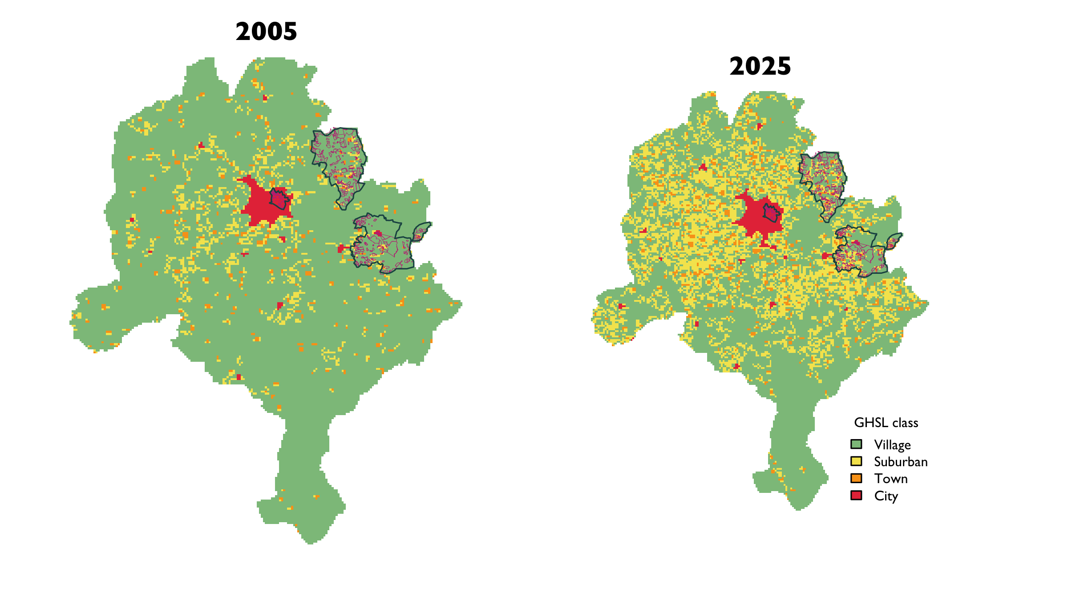
Figure E.1: Side-by-side comparison of the GHSL Degree-of-Urbanization raster over Kano at two epochs: 2005 (census era, left) and 2025 (current, right). Cells are coloured by collapsed SMOD class (Village / Suburban / Town / City). Sentinel LGAs (Gabasawa / Gaya / Nassarawa) are outlined in dark teal; LQAS-sampled GEA polygons are outlined in magenta. In the HTML version, drag the vertical handle to compare epochs; the DOCX render falls back to a side-by-side static pair of rasters.
A “sample point” in what follows is the GPS coordinate of the household that was actually interviewed for LQAS in a given GEA, not a GEA-level summary. Because the LQAS design tests one eligible child per GEA-lot, there is at most one interviewed-household point per GEA, and the Global Human Settlement Layer Settlement Model (SMOD) class is extracted at that point. This matters where a GEA straddles a boundary between classes (large or elongated GEAs on the urban fringe can contain both Village and Suburban cells, for instance); a GEA-level aggregation would have to pick a modal or centroid class in those cases, whereas an extraction at the interviewed point directly reflects what the enumerator was standing on.
Of the 608 GEAs sampled at stage one, 594 have an interview-point GPS coordinate (the LQAS fieldwork reached an eligible child there); the remaining 14 dropped out of dsg_lqas upstream for fieldwork reasons unrelated to SMOD (no eligible child located, security redirects, or similar). Rather than discard those 14 GEAs from the urbanisation diagnostic, we fall back to the GEA polygon centroid from the LQAS stage-one shapefile and extract the SMOD class there. The descriptive cross-tabulation below therefore reports all 608 stage-one GEAs. The design-based Generalized Linear Model (GLM) further on still runs only on the 594 interview-point rows, because the 14 centroid fallbacks have no child-level outcome or survey weight attached.

Class collapse caveats
The raw GHSL SMOD layer distinguishes eight cell classes. Throughout this report we collapse those eight into four (Table E.1) to keep factor levels stable when cross-tabulating or regressing on urbanisation: several of the raw classes are very sparsely populated in our study area, and left un-collapsed they produce empty or near-empty ward × class cells that destabilise calibration weights. The collapse is therefore driven by statistical tractability, not by geographic correspondence. A consequence is that two of the four labels we use here are deliberate oversimplifications rather than literal descriptions of what is on the ground:
- Village is a catch-all that groups the genuine rural-cluster class (GHSL 13) with a Dispersed rural area class (12), a Mostly uninhabited area class (11), and Water body cells (10). A cell labelled “Village” in the analysis below is therefore not guaranteed to contain a settled village; it only guarantees that the cell is below the suburban density threshold.
- Town groups Semi-dense town (22) with Dense town (23) under a single label.
The Suburban and City labels map one-to-one onto their raw GHSL classes (21 and 30 respectively) and can be read at face value. When we speak of urbanisation transitions in the rest of this annex, those transitions are transitions on the four-level collapsed scale, not on the raw eight-level SMOD scale.
Table E.1: Crosswalk from the raw 8-class GHSL Degree-of-Urbanization (SMOD) layer to the 4-class collapse used in this annex. Collapsed labels are stacked per group; each raw GHSL class maps to exactly one collapsed label.
Collapsed label | Raw GHSL code | Raw GHSL class name
Village | 13 | Village (rural cluster)
Village | 12 | Dispersed rural area
Village | 11 | Mostly uninhabited area
Village | 10 | Water body
Suburban | 21 | Suburban or peri-urban area
Town | 22 | Semi-dense town
Town | 23 | Dense town
City | 30 | City

SMOD drift, 2005 to 2025
Table E.2 cross-tabulates the GHSL Degree-of-Urbanization class at each sampled GEA between the 2005 epoch and the 2025 epoch. Of 608 GEAs with classifications at both epochs, 172 (28%) fall in a different class in 2025 than they did in 2005. Class reclassification is one-directional: no GEA moves down the urbanization gradient.
The MOS-staleness signal is carried almost entirely by Gabasawa and Gaya. Nassarawa contributes nothing: all 209 of its sampled GEAs sit in the dense urban core (GHSL class City) at both 2005 and 2025, so the MOS-staleness mechanism is structurally absent there and the weighting-drift argument does not apply. Readers should therefore treat Nassarawa as a baseline-coverage comparator in the cross-tabulation below rather than as evidence for or against staleness.
Table E.2: GHSL Degree-of-Urbanization class at each sampled LQAS GEA, 2005 vs 2025, for all 608 stage-one GEAs. Class is extracted at the interviewed-household GPS point where available (594 GEAs); for the 14 GEAs without an interview point (fieldwork attrition), class is extracted at the GEA polygon centroid instead. Rows group by 2005 class; columns group by 2025 class. Diagonal cells (shaded) are GEAs whose class was unchanged over the period; the off-diagonal upper triangle is the reclassified set. Row and column totals, separated by heavy rules, are bold.
 |  | 2025 class
 |  | Village | Suburban | Town | City | Total
2005 class | Village | 52 | 118 | 31 | 0 | 201
2005 class | Suburban | 0 | 70 | 23 | 0 | 93
2005 class | Town | 0 | 0 | 68 | 0 | 68
2005 class | City | 0 | 0 | 0 | 246 | 246
 | Total | 52 | 188 | 122 | 246 | 608
Figure E.3 visualises the same transitions as the cross-tabulation above, but in a flow form. Ribbons are coloured by 2005 source class and drawn translucent when the class is unchanged (stable) and more opaque when the GEA is reclassified — which makes the upward-only pattern and the volumes involved immediately legible. The By sentinel LGA tab breaks the same data apart by fieldwork LGA, so that Gabasawa’s pronounced Village-to-Suburban fan, Gaya’s mixed reshuffle, and Nassarawa’s complete stasis read off the page separately.

By sentinel LGA
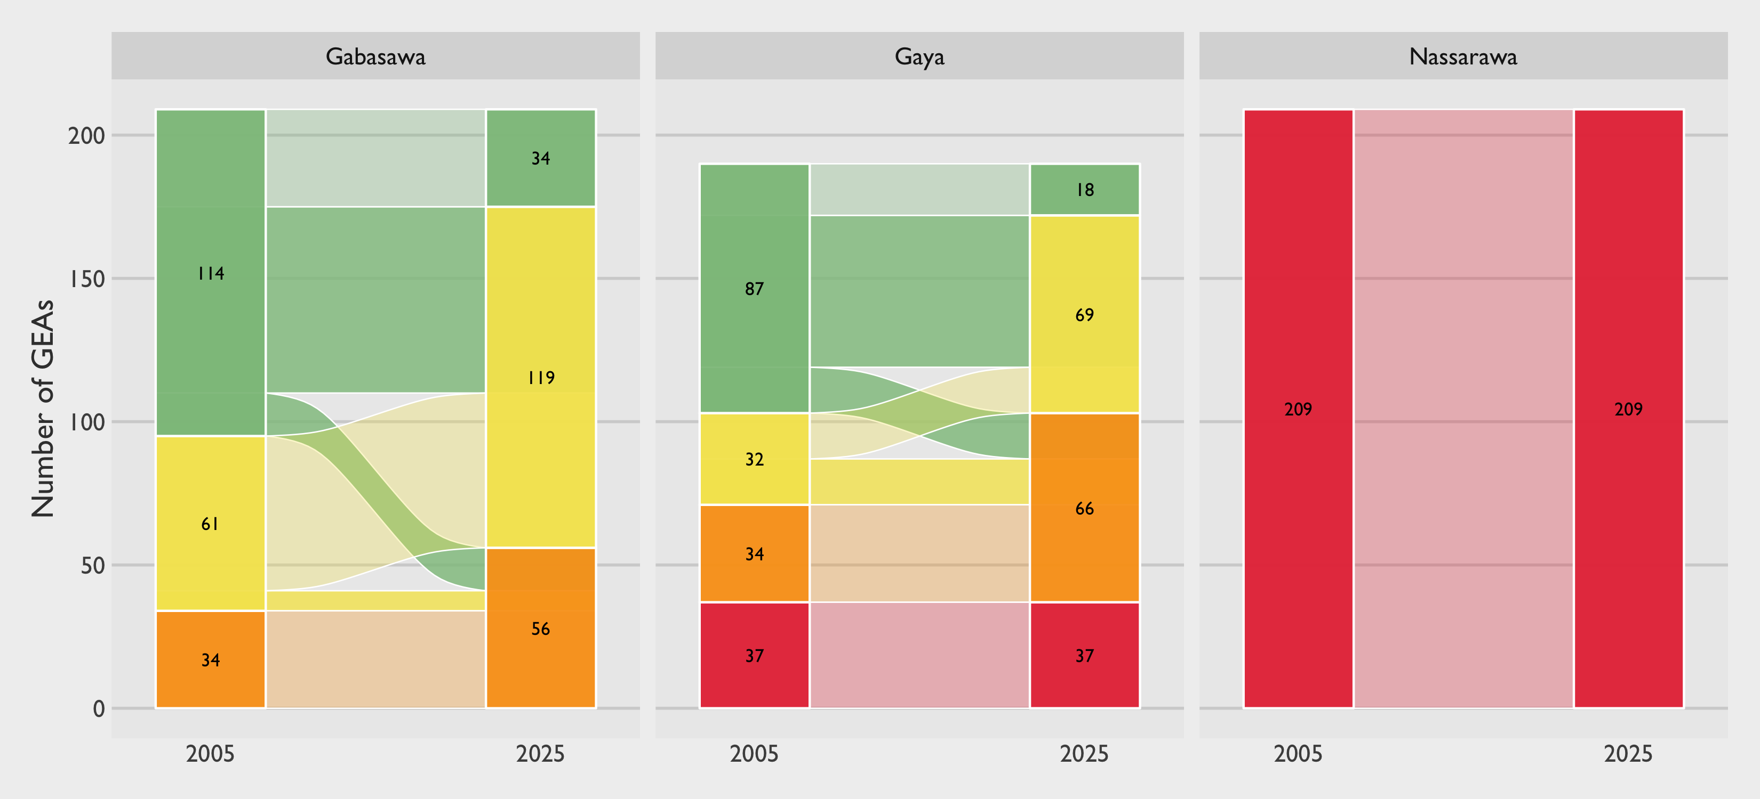
Figure E.2: SMOD transition 2005 → 2025 by sentinel LGA. Nassarawa is 100% City at both epochs (no reclassification possible); Gabasawa carries the bulk of the Village → Suburban fan; Gaya is a mixed reshuffle.

Overall
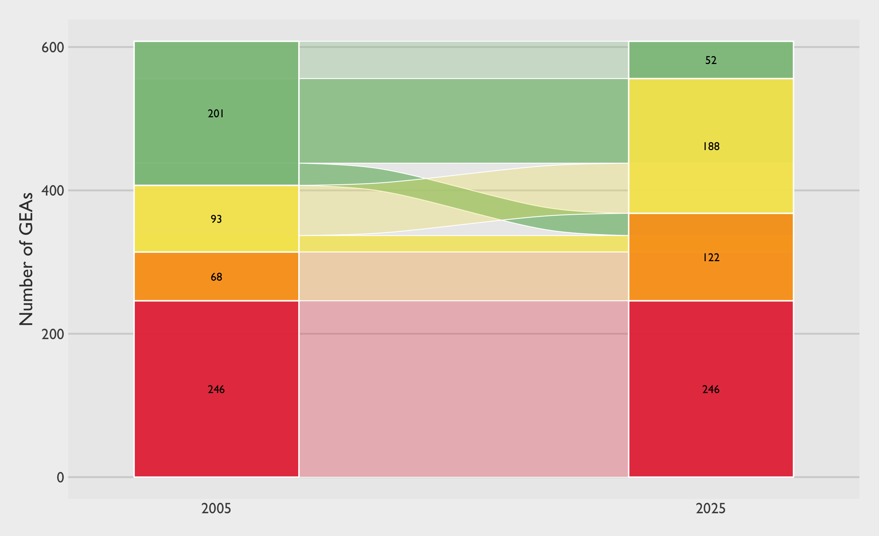
Figure E.3: SMOD transition 2005 → 2025 for all 608 sampled GEAs. Ribbons coloured by 2005 source class; translucent ribbons are unchanged class (diagonal in Table E.2), solid ribbons are reclassified (off-diagonal, upward only). Hover on a ribbon in the HTML version to see the exact count and share of its 2005 source class.
Under the same-child population served by the same stage-one sampling frame, a point now classified as Suburban that was rural in 2005 illustrates the MOS-staleness mechanism directly: its current share of the ward’s eligible children is not what the 2006 census assumed, so weights built on the original frame drift from the weights that current population shares would imply.

Zero-dose by urbanisation
The urbanisation drift documented above would be a curiosity, not a concern, if Penta-1 zero-dose prevalence were uncorrelated with where on the urbanisation gradient a GEA sits. It is not. Figure E.4 reproduces the GHSL Degree-of-Urbanization stratum from the gold-standard household-survey estimates reported in the Kano zero-dose baseline study (Mindset 2025) (findings-132-ri-coverage-zero-dose). Zero-dose prevalence is markedly lower in the dense urban core (City) and rises monotonically across Town, Suburban, and Village cells. The gap between the City point estimate and the Village point estimate is large relative to the CI on either, so the gradient is not an artefact of within-stratum noise.
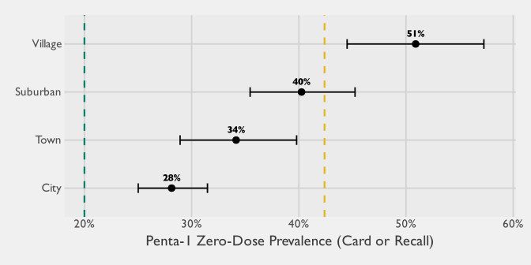
Figure E.4: Gold-standard Penta-1 zero-dose prevalence in Kano by collapsed GHSL Degree-of-Urbanization class, with 95% confidence intervals. Source: Mindset Nigeria zero-dose baseline study (Mindset 2025), fig-zd-by-domain. Dashed reference lines mark the 2023-24 DHS Kano zero-dose estimate (42.2%, yellow) and an 80%-coverage target (20% ZD, green).
As an exploratory probe into whether the MOS-drift mechanism is visible at the point-estimate level, we can further stratify the gold-standard estimates by whether each interviewed child’s GEA kept its SMOD class between 2005 and 2025 (stable) or moved up the urbanisation gradient (reclassified). The 2005 and 2025 classes are extracted at the child’s GPS coordinate in exactly the way the LQAS stratification was done above, just applied to the gold-standard household survey. We restrict this analysis to the three sentinel LGAs (Gabasawa, Gaya, Nassarawa) rather than to Kano-wide data so the scope aligns with the LQAS-sampled area that the rest of this annex concerns itself with; a broader sensitivity on all 15 LGAs tells a different (and less coherent) story, mostly driven by a handful of peripheral LGAs outside the LQAS catchment that have urbanised into the City class since 2005. Under the hypothesis that a GEA’s current catchment profile carries residual signal from its pre-urbanisation configuration — the inside-the-sample expression of MOS-drift — reclassified GEAs should carry systematically higher Zero-Dose (ZD) prevalence than stable GEAs of the same 2025 class. Village has no reclassified members by construction (it is the lowest class) and, in the sentinel LGAs, City reclassification is effectively absent (only 4 children sit in GEAs that moved into City since 2005 — Nassarawa was already overwhelmingly City in 2005). The comparison is therefore meaningful for Suburban and Town. Figure E.5 shows the stratification.
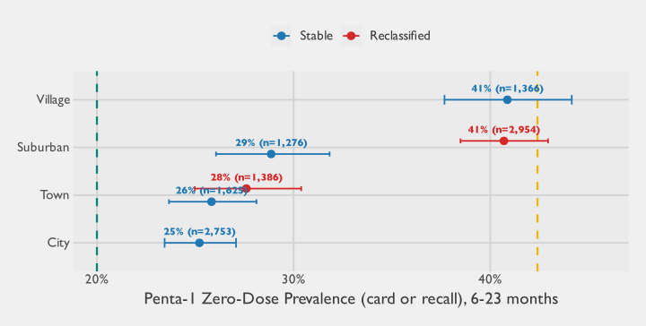
Figure E.5: Exploratory. Penta-1 zero-dose prevalence (card or recall) among children 6-23 months in the gold-standard survey, restricted to the three sentinel LGAs (Gabasawa, Gaya, Nassarawa), by 2025 SMOD class further stratified by whether the sample point kept its 2005 SMOD class (Stable, blue) or moved up the urbanisation gradient between 2005 and 2025 (Reclassified, red). Error bars are 95% design-based (logit) confidence intervals. Village has no reclassified cell by construction; the City reclassified cell carries only 4 children within the sentinel LGAs (Nassarawa was already overwhelmingly City in 2005) and is not drawn. Dashed reference lines: 2023-24 DHS Kano zero-dose estimate (42.2%, yellow); 80%-coverage target (20% ZD, green).
Within the sentinel LGAs, the stratified picture is clean and directionally consistent with the MOS-drift hypothesis. At Suburban, reclassified GEAs (almost all urbanised from Village since 2005) carry notably higher ZD than stable Suburban GEAs — roughly 41% vs 29%, with non-overlapping intervals. At Town, reclassified and stable GEAs sit close together (28% vs 26%, overlapping intervals): once a cell has already urbanised past Suburban, whether it did so in the last two decades or before 2005 no longer predicts a meaningful ZD differential.
The two design-based Wald tests back up this reading. A pooled test of the reclass main effect in an additive GLM (zd_cp1 ~ smod_2025 + reclass) is strongly significant: F = 27.99 (1, 495 df), p = <0.001. Allowing the reclass effect to vary by 2025 SMOD class (zd_cp1 ~ smod_2025 * reclass, fit on the Suburban / Town subset where the interaction is identifiable in the sentinel sample) is also significant: F = 6.30 (2, 494 df), p = 0.002. The interaction reflects the Suburban-vs-Town difference in the reclassified-vs-stable gap — the reclassified-vs-stable log-odds contrast is +0.53 at Suburban and attenuates by about -0.43 at Town, consistent with the picture the figure shows.
That the signal concentrates at Suburban is exactly where the MOS-drift mechanism predicts it should. Gabasawa and Gaya — the two sentinel LGAs that actually have Village-to-Suburban reclassification since 2005 (see Figure E.2) — are the peri-urban fringe of metropolitan Kano, and their newly-Suburban GEAs are precisely the cells whose 2006-era MOS under-represents current population relative to what a fresh listing would show. The observation that those cells also carry higher ZD than already-Suburban cells of similar 2025 classification is exactly the “informative drift” case flagged in the Listing, bias, and weights section: it suggests that, in addition to the always-present efficiency loss, there is a small directionally-consistent bias — the LQAS design under-samples children from the demographic profile that is most likely to be ZD. The size of the contrast (~12 percentage points within Suburban) is large enough that the annex’s overall “approximately unbiased, just less precise” headline deserves the caveat that the approximation is weakest exactly where the GEAs have urbanised the most. A more striking way to see the same result is to notice that the reclassified-Suburban point estimate (41%) sits essentially on top of the stable-Village estimate (41%) — and roughly 12 percentage points above the stable-Suburban estimate (29%). In other words: on the ZD outcome, peri-urban GEAs that urbanised since 2005 behave as though they were still Village, not as though they were Suburban.
Several candidate mechanisms are consistent with that pattern, and the data here cannot adjudicate between them. The most direct is a supply-side story: health-facility coverage, routine-immunisation outreach, and campaign logistics all follow built settlement, and they tend to follow with a lag of years rather than months — the buildings arrive, the services arrive eventually. A more specific version of that story, which we find compelling but speculative, is that the targeting infrastructure used by routine outreach and campaign partners (settlement rosters, facility catchment lists, LGA micro-plans) is typically built against the same vintage of population data that feeds the sampling frame: newly-urbanised peri-urban cells that were sparsely populated at the 2006 census may simply not appear in the settlement rosters that determine where teams go, even if the households are now numerous enough for a satellite-derived SMOD layer to label the cell Suburban. Under that reading, the MOS-staleness phenomenon this annex quantifies at the sampling layer is the visible half of a wider pattern of administrative data lag: the planning layer that shapes service delivery drifts from reality on roughly the same timeline, for roughly the same reason, and at roughly the same cells, which would explain why our newly-Suburban sample behaves in vaccination terms as though it were still Village. Two further mechanisms are also consistent with the pattern: migrant composition (peri-urban fringes draw rural-origin households whose care-seeking behaviour reflects their place of origin more than their place of residence) and SMOD measurement noise at 1 km resolution (a cell reclassified Suburban on satellite may in fact remain functionally Village on the ground). None of these can be ruled in or out from the data we have.
Two cautions are worth emphasising before drawing conclusions from the stratified analysis. First, the sentinel-LGA restriction was not incidental: in a Kano-wide sensitivity (see the commentary above), the City stratum rather than Suburban carries most of the signal, driven by a handful of peripheral LGAs outside the LQAS catchment where new urban classification is appearing for the first time. The GEA-level pattern is therefore clearly LGA-specific, and the “reclassified cells behave like their old class” statement should not be read as a claim about Nigeria or even Kano as a whole. Second, with only three sentinel LGAs the stratification of the interaction model rests on a single LGA-pair (Gabasawa and Gaya) contributing the reclassified-Suburban signal; a fourth sentinel LGA with a different urbanisation trajectory could pull the direction differently. The defensible take-away is narrower than the point estimates suggest: there are clear geospatial structural effects on ZD prevalence that operate at a finer scale than the SMOD class label captures, and those effects are worth exploring further even if the current data are not powered to generalise them.
The relevance to this annex is direct. The outcome of the study is correlated with the dimension on which the frame has drifted. That satisfies the condition under which stale-MOS efficiency loss — and, in the unfavourable case where the drift is also informative, a small residual bias — can bite on estimates of ZD prevalence. In principle, a GEA whose effective 2025 urbanisation profile differs from what the frame’s MOS implies is exactly the kind of unit that will carry more variance than the design budgeted for.
Readers seeking a headline should take away two things: first, the study’s estimates remain approximately unbiased under the conditions discussed in Listing, bias, and weights; second, the confidence intervals around those estimates are almost certainly wider than they would be under a freshly-listed 2025 frame, and that widening falls disproportionately on the GEAs that have urbanised the most since 2005 — which Figure E.4 and Figure E.5 together suggest are also the GEAs where zero-dose prevalence is highest.

Specifically, the sample was designed to detect a three-point difference in prevalence with 80% power at the level of each Sentinel LGA.
As noted in the WHO reference manual (2018), “[t]here has been a tendency to use a single design (most often 30 clusters of 7 individuals per cluster) without appropriate adaptation of sample size and survey design according to survey goals. The 2005 reference manual (WHO, 2005) gave guidance on how to adapt the design, but in practice this guidance was not often used.” The use of the $30×7$ benchmark here reflects its ubiquity rather than an implicit pronouncement on its appropriateness for a given set of survey objectives. Indeed, the maximal $±10$ percentage-point Margin of Error (MOE) that this design induces may often be unacceptably imprecise for many applications.
The version used for this study’s RCM implementation was an earlier version of this guidance branded by United States Agency for International Development (USAID)/MOMENTUM (MOMENTUM 2024). The core implementation features are substantially the same between the two versions; the newer WHO debranded version includes additional resources and a toolkit for conducting root-cause analysis.
The acronym RCM is also sometimes used for rapid coverage monitoring, an entirely distinct family of methods unrelated to the rapid convenience monitoring approach evaluated here. We use RCM throughout this report to refer exclusively to the latter.
This applies most directly to adaptive sampling and the administrative methods (DHIS2 audit), which are designed to estimate individual-level zero-dose prevalence. Network Scale-Up Method estimates the proportion of households with a zero-dose child rather than individual prevalence. Rapid Convenience Monitoring does not purport to estimate coverage, though it sometimes calculates the percentage of unvaccinated children observed. Lot Quality Assurance Sampling is primarily designed for classification relative to a threshold rather than prevalence estimation, though weighted estimates can be derived under certain circumstances.
The analogous weighted ratio estimator equivalent is defined as follows. Let $w_{j}$ denote the final survey weight for respondent $j$ (typically the inverse inclusion probability, with any nonresponse and calibration adjustments). The weighted prevalence estimator is $${\hat{q}}_{w}=\frac{\sum_{j=1}^{n}{w_{j}}m_{j}}{\sum_{j=1}^{n}{w_{j}}c_{j}}, \left(3.4\right)$$ and the weighted population-of-interest total is obtained by scaling with an estimate of the total population size $${\hat{h}}_{w}=\hat{t}⋅{\hat{q}}_{w}=\hat{t}⋅\frac{\sum_{j=1}^{n}{w_{j}}m_{j}}{\sum_{j=1}^{n}{w_{j}}c_{j}}. \left(3.5\right)$$ When $t$ is not treated as known externally, a design-based estimator $\hat{t}$ can be constructed using the same weights. In the simplest person-level setting, the Horvitz–Thompson estimator is $$\hat{t}=\sum_{j=1}^{n}{w_{j}}, \left(3.6\right)$$ with the understanding that in household-based designs or eligibility-restricted surveys, $\hat{t}$ may instead target the relevant total (for example, total households or total eligible individuals) via the appropriate weighted expansion.
This sample-size calculation treats the NSUM prevalence estimator q=i​yi/i​di as an alter-level binomial proportion, under the simplifying basic scale-up assumptions that (i) conditional on respondent degree $d_{i}$, the reported count $y_{i}$ follows a binomial model $y_{i}∣d_{i}∼Binomial\left(d_{i},q\right)$ with a common hidden-group prevalence $q$; (ii) respondents are independent and degrees $d_{i}$ are treated as known (or well-approximated by their sample mean), so that the total Y=i​yi is approximately $Binomial\left(D,q\right)$ with D=i​di; and (iii) a normal (Wald) approximation is used to map $Var\left(\hat{q}\right)≈q\left(1−q\right)/D$ to a margin of error. In practice, these assumptions are optimistic: non-random mixing (barrier effects), transmission error, differential visibility, and other violations of the basic model can introduce overdispersion and bias, and our applications additionally rely on complex survey designs where clustering, unequal weights, and other design features inflate variance. These calculations are therefore idealized and intended primarily to illustrate the theoretical efficiency gains NSUM can offer, relative to direct estimation of proportions, under the basic model.
Within the small share of multi-child households that do appear in the gold-standard child interview sample, the gap is further compressed by strong within-household concordance of vaccination status: about 80% have all sampled children sharing the same Penta-1 zero-dose status (roughly 55% all vaccinated, 25% all unvaccinated) and only 20% are mixed, so even for these households the household-level estimand stays close to the child-level prevalence. The re-expressions described below hold both definitions to a common scale for head-to-head comparisons.
This phrasing reflected an assumption about what respondents could plausibly report about children in their personal networks. We expected that, at best, respondents might be aware in general terms of whether a contact’s child had been vaccinated, rather than being able to report on a specific antigen such as Penta-1. The general phrasing was therefore chosen to align the NSUM instrument with what respondents could observe of their alters. A consequence is that in settings where campaign vaccines (for example, polio or measles) reach many children who nonetheless miss their routine series, the general phrasing can produce reports that drift from antigen-specific zero-dose definitions used elsewhere in the report; the re-expressions noted in the main text hold both targets to a common scale at the estimand level for head-to-head comparisons, but some definitional slippage at the level of individual network reports remains.
This package does not appear to have the ability to account for unequal probability sampling and so may only be applicable for cases where approximately equal selection probabilities are made.
Confidence intervals are logit-transformed intervals following Korn and Graubard (1998), with a Clopper–Pearson fallback when the estimated proportion is exactly zero or one.
As a rule of thumb for interpretation, Koo and Li (2016) propose that ICC values below 0.50 indicate poor reliability, 0.50 to 0.75 moderate, 0.75 to 0.90 good, and above 0.90 excellent; an earlier and similarly widely cited scheme from Cicchetti (1994) uses slightly different breakpoints (<0.40 poor, 0.40–0.59 fair, 0.60–0.74 good, 0.75–1.00 excellent). Both authors emphasize that these are general rules of thumb. What counts as an acceptable threshold is ultimately domain-specific: it depends on the intended use (test-retest reliability vs. ranking or classification of geographic units), on how variable the underlying quantity is across units, and on the consequences of misclassification. Readers should treat the verbal labels here as orienting rather than definitive.
Adaptive cluster sampling (Thompson 1990) is the older and better-known design, but it does not control the final sample size in the same way. The adaptive web design used here keeps the final number of PSUs bounded, which matters for survey budgets.
An unselected PSU bordering one preliminary PSU received that neighbor’s estimated zero-dose count as its new size measure. An unselected PSU bordering more than one preliminary PSU received the largest neighboring count. PSUs that did not border a preliminary PSU, and PSUs already selected in the preliminary phase, received a small positive size measure.
The preliminary adaptive-sampling estimate uses the same design-based estimator as the gold-standard analysis but applies two simplifications relative to it: the downstream nonresponse, multiplicity, and post-stratification adjustments are omitted, and the first-stage variance is computed under PPS-with-replacement rather than without-replacement. Both simplifications apply symmetrically to the preliminary and adaptive sampling estimates, so the within-chapter comparison is unaffected.
For example, if PSUs 1, 2, and 3 are selected in the preliminary component and PSUs 4 and 5 in the adaptive component, one valid reordering would place 1, 2, and 4 in the preliminary component and 3 and 5 in the adaptive component. In that five-PSU example, 10 reorderings are evaluated.
Rao-Blackwellization averages over reordered preliminary/adaptive partitions of the observed final sample, so each reordering has its own set of PSU-specific inclusion probabilities. Preserving that per-PSU alignment across reorderings is what keeps the Rao-Blackwell adaptive-sampling point estimates correct.
The non-sentinel gold-standard design is a three-stage PPS cluster sample (gridded enumeration area $→$ building $→$ child). The child-level inclusion probabilities determine the Horvitz-Thompson point estimates, but the dominant variance component comes from differences between PSUs. The sentinel fixed-universe simulation in Section 3.3.4.2 uses the same cluster-correct PSU-level variance principle.
Lower $ϕ$ values were explored in pilot runs but excluded because they left too few preliminary PSUs to guide the adaptive step and created unstable prevalence variance estimates.
Each grid cell is repeated $100$ times. The $30$-child cap rarely binds in these data, so the simulation is mostly testing PSU selection rather than intensive within-PSU sub-sampling.
The simulated universe is the sentinel sample treated as fixed, not the full Kano population. The model-based SE can understate uncertainty in the smallest cells, so the replicate-to-replicate empirical SD is the preferred operational check. One hundred replicates per cell leaves some Monte Carlo noise, so narrow differences between neighboring cells should not be read too strongly.
The word “potentially” underscores that a lot classified as “potentially unacceptable” was not necessarily below the 50 percent threshold. Rather, the research team could not confidently conclude that at least half of the children in the ward were vaccinated. It is likely that many wards labeled as “potentially unacceptable” actually had acceptable coverage but lacked sufficient evidence to confirm it statistically. Indeed, later comparison of LQAS results to the gold standard estimates supports this interpretation.
In a one-sided test, the null is typically written as $H_{0}:P_{d}=0.5$ rather than $H_{0}:P_{d}≤0.5$. The reason is that statistical tests are calibrated against a single boundary value—the sharp null. If the test controls the Type I error rate at $p=0.5$, then it will also control it for all other values within the broader null region ($p≤0.5$). In other words, the hardest case to distinguish from $p>0.5$ is the boundary itself ($p=0.5$), which is why the null in Equation 3.9 is defined at that point.
It must be noted that the chosen values for $α$ and $β$ represent upper bounds. Under our current design, and assuming that finite population effects are negligible, the actual rates are $α=$ 0.084 and $β=$ 0.068.
The interpretation of Type II error in LQAS studies comes with a caveat. In typical sample size planning applications, power is calculated using the researcher’s best estimate of the true coverage rate. In contrast, in LQAS, it is more common to calculate power assuming that the coverage rate is at the upper threshold (for this study, 80 percent). This assumption is a slight fiction: the research team typically knows that most wards fall below this aspirational target, and the Type II error will likely be higher than the nominal rate in practice. Therefore, in LQAS planning, the Type II error should be interpreted as the theoretical probability of falsely rejecting lots whose true coverage rate is at 80 percent, rather than the probability of falsely rejecting lots given our current knowledge of the actual coverage rates.
In the LQAS sample, 90.6 percent of eligible households contained exactly one child aged 12-23 months, while 9.4 percent contained two or more (48 with two, four with three, and one with four; mean 1.1 per eligible household). The share was fairly stable across the three sentinel LGAs, ranging from 8.8 percent in Nassarawa (the most urban LGA) to 10.2 percent in Gabasawa (the most rural); what varies much more sharply across the urban-rural gradient is the probability of encountering any eligible household in the first place, as documented in the demographic chapter of the baseline report (Mindset 2025). For the on-tablet portion of a visit specifically, the core survey’s time audit shows that households where two or more children were assessed averaged roughly 21 minutes longer per visit than single-child households (67 versus 46 minutes; see Figure 4.7), so across the LQAS sample the incremental time is a small addition to what is already the smallest component of per-visit LQAS cost and does not materially alter the per-household or per-child estimates reported in Chapter 4.
For the present study, software produced non-symmetric bounds based on a logit transform.
For the $j$th ward, the probability of rejection is Bernoulli-distributed as $r_{j}=Pr\left(X_{j}<d_{j}^{*}\right)$, where $X_{j}∼\text{Binomial}\left(n_{j},{\hat{p}}_{j}\right)$. Here ${\hat{p}}_{j}$ is the gold-standard Penta-1 coverage rate for ward $j$, $n_{j}$ is its sample size, and $d_{j}^{*}$ is its LQAS decision threshold. The sum of independent Bernoulli trials follows a Poisson-binomial distribution (Daskalakis, Diakonikolas, and Servedio 2013). The probability mass function of this distribution can be evaluated directly with available software in R (Hong and R Core Team 2024).
The distinction here is between the true variance of the estimator — which exists as a function of population parameters, including each cluster’s internal variability — and a sample-based estimator of that variance. With a single interview per cluster, the within-cluster component cannot be separately estimated from the data, since a within-stratum sample variance requires at least two observations per stratum. Standard survey-software variance estimators sidestep this with the ultimate-cluster (with-replacement) approximation, which treats all observed between-cluster variation as the total variance, absorbing the within-cluster component and yielding a slightly conservative estimate under without-replacement cluster sampling.
The estimated coverage-task DEFFs above may be understated, as the sampling design does not fully account for non-response and presumes—for simplicity—that the interviewed individual was the first and only sampled household in a GEA. In reality, as described above, enumerators conducted a random walk in the neighborhood until a successful interview was achieved. If we were to integrate any corrections for differential non-response, differential eligibility, or enumerator effects, we would expect the design effect to increase as such adjustments tend to increase weight variability.
At the time the sample was being finalized, Mindset was in talks to add two non-zero-dose LGAs to the study: Kano Municipal and Makoda. These two LGAs were subsequently withdrawn from the study, but not before data collection had begun. These two additional LGAs are therefore included in the data collected. Where possible and appropriate, they have been included in data modeling, but are used for comparison as they do not have an equivalent estimate from the gold standard data.
This technique is known in the literature as “multilevel regression and poststratification” (Gelman and Little 1997).
The regression model is given by: $$log\left({register_doses}_{i}\right)=β_{0}+β_{1}log\left({dhis2_doses}_{i}\right)+γ^{⊤}M_{t\left(i\right)}+u_{v\left(i\right)}+w_{g\left(i\right)}+a_{f\left(i\right)}+b_{f\left(i\right)}log\left({dhis2_doses}_{i}\right)+ε_{i},$$ $$u_{v}∼N\left(0,σ_{\text{vaccine}}^{2}\right), w_{g}∼N\left(0,σ_{\text{lga}}^{2}\right),$$ $$\left(\begin{matrix}a_{f} \\ b_{f}\end{matrix}\right)∼N​\left(\left(\begin{matrix}0 \\ 0\end{matrix}\right),\left(\begin{matrix}σ_{a}^{2} & σ_{ab} \\ σ_{ab} & σ_{b}^{2}\end{matrix}\right)\right), ε_{i}∼N\left(0,σ^{2}\right).$$
For example, if a given PHC has reported all but one month on DHIS2, the annualized figure would be average monthly doses for the 11 reported months, multiplied by 12.
The RCM implementation in this study followed an earlier unreleased version of this guidance document branded by USAID and MOMENTUM (MOMENTUM 2024) and marked as “Version: July 31, 2024”. The core implementation in that earlier version is substantially the same as the de-branded version available on the WHO website.
The choice of 1.75 kilometers reflects an ad hoc choice by the research team. It was intended to balance the competing aims of capturing enough data points to reduce sampling error while also not casting such a wide net that the comparison data no longer represented the neighborhood visited by each RCM. The arbitrary nature of this underscores the need for explicit boundary definitions of catchment areas in RCM implementations.
The geospatial estimate uses indicator kriging methods to smoothly estimate zero-dose prevalence across physical space. These geospatial methods were only supported in the three sentinel LGAs where the sample size was sufficiently large that the entire LGA was canvassed.
One child on the Kazurawa walk appears as zero-dose in Table 3.30 because all antigen-specific fields are missing from the dataset, despite the caregiver reporting that the child had been vaccinated and the enumerator confirming that a vaccination card was seen. The survey instrument correctly classified this child as vaccinated and skipped the reasons-for-non-vaccination battery. The apparent zero-dose classification is therefore a data-completeness artefact rather than a genuinely unvaccinated child.
$p$-values are derived from a paired bootstrap that uses Beta posterior draws (Jeffreys prior) for the RCM arm and survey replicate weights for the gold-standard arm, with a Beta posterior at the design-effect-adjusted effective sample size substituted where the observed proportion is exactly 0% or 100%.
If the quotient is calculated as $q=\frac{\text{unvaccinated children}}{\text{total children}}$ with sample size $n=20$, then an approximate margin of error could be expressed as $e=±1.96×\sqrt{\left(q\left(1−q\right)\right)/n}$.
An empirical density is a smooth, continuous version of a histogram that helps visualize the overall shape of a distribution. It can be thought of as a smoothed curve drawn over the histogram bars.
Although heuristic, the 80th percentile usefully bounds duration for four-fifths of cases. Because time distributions tend to be right-skewed, it captures most typical operations without letting a small long tail dominate the summary.
Unlike Table 4.2, which conditions on a completed child interview, Table 4.5 also includes NSUM-only completions (households with no age-eligible child, which skip the child immunization history module); the Total row median is therefore lower than the “I” row median in Table 4.2.
For the Gold Standard child module, households were eligible only if a child aged 0–23 months was present. For the NSUM module, households without an age-eligible child could still contribute if an adult respondent was available. In practice, when no eligible child lived at the address, the screener asked whether an adult was available for the NSUM interview.
The model in question is a multi-level Generalized Additive Model (GAM) with random intercepts for enumerators and fixed effects for the number of age-eligible children interviewed and whether an NSUM respondent was available for interview. A smoothing spline is fit to an index variable that enumerates the temporal order of a given interviewer’s successful survey interviews.
Although the curve in Figure 4.11 shows a noticeable drop after 300 surveys, this is likely a spurious finding. For one, the uncertainty band in this section is wider. Second, the drop likely reflects that only enumerators who tend to be fastest who end up reaching 300+ interviews. The research team believes that the survivorship bias in the data likely caused the model to overestimate the speed of interviews past the 300th interview.
Random intercepts represent each enumerator’s deviation from the population-average duration, with estimates shrunk toward zero by an amount that depends on how many surveys the enumerator contributed.
The model used is a negative binomial GAM with random intercepts for enumerator and LGA effects and smoothing splines on the proportion of LGA sampled cases completed.
The time and costs of conducting this costing analysis have been netted-out from all totals. They are ancillary to the implementation effort of the methods under comparison and therefore fall outside the costing boundary. No further meta-research activities — methodological simulations, cross-method benchmarking, or chapter-level methodological exposition that went beyond routine operational reporting — have been netted out separately. Some of the largest such activities, most notably the adaptive-sampling simulation work, were conducted after the time-motion data-collection window closed and therefore do not appear in these totals. For meta-research time that does fall within that window, the level of detail at which time was reported is not fine enough to cleanly separate “core” deployment work from methodological exploration. Two further caveats are useful for readers comparing these figures to other implementing arrangements. First, the report devotes a full chapter to each method’s methodology and findings, and likely turns over more stones than a typical operational exercise would for any single method. Second, the labor cost of analysis depends heavily on the staffing mix — heavy involvement of subject-matter experts and consultants (as here) costs substantially more than would a locally hired monitoring-and-evaluation officer. The planning and analysis figures reported in this chapter are therefore best read as upper bounds on what a routine, lean-staffed deployment of each method would have cost in those phases.
Supervisors were paid $70 United States Dollar (USD) per day and enumerators were paid $18.50 per day. As part of the $70 daily supervisor payment, supervisors were expected to cover the vehicle and fuel costs needed to support their team, even though no explicit split was specified. For this analysis, we treat $18.50 of the $70 as labor costs and attribute the remaining balance to transportation.
In this pipeline, wealth quintiles are computed from the child-module household frame rather than from all interview streams. As a result, the wealth adjustment is applied primarily to the core child-module interviews (GS and AS, and the subset of NSUM-linked cases with a matched child-module record). For methods/cases without an estimable wealth quintile (for example, all observed RCM cases and most LQAS/NSUM-only cases), the multiplier defaults to 1.0 for unknown cases, so valuation is effectively at the minimum-wage baseline. Re-estimating a harmonized wealth index across all instruments would require additional data engineering and is outside the current pipeline scope.
The daily series in Figure 4.34 is sourced from Bundesbank’s BBEX3 exchange-rate dataset (via DBnomics), specifically the Nigeria USD middle-rate series (D.NGN.USD.CA.AC.000).
The two quantities are not strictly the same estimand: the 7-percentage-point figure is a mean absolute deviation across LGAs between the 2018 modeled surface and the 2025 gold-standard estimates, while the ±10-percentage-point EPI target is a confidence-interval half-width (margin of error). We compare their magnitudes here as a rough order-of-magnitude check on prior-quality.
Non-sentinel areas in this study used gridded sampling rather than the same EA-based cluster definition used in sentinel areas. As a result, the meaning of a “cluster” and its implied ICC properties can differ across strata. Interpret cross-stratum comparisons of cluster-level ICC with this design distinction in mind.
Enumerator ID 123 is excluded throughout, matching the exclusion in Section 4.3.1.2. That ID corresponds to two records whose timestamps fall outside fieldwork hours and is treated as a non-production entry; including it does not change any of the headline figures in this section.

